GC311 – Database Concepts
Assignment #3

Q1: The many-to-many relationship between books and authors can be modeled with 3 tables, as shown below. A books table contains data about books (such as title and price); an authors table contains data about the authors (such as name and email). A table called books_authors joins the books and authors tables and captures the many-to-many relationship between books and authors.
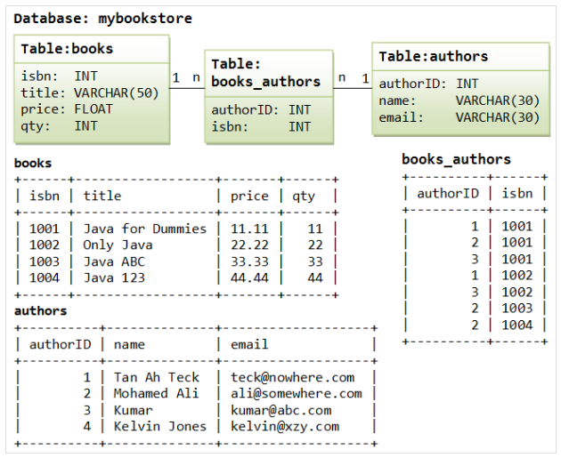

- Using Data definition language (DDL), write SQL query.
  - Create table statements for the above tables.
  - Add new column (sex) to authors table.
  - Set the default value for sex column to female (‘F’).
  - Remove books table and if any other objects depend for their existence on continued existence of this table, does not allow request.

