- What is the job of buddy-heap algorithm?

- What is the job of virtual memory?

- Explain how new processes are created using the fork() system call?

- Explain the following figure about Linux scheduler.
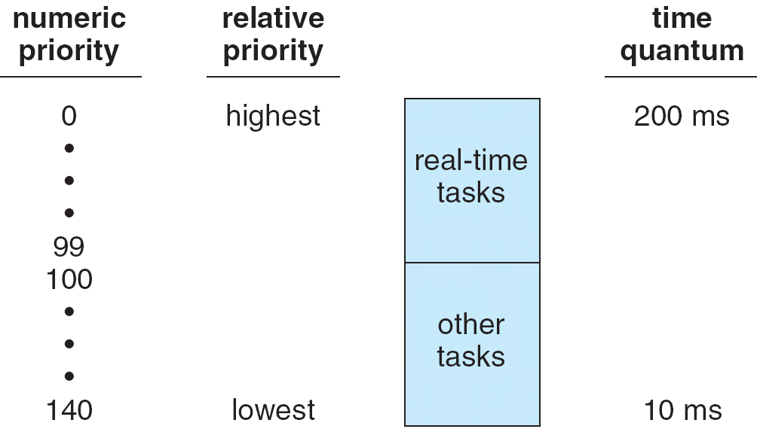

- What is the different between FCFS and Round-Robin scheduling?

- Compare between user mode and kernel mode.

