**Csc1203- assignment#3**

Q1: Present the relational schema mapped from the Library model shown in below.

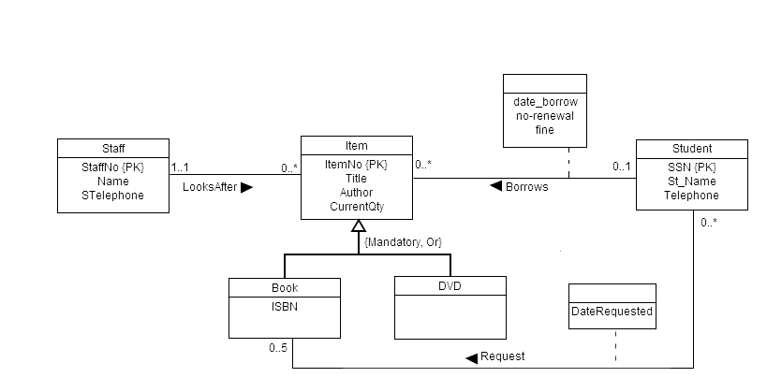

**Q2: Derive relation schema for the following conceptual data model:**

