Q1) from the following ER:

1. Redraw the following ER using chen notation .
2. Describe the cardinality and participation of "owns" relationship

Q2 ) What is the error in the following ER ?

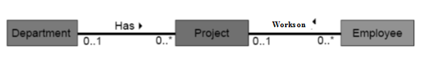

Q3) Give two different examples of Strong-Weak relationship (using UML Notation ) and define the PK of each entity ?

Eaxample 1 :

Example 2 :