**Q1: Draw an example of each of the following using UML notation :**

1. A Binary relationship.
2. A Unary Relationship.

1. A relationship type that has an attribute.
2. Strong-Weak relationship

Q2 ) What is the problem in the following ER and How you can solve ?

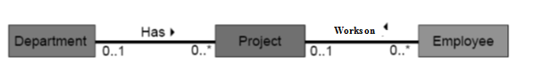

Q3 )

0..*

⮘ has

0..*

1..*

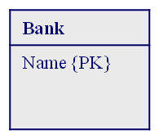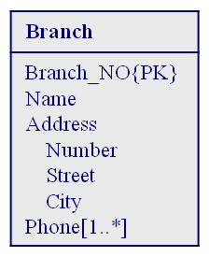

⮘ has

Owns ⮚

⮛ Contains

1..1

0..*

1..1

0..*

0..5

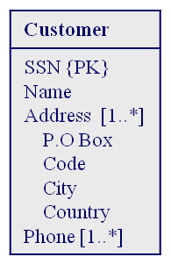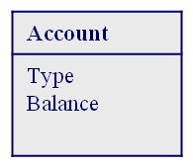

Account NO

1..1

1. Describe the cardinality and participation of "owns" relationship ?

* Each customer ………..

* Each account ………..

1. Redraw the following ER using chen notation .