Assignment #3
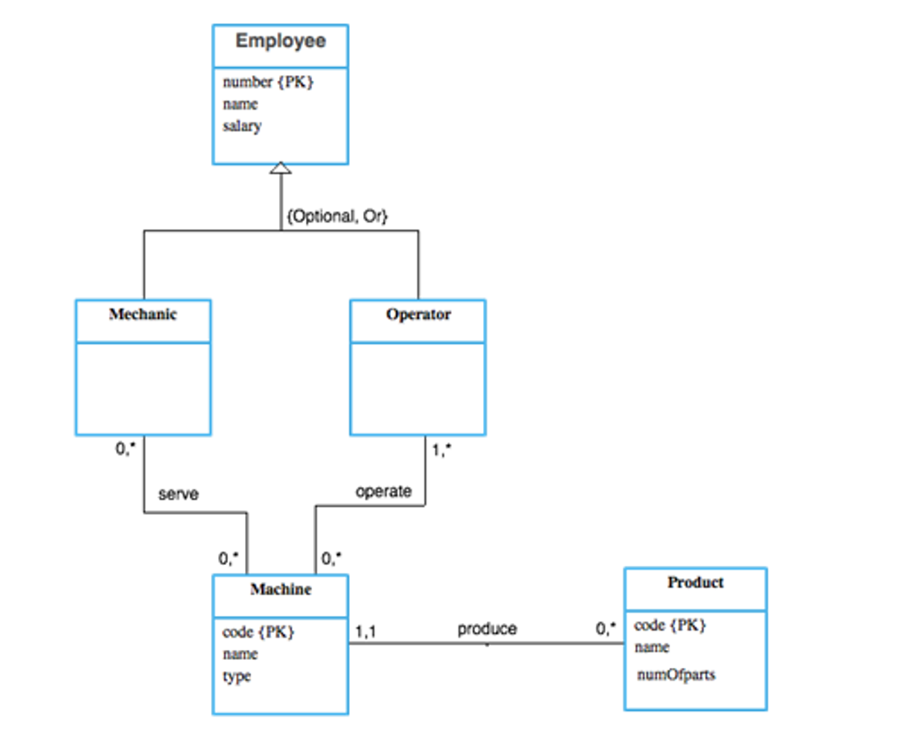
Map the EER model of the following databases, to a relational model. Show all integrity types (Clarify your answer by underline the Primary key, and dotted line the Foreign Key.(

