- Based on the agglutination pattern, determine the blood type and Rh factor and write the results on the line provided below each person’s name.
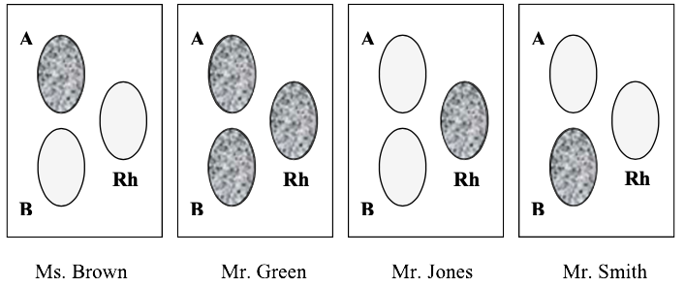
- Ms. Brown Type: _____ Rh: _____
- Mr. Green Type: _____ Rh: _____
- Mr. Jones Type: _____ Rh: _____
- Mr. Smith Type: _____ Rh: _____
- An emergency room patient has lost a lot of blood. Their blood type is AB⁺. There is a shortage of blood for transfusions, and all the ER staff can find is O⁻ blood. Do you think it will be safe to give the patient a transfusion with this blood? Why or why not?

- 4. A father and mother have the following blood types, AO and BB, respectively. Use the Punnett square shown to determine the possible blood types that their children might have.
- What are the possible blood types of the children?

- Which parent could donate blood to any of the children?

