Aquatic Ecosystem: An aquatic ecosystem is an ecosystem in a body of water. Communities of organisms that are dependent on each other and on their environment live inaquatic ecosystems. The two main types of aquatic ecosystems are marine ecosystems and freshwaterecosystems.
- Aquifers and springs
- Rivers and streams
- Lakes and ponds
- Wetlands
- Bay and estuaries
- Oceans and seas ( Pacific, Atlantic, Indian, Suthern Antarctic and Arctic)
Marine ecosystem: Salt Marshes, Intertidal zone, Estury, lagoons, mangroves, coral reef, deep sea and sea floor
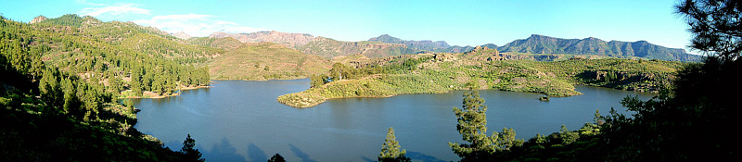
Freshwater Ecosystem (LAKE)
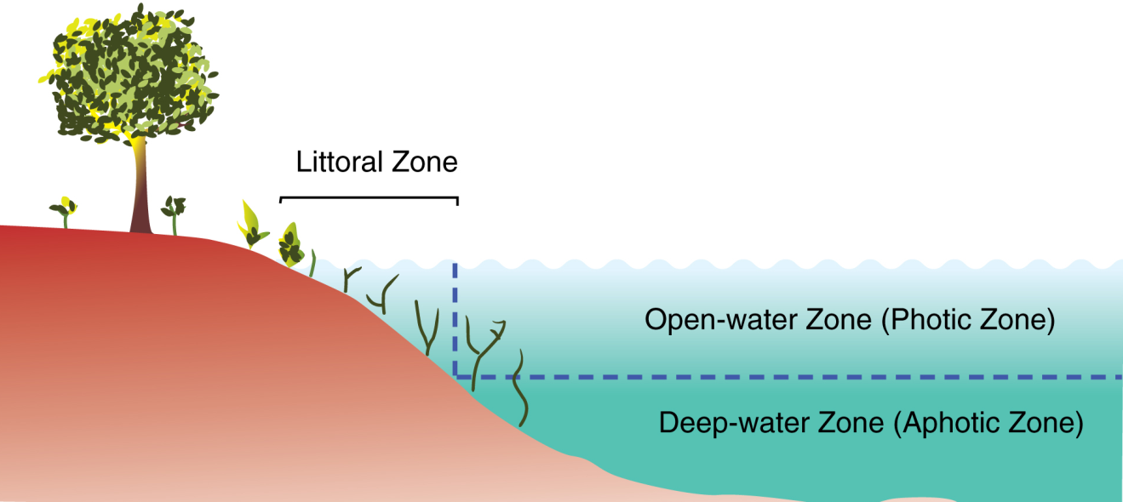
Three zone of a lake
Lake ecosystems can be divided into zones. One common system divides lakes into three zones (see figure). The first, the littoral zone, is the shallow zone near the shore. This is where rooted wetland plants occur. The offshore is divided into two further zones, an open water zone and a deep water zone. In the open water zone (or photic zone) sunlight supports photosynthetic algae, and the species that feed upon them. In the deep water zone, sunlight is not available and the food web is based on detritus entering from the littoral and photic zones. Some systems use other names. The off shore areas may be called the pelagic zone, the photic zone may be called the limnetic zone and the aphotic zone may be called the profundal zone. Inland from the littoral zone one can also frequently identify a riparian zone which has plants still affected by the presence of the lake—this can include effects from windfalls, spring flooding, and winter ice damage. The production of the lake as a whole is the result of production from plants growing in the littoral zone, combined with production from plankton growing in the open water.
River: The major zones in river ecosystems are determined by the river bed's gradient or by the velocity of the current. Faster moving turbulent water typically contains greater concentrations of dissolved oxygen, which supports greater biodiversity than the slow moving water of pools. These distinctions form the basis for the division of rivers into upland and lowland rivers. The food base of streams within riparian forests is mostly derived from the trees, but wider streams and those that lack a canopy derive the majority of their food base from algae. Anadromous fish are also an important source of nutrients. Environmental threats to rivers include loss of water, dams, chemical pollution and introduced species.^{[3]} A dam produces negative effects that continue down the watershed. The most important negative effects are the reduction of spring flooding, which damages wetlands, and the retention of sediment, which leads to loss of deltaic wetlands.
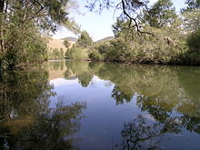
RIVER
Ponds: Ponds are small bodies of freshwater with shallow and still water, marsh, and aquatic plants.^{[7]} They can be further divided into four zones: vegetation zone, open water, bottom mud and surface film.^{[8]} The size and depth of ponds often varies greatly with the time of year; many ponds are produced by spring flooding from rivers. Food webs are based both on free-floating algae and upon aquatic plants. There is usually a diverse array of aquatic life, with a few examples including algae, snails, fish, beetles, water bugs, frogs, turtles, otters and muskrats. Top predators may include large fish, herons, or alligators. Since fish are a major predator upon amphibian larvae, ponds that dry up each year, thereby killing resident fish, provide important refugia for amphibian breeding.^{[9]} Ponds that dry up completely each year are often known as vernal pools. Some ponds are produced by animal activity, including alligator holes and beaver ponds, and these add important diversity to landscapes.
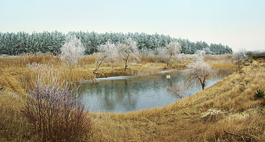

Oceans: An ocean is a body of saline water that composes much of a planet's hydrosphere. On Earth, an ocean is one of the major conventional divisions of the World Ocean. These are, in descending order by area, the Pacific, Atlantic, Indian, Southern (Antarctic), and Arctic Oceans. The word "ocean" is often used interchangeably with "sea" in American English. Strictly speaking, a sea is a body of saline water (generally a division of the world ocean) partly or fully enclosed by land, though "the sea" refers also to the oceans.
# | Ocean | Location | Area  (km²)  (%) | Volume  (km³)  (%) | Avg. depth  (m) | Coastline  (km)
1 | Pacific Ocean | Separates Asia and Oceania from the Americas^{[19][NB]} | 168,723,000  46.6 | 669,880,000  50.1 | 3,970 | 135,663
2 | Atlantic Ocean | Separates the Americas from Europe and Africa^{[20]} | 85,133,000  23.5 | 310,410,900  23.3 | 3,646 | 111,866
3 | Indian Ocean | Washes upon southern Asia and separates Africa and Australia^{[21]} | 70,560,000  19.5 | 264,000,000  19.8 | 3,741 | 66,526
4 | Southern Ocean | Sometimes considered an extension of the Pacific, Atlantic and Indian Oceans,^{[22][23]} which encircles Antarctica | 21,960,000  6.1 | 71,800,000  5.4 | 3,270 | 17,968
5 | Arctic Ocean | Sometimes considered a sea or estuary of the Atlantic,^{[24][25]} which covers much of the Arctic and washes upon northern North America and Eurasia^{[26]} | 15,558,000  4.3 | 18,750,000  1.4 | 1,205 | 45,389
Total – World Ocean |  |  | 361,900,000  100 | 1,335,000,000  100 | 3,688 | 377,412^{[27]}
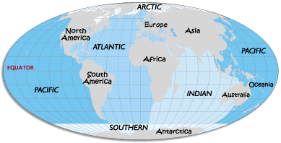
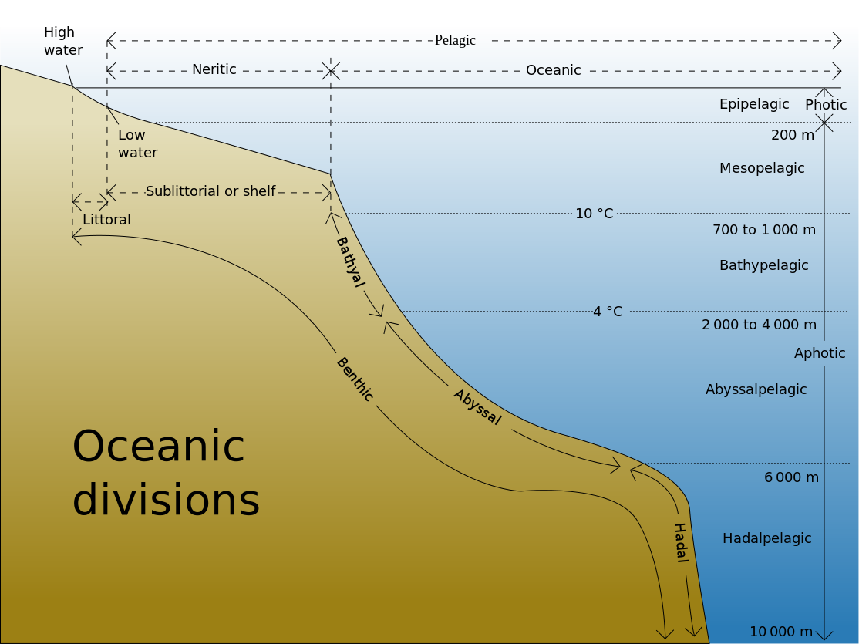
Classification of marine ecosystem

Wetlands
Wetlands are dominated by vascular plants that have adapted to saturated soil.^{[9]} There are four main types of wetlands: swamp, marsh, fen and bog (both fens and bogs are types of mire). Wetlands are the most productive natural ecosystems in the world because of the proximity of water and soil. Hence they support large numbers of plant and animal species. Due to their productivity, wetlands are often converted into dry land with dykes and drains and used for agricultural purposes. The construction of dykes, and dams, has negative consequences for individual wetlands and entire watersheds.^{[9]} Their closeness to lakes and rivers means that they are often developed for human settlement.^{[3]} Once settlements are constructed and protected by dykes, the settlements then become vulnerable to land subsidence and ever increasing risk of flooding.^{[9]} The Louisiana coast around New Orleans is a well-known example;^{[10]} the Danube Delta in Europe is another.^{[11]}

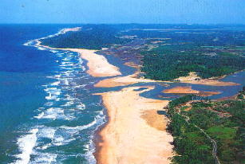
Estury mouth
Estury: An estuary is a partially enclosed coastal body of brackish water with one or more rivers or streams flowing into it, and with a free connection to the open sea.^{[1]}
Estuaries form a transition zone between river environments and maritime environments. They are subject both to marine influences—such as tides, waves, and the influx of saline water—and to riverine influences—such as flows of fresh water and sediment. The mixing of sea water and fresh water provide high levels of nutrients both in the water column and in sediment, making estuaries among the most productive natural habitats in the world.^{[2]}
Salt March: A salt marsh or saltmarsh, also known as a coastal salt marsh or a tidal marsh, is a coastal ecosystem in the upper coastal intertidal zone between land and open saltwater or brackish water that is regularly flooded by the tides. It is dominated by dense stands of salt-tolerant plants such as herbs, grasses, or low shrubs.^{[1][2]} These plants are terrestrial in origin and are essential to the stability of the salt marsh in trapping and binding sediments. Salt marshes play a large role in the aquatic food web and the delivery of nutrients to coastal waters. They also support terrestrial animals and provide coastal protection.^{[2]}
A coral reef is an underwater ecosystem characterized by reef-building corals. Reefs are formed of colonies of coral polyps held together by calcium carbonate. Most coral reefs are built from stony corals, whose polyps cluster in groups.
Coral belongs to the class Anthozoa in the animal phylum Cnidaria, which includes sea anemones and jellyfish. Unlike sea anemones, corals secrete hard carbonate exoskeletons that support and protect the coral. Most reefs grow best in warm, shallow, clear, sunny and agitated water.
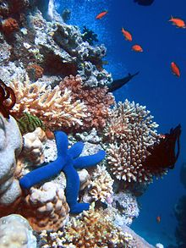A lagoon is a shallow body of water separated from a larger body of water by barrier islands or reefs. Lagoons are commonly divided into coastal lagoons and atolllagoons. They have also been identified as occurring on mixed-sand and gravel coastlines. There is an overlap between bodies of water classified as coastal lagoons and bodies of water classified as estuaries. Lagoons are common coastal features around many parts of the world.
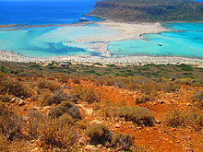A mangrove is a shrub or small tree that grows in coastal saline or brackish water. The term is also used for tropical coastal vegetation consisting of such species. Mangroves occur worldwide in the tropics and subtropics, mainly between latitudes 25° N and 25° S. The total mangrove forest area of the world in 2000 was 137,800 square kilometres (53,200 sq mi), spanning 118 countries and territories.^{[1]}
