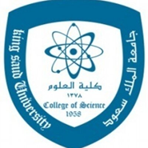 **بسم الله الرحمن الرحيم**



**King Saud University / College of Science /Zoology Department**

**Course content (Zoo 424): Principles of Experimental Embryology 2(1+1)**

**Sec. 94679 Lecture time Monday 1--2 Room 73 B1 / Lab Mon: 2-4 Lab no. 68 B1**

|  |  |  |
| --- | --- | --- |
| **Zoo 424** | **Course title: Principles of Experimental embryology**  **http://fac.ksu.edu.sa/ahimaidi** | **2 hours 2(1 +1)** |
| **Objective** | **The aim of this course is to provide the student with basic information about experimental embryology that led to understanding the process of embryonic cell differentiation and organogenesis of embryos development, embryo and cancer cell, teratology. Parthenogenesis and study some applied experiment on embryos, such as IVF, twin production ,cloning, and stem cells** | اهداف المقرر |
| **Lecture:1 25 Aug. 25** | **Course Content** Introduction, course contents and requirements | **Week12/3/47** |
| **lecture : 2 1 Sept. 25** | **-** **Theory:** A historical overview of experimental embryology | **week 2 9/3/47** |
| **Lecture:3 8 Sept.25** | **Embryonic induction and Cellular differentiation:**  **(A1- Cellular Determination :**Factors that control cell differentiation:(Role of Nucleus, cytoplasm, hormones, environment factors. **2- Embryonic induction:** Definition of Embryonic Induction | **Week 3**  **16/3/47** |
| **Lecture:4 15 Sept. 25** | -       **3-Embryonic Organizer** and  **Cellular differentiation:**  In In amphibians, birds, and mammals | **Week4 23/3/47** |
| **lecture:5 22 Sept.25** | **Embryonic cells and cancer cells:** Cancer cells /'theories of carcinogenesis. Similarities between embryonic cells and cancer cells | **Week5 30/3/47** |
| **Vacation** | **National day Vacation 23 September 25اجازة اليوم الوطني 1ربيع الاخر47** | الثلاثاء |
| **Lecture 6**  **29 Sept 25** | **First Mid Term Exam From lectur1 to 5 الاختبار الفصلي الاول من المحاضرة 1**  **يوم الاثنين 7 ربيع الاخر الموافق 29 سبتمبر 2025م 10 درجات** | **Week6 7/4/47** |
| **Lecture:7 6 Oct. 25** | **Birth defects: Teratology** The critical period of fetal development. Experimental studies Factors that cause birth defects in of embryos. | **Week7 14ربيع الثاني** |
|  |  |  |
| **Lecture:8 13 Oct.25** | **Parthenogenesis :** The concept of parthenogenesis reproduction /Artificial parthenogenesis .how parthenogenesis occurs. | **Week8**  **21 ربيع الثاني** |
| **lecture 9 20 Oct. 25** | **Applied studies on experimental embryology Assisted Reproduction Technology (ART)=** Artificial insemination (AI), and *In vitro* fertilization(IVF) | **Week9**  **28ربيع الثاني** |
| **lecture 10 27 Oct. 25** | **Twins Production and Cloning**. | **Week10 5جمادى1** |
| **lecture 11 3 NOV. 25** | **Chimera: of embryo Cell fusion** | **Week11 12جمادى الاول** |
| **Lecture 12 10. Nov.25** | **Stem cells: Embryonic and Somatic stem cells** | **Week12 19 جمادى ا** |
| **Lecture:13**17 Nov. 25 | **الاختبار الفصلي الثاني من المحاضرة 6 الى المحاضرة 10 ( 10 درجات) Second Mid Term Exam (10 marks) from Lecture 6-10** | **Week1426 جمادى** |
| **Lecture 24 Nov. 25** | **اجازة الخريف من 3/الى 8 / 6/47 One Week Vacation from 23 to 29 Nov** | **Week15 3جمادى2** |
| **Lecture 14**  **1 DEC 25** | **Term paper topic presentation (10 marks). (Lab Exam week)** | **Week16**  **10جمادى 2** |
| **Final exam 8-25 Dec.25** | **Final exam (40 marks)during Weeks 17 to 19 Form 8 to 26 Dec. بداية اختبارات الاعداد العام والنهائتية من تاربخ 7 -25جمادى الثاني 1446 هـ** | **Weeks 17 to 19** |
| **Text book References For Theory and lab** | 1- Wep site lecture home page: [**http://fac.ksu.edu.sa/ahimaidi**](http://fac.ksu.edu.sa/ahimaidi) **2-Text book: Experimental Embryology:** by Ahmad Rashe Al Himaidi and Saleh Abdulaziz Karim / King Saud Universit Press ,2008. **3-Developmental Biology "**by Scott F. Gilbert 2014. 10th ed .Sinauer Association Inc. Sunderland Massachusetts's **Lab book :Embryonic Technologies/** by Ahmed Al Himaidi/ King Saud University Press/2012/1433H | |

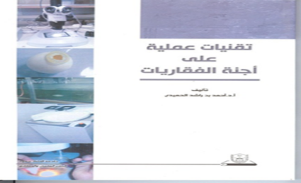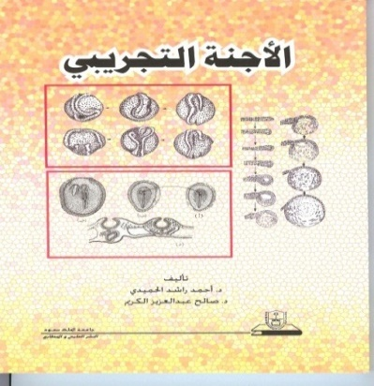 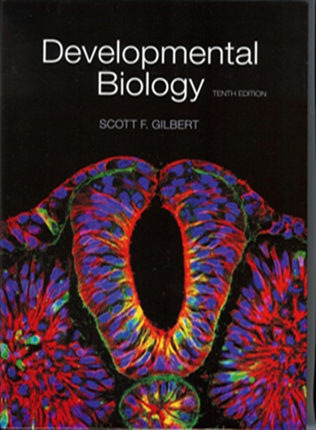

 **بسم الله الرحمن الرحيم**



**King Saud University / College of Science /Zoology Department**

**Lab Course content (Zoo 424): Principles of Experimental Embryology (2hr.)**

**Lab: Monday: 2. - 4Lab no. 68 B1**

|  |  |
| --- | --- |
| **Week /Lab .no** | **Principles of Experimental embryology**  **Zoo (424 ) Practical content:(2hr per lab per week)** |
| **Practical :I** | **Tools and devices** used in experimental embryology labs. |
| **Practice: II** | **Micro tube preparation**: Hair loop and needles pull micro tubes. |
| **Practical: III** | **Activate the ovaries** with hormones in the frog and fertilization. |
| **Practice :IV** | **Superovulation of frog**: Activate ovaries by the pituitary gland. |
| **Practice :V** | **Chick embryo** : Making a window on chicken embryo |
| **Practice :VI** | **The Shell cover** chicken embryo development |
| **Practice :VII** | **Whole mount slide** of chicken embryo |
| **Practice: VIII** | **Teratology: Effect** of some factor affected embryos development. |
| **Practical: IX** | **Reproductive Cycle** :Vaginal smear estrus cycle detection |
| **Practice: X** | ***In vitro* fertilization (IVF)** :Superovulation and *in vitro* fertilization in mice.(Sperm and ova collection and )and **Embryo** culture |
| **Practical XI** | **The Final Exam** : (20 marks) +Weekly reports 10 marks =**30 marks** |

|  |  |
| --- | --- |
| **Reference book** | **Title :Embryonic Technologies/** by Ahmed Al Himaidi/ King Saud University Press/2012/1433H. |