WRITING 2
Week | هجري  35-1434 | Gregorian  2013-2014 | Lesson
1 | 25-29/10/34هـ | 1-5/9/13 | Registration
2 | 2-6/11/34هـ | 8-12/9/13 | Introduction+Chapter 1
3 | 9-13/11/34هـ | 15-19/9/13 | Ch 1 + Ch 2
4 | 16-20/11/34هـ | 22-26/9/13 | Ch2 +Ch 3
5 | 23-27/11/34هـ | 29/9-3/10/13 | Ch 3+ Ch 4
6 | 1-3/12/34هـ | 6-8/10/13 | 1st Mid-Term  Tuesday 8/10/2013
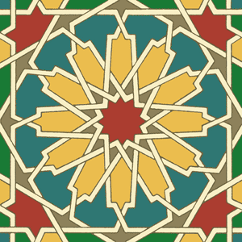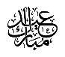
7 | 16-19/12/34هـ | 21-24/10/13 | Ch 4 + Ch 5
8 | 22-26/12/34هـ | 27-31/10/13 | Ch 5 + Ch 6
9 | 29/12/34هـ -  4/1/1435هـ | 3-7/11/13 | Ch 6 + Ch 7
10 | 7-11/1/35هـ | 10-14/11/13 | Ch7 + Ch 8
11 | 14-18/1/35هـ | 17-21/11/13 | Ch 8 + Ch 9
12 | 21-25/1/35هـ | 24-28/11/13 | 2nd Mid-Term  Tuesday26/11/2013
13 | 28/1-2/2/35هـ | 1-5/12/13 | Ch 9 + Ch 10
14 | 5-9/2/35هـ | 8-12/12/13 | Chapter 10
15 | 12-16/2/35هـ | 15-19/12/13 | Revision
16 | 19-23/2/35هـ | 22-26/12/13 | Oral & Makeup Exams
17 | 26/12-2/3/35هـ | 29/12/13 -2/1/2014 | General Exams
18+20 | 4-15/3/35هـ | 5-16/1/14 | Final Exams
1st In-term Exam: 25 pts. 2nd In-term Exam: 25 pts. Course Work: 10 pts. Final Exam: 40 pts.
SYLLABUS

Very Important Note:
Do NOT be absent for the in-term exams because there will not be any make up exams. If you have an extreme medical reason for being absent, you will need to present official verification from a government hospital of your medical situation, and then each individual case will be dealt with accordingly. If the leave is approved, the make-up exam will take place at the end of the semester, and will include ALL the chapters covered during the whole semester.
If a student misses both in-terms, the make-up exam will cover the mark of ONE exam only (i.e. 25 marks only).

Required material:
Interactions 2 \ Writing – Middle east Gold edition

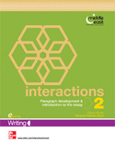

Email:
hfalkhalifa@ksu.edu.sa
For more information visit my website:
staff.ksu.edu.sa/hfalkhalifa/en
To get the latest ads about the course follow me on Twitter:
@Writing2najd
Office hours: Tuesday 8-10

I wish you much success……
T. Hayat Al Khalifah

