**Unit IV**

**normal Postpartum period** 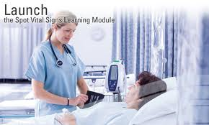

# Normal Physiological and Psychological Changes during Postpartum Period

**🖎Introduction :**

* Many of the physiologic change are retrogressive in nature; that is, changes that occurred in body system during pregnancy are reversed as the body returns to nearly pre-pregnancy state.
* During this time, mothers experience numerous physiological and psychological changes.
* To provide quality of care the nurse must be knowledgeable about the physical & emotional changed necessary for postpartum adaptation.

## ☞ Definition of puerperium:

**postpartum or puerperium period** : it is a period that start from delivery until 6 week after that or until return reproductive organ to the non-pregnant state.

**Puerperium** is divided into immediate postpartum (first 24 hours), early postpartum (first week), and late postpartum "from second week till end of six weeks".

## Characteristics of PPP:

* **Involution:** of the reproductive organs

or regressive changed.

* **Lactation:** is initiated.
* **Recovery:** from physiological effort &

emotional symptoms **“Recuperation”.**

## Physiologic Changes of the Puerperium

To check the postpartum changes is the use of the acronym **BUBBLERS:**

**B: Breast.:**

**-Colostrums**, a yellowish fluid that contains more minerals and protein but less sugar and fat than mature breast milk, and has a laxative effect on the infant, is secreted for the first 3 to 4 days postpartum.

**- Mature milk** secretion is usually present after the third postpartum day, but may be present earlier if a woman breast-feeds immediately after delivery.

**U: Uterus:**

1. 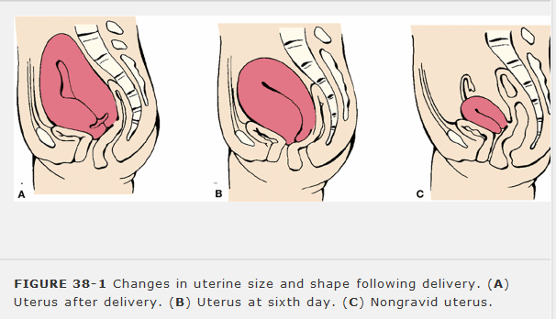The fundus or uterine involution is usually midline and approximately at the level of the woman's umbilicus after delivery(6-12hrs). Within 12 hours of delivery, the fundus may be (1 cm) above the umbilicus. After this, the level of the fundus descends approximately 1 fingerbreadth each day, until by the 10th to the 14th day, it has descended into the pelvic cavity and can no longer be palpated. And it must be firm on palpation It's return to near it's non- pregnant size by 4 to 6 postpartum week

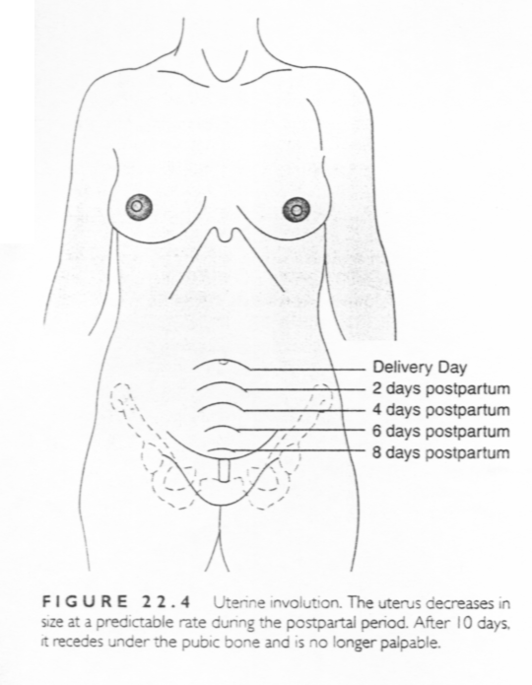

** the site of placental attachment require 6-7 weeks to heal. In process called **Exfoliation**

**⮱Factors that enhance involution include:**

* Uncomplicated labor and birth.
* Breast-feeding.
* Early, frequent ambulation.

**⮱Factors that slow uterine involution include:**

* Prolonged labor.
* Incomplete separation and expulsion of placenta.
* Previous labors.
* Distended (full) bladder.
* Anesthesia.

2.Immediately after delivery of the placenta the **cervix** has little tone and become more thicker and firm. Complete cervical involution may take 3-4 months and child birth result in a permanent change in an cervical OS from round to elongated.

3.**Vagina:** smooth and swollen with poor tone after delivery .rugae reappear by 3 – 4 postpartum week.

4.**Perineum:** appear edematous and bruised after delivery

5.**Vulva:** Edema, minute or frank laceration may be seen immediately after labor. Edema disappears gradually in a few days while lacerations, if not properly mended by sutures, may lead to the formation of a post partum ulcer.

**🖝 Resumption of Ovulation and Menstruation:**

* Most non-nursing mothers resume menstruation within 7 to 9 weeks after childbirth.
* In lactating mothers, menstruation usually reappears not earlier then 3-4 months, and some times as late as 24 months.
* The first period is generally profuse and prolonged.
* It should be mentioned that ovulation can commence in the absence of menstruation, and another pregnancy can occur.

**🖝 Body weight:**

* Loss of weight is observed during the first l0 days particularly in the non-lactating mothers. There is about a 4 – 5 kg loss of body weight (sometimes 8 kg) due to evacuation of uterine contents and diuresis.

**L:** Lochia.

After delivery, lochia, a vaginal discharge during the first 3-4 weeks or the post partum. that consists of fatty epithelial cells, shreds of membrane, leukocyte , decidua, and blood, is red with clot (lochia rubra) for approximately 2 to 4 days.

It then progresses to a pink or more brownish color (lochia serosa) 4-9 days which it's a serosanguineous discharge containing epithelial cells , leukocyte , cervical mucus, microorganism .lochia serosa has strong odor

a whitish or yellowish color and is almost colorless (lochia alba) in the 10th day until 2-6 weeks postpartum . it's containing epithelial cells , leukocyte , cervical mucus, deciduas and bacteria and **should not has odor**. Lochia usually ceases by 3 weeks.

**\*\*according to the amount the lochia classify to :**

* 1. **scant lochia:**  less than 2-5 cm blood on the perineal pad
  2. **light or mild lochia**: less than 10cm blood on the perineal pad\hrs
  3. **moderate lochia**: less than 15cm stain perineal pad\hrs
  4. **heavy lochia**: 1 saturated pad\hrs
  5. **sever lochia** : more than 1 saturated pad \hrs

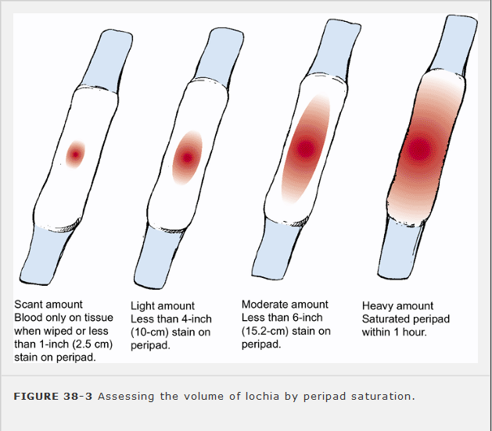

**E:** Episiotomy. It is assessed for (REEDA)

* + **R:** Redness.
  + **E:** Edema.
  + **E:** Ecchymosis (purplish patch of blood flow).
  + **D:** Discharge.
  + **A:** Approximation, or the closeness of the skin edge.

**B:** Bladder.

**-**Mild proteinuria is common for 1 to 2 days after delivery in 50% of postpartum women.

-Lactoseuria may occur in breast-feeding woman as a result of the lactation process

* - The urine may also test positive for acetone / ketonuria resulting from dehydration during a prolonged labor.

**-**Bladder tone returns between 5 and 7 days

**-**1st day urinary retention due to :

**1.** loss of the bladder elasticity and tone

**2** Urinary retention and over distention of the bladder may cause two complications:

1.Urinary tract infection. 2. Post partum hemorrhage**.** loss of sensation

**-** 2-5 days women has diuresis ( increase urine output )

**B** :Bowel.

-Gastrointestinal tone and motility decreases in the early postpartum , commonly causing constipation.

* + Constipation may be present as a result of:

1. Intestinal atony.
2. Anorexia after labor.
3. Loss of body fluids.
4. Laxity of the abdominal wall.
5. Hemorrhoids, perineal trauma and episiotomy.
6. Reflex inhibition enema in labor

- Normal bowel function returns approximately 2 to 3 days postpartum

- women feel hungry and thirst .

- Inform the woman that pain from hemorrhoids, lacerations, and episiotomies may cause her to delay her first bowel movement

- Women may return to her prepregnant weight in 6-8 weeks if weight gain during pregnancy within normal range

- Gall bladder contractility increases to normal, allowing for expulsion of small gallstones.

-After cesarean section, bowel tone returns in few days and flatulence causes abdominal discomfort

**R: Emotional response(Psychological Changes).**

After delivery, the woman may progress through Rubin's stages of taking in, taking hold, and letting go.

**a. Dependent or Taking in:**

**-** It takes 2-3 days,

-May begin with a refreshing sleep after delivery.

-Woman exhibits passive, dependent behavior.

-Woman is concerned with sleep and the intake of food, mainly for herself.

**b. Dependent – independent or Taking hold:**

-Woman begins to initiate action and to function more independently; occurs usually on days 2 to 7.

-Woman may require more explanation and reassurance that she is functioning well, especially in caring for her infant.

-Openness to teaching on care of self and neonate.

**c. Letting go:**

-Begins near the end of the first week..

-Reestablishment of couple relationship.

-As the woman meets success in caring for the neonate, her concern extends to other family members and to their activities

* Mothering functions become more established

***there are two separations that the mother must accomplish***.

**One** is to realize and accept physical separation from the infant

**Second** is to relinquish her former role as a childless person and accept the enormous implications and responsibilities other new situation. She must adjust her life to the relative dependency and helplessness other child.

* Some women may experience **euphoria** in the first few days after deliver

*Many women may experience temporary mood swings during this period because of the discomfort, fatigue, and exhaustion following labor and delivery, and because of hormonal changes after delivery. If this continue after 10 day this called postpartum depression.

* Some mothers may experience **postpartum blues** at approximately the third postpartum day and may exhibit irritability, poor appetite, insomnia, tearfulness, or crying. Caused by:

* + Changing hormone levels
  + Psychologic adjustments
  + Unsupportive environment
  + Insecurity
  + Fatigue
  + Discomfort
  + Overstimulation

**S:** Homans' sign.

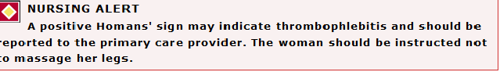Inspect legs for signs of thromboembolism

**Ovarian function:**

* Estrogen and progesterone levels decrease rapidly after delivery of the placenta.
* Estrogen reaches the follicular phase by 3 weeks after birth, as long as the woman is not lactating.
* Ovulation may occur as early as 27 days after delivery. The average time is 70 to 75 days post delivery and 190 days post delivery if breast-feeding.
* The start of menses after delivery is individualized. Usually, the first menses occurs approximately 3 months after delivery, although breast-feeding women may not start their first menses until 8 months.

**Neurological function**

* Discomfort and fatigue are common.
* 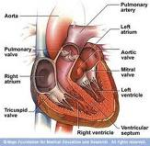Frontal and bilateral headaches are common and are caused by fluid shifts in the first week postpartum.

**Cardiovascular function**

* Most dramatic changes occur in this system.
* Cardiac output decreases rapidly and returns to normal by 2 to 3 weeks postpartum.
* Hematocrit increases and increased red blood cell (RBC) production stops.
* Leukocytosis with increased white blood cells (WBCs) common during the first postpartum week
* If the patient is Rh negative, evaluate her need for RhO(D) immune globulin (RhoGAM). If indicated, administer the RhoGAM within 72 hours of delivery
* Following delivery, despite 300 to 500 ml of blood loss during normal vaginal delivery, and 500-1000 ml is lost in cesarean births, excess blood volume, which was necessary during pregnancy, remains in the intravascular compartment and in interstitial spaces.
* ***The body rids itself of the excess fluids by two methods***:

**1.Diuresis:** **“increased excretion of urine”** is facilitated by a decline in the adrenal hormone aldosterone, which is increased during pregnancy to counteract the salt-wasting effect of progesterone.

urinary output of 3000 ml per day is not common for the first few days of the post partum period.

2. **Diaphoresis** **“profuse perspiration”** also rids the body of excess fluids through skin "sweating often occurs at night"

* **Coagulation:** During pregnancy, plasma fibrinogen necessary for coagulation increased as a protection against post partum hemorrhage. As a result, the mother’s body has a great ability to form clots and thus prevent excessive bleeding
* **. Blood values:**

**The white blood cells count increasing** 10.000/mm up to 20.000 or even 30.000/mm during postpartum

**A moderate increase in the fibrinogen** and sedimentation rate occurs during the first postpartum period, and then gradually gets back to normal values.

**Respiratory function**

Returns to normal by approximately 6 to 8 weeks postpartum

**Musculoskeletal function**

* Generalized fatigue and weakness is common.
* Decreased abdominal tone is common.
* Diastasis recti heals and resolves by the 4th to 6th week postpartum Until healing is complete, abdominal exercises are contraindicated.

**Integumentary function**

* Striae lighten and melasma is usually gone by 6 weeks postpartum .
* Hair loss can increase for the first 4 to 20 weeks postpartum and then re-growth will occur, although the hair may not be as thick as it was before pregnancy.

**Endocrine/metabolic function:**

* Thyroid levels are normal by 4 to 6 weeks postpartum .
* Glucose levels are low secondary to decreased human placental lactogen and decreased growth hormone.

**Vital signs**:

at least twice daily and more frequently if indicated:

**temperature** : may increase in the first 24 hrs reach to 38 c after delivery ,because of the dehydration during labor so encourage fluid intake .

**pulse** : decrease pulse rate during the 1st week to 60-70 beat\mint(24-48 hrs), if increase you should think of hemorrhage, anxiety, excitement.pain, visitor

**Blood pressure** : should be unchanged , if BP >140\90mmhg may indicate postpartum hemorrhage.

**Respiratory rate**: unchanged . **Respiratory function** Returns to normal by approximately 6 to 8 weeks postpartum

**Physiology of lactation**

**Lactation consists of two distinct processes**

**1. "Milk production** After labor, sudden fall of estrogen and progesterone levels leads to marked rise of prolactin level. This hormone stimulates the alveolar cells leading to milk secretion.

**2.Milk** ejection:Stimulation of the nipple and areola (by suckling), leads to increased production of oxytocin from posterior pituitary. This hormone acts on the myoepithelial cells which line the ducts causing its contraction. Milk is ejected into the lactiferous ducts and cysternae, where it is readily available to the suckling infant (**Let down reflex"** ) .

**\*Nipple erection reflex"** results also from stimulation of the nipple by suckling or tactile stimulation of the nipple. This is of great help to the baby during suckling.

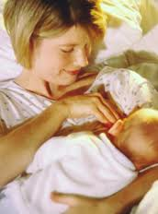

**Factors Affecting Milk Production**

1- Regular complete breastfeeding.

2- Suckling abilities of newborn.

3- Maternal health, and Nutrition.

4- Psychological factors.

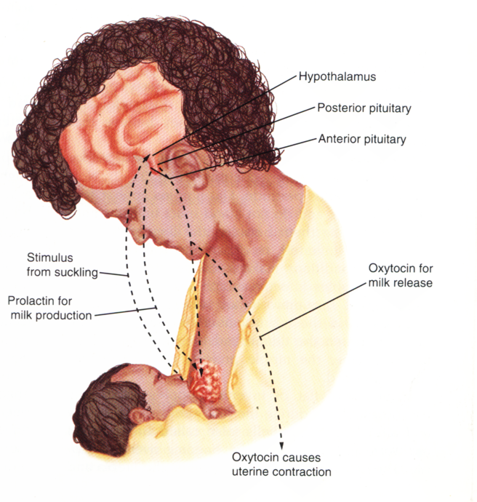5-Hormones : Prolactin, Oxytocin, Thyroxin, Growth hormone, in addition to Progesterone and estrogen. Normal levels of these hormones are essential for initiation & maintenance of lactation.

**Management of Postpartum Period**

* ***Early needs of the mother:***

***1- Observation and recording to:***

⮱**A**.**Vital signs**

* Check vital signs 2 times daily "morning and evening".
* Observe for symptoms of hypovolemic shock and hemorrhage.
* A temperature of 38c or above, for two consecutive days
* after the first24hrs.is considered an early sign of puerperal infection
* Bradycardia is a normal physiological phenomenon

⮱**B. Subsequent postpartum Assessment:**

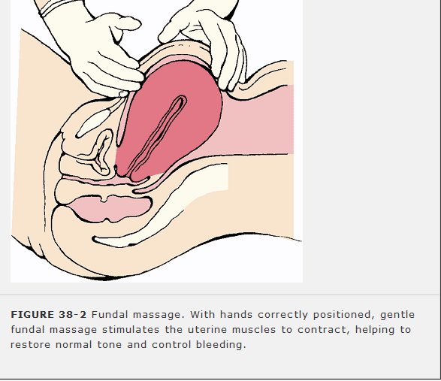**1.** Check firmness of the fundus at regular intervals. Perform fundal massage if the uterus is boggy (not firm)

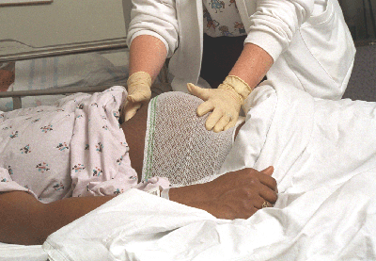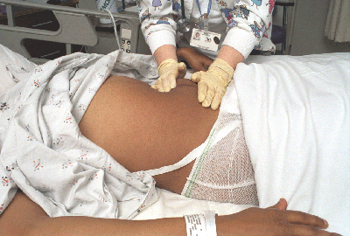

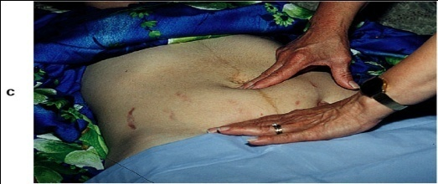

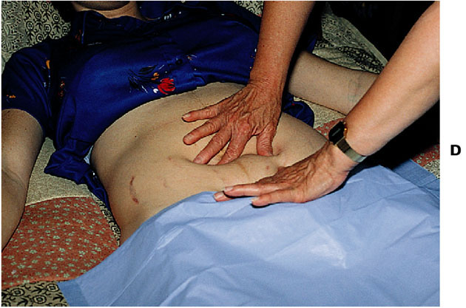**Assessment of involution of uterus after childbirth– 2 days after childbirth**

**Assessment of involution of uterus after childbirth– 4 days after childbirth**

⮱**Perineum**

* Observe perineum and suture line if present, for redness, ecchymosis, and edema or gapping. Check healing and cleanliness
* During the examination haemorrids may be noted and appropriate treatment advised.

⮱**Lochia**

* Check lochia for color, amount, odor, consistency and blood clots.

⮱**Urine out put**

The urine out put is usually recorded for the first 24 hours after delivery to ensure that the woman is passing and adequate amount of urine. Assess bowel and bladder elimination. offer the opportunity to void within the first 4 to 8 hrs after delivery and every 2 to 3 hrs thereafter.

⮱**Legs**

* The midwife examines the patient's leg for pain and edema.

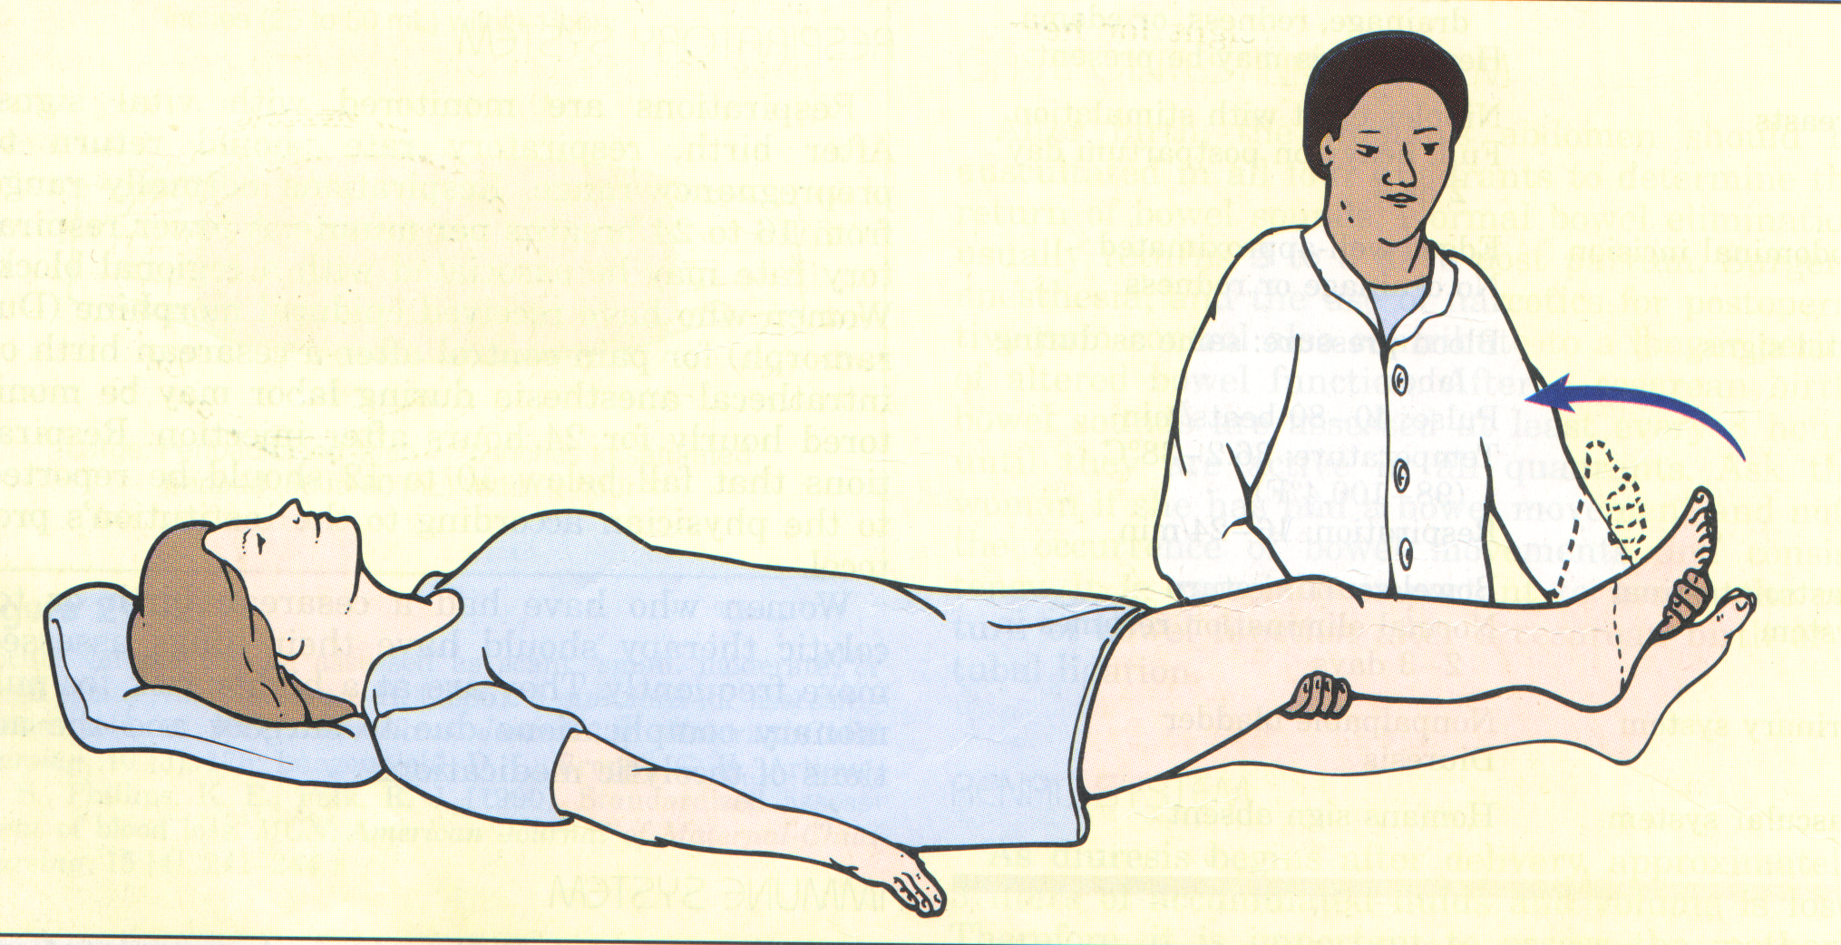

4.Evaluate interaction and care skills of the mother and family with infant.

5.**Assess for breast** engorgement and condition of the nipples if breast-feeding

7.Assess incisions for signs of infection and healing.

9. **Postpartum Vaccination** :If the woman is not rubella immune, a rubella vaccination may be given, and pregnancy must be avoided for at least 3 months.

**10.Psychological Assessment**:

-Focuses on mother’s general attitude, feelings of competence, support systems, caregiving skill

– evaluates fatigue and ability to accomplish developmental tas

-Describe level of attachment to infant

-Determine mother’s phase of adjustment to parenting

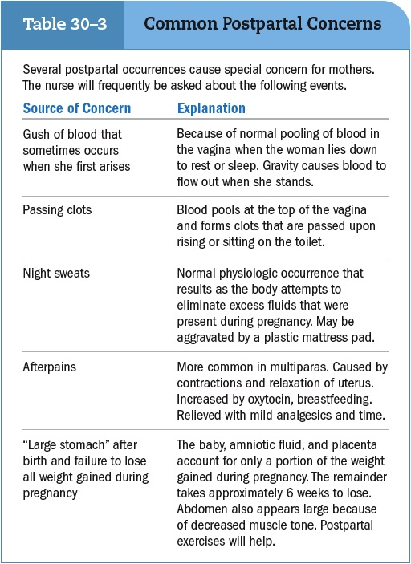

***2. Rest and sleep:***

* Provide for sufficient periods of rest and sleep to maintain physical and mental health, as to promote lactation (8hrs nighttime sleep and 2hrs after noon-nap are needed).

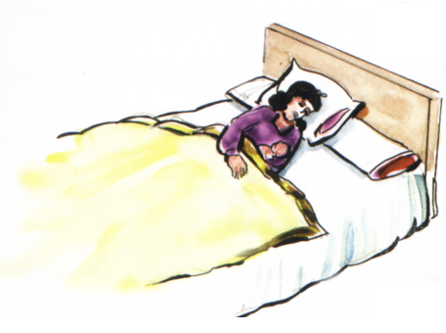

***3. Diet:***

* Provide diet high in proteins and calories to restore tissues.
* A daily requirement of 3000-3500 cal/day is needed in the form of a well balanced diet rich in 1st class proteins, calcium, iron, vitamins, thiamine, riboflavin and ascorbic acid
* Liberal amounts of fluids are required "the daily fluid intake should be 2.5-3 liters" (e.g. milk, juice ….ect."

***4. Hygiene:***

* The women should be taken shower daily.
* The vulva and perineal care include washing or swabbing with warm water and antiseptic solution, the area must be kept clean and dry and free from infection.
* The perineum must be inspected daily if there are sutures to see that healing is taking place. Non-absorbable sutures are removed on the fifth or sixth day.
* Breast care should be done before and after feeding. The nurse teaches the mother the technique of breast care and encourages her to initiate breast-feeding.

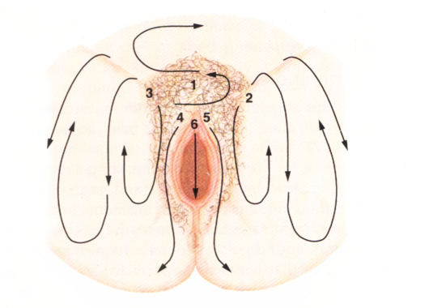

**PATIENT EDUCATION GUIDELINES**

**1.Breast feeding :**

* Breast feeding :is the best possible source of nutrition for your infant. It provides an immunologic boost for the infant, protects against breast cancer, hastens postpartum healing, and serves as a wonderful bond between the infant and mother.

**Advantages of Breast Feeding**

**For baby:**

* Immunological properties help prevent infections.
* Provides nutritional needs.
* Easily digested.
* Less sodium and protein than in cow's milk; puts less stress on newborn's kidneys.
* Calcium is better absorbed.
* Least allergenic food for infant.
* Promotes development of facial muscles, jaw, and teeth.
* Less likely to be overfed; less obesity.
* Has natural laxative effects.
* Fulfilling psychological needs.

**For the mother:**

* Oxytocin release aids uterine involution.
* Strong mother-infant relationship.
* Convenient; always available; no preparation.
* Cost effective.
* Less incidence of cancer breast.
* Natural contraception.
* You should begin breast feeding in a quiet, comfortable place that is free from interruption. You may need a pillow to help support the infant and a footstool to use to elevate your leg.
* Make sure the infant is awake and dry before the feeding started. If awake and comfortable, the infant will settle down and feed better. The infant should also be hungry.
* Dress the infant appropriately so that the infant is not too warm or too cool during the feeding . If too warm, the infant may fall asleep after the first few sucks of milk. A sleepy infant will not nurse well. If too cool, the infant may be fussy and restless.
* Have the mother wash her hands before feeding to help prevent infection
* Position infant at the breast by placing the infant in a semi-sitting position with face close to the breast and supported by one of your arms and hand. A pillow may be used under the infant for support. You may need to support your breast with your other hand. Proper positioning will provide the infant with comfort and security and make it easier for the infant to suck and swallow. This makes the nipple more easily accessible to the infant's mouth and prevents obstruction of nasal breathing.

Note " Common positions for holding the baby are the **cradle hold**, with the baby's head and body supported against the mother's arm, with buttocks resting in her hand; the football hold, in which the baby's legs are supported under the mother's arm, and the head is at the breast , resting in the mother's hand; and lying on the side with the baby lying on his/her side facing the mother. See figure below

* When the feeding to start, let the breast touch the infant's cheek. Do not hold the cheek, but try to help the infant find the nipple. The rooting reflex will take over and the infant will turn head toward breast with mouth open. If you touch the cheek, the infant will become confused, perhaps turning toward your hand.
* [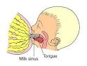](http://www.google.com.sa/imgres?imgurl=http://www.chw.org/display/displayFile.asp?filename=/Groups/PediatricHealthInformation/NewbornCare/06Milktff.jpg&imgrefurl=http://www.chw.org/display/PPF/DocID/23290/router.asp&usg=__eWzpSI7hTtZTDpmLN3FxeD_WQlU=&h=302&w=400&sz=26&hl=ar&start=12&sig2=Qwz8RHfC9rWKy2R1bbDFxw&zoom=1&itbs=1&tbnid=J6EjZmQDkzPy9M:&tbnh=94&tbnw=124&prev=/images?q=feeding+position&hl=ar&safe=active&sa=G&biw=1276&bih=567&gbv=2&tbs=isch:1&ei=zHZSTZPgJcKCswbg6sTaBg)The infant's lips should be out over the areola and not just around the nipple before beginning to suck. Because the nipple is so small, suction cannot be achieved merely by grasping it. The areola must be in the infant's mouth to establish suction and make the suck effective.
* You may notice the let-down‌ reflex during the nursing period. Milk flowing from the other breast during nursing is quite normal.
* The length of feeding time may vary from 5 to 30 minutes. Let the infant nurse until satisfied. When the infant is satisfied and has nursed well, the infant is relaxed and usually falls asleep. The infant will stop sucking.
* Burp the infant during and at the end of the feeding to prevent abdominal distention or regurgitation from air swallowed during the feeding .
* One or both breasts may be used at each feeding. It makes no difference as long as the infant is satisfied at the end of the breast and one breast is completely emptied at the breast . If both breast were used, the second breast is not usually emptied and should be used first at the next feeding Regular and complete emptying of the breast is the only stimulation for the production of milk.
* When the infant has stopped sucking, the infant typically likes to cling to the breast . To break this suction, insert a finger to the corner of the infant's mouth and gently pull.
* When the infant has finished feeding , change the diaper if it is wet or soiled. Position the infant on the right side in bed. Note whether the infant appears satisfied or still seems to be hungry.
* To continue successful breast feeding adequate rest and nutrition.
* For information and support, contact LaLeche League International, 1400 N. Meacham Road, Schaumburg, IL 60173, 847-519-7730, [http://www.laleche.org](http://www.laleche.org/); or read their publication The Womanly Art of breast feeding (6th ed.).

**Getting comfortable**

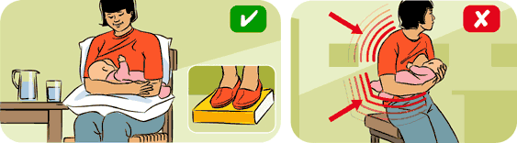

* Making sure that you’re **comfortable and relaxed** and that [**baby is correctly attached**](http://www.abc.net.au/parenting/parenting_in_pictures/breastfeeding_techniques.htm)can help to make breastfeeding easier and more enjoyable. Try to feed in a chair that offers **good back support**; use cushions or pillows to prop up your arms; and if necessary, rest your feet on a telephone book or footstool. It’s also good to experiment with the different feeding positions, shown below, until you find one that works for you and baby.
* **Breastfeeding positions**
* 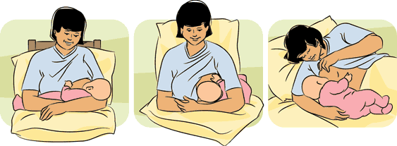
* This is the classic **'front hold'** or **'cradle position'.**
* The **'underarm position'** shown above is also known as the **'footy hold'**. It’s possible to feed twins together in this position (see below).
* The **'lying down'** position is particularly good for mums who’ve had caesareans or if your bottom is sore after the birth.
* [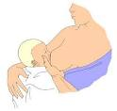](http://www.google.com.sa/imgres?imgurl=http://www.chw.org/display/displayFile.asp?filename=/Groups/PediatricHealthInformation/NewbornCare/07DancersHff.jpg&imgrefurl=http://www.chw.org/display/PPF/DocID/23290/router.asp&usg=__g_K76-6tctoSQ-rX57GDgUZB_F0=&h=381&w=400&sz=20&hl=ar&start=11&sig2=V8VTCFsh2iD2BwkJLy32kw&zoom=1&itbs=1&tbnid=9RiGrU4D0a_tGM:&tbnh=118&tbnw=124&prev=/images?q=fottball+feeding+position&hl=ar&safe=active&sa=G&biw=1276&bih=567&gbv=2&tbs=isch:1&ei=h3tSTYfPNIf2sga_kMD1Bg) **Cross-cradle Hold:** This position is similar to the cradle hold breast feeding position except that you hold the baby’s head in your hand to direct it toward the nipple.
* **Other positions**
* 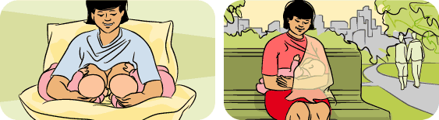
* In the first few weeks, it may be easier to feed twins separately. However, once you’ve got the hang of it, you can try feeding them together using the **'twin hold'.**
* If you feel uncomfortable or self-conscious when **breastfeeding in public**, drape a light muslin wrap over your shoulder so it covers your breast and baby.

**2.Promoting Proper Bowel Function**

* Teach the woman that bowel activity is sluggish because of decreased abdominal muscle tone, anesthetic effects, effects of progesterone, decreased solid food intake during labor, and pre-labor diarrhea.
* Inform the woman that pain from hemorrhoids, lacerations, and episiotomies may cause her to delay her first bowel movement.
* Review the woman's dietary intake with her.
* Encourage daily, adequate amounts of fresh fruit, vegetables, fiber, and at least eight glasses of water.
* Encourage frequent ambulation.
* Administer stool softeners as indicated.

**3.Reducing Fatigue**

* Provide a quiet and minimally disturbed environment.
* Organize nursing care to keep interruptions to a minimum.
* Encourage the woman to minimize visitors and phone calls.
* Encourage the woman to sleep while the baby is sleeping, and specifically to nap or lie down and get off her feet at least 30 minutes per day.

**4.Preventing Infection**

-Observe for elevated temperature above 100.4آ° F (38آ° C).

-Evaluate episiotomy/perineum for redness, edema, ecchymosis, discharge (color, amount, odor) and approximation of the skin (REEDA).

-Assess for pain, burning, and frequency on urination.

-Administer antibiotics as ordered.

**5*. Post natal exercise:***

* Encourage post partum exercise which promotes circulation.
* Lessen the possibility of venous thrombosis and restore the muscle tone of the abdominal wall and pelvic floor.
* Postnatal exercises help to give the patient a sense of well being.

Certain patients, such as those suffering from heart lesions, should not be allowed to perform all the exercises, though even they may be encouraged, on medical advice to take gentle exercise.

Deep breathing and free movements in the bed should be encouraged from the day of the delivery. On the second day the following exercises may be done provided the labor has been normal and the patient is in health. In prescribing exercises discretion must be used and the exercises must be adapted to the individual. In hospital the exercises will probably be directed by a physiotherapist.

🖝Breathing exercises:

Deep-breathing exercises should be performed as described for antenatal period, with the patient lying flat in be stretch, stiffen and reflex the muscles of the right and let leg alternately.

🖝Pelvic floor tone. Several exercises may be performed:

1. Lie flat on the back with body relaxed. Tighten the anus for ten seconds as though trying to control a loose motion or retain an enema. Repeat six times, and then rest for one minute. Carry out the same procedure eight times.
2. Lie flat on the bed and forcely abduct the thighs against resistance (the nurse attempts to hold the thighs together while the patient pushes them apart. Repeat slowly six times. Later the same exercise may be carried out, but with the nurse holding the patient’s Knees together instead of the thighs.
3. Lie flat upon the back with the hands upon the hips and elevate the feet alternately, counting one to six, up, and one to four, down.
4. Lie flat with the hands resting lightly on the abdominal wall. Then slowly raise the head and shoulders. The patient must not push the chin forwards or the abdominal wall will be pushed outwards instead of contracting, nor must any weight be rested on the elbows.
5. Sit up in bed with the hands clasped round the flexed knees and endeavor to touch the knees with the chain. The nearer the head and knees approach the greater the contraction of the abdominal muscles.

🖝Strengthening the muscles generally:

The patient, sitting up in bed and bedding forward with legs outstretched places her hands on her ankles. The trunk is then stretched backwards and the arms drawn up and bent to imitate rowing, the knees are slightly flexed at the same time.

**🖝*Late needs of the mother***

#### 🖎Health education and counseling

The midwife nurse plays an important role as health educator and counseling which should provide the woman health education and counseling about:

1. Breast feeding, definite, technique and position.
2. Resumption of sexual relations. Include information about when to expect menstruation.
3. Post natal exercise, hygiene, rest, sleep and nutrition.
4. The care of the baby which includes hygiene, prevention of infection, feeding and giving him love and sense of security feel her about the advantages of rooming in.
5. Family planning methods for spacing of pregnancy.
6. Stress the importance of post partum examination. Visits and follow up to assess involution, general health and well being of the mother before discharge.

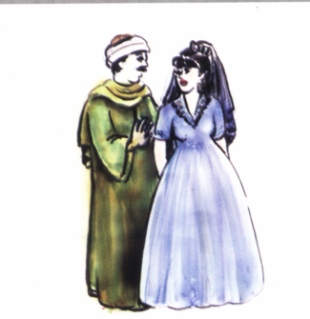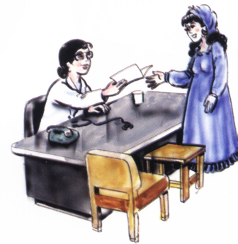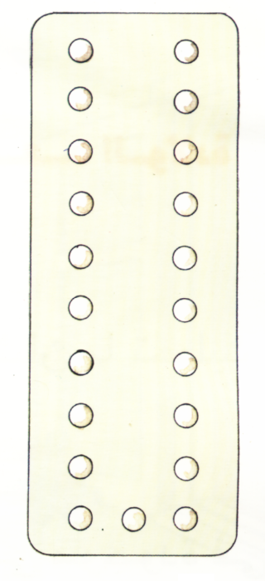

**🖎** **Minor Discomforts during the Postpartum Period**

They are minor complaints felt by the parturient during postpartum period. Simple nursing measures (interventions) are needed to alleviate these complaints

**1.After pain** : it's intermittent cramping during first 2-3 days postpartum and it's similar to that accompany a menstrual period mostly in multiparous and increase with breast feeding .

**Managements:**

1. encourage relaxation and breathing exercise
2. ordering analgesia
3. bladder should be kept empty
4. uterus massage
5. mother is advise not to used hot water bottle
6. advice the mother to lye in an comfortable position .

2.***Urinary Retention***

It is the inability to excrete urine, i.e. urine is accumulated within the urinary bladder. A common complaint during the first few days after labor.

⮱***Causes:***

* Laxity of the abdominal muscles.
* Inability to micturate in the recumbent position.
* Reflex inhibition due to stitched perineum or bruised urethra.
* Atony of the bladder.
* Compression of the urethra by edema or haematoma.

⮱***Nursing management:***Urine should be passed approximately 8-12 hrs after delivery. If not, the following measures should be attempted:

* Perineal care with warm water.
* Privacy and reassurance,
* Warm bedpan.
* listening to the sound of running water
* Hot-water bottle over the symphysis pubis
* If these measures fail, catheterization should be performed using complete aseptic technique.

**3. *Constipation***

An abnormal infrequent and difficult evacuation of feces may occur during the first few days postpartum.

⮱***Nursing management:***

Health teaching should consider the following:

* Diet rich in roughage.
* Increase fluid intake.
* Milk before bedtime.
* Exercises.
* After 72 hrs a glycerin suppository, or mild laxative, may be administered as ordered.

**4.Breast engorgement** with milk, venous and lymphatic stasis, and swollen, may occur between day 3 and day 7 postpartum .. engorgement is the result of ineffective or infrequent milk removal from the breast.

* **Sings of Breast engorgement** :

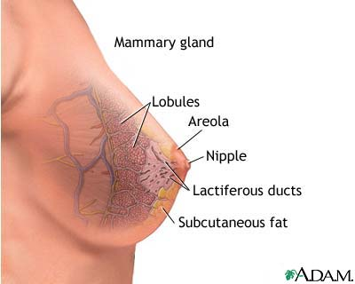-Enlarged, , hard to touch, firm, tender, hot, shiny

- Areola firm, flattened nipple if engorgement involve the Areola in sever cases .

- the mother may experience throbbing and aching that may extend all the way to her axilla.

**Causes:**

* Congestion and increased vascularity
* accumulation of milk:

1- ineffective breastfeeding ( improper breast feeding technique).

2- infrequent and delayed breast-feeding.

3- over production of milk.

**Management of engorgement**:

1. application of hot compassion prior to feeding . following effective feeding or pumping ,cold compresses applied may reduce swelling , vascularity, and pain

2. beast massage will help initiation of milk flow

3. frequent breast feeding every 2 hours for 15- 20 min /side , if not breast feed use a manual or electronic pump

4. wear loss breast bra.

5. The application of cool cabbage leaves to the breast, left in place for 20 minutes, may reduce symptoms of engorgement. **One Study looking at this technique found that symptoms were relive in 2to 24 hrs .**

6. Anti-inflammatory medication.

7.Assessment to nipple and breast.

**Prevention:**

* + - 1. Frequently breastfeeding every 2-3 hours for 15-20 min /side.
      2. Begin breastfeeding as soon as possible after the birth

3- Avoid early use of bottles and pacifiers

4. ensuring that baby is correctly latchet on at each feed. See figure in teaching point.

6- **breast mastitis :** it is an inflammation of the breast duct It is common and usually occurs in women who are breast-feeding. characterized by Sadden onset of flu-like symptoms

It is usually affects only one breast, but may affect both breasts, most common in upper outer quadrant of the breast.

**Most Common organisms:**

* Staphylococcus aurous
* Streptococcus
* Escherichia Coil
* Symptoms
* Mastitis affects 1% of women after Childbirth (lowdermilk, 2004)

Source of infection may be from hands of patient, personnel caring for patient, baby's nose or throat, or blood-borne.

**Symptoms:**

* Fever
* Fatigue
* headache
* Aches, chills, or other flu-like symptoms
* Redness, tenderness, warm , and edema of the breast
* A burning feeling in the breast
* A hard feeling or tender lump in the breast
* Pus draining from the nipple
* Swollen lymph glands in the arm
* Localized breast pain

**Predisposing factors :**

Obstructed milk duct Engorgement

Cracked, sore nipple Poor nutrition

Trauma Stress- fatigue

Tight bra Sericulture factor: Lack of support systems

**Managements:**

1.Antibiotic (Cloxacillin , Cephalosporin)

2.analgesia

3.provide warm compresses to resolve tissue reaction; may cause increased milk production and worsen symptoms.

4.May apply cold to decrease tissue metabolism and milk production.

5.continue breast feeding with appropriate and correct feeding position , May have patient stop breast-feeding (controversial).

6.massage breast

7.wear a well fitting bra

8.avoid wash breast with soap

9.balance diet (Vitamin C)

10. Increase fluid intake

**7.*Cracked Nipple***

Fissured nipple occurs in about half of the nursing mothers at one time or another. Nipple tenderness and soreness are usually the result of trauma and irritation.

⮱***Causes:***

* Improper antenatal care.
* Improper technique of breastfeeding.
* Unnecessary prolonged lactation.
* Flat or large size nipple--- excoriation.
* The use of irritating substances e.g. soaps, lotions.
* Conditions as candidiasis, and contact dermatitis.
* Engorgement of the breast.

⮱***Signs and symptoms:***

* Irritation of the nipple in the form of minute blisters or petechial spots.
* Persistent pain and tenderness.
* Bleeding.
* Inflammation signs.

⮱***Nursing management:***

* Proper technique of breast-feeding should be followed.
* Apply moist heat and massage before feeding (3-5 min).
* Frequent, short feedings.
* Air/sun exposure.
* Avoid engorged breast.
* Avoid irritating materials.
* Use supportive bra.
* Mild analgesic and panthenol ointment may be used.
* Treatment of candidiasis and dermatitis.

8.*Insufficient milk supply:*

Physiological variations in milk secretion are often perceived as milk insufficiency.

⮱***Nursing management:***

* Encourage the mother to follow frequent breast-feeding.
* Mother should drink more fluids.
* Reduce outside activities that are strenuous.
* Avoid supplementary hour feeds.
* Nurse the baby every hour if necessary.
* Nurse in a relaxed position.
* Try to avoid distracting or up setting situation while breast-feeding.
* Breast-feed just as the baby wakes up before he can begin crying from hunger.
* Have a warm or cool drink each time the baby is breast-fed.

9. *Leaking of breast milk:*

Women who have active ejection reflexes often find that breasts leak milk during the first few weeks after delivery.

⮱***Nursing management:***

* The mother should put clean pieces of gauze or cloth inside the bra to soak up the milk.
* Change the clothes frequently.
* Breast care frequently.

***10*.*Perineal Discomfort***

It usually occurs due to presence of tears, lacerations, episiotomy and edema.

⮱***Nursing management:***

* Frequent perineal care under aseptic technique, (the area should be kept clean and dry).
* Soaks of magnesium sulphate compresses in case of edema.
* Expose to dry heat (electric lamp) will help the healing process.
* Health education that includes:

Perineal self care.

1. Position (lateral with a pillow between thighs).
2. Diet: rich in protein.
3. Sources of strain such as coughing, constipation and carrying heavy objects should be avoided.
4. Encourage pelvic floor muscle exercises.
5. Avoid infection.
6. The use of cotton underwear.

**🖝 *Postpartum Blues (Depression)***

Rev a Rubin defined postpartum blues as "the gap between the ideal and reality: the new mother's expectations may exceed her capabilities, resulting in cyclic feelings of Depression". This condition is usually temporary and may occur in the hospital. The condition is partly due to hormonal changes, and partly due to the ego adjustment that

Accompanies role transition.

⮱***Signs and symptoms:***

* + Disturbed appetite and sleeping patterns.
  + Discomfort, fatigue and exhaustion.
  + Episodes of crying for no apparent cause.
  + The mother may experience a let down feeling accompanied by irritability and tears which often relieves the tension.
  + Guilt feeling at being depressed.

⮱***Predisposing factors:***

* The first pregnancy or pregnancy in late childbearing age.
* Social isolation.
* Ambivalence toward the woman's own mother.
* Prolonged, hard labor.
* Anxiety regarding finances.
* Marital disharmony.
* Crisis in the family.

⮱***Nursing management:***

* + Reassurance, understanding, and anticipatory guidance will help the parents become aware that these feelings are a normal accompaniment to this role transition.