UNIT 3

NORMAL LABOUR

## INTRODUCTION

The **intrapartum period** begins with the onset of regular uterine contractions and lasts until the expulsion of the placenta. The process by which this normally occurs is called **labor** The labor process is an exciting and anxious time for the woman and her family.. **Childbirth** is the period from the conclusion of the pregnancy to the start of extrauterine life of the infant. This Unit discusses the intrapartum/ childbirth process including the factors affecting labor and delivery, progression of labor and delivery, and the nursing care involved.

###### **Types of child birth**:

1. **Spontaneous vaginal birth**—the baby is born through thevagina, usually with only guidance and assistance by the doctoror midwife.

* **Vacuum-assisted vaginal birth**—a suction(vacuum) deviceis placed on the baby's head to help the baby'sbody transitthe birth canal.

1. **Forceps-assisted vaginal birth**—instrumentscalled forcepsare placed around the presenting part (usuallythe baby's head),allowing the doctor to complete a difficultdelivery.
2. **Cesarean** **birth** (abdominal delivery)—a majorsurgical procedurerequiring anesthesia and a recovery period.About 20% of birthsin the United States are accomplished usingcesarean birth.The cesarean rate in other parts of the worldvaries greatly.

**Definitions:**

**labor :**  it is a series of events by which the fetus, placenta, and membrane are expelled out through the birth canal. as the result of regular, progressive frequent & strong uterine contractions. **OR Labor** is a series of rhythmic, progressive contractions of the uterus that gradually move the fetus through the lower part of the uterus (cervix) and birth canal (vagina) to the outside world.

**\*delivery** : refers to the actual delivery of the infant.

***L*ABOR TRIGGERS**

The question of when and how labor begins has been studied for years. The exact cause of the onset of labor is not completely understood, although there are several theories. Generally it is proposed that labor is triggered by both maternal and fetal factors (Mattson & Smith, 2004; Simpson & Creehan, 2008).

**Maternal Factors**

■ Uterine muscles are stretched to the threshold point by increase size of fetus & amniotic fluid and this compensated by hypertrophy & hyperplasia of uterine muscles under effect of estrogen in the first half of pregnancy, So it is leading to release of prostaglandins that stimulate uterine contractions in the late of pregnancy .

■ Increased pressure on the cervix stimulates the nerve plexus, causing release of oxytocin by the maternal pituitary gland, which then stimulates contractions.

■ Estrogen increases, stimulating the uterine response. The placenta produce estrogen mainly oestriol, estrogen infusion in sheep leads to appearance of prostaglandin F in uterine vein & event initiated premature labor. Oestriol is important for the storage of esterified arachidonic acid in fetal membrane then free arachidonic acid is oestrogen also disrupts the uterus lysomes.

■ Progesterone, which has a quieting effect on the uterus, is withdrawn,

allowing estrogen to stimulate contractions.

■ Oxytocin stimulates myometrial contractions.Oxytocin and

prostaglandin work together to inhibit calcium binding in muscle

cells, raising intracellular calcium levels and activating contractions.

■ The oxytocin level surges from stretching of the cervix.

**Fetal Factors**

■ As the placenta ages it begins to deteriorate, triggering initiation

of contractions.

■ Prostaglandin synthesis by the fetal membranes and the decidua

stimulates contractions.

■ Fetal cortisol, produced by fetal adrenal glands, rises and acts on

the placenta to reduce progesterone that quiets the uterus, and

increases prostaglandin that stimulates the uterus to contract

**Characteristic of the normal labor**

1. should occur at term (38-41 gestational week).

2. the fetus is living

3. the fetus presentation is cephalic presentation

4. start spontaneously

5. the process of labor is completed through vagina without assistance.

6. the time of labor is not less than 3hours and not more than 24hours.

7. result healthy baby ( weight 2.500kg-4kg) and health mother.

**Signs of Impending Labor**

few weeks before labor, changes occur that indicate the woman’s body is preparing for the onset of labor. These changes are also referred to as premonitory signs of labor**. These signs are:**

1. Lightening : it's the descend of the fetus and in the lower uterine segment in pelvic cavity, occurs 2 to 3 weeks before term in the primigravida and later, during labor in the multigravida.

-Breathing becomes easier as the fetus falls away from the diaphragm

-Lordosis of the spine is increased as the fetus enters the pelvis and falls forward. Walking may become more difficult; leg cramping may increase.

2. Membranes may rupture may occur before labor.

3. low back pain: due to sacroiliac joint relaxation

4. braxon hick contraction: These are irregular UCs that do not result in cervical change and are associated with false labor.

5. urinary frequency.

6. weight loss of about 0,5kg -1.5 kg. and some experience diarrhea, nausea, or indigestion preceding labor.

7. burst of energy(nesting) or increase fatigue .

8. increase vaginal secretion : expulsion of mucus plug bloody show (brownish or bloody vaginal mucus).,

9. cervix softening "ripening" and may become partially effaced and begin to dilated.

**Factors Affecting labor**

**1.passageway( birth canal ) it's include :**

**-Bony Pelvis : It is composed of :**

A. type of pelvis : gynecoid pelvis is the suitable for labor

**\*\* The anatomical structure of the pelvis includes the ileum, the ischium, pubis, sacrum, and coccyx.**

B .The bony pelvis is divided into:

■ False pelvis, which is the shallow upper section of the pelvis. ( above the brim)

■ True pelvis, which is the lower part of the pelvis and consists (below the brim which help in labor ).and consists of three planes: the inlet, the midpelvis, and the outlet.

**- pelvis Inlet(Pelvic brim):** Largest diameter of inlet is transverse, Anteroposterior diameter is most important diameter of inlet and adequate diameter is usually 11.5 cm. it is heartly shaped bounded by the sacrum posteriorly, the linea terminalis laterally, and the symphysis pubis anteriorly.

**diameters:**

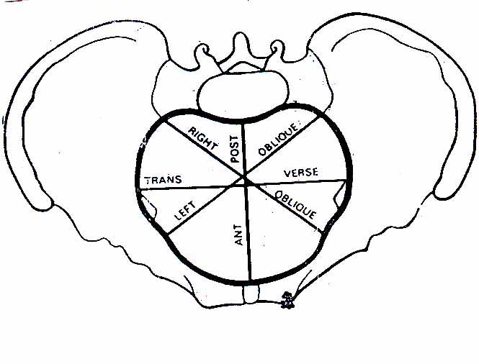Anatomical Anteroposterior diameter (A.P.D) 11 cm.

Obstetric conjugate 10.5 cm.

Transverse diameter 13 cm

Oblique diameter 12.5 cm

- **The pelvic cavity (midpelvis)**

**Boundaries:**

Superior by plane of pelvic inlet.

Inferior by plane of least pelvic dimensions.

Laterally by the ischial spines.

**All diameters** are equal (12 cm).

Antero-posterior diameter 12 Cm.

Transverse diameter : 12 cm. Widest transverse diameter across the plan of pelvic cavity.

Plane of widest pelvic dimensions imaginary plane bounded anterior by center of post. Surface of S.P. and Post. By Junction between 2nd and 3rd sacral vertebrae.

Oblique diameter : 12 Cm.

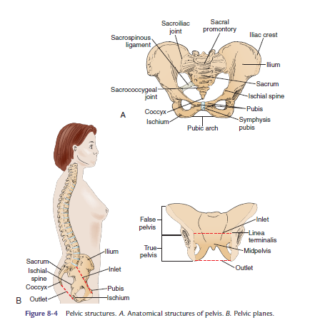**-pelvis Outlet** :Lowest boundary of the true pelvis, it is ovoid, some what diamond shaped, bounded by the pubic arch anteriorly, the ischial tuberosities laterally, and the tip of the occyx posteriorly.

**diameters:**

A.P.D 13 cm

Transverse diameter 10.8 – 11cm

Bispinous diameter 10.5

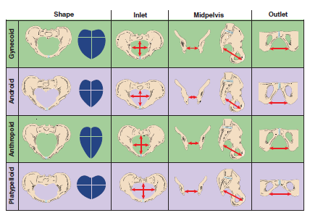

**Soft Tissue:**

**a. uterus:** appropriate uterine contraction lead to cervix dilatation (10cm) and cervix effacement(0-100%) so the fetus descent.

**b. cervix :**

- dilatation: opening or distention of cervix 1-1ocm

- effacement: shortening and thickening of cervix expressed in %.

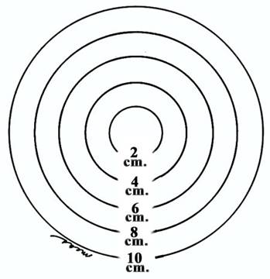 **c. pelvis floor muscle and vulva**. helps the fetus in an anterior rotation as it passes through the birth canal.

**2. passenger**

it's refer to the fetus , placenta, membrane and umbilical cord and its relationship to the passageway that is the major factor in the birthing process.. The relationship between the fetus and the passageway includes fetal skull fetal attitude, fetal lie, fetal presentation, fetal position and fetal size.

a. fetal size and capability of the head to mold to the passageway.

.b Fetal Skull

■ The fetal head usually accounts for the largest portion of the

fetus to come through the birth canal.

■ **Bones and membranous** spaces help the skull to mold during

labor and birth.

■ **Molding** is the ability of the fetal head to change shape to

accommodate/fit through the maternal pelvis.

■ The fetal skull is composed of two parietal bones, two temporal

bones, the frontal bone, and the occipital bone

■ The **biparietal diameter (BPD)**, 9.25 cm, is the largest transverse

measurement and an important indicator of head size

■ **The membranous** space between the bones (sutures) and the fontanels

(intersections of these sutures) allows the skull bones to overlap and

mold to fit through the birth canal .

**■ Sutures** are used to identify the positioning of the fetal head during

a vaginal exam. By identifying the anterior fontanel in relationship

to the woman’s pelvis, the examiner can determine the position of the head and the degree of rotation that has occurred.

* The sagittal suture: between 2 Parietal bones.
* The coronal suture: between 2 parietal & 2 frontal bones.
* The lambdoidal suture: between 2 Parietal & occipital bone.
* Frontal suture: between 2 frontal bones; becomes the anterior continuation of the sagittal suture.

■ The fontanells:

A-Anterior fontanell:

It is found at the intersection of the coronal & sagital sutures, it is diamond in shape.

B- Posterior fontonell:

It is at the junction between the sagittal suture & lambdoidal suture.

It is triangular in shape

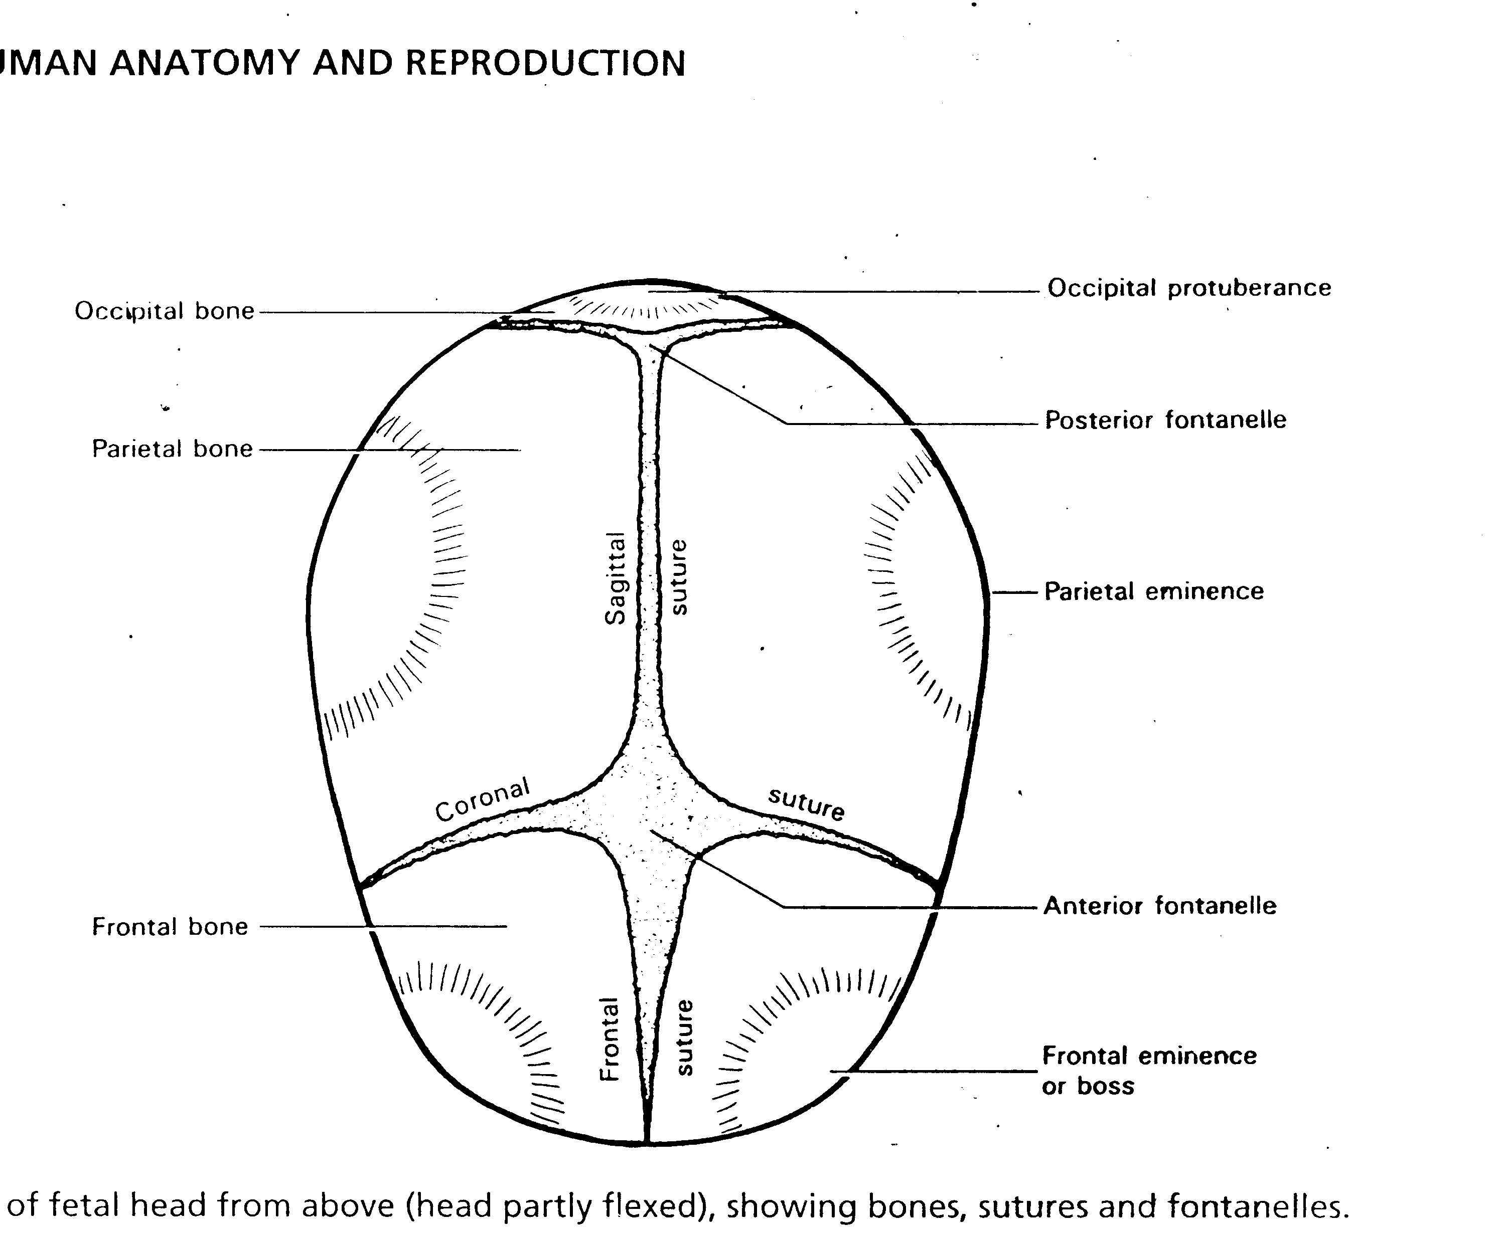

**-Measurements:**

**A- Anteroposterior diameter**

Occipitomental: 13.5 cm from occiput to mentum.

Occipito frontal: 11.75 cm the posterior fontanel to the bridge of nose.

Suboccipito bregmatic. 9.5 cm from anterior fontanell to the posterior end of occiput.

**B-Transverse diameters:**

Biparietal : 9.25 cm between 2 parietal bones.

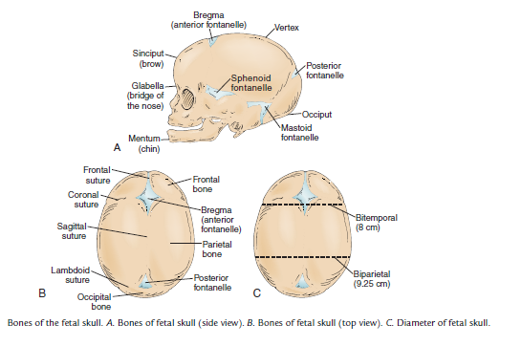Bitemporal: 8 cm between 2 temporal bones.

Bimastoidal: 7 cm between 2 mastoid bones.

1. 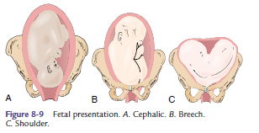fetal presentation : part of fetus that enter the pelvis ,for example cephalic, beech or transverse lie.

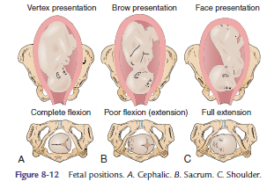

d. fetal lie: relationship between long axis of the fetus to the long axis of mother example, longitudinal , transverse lie .

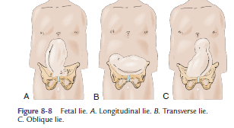

1. fetus position: relationship of the fetus presenting part to the front, back or side of mother pelvis .

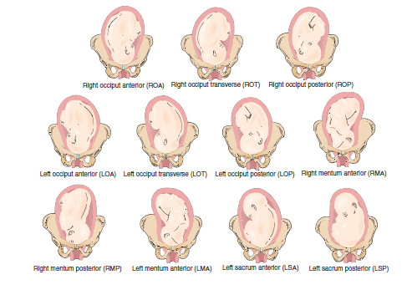

f. fetus attitude: the relation of fetal body parts to each other. is noted by the flexion or extension of the fetal joints.

■ At term, the fetus’ back becomes convex and the head flexed

such that the chin is against the chest. This results in a rounded

appearance with the chin flexed forward on the chest, arms

crossed over the thorax, the thighs flexed on the abdomen, and

the legs flexed at the knees.

■ With proper fetal attitude, the head is in complete flexion in a

vertex presentation and passes through the true pelvis easily.

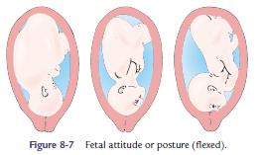

g. station: relationship of the fetus presenting part to the mother ischial spine and assists in assessing for fetal descent during labor (Fig. 8-5). Station 0 is the narrowest diameter the fetus must pass through during a vaginal birth

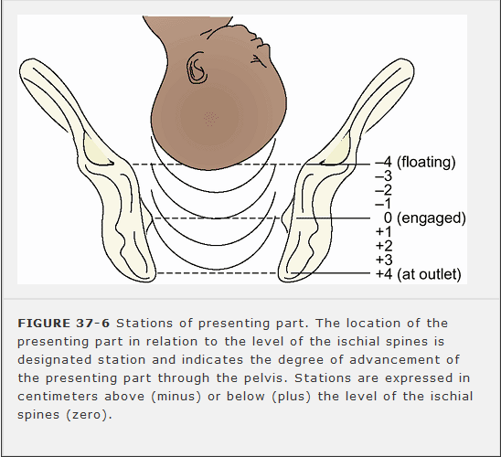

**3.power:**

**Powers** refer to the involuntary UCs of labor and the voluntary pushing

or bearing down powers that combine to propel and deliver the fetus

and placenta from the uterus it's include

-primary power: involuntary uterine contraction

- secondary power: voluntary bearing down(mother feel urge to defecate).

**Uterine Contractions**

■ The uterine muscle, known as the myometrium, contracts and

shortens during the first stage of labor.

■ The uterus is divided into two segments known as the upper

segment and the lower segment.

■ The upper segment composes two-thirds of the uterus and

contracts to push the fetus down.

■ The lower segment composes the lower third of the uterus and the

cervix and is less active, allowing the cervix to become thinner

and pulled upward.

■ Uterine contractions are responsible for the dilation (opening)

and effacement (thinning) of the cervix in the first stage of labor.

■ Uterine contractions are rhythmic and intermittent

■ Each contraction has a **resting phase** or uterine relaxation period

that allows the woman and uterine muscle a pause for rest. This

pause allows blood flow to the uterus and placenta that was temporarily

reduced during the contraction phase. It is during this

pause that much of the fetal exchange of oxygen, nutrients, and

waste products occurs in the placenta.With every contraction,

500 mL of blood leaves the utero–placental unit and moves back

into maternal circulation.

■ Uterine contractions are described in the following ways

■ **Frequency:** Time from beginning of one contraction to the beginning

of another. It is recorded in minutes (e.g., occurring every

3–4 minutes).

■ **Duration:** Time from the beginning of a contraction to the end

of the contraction. It is recorded in seconds (e.g., each contraction

lasts 45–50 seconds).

■ **Intensity:** Strength of the contraction. It is evaluated with palpation

using the fingertips on maternal abdomen and is described as:

■ Mild: The uterine wall is easily indented during contraction.

■ Moderate: The uterine wall is resistant to indentation

during a contraction.

■ Strong: The uterine wall cannot be indented during a

contraction.

■ There are three phases of a contraction

■ **Increment phase:** Ascending or buildup of the contraction that

begins in the fundus and spreads throughout the uterus

■ **Acme phase:** Peak of intensity

■ **Decrement phase;** Descending or relaxation of the uterine muscle

■ Contractions facilitate cervical changes

■ Dilation and effacement occurs during the f irst stage of labor

when UCs push the presenting part of the fetus toward the

cervix, causing it to open and thin out as the musculof ibrous

tissue of the cervix is drawn upwards

■ **Dilation** is the enlargement or opening of the cervical os.

■ The cervix dilates from closed (or <1 cm diameter) to

10 cm diameter

■ When the cervix reaches 10 cm dilation it is considered

fully or completely dilated and can no longer be palpated

on vaginal examination.

■ **Effacement** is the shortening and thinning of the cervix

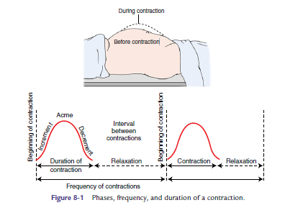

■ The cervix is 2 to 3 cm long and approximately 1 cm thick.

■ The degree of effacement is measured in percentage and

goes from 0% to 100%.

■ Effacement often precedes dilation in a first-time pregnancy.

Effacement and dilation progression of the cervix occurs together

in subsequent pregnancies.

***Assessing the contraction:***

- Subjective description given by the mother.

- Palpation by using the finger tips.

-Electronic monitoring devices.

**Secondary power Bearing-Down Powers**

Once the cervix is fully dilated (10 cm) and the woman feels the urge to push, she will involuntarily bear-down. The urge to push is triggered by the Ferguson reflex, activated when the presenting part stretches the pelvic floor muscles. Stretch receptors are activated, releasing oxytocin, stimulating contractions The bearing-down powers are enhanced when the woman contracts her abdominal muscles and pushes.

**Factors affecting bearing down:**

1- Maternal condition (Fatigue, severe pain).

2- Fear & anxiety.

Fear (muscle tension…..general fatigue….. increase perception of pain…. Interfere use skills to relive pain.

3- Child births education (labor preparation).

4- Motivation of child bearing (unwanted pregnancy of IUFD).

**4 factor . position of the mother**: upright position is preferable , and supine position is dangerous .

■ During the first stage of labor an upright position (walking,

sitting, kneeling, or squatting) and/or a lateral position is

encouraged

■ These positions are used to decrease the compression of the maternal

descending aorta and ascending vena cava that could result

in a compromised cardiac output. Compression of these vessels can

lead to supine hypotension, resulting in decreased placental perfusion

■ The upright position has shown benefit its of aiding in the descent

of the infant and more effective contractions that result in shorter

labor (Gupta, Hofmeyr, & Smyth, 2004).

■ Frequent position changes are associated with a reduction of

fatigue, an increase of comfort, and improved circulation to both

mother and fetus.

■ During the second stage of labor, the upright position has been

shown to increase the pelvic outlet and better aligns the fetus

with the pelvic inlet (Simkin & Ancheta, 2000).

■ The position most used in births in the United States is the

lithotomy position

**5. psychological status:** mother fear, anxiety, support.and sleep .

**ONSET OF LABOR**

As the woman comes closer to term pregnancy, the uterus becomes more sensitive to oxytocin and the contractions increase in frequency and intensity. This can be an anxious time for the woman and family in trying to determine if she needs to proceed to the birthing center. An understanding of true versus false labor can help to alleviate some of these fears

**True Labor Versus False Labor**

■ True labor contractions occur at regular intervals and increase in

frequency, duration, and intensity.

■ True labor contractions bring about changes in cervical effacement

and dilation.

■ False labor is irregular contractions with little or no cervical

changes.

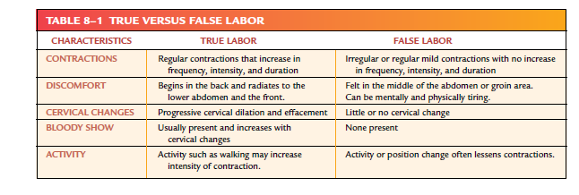

***Mechanism of Normal labor****:*

■ Descent: Movement of the fetus through the birth canal during

the first and second stage of labor

■ Engagement:When the greatest diameter of the fetal head

passes through the pelvic inlet; can occur late in pregnancy or

in early in labor

Descent: Movement of the fetus through the birth canal during

the first and second stage of labor

■ Flexion:When the chin of the fetus moves toward the fetal

chest; occurs when the descending head meets resistance from

maternal tissues; results in the smallest fetal diameter to the

maternal pelvic dimensions; normally occurs early in labor

■ Internal rotation:When the rotation of the fetal head aligns

the long axis of the fetal head with the long axis of the maternal

pelvis; occurs mainly during second stage of labor

■ Extension: Facilitated by resistance of the pelvic floor that causes

the presenting part to pivot beneath the pubic symphysis and

the head to be delivered; occurs during the second stage of labor

**Crowning of Head**

When the head with the widest diameter passes under the symphysis pubis embraced by the vulva and does not recede in between contractions. This is called crowning. If episiotomy is needed it should be done after crowning (distension of the vulval ring by biparital diameter of the fetal head & not retained again after contraction)

■ External rotation: During this movement, the sagittal suture

moves to a transverse diameter and the shoulders align in the

anteroposterior diameter. The sagittal suture maintains alignment

with the fetal trunk as the trunk navigates through the

pelvis

■ Expulsion: The shoulders and remainder of the body are delivered

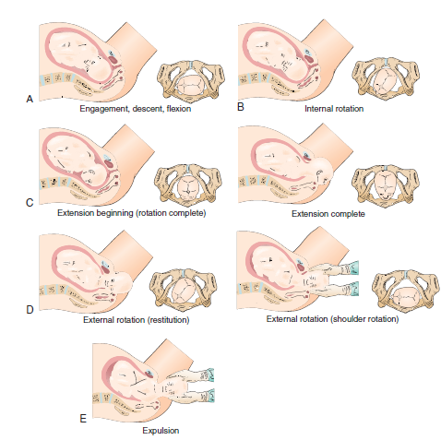

**Stages of Labor**

**1.First Stage of labor** (Stage of Cervical Dilation): Begins with the first true labor contractions and ends with complete effacement and dilation of the cervix (10 cm dilation). It's include 3 phases

a. latent phase : start with the onset of true labor contractions and ends with effacement and dilation of the cervix 3-4 cm.

b. active phase: dilatation from 4 -7cm, and contraction become more stronger , frequent and more painful.

c. transition phase: cervix dilatation from 8-10cm, women feel to urge to push

**Nursing management of the first stage of labor :**

1. admission of the women
2. assessment : take complete health history as patient name, age.
   * history of labor: When did contractions begin? How far apart are they? How long do they last? Intensity level?
   * Have the membranes ruptured
   * bloody show
   * Assess gravidity, parity, expected date of delivery or confinement
   * Medical Problems Arising during Gestation , as blood pressure elevation, bleeding

-History of Past Pregnancies, Medical History, and Psychosocial and Emotional History

-sleep ,rest, and food: ask the women if she has enough rest and sleep, and if she has had food within 6 hours.

3. Physical Examination:

A .General Examination as vital sign

B. Obtain a urine specimen for glucose and protein and Blood type and Rh

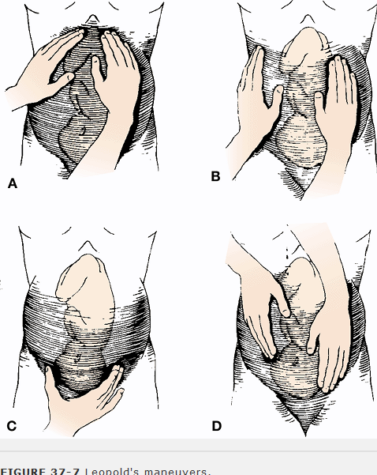 C. Abdominal Examination, inspection color , palpation to determine uterine fundus, Leopold's Maneuvers to determine the position of the fetus within the uterus , lie, presentation for labor management

D. observe and record the frequency ,duration and intensity of the contraction.

E. auscultation of the fetal heart rate normal range is 12o-180 beat\ min .

F. enema, and frequently emptying the bladder .

G. ultrasound

H. vaginal exam to assess the degree of cervical dilation and effacement and Station of the presenting part

**Assessment of Rupture of the Membranes**

■ **Spontaneous rupture of the membranes (SROM)** may occur

before the onset of labor but typically occurs during labor.

Once the membranes have ruptured, the protective barrier to

infection is lost and ideally the woman should deliver within

24 hours to reduce the risk of infection to her and her fetus.

■ Assessing the status of membranes

■ Nitrazine paper: Nitrazine paper is placed in a visible pool of

fluid around the cervix. The paper turns blue when in contact

with amniotic fluid.

■ Ferning: A sterile speculum exam may be performed to conf irm

rupture of membranes (ROM).

■ A sample of fluid in the upper vaginal area is obtained.

■ The fluid is placed on a slide and assessed for “ferning

pattern” under a microscope.

■ A ferning pattern confirms ROM.

**Nursing Actions**

■ Assess the amniotic fluid for color, amount, and odor.

■ Normal amniotic fluid is clear or cloudy with a normal odor that

is similar to that of ocean water.

■ Fluid can be meconium stained and this needs to be reported to

the care provider, as this may be an indication of fetal compromise

in utero.

■ Assess the FHR.

■ There is an increase risk of umbilical cord prolapse with ROM.

■ There is a higher risk of umbilical cord prolapse when the presenting

part is not engaged.

**4. planning and implantation**: give women ice chips and start IV fluid to prevent dehydration and solid food must avoided.

5.record intake and output chart.

6. encourage mother ambulation if membrane not rupture.

7. support, and do back and abdominal massage to relive pain:

-**Perineal swabbing**

During labor, pathogenic bacteria can easily ascend the birth canal thus every effort must be made to protect the mother from intrapartal infection, it is necessary before the swabbing to cut hair from the monspubis, labia and perineum, the aim of dipping and swabbing is to clean and disinfect the immediate area out the vagina. Thus it becomes easier to visualize the perineal area better and to prevent any contamination of birth canal, perineal swabbing should be done every 6 hours , before and after vaginal examination

**- Pain Management**

Non drug techniques in labor

(Includes massage, heat packs, hydrotherapy, position changes etc.)

Aim

Ensure awareness of staff to non-drug techniques of [pain relief](http://get-faster.com/?go=pain+relief) in labor.

Options

a) **Hotpacks**. It is important for the hot packs to be wrapped correctly and the skin area check every half-hour for increased heat and/or trauma. Mothers and support people should be aware that intense pain could block the milder perception of pain from the skin proprioreceptors. This can result in the skin being blistered or burnt. Hot packs retain their heat for 2-4 hours.

b) **Hot showers**. These are available to mothers who are permitted to ambulate. Care should be exercised with temperature of the water as indicated. **Hydrotherapy;** immersion in water during labor.

c) **Massage.** Support people can be instructed in the technique of massaging the lower back, thighs, abdomen, legs, arms or neck. Some mothers like different degrees of pressure and different massage areas. Midwives and support people need to ascertain mothers likes and dislikes. Powder, oil or back cream may be used to prevent friction if required.

D.**Breathing techniques**. Some mothers benefit from assistance or guidance in the various breathing techniques.

g) **Relaxation techniques**. This is a learnt art and unless mother has had previous experience it is difficult to achieve during labor. The technique can be used in conjunction with massage, Acupressure, breathing and changes in position.

**-General hygiene:**

General hygiene should be done after the enema has been performed. The parturient should be assisted to have a bath or a shower. If the membranes have ruptured, a wash in bed is preferable, necessary care is given to hair and nails. Also, mouth care is important, especially if oral fluid intake is limited because the dry mouth and lips can be very uncomfortable. In addition to these the nurse should keep the parturient’s clothes and bed dry and clean. This gives her a feeling of comfort.

#### -Voiding:-

The urinary out put must be observed. The parturient should be encouraged to empty her bladder at least every two hours, because a full bladder can inhibit uterine action, occupy the pelvic space and retard the labor process. The bladder is only catheterized if the parturient is unable to void after some time and then only after the usual nursing measures have been tried and failed. All urine passed during labor is charted and tested for acetone, albumin and sugar.

#### -Diet

It is very important that the parturient eats soft diet like jelly, honey, jam, milk during early first stage of labor why?

If the muscles lacking glucose, uterine contraction will be weak resulting in prolonged labor.

The mother needs a lot of energy to bear down during the 2nd stage of labor.

If the liver is deprived from glucose and the mother is going to take anaethesia, a serious liver damage may occur, so the nurse should encourage the mother to eat soft diet and fluid.

**4-Signs of fetal and maternal distress**

**\*Signs of fetal distress**

Bradycardia decrease heart rate less than 100 b/min (deceleration), Tachycardia (acceleration) increase heart rate more than 160 b/min.

Passage of meconium stained with amniotic fluid in cephalic presentation.

Excessive formation of caput succedenum.

**\* Signs of maternal distress**

1-Flushing of face. 2-Elevating pulse rate.

3-Epigastric pain. 4-Excessive respiration

5-Elevation of the temperature 38oC.

6-Dark vomiting. 7-Headache.

8-Appearance of ketone bodies in urine.

5-Watching for Signs & Symptoms of approaching second stage:-

1. Strong uterine contraction of expulsive nature which are continuous and give woman un controlled urge to beardown.
2. Gaping of anus and vulva.
3. Appearance of presenting part at the vulva.
4. Plugging of perineum.
5. Spontaneous rupture of membrane.
6. Trickling of blood stained mucus through vagina.
7. No os is felt indication full dilatation and complete effacement.
8. Change in the woman cry.
9. Flushing of the face.

**3- The nurse should be alert for danger signs during labor:**

*The nurse should immediately notify the doctor if any of the following signs occur;*

1. Increased maternal blood pressure (≥ 140/90 mmhg).
2. Decreased suddenly maternal blood pressure (≤ 90/50 mmhg).
3. Increased temperature (> 100.4 f).
4. Green, cloudy or foul smelling amniotic fluid.
5. No reassuring FHR patterns.
6. Prolonged uterine contraction (> 90 sec.).
7. Failure of the uterus to relax between contractions.
8. Heavy or bright red bleeding.
9. Maternal report of unrelenting pain, right upper quadrant pain or visual changes.

***Evaluation:* -** the women progress normally.

* She experiences increased comfort.
* The fetal heart rate remains within normal limits.
* The women hydration remains within normal limits.

SECOND STAGE OF LABOR(**expulsion stage)**

**Definition :** it's begin from full dilatation of the cervix and end when the fetus is delivered.

**[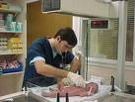](http://images.google.com.sa/imgres?imgurl=http://www.uslinksintl.com/_borders/infant_assessment.jpg&imgrefurl=http://www.uslinksintl.com/answers.htm&usg=__uYa44PcVYDKPOdimFRHf2HUZV98=&h=480&w=640&sz=64&hl=ar&start=61&um=1&tbnid=Je0xPzmn5kjKPM:&tbnh=103&tbnw=137&prev=/images?q=ASSESS+UTERINE+CONTRACTION&ndsp=20&hl=ar&sa=N&start=60&um=1)Sign and symptom of this stage :**

1. uterine contraction become more strong , more frequent
2. bearing down or pushing feeling
3. rupture of membrane
4. crowing when the fetus presented part seen in the vaginal opining.
5. episiotomy done

***Nursing diagnosis:*** - pain related to descent of fetal head.

* Fatigue related to inability to rest and pushing efforts.
* Anxiety related to unknown outcome.
* High risk of infection.

**nursing management**

1. planning and implantation:
   * transfer the women to delivery room
   * put the women in lithotomic position
   * preparation as empty bladder, prepare all the equipment needed
   * promoting the women comfort as encourage women to relax between contraction ,

-keep the women informed of her progress, and teach her how to do bearing down.

* + Observation for the mother and fetus, vital sign every 10 mint

- Keep her clean and dry.

-Avoid unnecessary manipulation in between the contractions to ensure relaxation.

-Clamp the cord twice with two artery forceps cut in between.

- Use suction to ensure the clearance of newborn’s air way.

- Wrap up the baby in a sterile towel.

**Evaluation:**

**-** the woman is able to push effectively.

* Her physiological & psychological status has been maintained.
* The infant is born without difficulty.

Third stage of labor

* **Definition:** it start from delivery of the baby to separation and expulsion of the placenta.

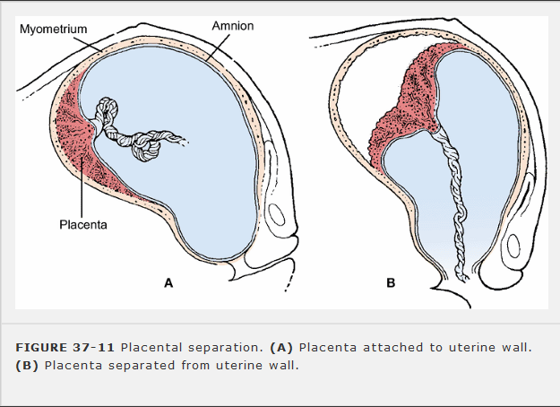

* **Sign of this stage:**

1. The uterus rises upward in the abdomen, and becomes globular in shape, hared

2.gush of blood appears from vagina

3. suprapubic bulge

4.loss pulsation in the cord

***Assessment:*-**

- Check the vital signs (temp, pulse, Bp.,….).

- Ensure the signs of placental separation which include:-

1. Firmly contracting rising fundus.
2. Change in the configuration of the fundus from discoid to globular shape.
3. Elevate the suprapubic region.
4. Sudden gush of blood from the introitus.
5. Elongation of the cord.
6. No pulsation of the umbilical cord.

**Nursing diagnosis:**

* Fatigue related to inability to rest.
* Alteration of comfort related to episiotomy and perineal distension.
* Knowledge deficit related to self-care & newborn care.
* High risk of infection.

**Nursing management:**

1. Fundal pressure is never applied to facilitate delivery of the fetus or the placenta.

2. apply forceps and cut the umbilical cord

3. careful inspect the vagina , perineum, and laceration

4. observe vaginal bleeding, hematoma

5. insert catheter to empty the bladder

6. Immediately after delivery of the placenta, administer oxytocin

7. Check to see that the placenta and membranes are complete. Examine the cord to (2 arteries and one vein).

8. Evaluate and massage the uterine fundus until firm

9. Monitor vital signs, especially pulse and blood pressure.

10.Wash the introitus by ante septic solution

**Evaluation:**

**-** the placenta is expelled without difficulty.

-The physiological status of the woman remains normal.

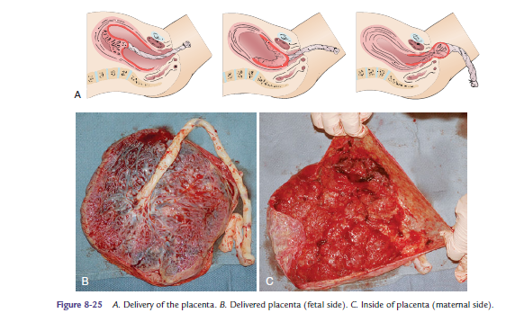

Forth stage of labor

**Definition :** first 2hours after delivery of placenta.

**Nursing management:**

1. the nurse must remain beside the patient

2. check and record maternal vital sign every 15min

3. check the uterus to ensure that is well contracted to prevent bleeding.

[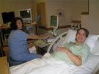](http://images.google.com.sa/imgres?imgurl=http://i.ehow.com/images/GlobalPhoto/Articles/4828938/133354-main_Full.jpg&imgrefurl=http://www.ehow.com/about_4740171_description-labor-delivery-nurse.html&usg=__C5hfozL6J6VZCpBmpcMSHFKl0-Q=&h=450&w=600&sz=31&hl=ar&start=16&um=1&tbnid=a4UdsQqVrl3T_M:&tbnh=101&tbnw=135&prev=/images?q=NURSE+IN+LABOR&hl=ar&sa=G&um=1)4. observe the amount of lochia

5. inspect the perineum for edema and hematoma.

6. encourage the women to urinate

7. give the mother snack, drink

8. show the mother baby, and change her clothes

**Nursing care during the fourth stage of labor:**

**Assessment:**

* check maternal Vital signs (temp, pulse, Bp).
* Observe the amount of vaginal blood loss every 15-min.
* Check the uterus for fundal height & contraction.
* Assess the condition of bladder & perineum.
* Observe Signs of hypovolemic shock.

**Nursing diagnosis*:***

* Fatigue related to inability to rest.
* Alteration of comfort related to episiotomy and perineal distension.
* Knowledge deficit related to self-care & newborn care.
* High risk of infection.

**Planning & implementation:**

**1-Observation:**

During this stage a closed nursing observation should be provided to mother, for maternal V.S., the uterus is contracted, amount of lochia, perineum using REEDA scale.

1. **Gentle frequent rubs of uterine fundus every 15 min.**
2. It there is **I.V infusion with or without oxytocin** going on it is continued till the mother is safe in her postnatal bed.
3. **Immediate Mother care before transfer to postnatal ward:**

- A fresh sterile vulval pad is put.

- Recording maternal observation.

* Identity label for baby should be checked immediately before transfer to the ward.

1. **Observe the infant’s** cord clamp, skin color, respiration &temperature and provide eye & cord care.
2. **Detect & treat complication early.**
3. **Promoting early family attachment:**

- Ideal time at one hour after birth.

- Provide privacy when parents observe their baby.

- Put the baby in the parent’s arm.

- Encourage the breast-feeding.

* Consider cultural especially.

**8 -The nurse should be alert for the following signs** during this stage:

- Sever perineal pain suggestive for haematoma formation.

- Rapid pulse increases hypotension.

- Sever headache hypereflexia may precede eclampsia.

* Distended bladder often visible will lead to enhanced uterine bleeding, catheterization for retention when necessary.

1. **Instruct the mother how to care an episiotomy;**

* Avoid touching the open wound to avoid infection.
* Cold packs to the perineum to decrease swelling.
* Sit in a warm bath three or four times a day after perineal care to soothe the perineum & cleanse the wound.
* Apply a topical spray to the perineum to relieve pain.
* Sit on a pillow or inflatable ring to avoid pain.
* Walking can be good exercise to increase blood flow & speed healing.
* Do 10 – 12 kegel exercises every time you feed the baby to help tighten your pelvic floor muscles & increase blood flow to the perineum.
* Call your provider if; the area of the episiotomy becomes reddened, the area becomes more swollen, there is an increase in drainage or discharge from the vagina, a fever develops or the pain gets worse.

1. **- Complete the records for woman and infant.**

**Evaluation:**

* the woman’s physiological status is within normal limits.
* She has been able to initiate breast-feeding.
* Woman infant bonding has been enhanced.

**Duration of the normal labor:**

|  |  |  |  |  |
| --- | --- | --- | --- | --- |
| Stages of labor | **1st stage** | **2nd stage** | **3rd stage** | **Total** |
| Primigravida | 12.30 hrs | 1.20 hrs | .10 minutes | 14 hours |
| Multigravida | 7.20 hrs | .30 hrs | .10 minutes | 8 hours |

**Nursing Diagnoses**

* _ Pain related to the labor and delivery process
* _ Fear related to unknowns of labor; threat of potential harm
* to self or fetus
* _ Deficient knowledge of labor process
* _ Risk of ineffective maternal/fetal perfusion related to
* perfusion in labor
* _ Risk of infection related to vaginal exams after rupture of
* membranes

**Nursing Outcomes**

* _ The woman will have decreased pain.
* _ The woman will understand the process and interventions
* related to labor.
* _ The woman will have decreased fear during labor.
* _ The woman and her partner will express positive feelings
* regarding their birthing experience.
* _ The woman’s vital signs and fetal heart rate remain stable.
* _ The woman will be free of infection