Summarizing & presenting scientific research paper:

Scan then read the abstract & the whole paper

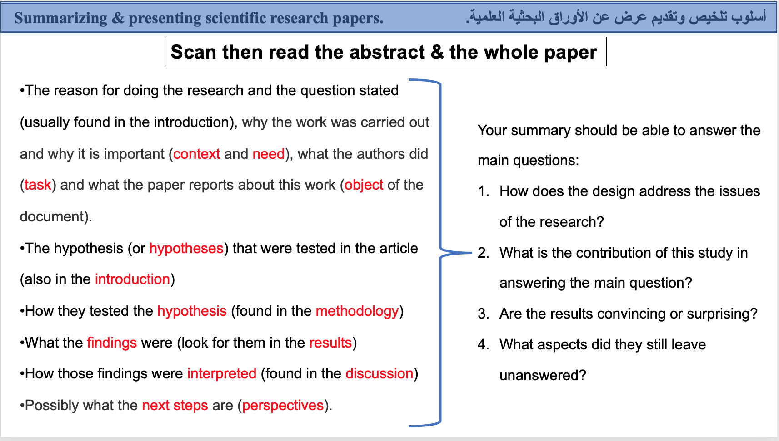

Due date: 5 – 01- 2023
Score: 10 points

Note : you have to follow the instruction above in order to get high score.

Homework:

Student Name:
Student No:
Course:
- Write a summary of your chosen scientific paper?
- http://www.bio21.bas.bg/ipp/gapbfiles/v-33/07_3-4_221-234.pdf
- https://academic.oup.com/jxb/article/72/8/2822/6146810
- https://www.sciencedirect.com/science/article/abs/pii/S0098847211001924

