Summarizing & presenting scientific research paper:

**Scan then read the abstract & the whole paper**

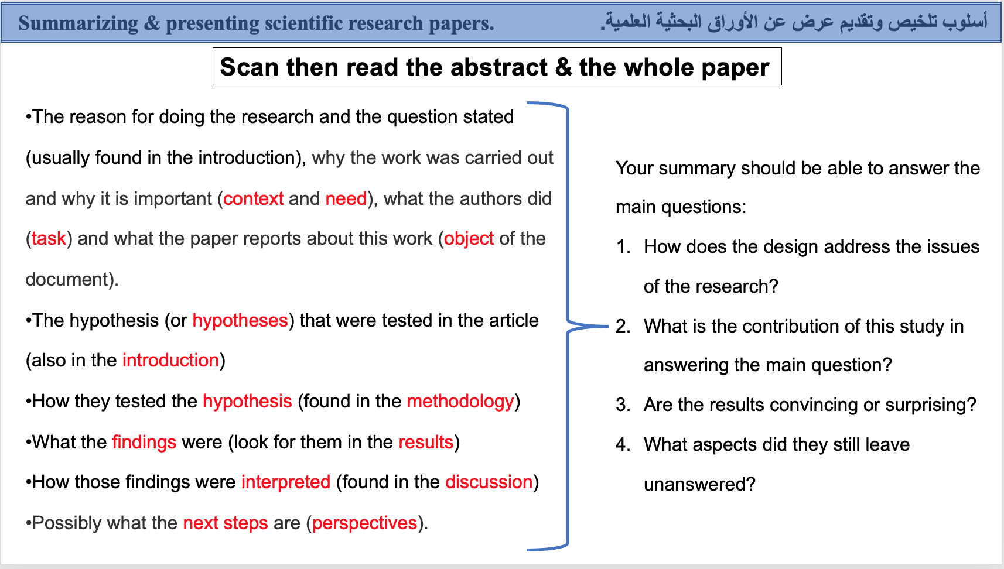

**Due date: 20 – 27- 2022**

**Score: 10 points**

**Note : you have to follow the instruction above in order to get high score.**

**Homework:**

Student Name:

Student No:

Course:

* Write a summary of your chosen scientific paper?

1. https://www.researchgate.net/publication/275517805_Determination_and_Morphogenetic_Competence_in_Plant_Tissue_Culture
2. Andersone U, Ievinsh G. Changes of morphogenic competence in mature Pinus sylvestris L. buds in vitro. Ann Bot. 2002 Aug;90(2):293-8. doi: 10.1093/aob/mcf176. PMID: 12197528; PMCID: PMC4240419.
3. 51052392_Morphological_classification_of_plant_cell_deaths
4. 330638465_Vascularization_plant_decellularization_and_electrospinning_techniques_for_the_development_of_small_and_medium_caliber_blood_vessels
5. <https://academic.oup.com/jxb/article/58/14/3829/462563>