Summarizing & presenting scientific research paper:

**Scan then read the abstract & the whole paper**

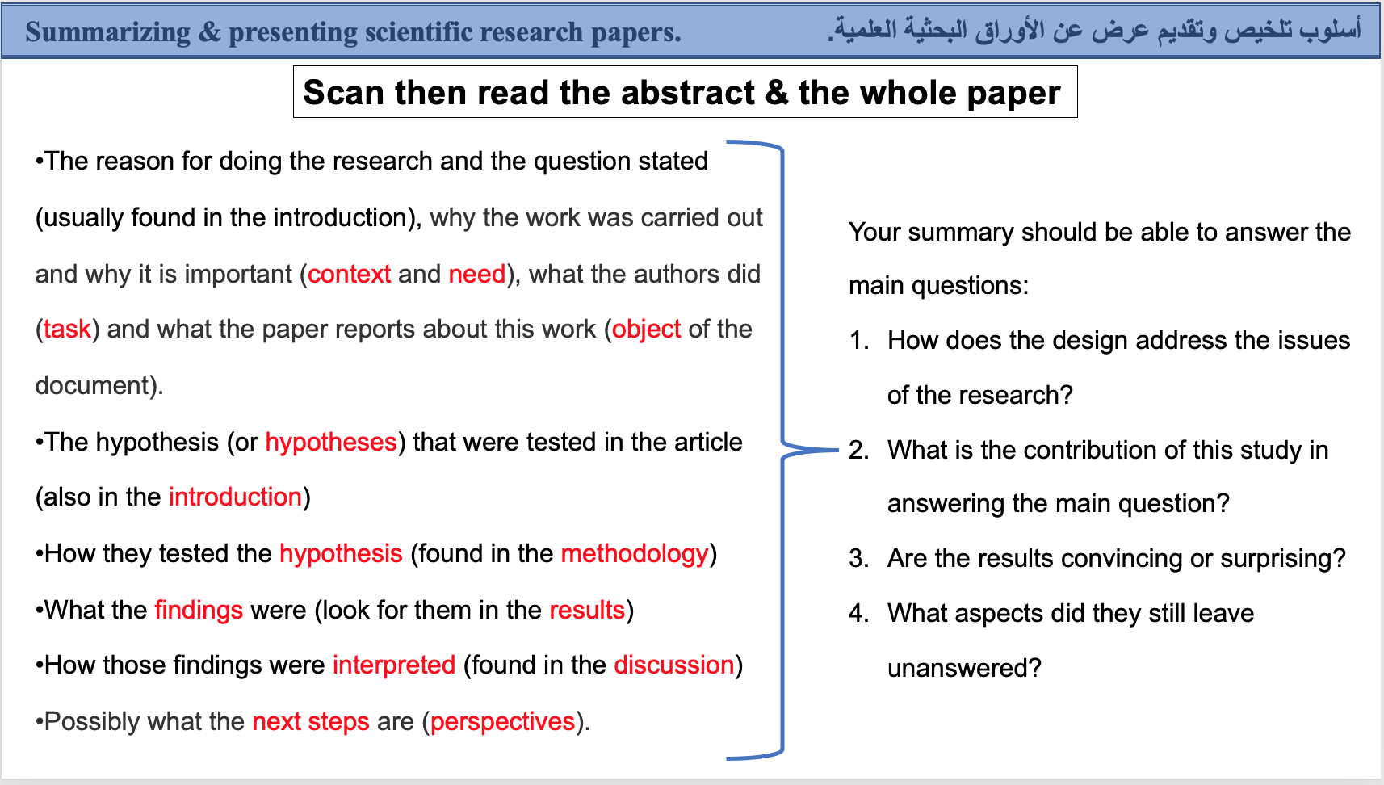

**Due date: 4 – 1- 2023**

**Score: 10 points**

**Note : you have to follow the instruction above in order to get high score.**

**Homework:**

Student Name:

Student No:

Course:

* Write a summary of your chosen scientific paper?

1. <https://www.sciencedirect.com/science/article/abs/pii/S0168945218311555>
2. <https://academic.oup.com/plphys/article/130/3/1143/6110516>
3. <https://www.tandfonline.com/doi/full/10.1080/17429145.2017.1362051>