.Self-Learning Plan
Self-Learning IT Skills Department
Preparatory Year - King Saud University

Self-Learning Plan for Year 2012 -2013

Introduction
Self-learning is added in IT 140 to make student's self-dependent. It is a special academic curricular activity in which students will have to do most of the work (70%), and they will get (30%) help from Teachers. They will learn additional topic as per their interests within the given criteria. We want to give students the software/Hardware knowledge which will be helpful for them in future IT endeavor.

Goal
This Self-learning is designed to provide Intermediate Knowledge of selected software.
We will provide help to students to complete their Self-Learning and its project.
At the end they will be able to do Productive work on that software.

Instructions
- Self-Learning Classes will begin after Mid-semester.
- Self-Learning will complete in 1 ½ weeks (Total-9 hours).
- Students have to submit their Project Report (Word) along with their Project Output.
- The Project Presentation (PowerPoint) is excluded from Self-Learning this year.
- Self-Learning Trainer & Students will be the same as for Lecture.
- No student will be allowed to change his classroom or teacher, if he does the same, he’ll be treated as absent.
- Trainer and students together will select a Self Learning topic from the provided list. (If a Trainer or students want to do some excellent project they can submit the synopsis for approval from supervisor)
- Trainers need to prepare the day wise breakup and other required contents for Self-Learning session.
- Trainers should send Self-Learning topic and syllabus to supervisor before 10 days for prior permission.
- There is no separate Self-Learning Attendance it will be same as Lecture.
- Self-Learning report will be included in the trainer's daily report.
- All the students have to develop projects individually. (Group Projects are allowed only after Supervisor’s approval to Trainer.)
Following is the list of available Self-Learning Activities
Topics/Activity | Software | Description
Image Editing | Adobe Photoshop | Adobe Photoshop is a program that helps you edit/modify digital images. Photoshop can transform them into anything you can imagine, and showcase them in extraordinary ways
Desktop Publishing | MS Publisher | Publisher is a desktop publishing program that helps you design professional publications, such as newsletters, web sites, brochures, catalogs, flyers, signs, postcards, invitation, greeting and business cards, letterheads, envelopes, business forms, banners, calendars, certificates and menus.
Web Development | HTML | Hyper Text Markup Language is the main markup language for displaying web pages and other information in a web browser; students can design simple webpages using different HTML Tags.
Windows Application development | Visual Basic 6 / MS Access | VISUAL BASIC is a high level programming language. It is a very easy programming language to learn. The code looks like English Language. However, people prefer to use Microsoft Visual Basic today, as it is a well-developed programming language and supporting resources are available everywhere.
Database Management Systems | MS Access | Microsoft Access is a computer application used to create and manage databases on desktop computers and on connected computers. Microsoft Access can be used for personal information management (PIM), in a small business to organize and manage data, or in an enterprise to communicate with servers
Computer Programming | C (Language) | C is a computer programming language. C is use to create lists of instructions for a computer to follow. C is most popular because it gives programmers maximum control and efficiency. C is an easy language to learn. It is called a compiled language.
Topics/Activity for Humanitarian Path Students
Topics/Activity | Description
Computer Hardware | Installation (assemble & disassemble) and Maintenance of Personal Computer.
Computer Networking | Networking Methodology and Installation of Network (DUN and RDUN)
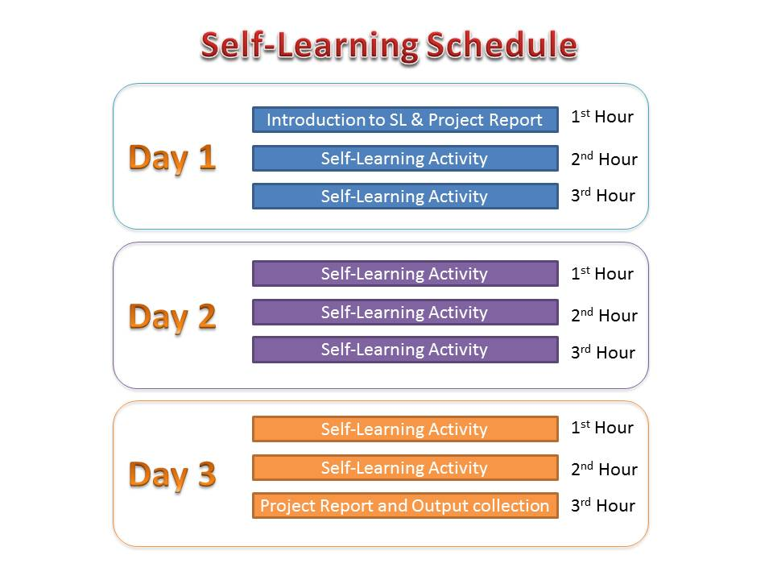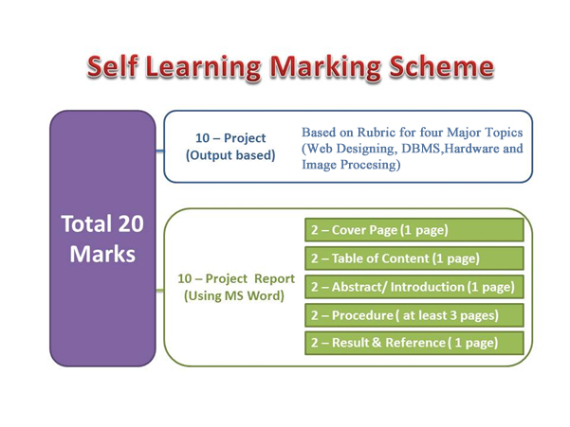
Rubric Marking Scheme for Project Outputs for 4 Major Different topics
1 Mark - Minimum 3 Images.
1 Mark - Minimum 5 Web Pages.
Web designing :
HTML/ Publisher
1 Mark - Webpage Background (Color/Image)
1 Mark - Website Title
2 Marks - Minimum 1 table.
1 Mark - Home Link on each page
1 Mark - Forward and Backward Buttons on each page
1 Mark - Minimum 5 Hyperlinks.
10 Marks

1 Mark - Minimum 1 Marquee effect

1 Mark - Table Name
1 Mark - Minimum 1 Table
DBMS :
MS Access
1 Mark - Minimum 1 Form
1 Mark - Minimum 1 Report
1 Mark - Query name
1 Mark - Form Name
1 Mark - Report Name
1 Mark - Minimum 1 Query
10 Marks

1 Mark - Primary key
1 Mark - Query output

2 Marks – Processor Fan Fixing Demonstration
2 Marks - CD ROM Fixing Demonstration
HARDWARE :
2 Marks - Hard disk Fixing Demonstration
10 Marks
2 Marks - Processor Fixing Demonstration
2 Marks - RAM Fixing Demonstration

Important note: Student should submit computer hardware assembling demonstration video of himself with voice for future reference in which teacher and student are easily identifiable.

1 Mark - Image Border
Image Editing:
10 Marks
Photoshop
1 Mark - Minimum Two Layers
1 Mark - Raw Image
1 Mark - At least one Text Layer
1 Mark - Processed Image in JPEG/PNG Format
2 Marks- Image in .PSD format
1 Mark - Black & white conversion of output image in PNG/JPEG format
1 Mark - At least one blending option feature
1 Mark - Resizing and cropping of Image in PNG/ JPEG format

