Quiz 1
EE 202
Name:
Student ID:
Q1
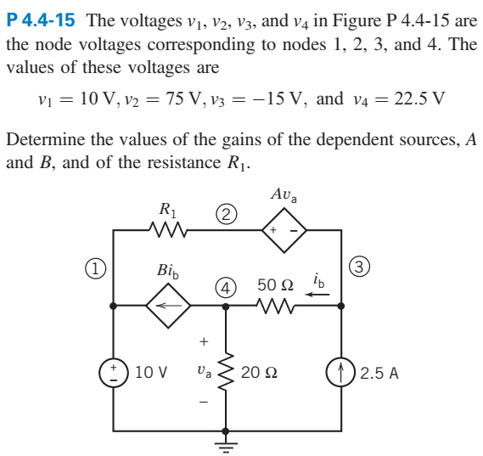

Q2
Find $i_{1}$ and $i_{2}$
