For full credit, show all calculations with answers in standard units (kg, m, s, C, N, J) unless otherwise specified. If no calculations are required, give logical justification for your answer. Answer each question as completely as you can. Please read the questions carefully as many contain multiple parts. Watch your units! No work means no credit.

- Describe what is meant by “diode breakdown.” How can this flaw be used as a feature?

- Draw a line to match each of the following diode symbols with its diode type.
 | Zener Diode
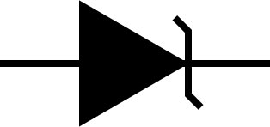 | “Basic” diode
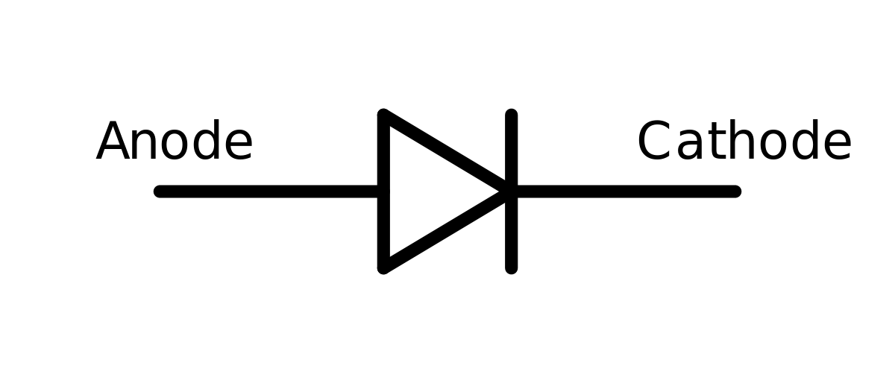 | Photodiode
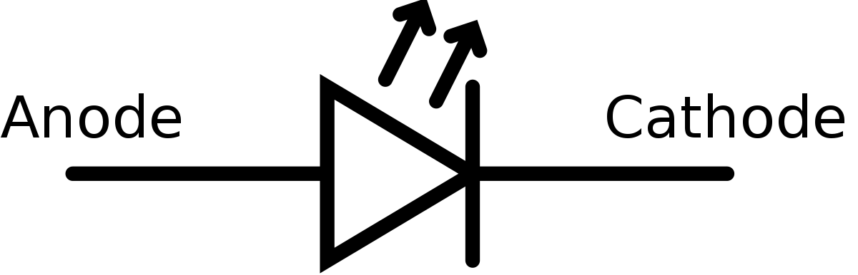 | Schottky Diode
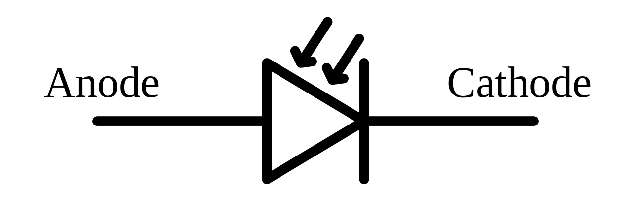 | Light-Emitting Diode

- Explain and demonstrate how diodes can be used to form basic logic gates.

- Describe doping with regards to semiconductors. Why are doped semiconductors better than pure elemental semiconductors?

- Describe a PN junction. Be sure to define both P- and N-type semiconductors.

- Rectifiers are used to convert an AC input to a DC output. Describe some ways to smooth the signal.

