For full credit, show all calculations with answers in standard units (kg, m, s, C, N, J) unless otherwise specified. If no calculations are required, give logical justification for your answer. Answer each question as completely as you can. Please read the questions carefully as many contain multiple parts. Watch your units! No work means no credit.

Define the following terms:
- Electron Affinity
- Ion
- Conductor
- Insulator
- Coulomb’s Law

- You have a copper wire of diameter 0.16 mm, length 2.0 m, and resistance 1.76 Ω.
  - Find the resistivity.
  - Assuming part (a) was performed at a temperature of 20 ºC, find the resistance of the same copper wire at 0 ºC.
  - Based on your knowledge of conductors, should the wire be more or less conductive at the colder temperature?

- Describe Kirchhoff’s Loop Rules for circuits.

- Based on the following diagram, find the magnitude and direction of the current running through each loop in the circuit.
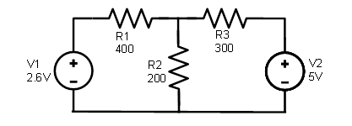
- Two parallel plate capacitors have an area of 5.56 cm² each, and a separation of 5.5 mm. Both are filled with a dielectric, with one having a constant of 7.0, and the other a constant of 9.0. If the capacitors are connected in series, find the total capacitance of the combined capacitors.

- Your laptop requires a 24-V emf to function. The average AC outlet in the US provides 120 V.
  - What should be the ratio of the primary coil turns to secondary coil turns in the transformer to power the laptop?
  - Suppose you travel to Europe where the voltage is 240 V. Answer part (a) again using this voltage.

