For full credit, show all calculations with answers in standard units (kg, m, s, C, N, J) unless otherwise specified. If no calculations are required, give logical justification for your answer. Answer each question as completely as you can. Please read the questions carefully as many contain multiple parts. Watch your units! No work means no credit.

- Describe Kirchhoff’s Loop Rules for circuits.

- An NPN transistor with three terminals labeled E, B, and C is connected in the following illustrated circuit.
  - Calculate I_{E}.
  - Calculate V_{C} and V_{E}.
  - If terminal B is 0.6 V more positive than terminal E, calculate the ratio of R₁ and R₂, assuming I_{E} is very large compared to the 20µA flowing into terminal B.
  - Calculate the approximate power dissipated in the transistor.
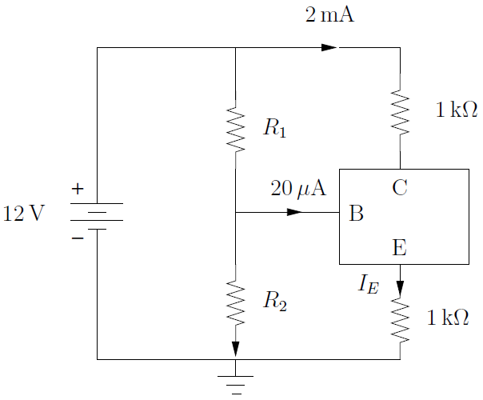

- The book describes an electronic device as one with an active component. What is the difference between active and passive components? Give an example of each.

- What is the difference between an analog signal and a digital signal? Give some examples of when each might be used.

- Match each of the following op amp circuits to its name.

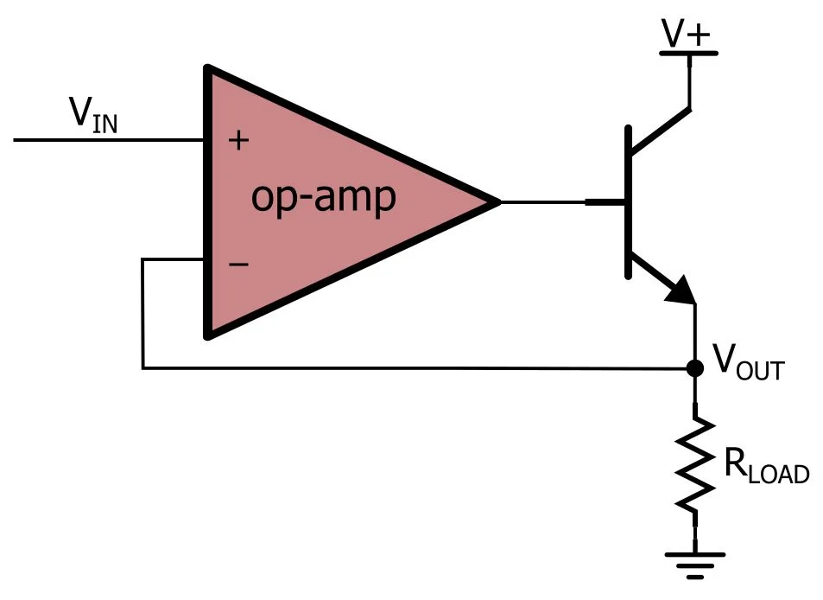 | Non-Inverting Amplifier  (Closed Loop, Positive Feedback)
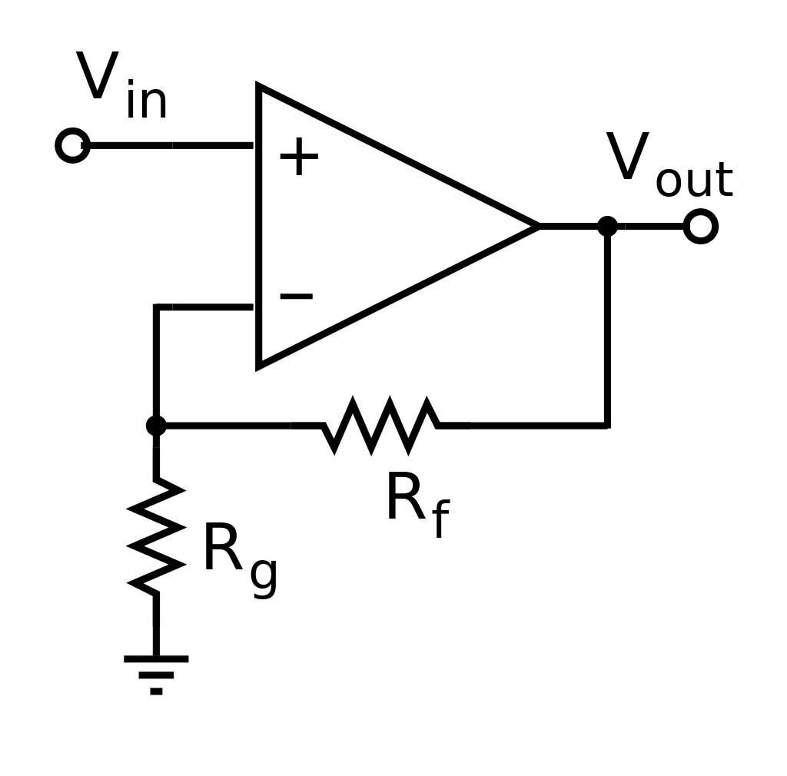 | Buffer  (Closed Loop)
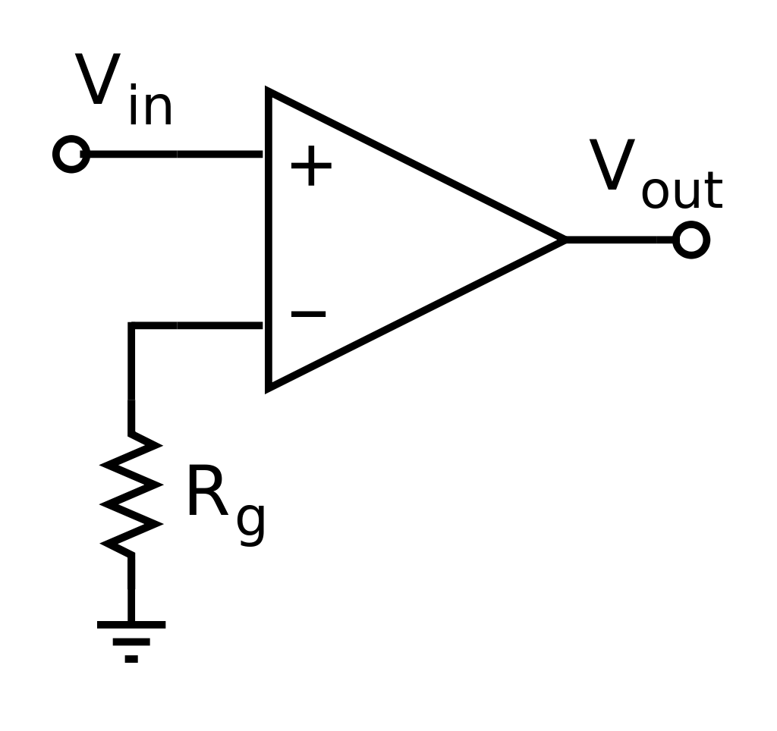 | Inverting Amplifier  (Closed Loop, Negative Feedback)
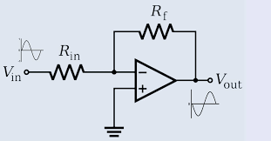 | Open Loop

- List the two primary rules of op amps (Hint: one focuses on current, another on voltage).

- Describe what is meant by “diode breakdown.” How can this flaw be used as a feature?

- Describe the basic function of an oscilloscope.

- Rectifiers are used to convert an AC input to a DC output. Describe two ways to smooth the signal.
- Identify each of the following circuit symbols.
 | 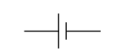
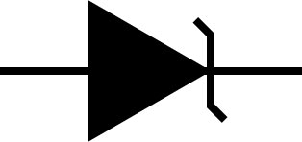 | 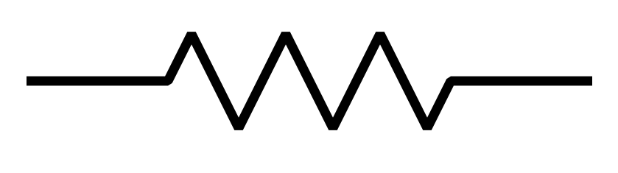
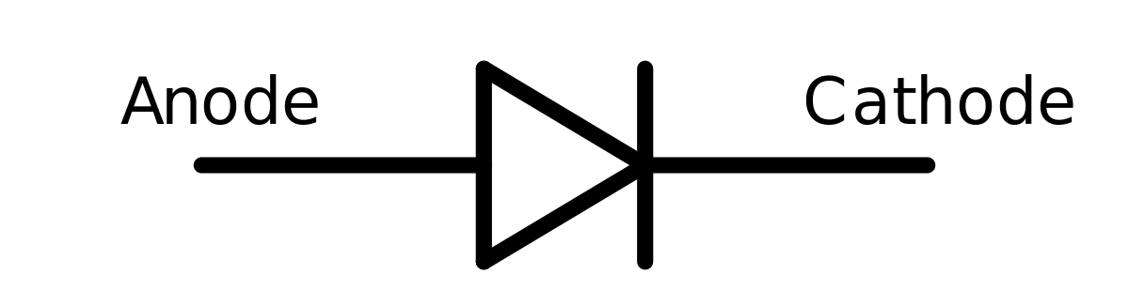 | 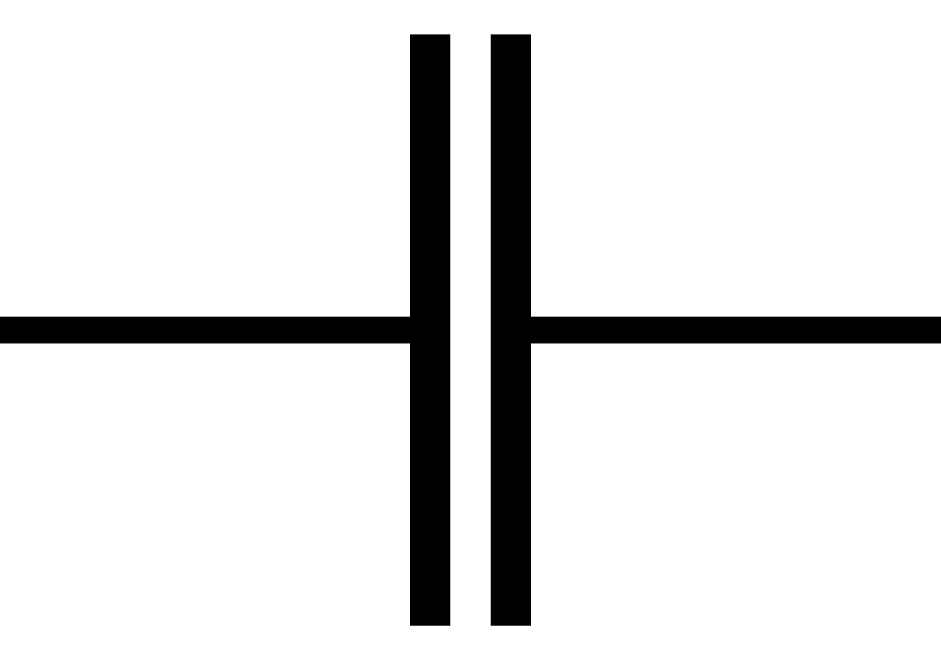
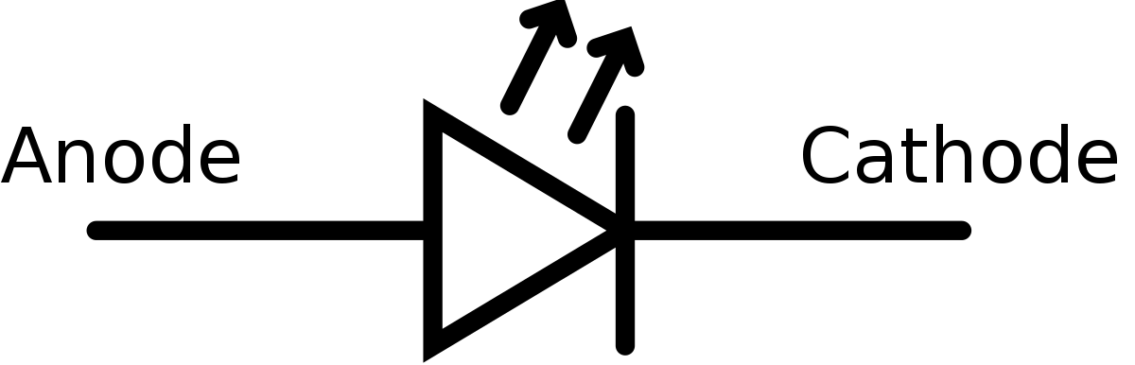 | 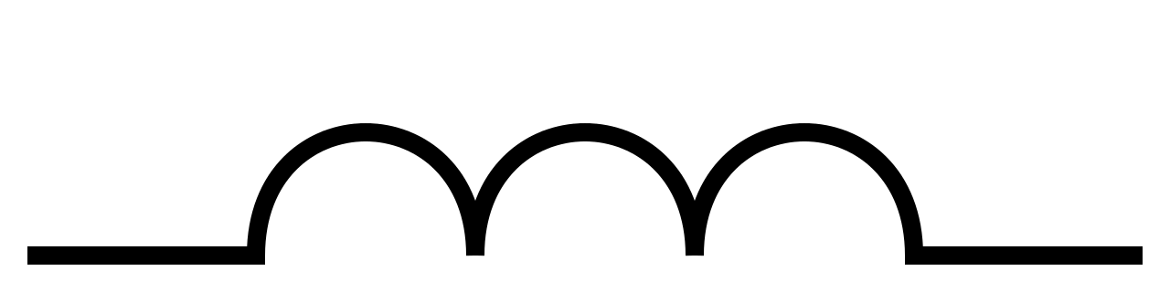
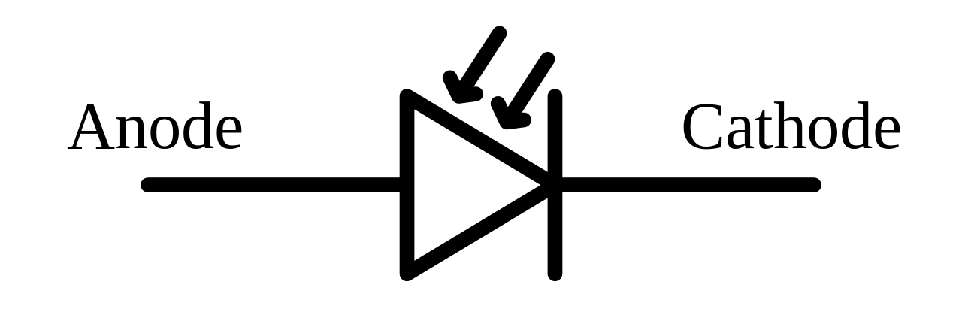 | 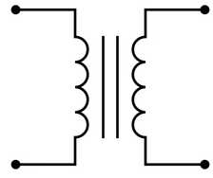

- For each of the components above, give a brief description of its properties and uses.

- Why are doped semiconductors better than pure elemental semiconductors?

- Describe a PN junction. Be sure to define both P- and N-type semiconductors.

- Draw a diagram of a physical NPN BJT (not circuit diagram). Label the input, output, and controller nodes with appropriate names.

- Draw a diagram of a physical NMOS (not circuit diagram). Label the input, output, and controller nodes with appropriate names.

- BJTs are ______________ controlled transistors and MOSFETs are ______________ controlled transistors.

- The typical bias of a germanium transistor is __________ V, and a silicon transistor is __________ V.

Important Information
$V=IR$ $R=ρ\frac{l}{A}$ $C=\frac{ϵA}{d}$
S.I. Units | Series | Parallel
I(A) | I = I₁ = I₂ = I₃ = … | I = I₁ + I₂ + I₃+ …
R(Ω) | R = R₁ + R₂ + R₃ + … | 1/R = 1/R₁ + 1/R₂ + 1/R₃ + …
V(V) | E = V₁ + V₂ + V₃ + … | E = V₁ = V₂ = V₃ = …
C(F) | 1/C = 1/C₁ + 1/C₂ + 1/C₃ + … | C = C₁ = C₂ = C₃ = …
L(H) | L = L₁ + L₂ + L₃ + … | 1/L = 1/L₁ + 1/L₂ + 1/L₃ + …

