For full credit, show all calculations with answers in standard units (kg, m, s, C, N, J) unless otherwise specified. If no calculations are required, give logical justification for your answer. Answer each question as completely as you can. Please read the questions carefully as many contain multiple parts. Watch your units! No work means no credit.

- Draw a diagram of a physical NPN BJT (not circuit diagram). Label the input, output, and controller nodes with appropriate names.

- Draw a diagram of a physical NMOS (not circuit diagram). Label the input, output, and controller nodes with appropriate names.

- BJTs are ______________ controlled transistors and MOSFETs are ______________ controlled transistors.

- The typical bias of a germanium transistor is __________ V, and a silicon transistor is __________ V.

- List and define the five operational states of a BJT.

- List and define the three operational states of a MOSFET.

- Define a cascade in reference to amplifiers.

- Define a cascode in reference to amplifiers.

- An NPN transistor with three terminals labeled E, B, and C is connected in the following illustrated circuit.
  - Calculate I_{E}.
  - Calculate V_{C} and V_{E}.
  - If terminal B is 0.6 V more positive than terminal E, calculate the ratio of R₁ and R₂, assuming I_{E} is very large compared to the 20µA flowing into terminal B.
  - Calculate the approximate power dissipated in the transistor.
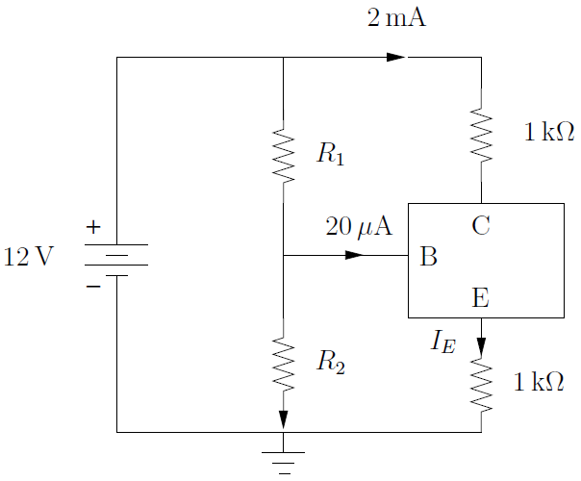
- Define and describe a current mirror.

- Write a simple formula for each of the following:
  - Express the relationship between I_{C}, I_{B}, and I_{E} in a BJT.
  - Write an expression for I_{C} and a function of I_{B} and ⍺.
  - Write an expression for I_{C} and a function of I_{B} and ꞵ.
  - Write an expression for I_{C} and a function of I_{E} and ⍺.
  - Write an expression for I_{C} and a function of I_{E} and ꞵ.
  - Write an expression for I_{B} and a function of I_{E} and ⍺.
  - Write an expression for I_{B} and a function of I_{E} and ꞵ.

- For the circuit shown below, V_{B} = −1.5 V. Assuming V_{BE} = 0.7 V, calculate V_{E}, α, β, and V_{C}. If a transistor with β = ∞ is used, what values of V_{B}, V_{E}, and V_{C} result?

