For full credit, show all calculations with answers in standard units (kg, m, s, C, N, J) unless otherwise specified. If no calculations are required, give logical justification for your answer. Answer each question as completely as you can. Please read the questions carefully as many contain multiple parts. Watch your units! No work means no credit.

Give a brief definition of the following terms.
- Electron Affinity
- Ion
- Conductor
- Insulator
- Coulomb’s Law

- You have a copper wire of diameter 0.002 m, length 5.0 m, and resistivity 1.77×10⁻⁸ Ω݀-m.
  - Find the resistance.
  - Based on your knowledge of conductors, should the wire be more or less conductive at a colder temperature?

- Describe Kirchhoff’s Loop Rules for circuits.

- Use the diagram below to answer the following questions.
  - Find the equivalent resistance of the parallel parts of the circuit.
  - Find the equivalent resistance across the entire circuit.
  - Find the magnitude of the current running through each part of the circuit.

12 V

100 Ω
25 Ω
25 Ω
50 Ω
100 Ω
90 Ω

- Two parallel plate capacitors have an area of 0.005 m² each, and a separation of 0.005 m. Both are filled with a dielectric, with one having a constant of 6.0, and the other a constant of 7.0. If the capacitors are connected in series, find the total capacitance of the combined capacitors.

- The book describes an electronic device as one with an active component. What is the difference between active and passive components? Give an example of each.

- Match each of the following op amp circuits to its name.

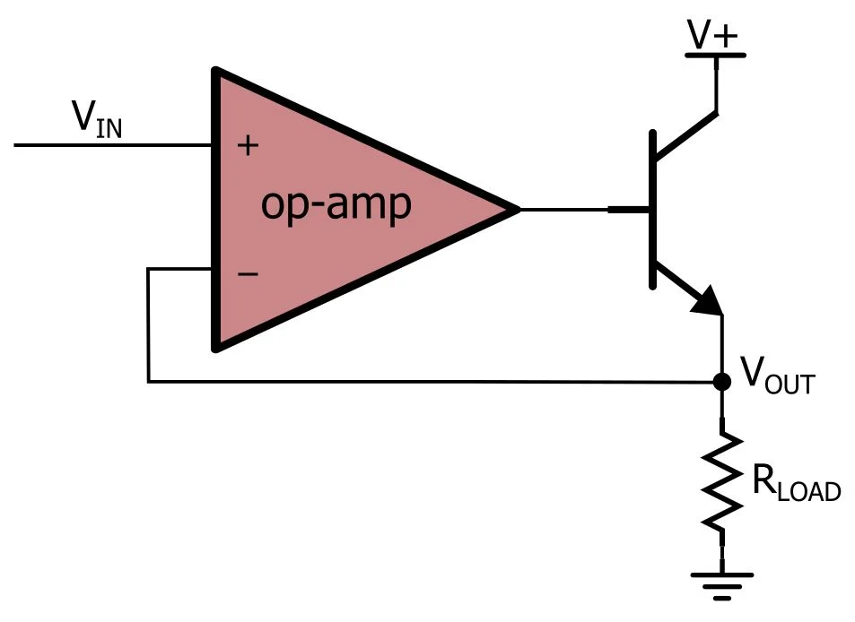 | Non-Inverting Amplifier  (Closed Loop, Positive Feedback)
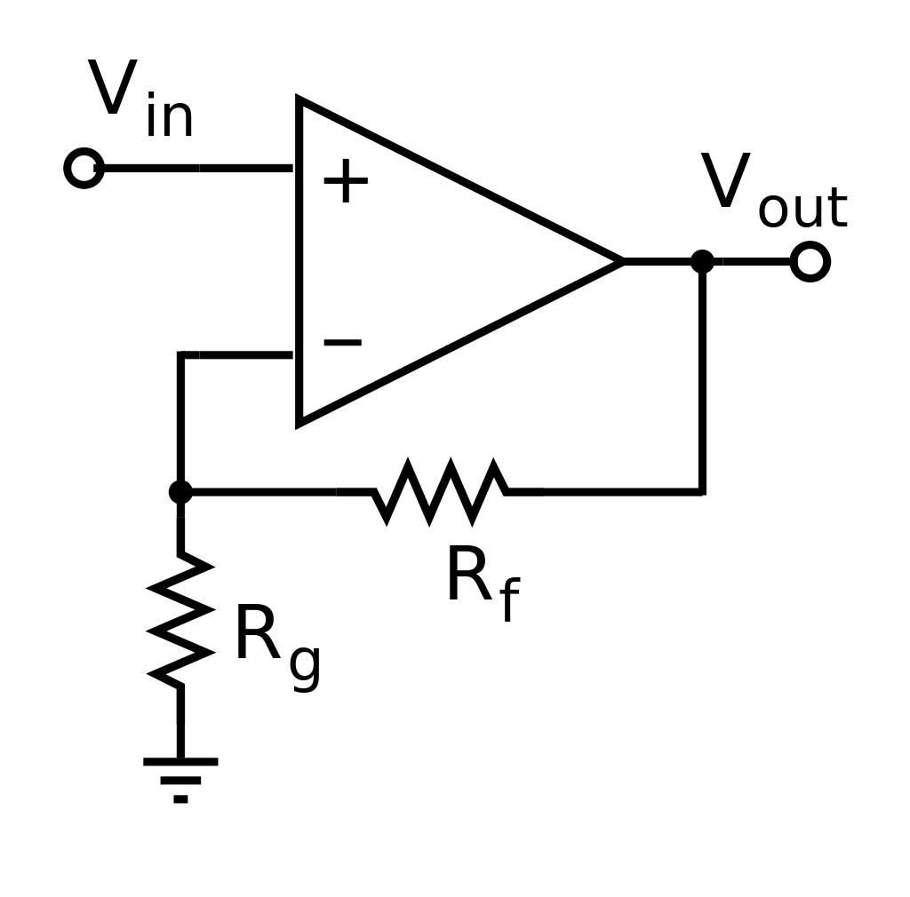 | Buffer  (Closed Loop)
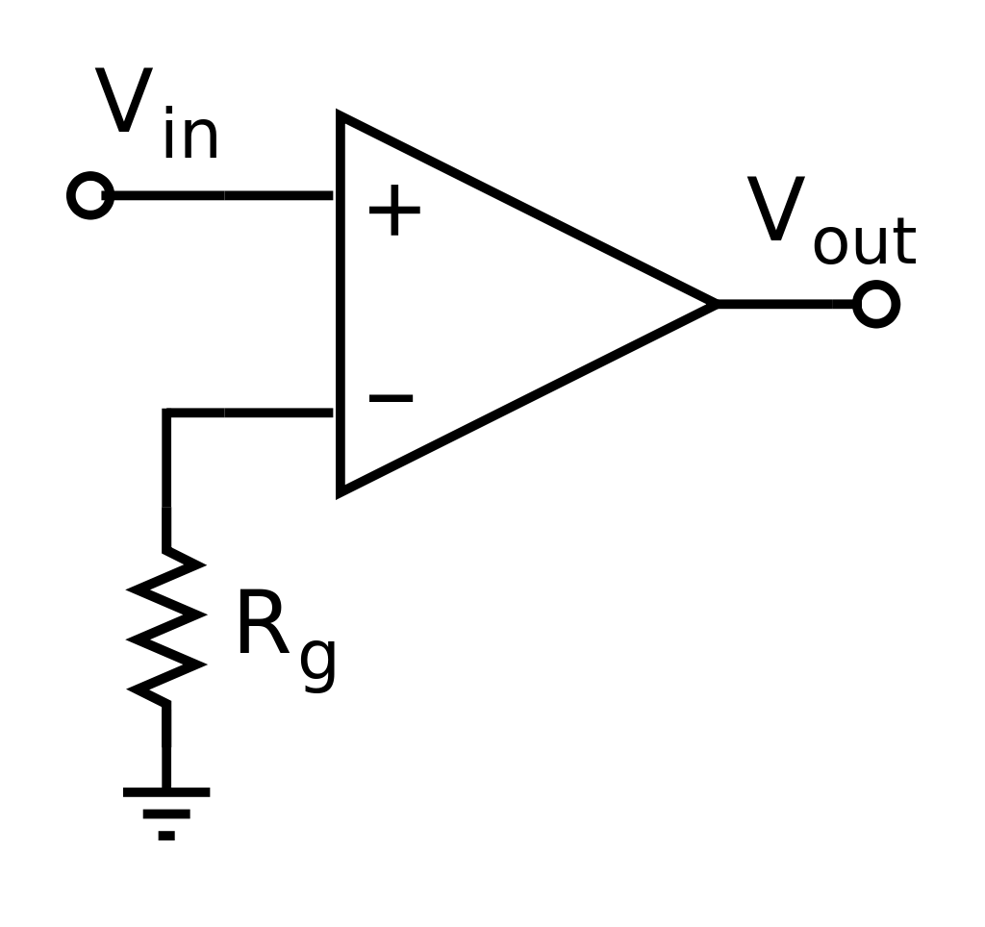 | Inverting Amplifier  (Closed Loop, Negative Feedback)
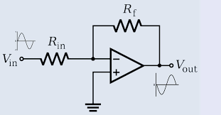 | Open Loop

- List the two primary rules of op amps (Hint: one focuses on current, another on voltage).

- Describe what is meant by “diode breakdown.” How can this flaw be used as a feature?

- Describe the basic function of an oscilloscope.

- Show how diodes can be used to form basic AND/OR logic gates.

- Rectifiers are used to convert an AC input to a DC output. Describe two ways to smooth the signal.

- Match each of the following diode symbols with its diode type.
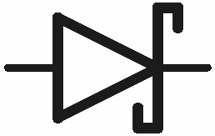 | Zener Diode
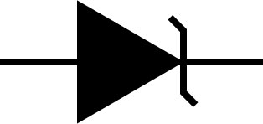 | “Basic” diode
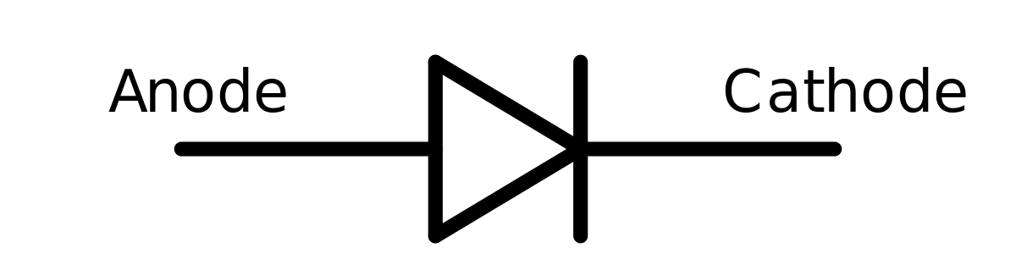 | Photodiode
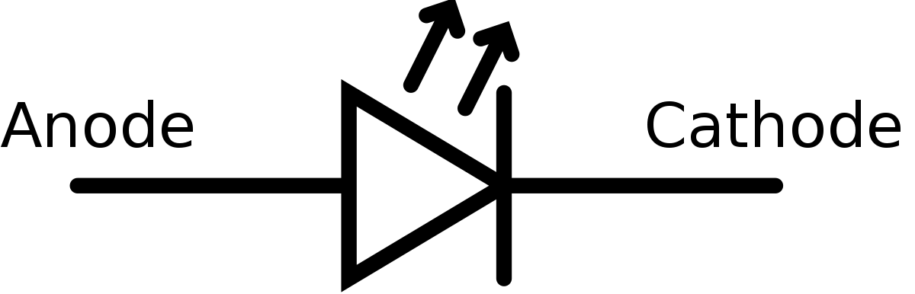 | Schottky Diode
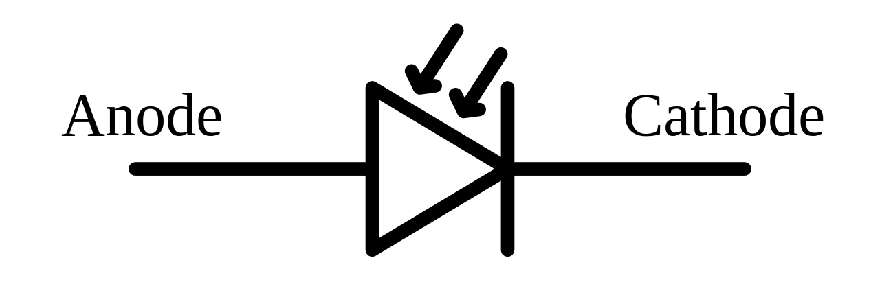 | Light-Emitting Diode

- For each of the diodes above, give a brief description of its properties and uses.

- Why are doped semiconductors better than pure elemental semiconductors?

- Describe a PN junction. Be sure to define both P- and N-type semiconductors.

Important Information
$V=IR$ $R=ρ\frac{l}{A}$ $C=\frac{ϵA}{d}$
S.I. Units | Series | Parallel
I(A) | I = I₁ = I₂ = I₃ = … | I = I₁ + I₂ + I₃+ …
R(Ω) | R = R₁ + R₂ + R₃ + … | 1/R = 1/R₁ + 1/R₂ + 1/R₃ + …
V(V) | E = V₁ + V₂ + V₃ + … | E = V₁ = V₂ = V₃ = …
C(F) | 1/C = 1/C₁ + 1/C₂ + 1/C₃ + … | C = C₁ = C₂ = C₃ = …
L(H) | L = L₁ + L₂ + L₃ + … | 1/L = 1/L₁ + 1/L₂ + 1/L₃ + …

