Parasitology Sample Test
Q1: The fecal sample in the device at your place came from a 4-year-old male Rottweiler as part of his yearly check-up. Examine the sample and identify the eggs of the parasite (give Genus and species)
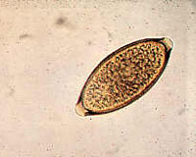
Q2: The worms seen under the microscope were recovered from the small intestine of a sheep which died of bacterial pneumonia. Identify the parasite (give Genus only).

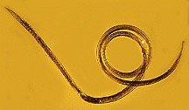
Q3: A 6-year-old male mix breed dog was brought in to your practice with the complaint that it had chronic vomiting. The results of a saturated salt flotation fecal examination is shown under the microscope. Identify the egg (give Genus and species).
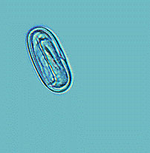
Q4: Most helminths do not multiply in humans. What are 2 exceptions?

Q5: How is Enterobius diagnosed?

Q6: Eggs of Echinococcus spread to what organ?

Q7: Are Eosinophil levels high in protozoal infections? Helminth infections?

