**Résumé**

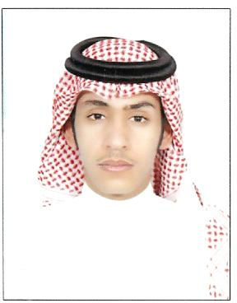

**Personal Information:**

**Name:** Yunus Ayyat AlAnazi

**Nationality:** Saudi

**Date of Birth:** 07 Feb 1989

**Address:** Saudi Arabia, Riyadh, Hassan Bin Thabit St., House No. 7

**Mobile No.:** + 966 567 899 221

**E-mail:** yunus.anazi@gmail.com

**Education Information:**

Graduated from College of Engineering at King Saud University in February 2011G with Bachelor of Science in Petroleum and Natural Gas Engineering.

**G.P.A.:** (4.10out of5)

**Summer Training Program:**

Artificial Lift & Well Completion Unit, East Admin Building, Abqaiq, Southern Area Oil Operation (SAOO), **Saudi Aramco**, 2009.

**Latest Workshops and Seminars:**

1. Borehole Imaging Workshop in Jan 2011, *Baker Hughes Trainer*
2. Drilling Real Time Operation Seminar in Dec 2010, *Saudi Aramco* *Presenter*
3. Carbonate Matrix Acidizing Seminar in Dec 2010, *Schlumberger* *Presenter*
4. Intelligent Wells Technology Seminar in Nov 2010, *Saudi Aramco Presenter*

**Awards:**

1. Academic Excellence Awards
2. Best Graduation Project Award of 2010/2011
3. Second Winner Award of SPE Sub-regional Student Paper Contest (paper titled: *Application of Hydraulic Fracturing in Tight Gas Reservoir*), Jan 2011

**Skills:**

Familiar with **Microsoft Office** programs.

Ability of programming by **Visual Basic**, **FORTRAN** and **MATLAB**.

**Recommendation Letters:**

I have received recommendation letters from:

1. Prof. Adel Hemeida
2. Dr. Ahmed Gawish

**Sociality:**

Member of Society of Petroleum Engineers **SPE**.

Active member of **SPE-KSU** Chapter.

**Languages:**

Arabic, English