College of Sciences
Department of
Statistics and Operations Research
كلية العلوم
قسم الإحصاء وبحوث العمليات

Midterm Exam

Wednesday, 03 / 07 / 1444 H | STAT 332 | Academic year 1444 H
7:00 – 09:00 pm | Regression Analysis | Second Semester

30
Student’s Name |  | اسم الطالب
ID number |  | الرقم الجامعي
Section No. |  | رقم الشعبة
Classroom No. |  | رقم قاعة الاختبار
Teacher’s Name |  | اسم أستاذ المقرر
Roll Number |  | رقم التحضير
Important Notices:
Answer the following questions (3 questions, two pages)
Answer a new question in a new page.
_____________________________________________________
Question One (8 Marks)
Suppose that $(y_{1},x_{1}),(y_{2},x_{2}),.....,(y_{n},x_{n})$ is a data set to which we fit a simple regression model,

$$Y_{i}=β_{0}+β_{1}X_{i}+ε_{i},i=1,2,...n.$$
- If $β_{0}=0$, find the least squared estimate of the of $β_{1}$, next, discuss the unbiasedness and derive its variance.
- Ifprove that:
- The sum of residuals is equal to zero.
- The total sum of square error is equal to the sum the regression square error of the plus the sum of square error.

- When , find the least squared estimate of the of , next, discuss the unbiasedness and derive its variance.
$Y_{i}= β_{1}X_{i}+ε_{i}$ $⇒ε_{i}=Y_{i}- β_{1}X_{i}$
$Q=\sum_{i=1}^{n}{{ε_{i}}^{2}}=\sum_{i=1}^{n}{{\left(Y_{i}- β_{1}X_{i}\right)}^{2}}$
$$\frac{∂Q}{∂β_{1}}=0⇒-2X_{i}\sum_{i=1}^{n}{{\left(Y_{i}- {\hat{β}}_{1}X_{i}\right)}^{}}=0$$
$⇒X_{i}\sum_{i=1}^{n}{{\left(Y_{i}- {\hat{β}}_{1}X_{i}\right)}^{}}=0$
$\sum_{i=1}^{n}{Y_{i}X_{i}}-{\hat{β}}_{1}\sum_{i=1}^{n}{{X_{i}}^{2}}=0⋯\boxed{2}$
$${b_{1}=\hat{β}}_{1}=\frac{\sum_{i=1}^{n}{Y_{i}X_{i}}}{\sum_{i=1}^{n}{{X_{i}}^{2}}}$$

************
$$E\left({\hat{β}}_{1}\right)=E\left(\frac{\sum_{i=1}^{n}{Y_{i}X_{i}}}{\sum_{i=1}^{n}{{X_{i}}^{2}}}\right)=\frac{\sum_{i=1}^{n}{X_{i}}}{\sum_{i=1}^{n}{{X_{i}}^{2}}}E\left(Y_{i}\right)$$
$$=\frac{\sum_{i=1}^{n}{X_{i}}}{\sum_{i=1}^{n}{{X_{i}}^{2}}}*β_{1}X_{i}=β_{1}\frac{\sum_{i=1}^{n}{{X_{i}}^{2}}}{\sum_{i=1}^{n}{{X_{i}}^{2}}}=β_{1}$$

************
$$V\left({\hat{β}}_{1}\right)=V\left(\frac{\sum_{i=1}^{n}{Y_{i}X_{i}}}{\sum_{i=1}^{n}{{X_{i}}^{2}}}\right)=\frac{\sum_{i=1}^{n}{{X_{i}}^{2}}}{{\left(\sum_{i=1}^{n}{{X_{i}}^{2}}\right)}^{2}}V\left(Y_{i}\right)=\frac{σ^{2}}{\sum_{i=1}^{n}{{X_{i}}^{2}}}$$

- When Prove that
- The sum of residuals is equal to zero
$$e_{i}=Y_{i}-\hat{Y_{i}}=Y_{i}-{\hat{β}}_{0}-{\hat{β}}_{1}X_{i}$$
$\sum_{i=1}^{n}{e_{i}}=\sum_{i=1}^{n}{\left(Y_{i}-{\hat{β}}_{0}-{\hat{β}}_{1}X_{i}\right)}$
$=\sum_{i=1}^{n}{\left(Y_{i}-\left(\overline{Y}-{\hat{β}}_{1}\overline{X}\right)-{\hat{β}}_{1}X_{i}\right)}$
$=\sum_{i=1}^{n}{Y_{i}}-n\overline{Y}+n{\hat{β}}_{1}\overline{X}-{\hat{β}}_{1} \sum_{i=1}^{n}{X_{i}}$
$=n\overline{Y}-n\overline{Y}+n{\hat{β}}_{1}\overline{X}-n{\hat{β}}_{1}\overline{X}=0$
- The total sum of square error is equal to the sum the regression square error of the plus the sum of square error 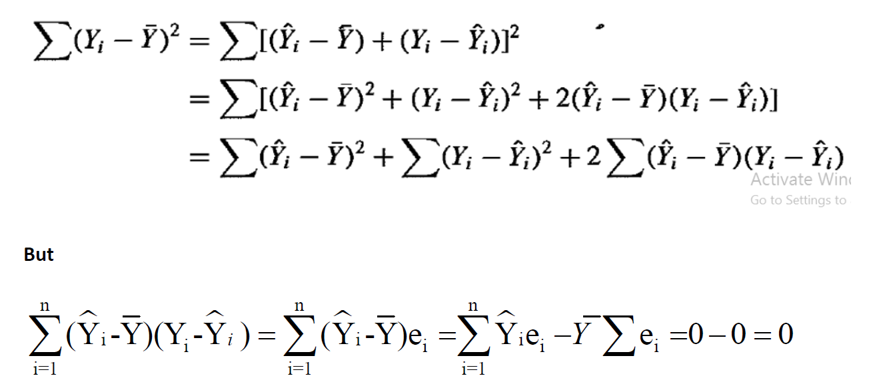
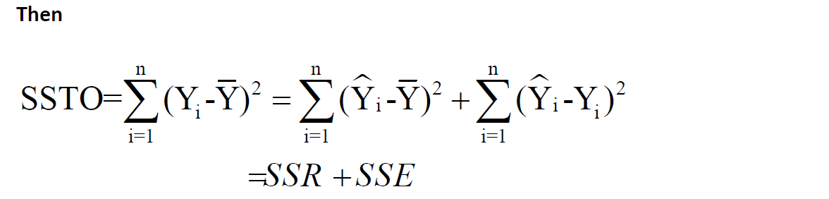

Question Two (12 Marks)
> X=c(3.4,1.8,4.6,2.3,3.1,5.5,0.7,3.0,2.6,4.3,2.1,1.1,6.1,4.8,3.8)
> X
[1] 3.4 1.8 4.6 2.3 3.1 5.5 0.7 3.0 2.6 4.3 2.1 1.1 6.1 4.8 3.8
> Y=c(26.2,17.8,31.3,23.1,27.5,36.0,14.1,22.3,19.6,31.3,24.0,17.3,43.2,36.4,26.1)
> Y
[1] 26.2 17.8 31.3 23.1 27.5 36.0 14.1 22.3 19.6 31.3 24.0 17.3 43.2 36.4 26.1
> model=lm(Y~X)
- Estimate the regression line and interpret the coefficients.
> lm(Y~X)
Call:
lm(formula = Y ~ X)
Coefficients:
(Intercept) X
10.278 4.919
The regression model is given by
$$\hat{Y}=10.278+{4.919 X}_{i}$$
${\hat{β}}_{0}$ => The mean response Y (the amount of fire damage) is equal 10.278 thousand SR at X (the distance between the residence and the nearest fire station) is zero. (The part of Y does not depend on X)
${\hat{β}}_{1}$ => The mean of response Y (the amount of fire damage) increases by 4.919 thousand SR when X (the distance between the residence and the nearest fire station) increases by one mile.
- Calculate the estimate of the standard deviation of fire damage for all homes the same distance from the fire station is (in SR1000)
> anova(model)
Analysis of Variance Table
Response: Y
Df Sum Sq Mean Sq F value Pr(>F)
X 1 841.77 841.77 156.89 1.248e-08 ***
Residuals 13 69.75 5.37
$$s=\sqrt{MSE}=\sqrt{5.37}=2.317326045$$
- Construct 90% confidence intervals for the model coefficients and explain the results.
> confint(model,level=0.9)
5 % 95 %
(Intercept) 7.762711 12.793146
X 4.223801 5.614861
$${4.223801≤β}_{1}≤5.614861$$
This means that when the distance between the residence increases by one mile, the damage increases from 4.22 to 5.6 thousand SR.
$${7.762711≤β}_{0}≤12.793146$$
This means there the amount of damage that does not depend on the residence distance is between 7.76 to 12.79 thousand SR.
- Test the linearity by using ANOVA.
Hypothesis: $H_{0}:β_{1}=0$ $H_{1}:β_{1}≠0$
F-statistic = $F_{0}=\frac{MSR}{MSE}=156.89$
> qf(0.95,1,13) [1] 4.667193
The critical value = $F_{α,1,13}=4.667193$
Since $F_{0}=156.89>4.667193$, we reject $H_{0}$, so the model in linear $\left(β_{1}≠0\right).$
- Find 95% confidence interval for the mean fire damage for all house 3.5 miles from the fire station is (in SR1000).
Confidence interval for ${E(Y}_{h})$
> newx=data.frame(X=3.5)
> predict (model,newx,level=0.95,interval="confidence")
fit lwr upr
1 27.49559 26.1901 28.80107
$${26.1901≤E(Y}_{h})≤28.80107$$
- Calculate the residual corresponding to the of the damage at the house of 5.5 miles (in SR1000).
This is the residual corresponding the value number 5 $e_{6}$ which X = 5.5 and Y = 36.0
> summary(model)$res
1 | 2 | 3 | 4 | 5 | 6 | 7
-0.80365 | -1.33272 | -1.60685 | 1.507611 | 1.972146 | -1.33425 | 0.37854
8 | 9 | 10 | 11 | 12 | 13 | 14
-2.73592 | -3.46819 | -0.13105 | 3.391477 | 1.610808 | 2.914154 | 2.509284
15
-2.87139
$$e_{6}=-1.33425$$

Question Three (10 Marks)

- Fit the model
> x=c(10,10,15,15,20,20,25,25,25,30,35,35)
> y=c(73,78,85,88,90,91,87,86,91,75,65,63)
>model=lm(y~x)
>summary(model)
Coefficients:
Estimate Std. Error t value Pr(>|t|)
(Intercept) 92.0025 7.7638 11.850 3.29e-07 ***
x -0.4982 0.3292 -1.514 0.161
$\hat{y_{i}}$=92.002-0.498$x_{i}$

- Test the linearity using t-test.
Test the hypothesis 𝐻0: 𝛽1=0. VS 0: 𝛽1$≠$0
>anova(model)
Response: y
Df Sum Sq Mean Sq F value Pr(>F)
x 1 204.27 204.273 2.2908 0.1611
Residuals 10 891.73 89.173
Since p-value=0.1611> 0.05
The decision: reject 𝐻1 and accept 𝐻0 (there is no linear relation between X and Y.

- Discuss the lack of fit test.

𝐻0: The regression function is linear (no lack of fit)
H1: The regression function is not linear (lack of fit)
> install.packages("olsrr")
>library(olsrr)
> ols_pure_error_anova(model)
Lack of Fit F Test
--------------
Response : y
Predictor: x

Analysis of Variance Table
----------------------------------------------------------------------
DF Sum Sq Mean Sq F Value Pr(>F)
----------------------------------------------------------------------
x 1 204.2734 204.2734 36.58628 0.0001238284
Residual 10 891.7266 89.17266
Lack of fit 4 858.2266 214.5566 38.42806 0.0002061043
Pure Error 6 33.50 5.583333
----------------------------------------------------------------------
Another package

>install.libraries("EnvStats")
>install.packages("EnvStats")
>library(EnvStats)
>anovaPE(model)
Df Sum Sq Mean Sq F value Pr(>F)
x 1 204.27 204.273 36.586 0.0009245 ***
Lack of Fit 4 858.23 214.557 38.428 0.0002061 ***
Pure Error 6 33.50 5.583
p-value = 0.0002061<0.05
We reject 𝐻0 (there is a lack of fit)
__________________
- A linear regression was run on a set of data. You are given only the following partial information from R:
Coefficients:
Estimate Std. Error t value
(Intercept) 293.89 5.62 52.294
X (1)-1.7069 0.13 -13.13
Analysis of Variance Table
Response: y
Df Sum Sq Mean Sq F value
X 1 7621.667 (2) $7621.667$ (4) 172.3969
Residuals 5 (3) 221.05 44.21

Complete the table as follows

(1) $T=\frac{{\hat{β}}_{1}}{{\hat{s(β}}_{1})}$ $-13.13=\frac{{\hat{β}}_{1}}{0.13}$ ${\hat{β}}_{1}=-13.13*0.13=-1.7069$
(2) $MSR=\frac{SSR}{df}=\frac{SSR}{1}=7621.667$
(3) $MSE=\frac{SSE}{5}==>44.21=\frac{SSE}{5}==>SSE=44.21*5=221.05$
(4) $F_{0}=\frac{MSR}{MSE}==>172.3969=\frac{MSR}{44.21}==>MSR=172.3969*44.21= =7621.667$
________________________________________________________
With My Best Wishes and Regards ..
Dr. Mahmoud Bakr

