

**King Saud University**

**Department of Mathematics**

**Third Trimester 1444 H**

**Midterm Exam**

**Actuarial Corporate Finance**

**ACTU 262, Duration:2 Hours**

|  |
| --- |
| **Name:**  **Sequence Number:**  **Section:**  **Date: 9/5/2023** |

***Note*: *The exam consists of 4 pages***

|  |  |
| --- | --- |
| **Question** | **Mark** |
| **Exercise 1 (MCQ)** | **10** |
| **Exercise 2** | **6** |
| **Exercise 3** | **4** |
| **Exercise 4** | **10** |
| **Total** | **30** |

**Exercise 1 (MCQ). [10]**

1. **Which one of the following terms is defined as the management of a firm's long-term investments?**
   * + 1. Working capital management.
       2. Financial allocation



* + - 1. Agency cost analysis.
      2. Capital budgeting.
      3. Capital structure

1. **A common-size balance sheet helps financial managers determine:**
   * + 1. which customers are paying on a timely basis.
       2. if costs are increasing faster or slower than sales.
       3. if changes are occurring in a firm's mix of assets.



* + - 1. if a firm is generating more or less sales per dollar of assets than in prior years.
      2. the rate at which the firm's dividends are changing.

1. **Which of the following individuals have unlimited liability based on their ownership interest?**
   * + 1. General Partner
       2. Sole proprietor



* + - 1. Stockholder.
      2. Limited partner.

1. **Which one of the following will increase the profit margin of a firm, all else constant?**
   * + 1. Increase in interest paid.
       2. Increase in fixed costs.
       3. Increase in depreciation expense.



* + - 1. Decrease in the tax rate.
      2. Decrease in sales.

1. **Firm A has a Return on Equity equal to 24%, while firm B has a ROE of 15% during the same year. Both firms have a total debt ratio equal to 0.8. Firm A has an asset turnover ratio of 0.9, while firm B has an asset turnover ratio equal to 0.4. From this we know that**
   * + 1. Firm A has a higher profit margin than firm B
       2. Firm B has a higher profit margin than firm A



* + - 1. Firm A and B have the same profit margin
      2. Firm A has a higher equity multiplier than firm B

1. **An increase in which one of the following accounts increases a firm’s current ratio without affecting its quick ratio?**
   * + 1. Account payable
       2. cash



* + - 1. Account receivable
      2. inventory

1. **DJ, Inc., has net working capital of $3,810, current liabilities of $5,600, and inventory of $4,840. Current ratio is:**
2. 1.98 times



1. 1.77 times
2. 1.68 times
3. 1.86 times
4. **A firm has a current ratio of 1.4 and a quick ratio of 0.9. Given this, you know for certain that the firm:**
   * + 1. pays cash for its inventory
       2. has more than half its current assets invested in inventory.



* + - 1. has more cash than inventory.
      2. has more current liabilities than it does current assets.
      3. has positive net working capital.

1. **Which one of the following best indicates a firm is utilizing its assets more efficiently than it has in the past?**
2. Decrease in the capital intensity ratio
3. Increase in days' sales in receivables



1. Decrease in the profit margin
2. Decrease in the inventory turnover rate
3. **Which one of the following is the maximum growth rate that a firm can achieve without any additional external financing?**
4. DuPont rate
5. External growth rate



1. Sustainable growth rate
2. Internal growth rate
3. Cash flow rate

**Exercise 2. [6]**

Cusic industries had the following operating results for 2019:

Sales=$24,360: cost of goods sold=$17,600; depreciation expense=$3,400; interest expense=$860; dividends paid=$790. At the beginning of the year, net fixed assets were $18,650, current assets were $5,560, and current Liabilities were $3,040. At the end of the year, net fixed assets were $21,180, current assets were $6,410, and current liabilities were $3,445. The tax rate was 21 percent.

1. What is the net income for 2019?
2. What is the operating cash flow for 2019?
3. What is the cash flow from assets for 2019? Is this possible? Explain.
4. If no new debt was issued during the year. What is the cash flow to creditors? What is the cash flow to stockholders? Explain and interpret the positive and negative signs of your answer in (i) through (iv).

Answer:

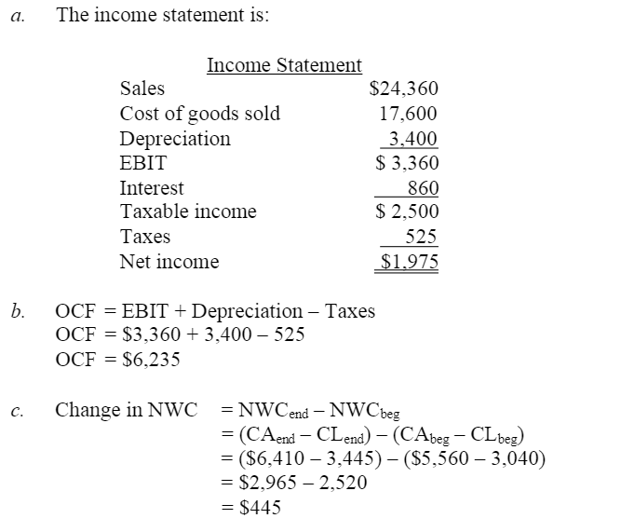



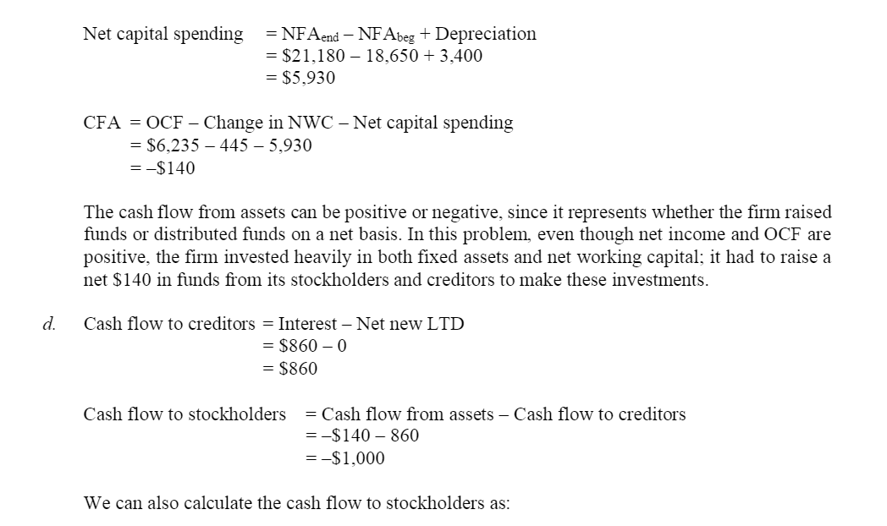



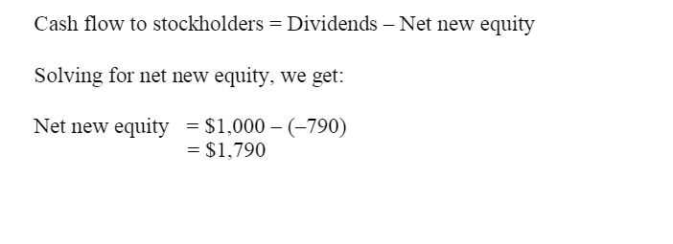

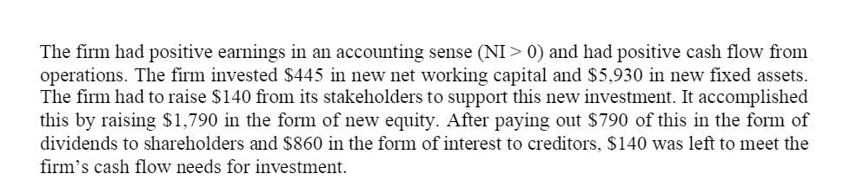

**Exercise 3 [4]**

Just Dew It Corporation reports the following balance sheet information for 2008 and 2009.

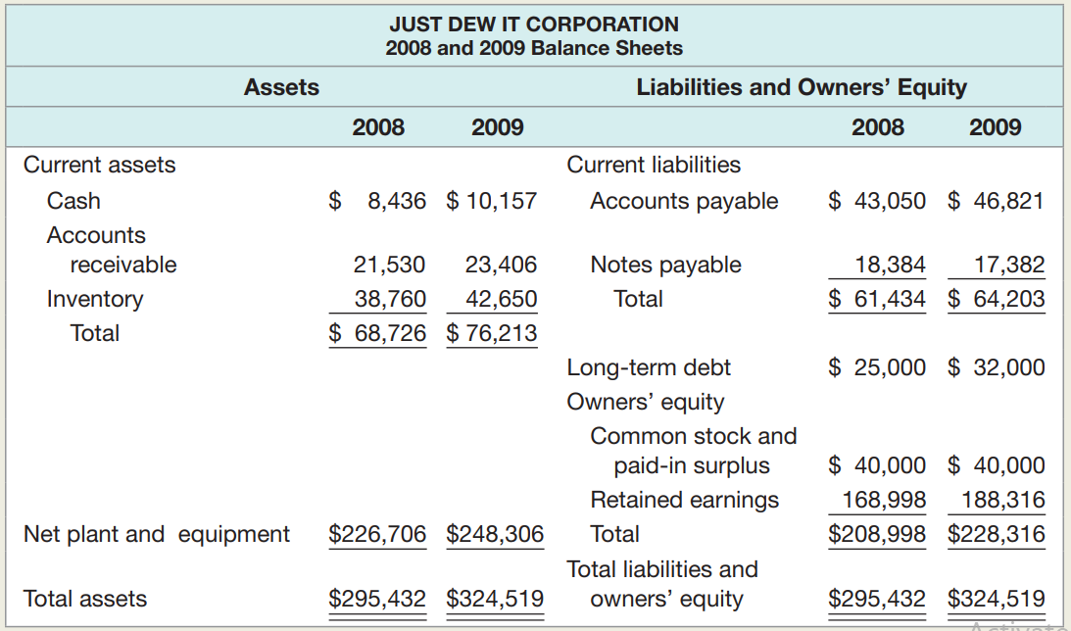

Based on the balance sheets given for Just Dew It, calculate the following

financial ratios for each year:

1. Quick ratio

Quick ratio 2008= 48.7 %



Quick ratio 2009= 52.27%

1. Cash ratio.

Cash ratio 2008= 13.73%

Cash ratio 2009=15.82%



1. NWC to total assets ratio.

NWC to total assets ratio 2008= NWC/ total asset = 0.02times

NWC to total assets ratio 2009= NWC/ total asset =0.037 times



1. Debt–equity ratio and equity multiplier.



Equity multiplier= Assets/Total equity

Debt–equity ratio 2008= 0.11



equity multiplier 2008= 1.41

Debt–equity ratio 2009=0..14

equity multiplier 2009=1.42

**Exercise 4. [10]**

The most recent financial statements for Scott, Inc., appear below sales for 2020 are projected to grow by 20 percent. Interest expense will remain constant: the tax rate and the dividend payout rate also will remain constant. Costs, other expenses, current assets, fixed assets, and accounts payable increase spontaneously with sales.

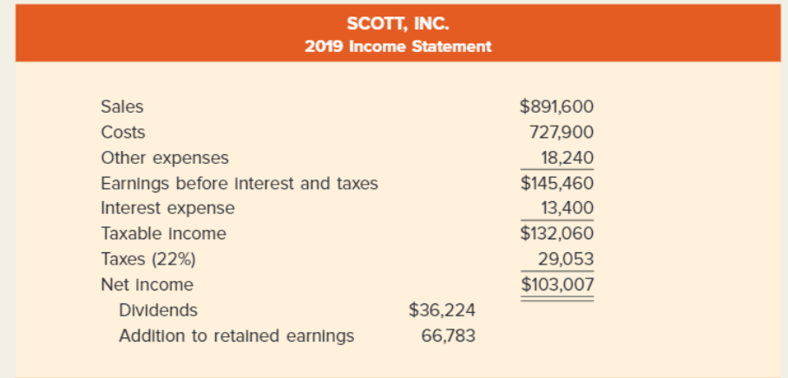

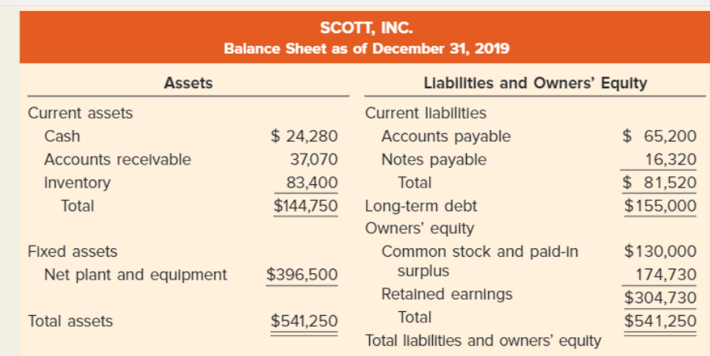

1. Suppose that the firm is operating at full capacity and no new debt or equity is issued, what EFN is needed to support the 20 percent growth rate in sales?
2. Suppose that the firm is operating at 80% full capacity and no new debt or equity is issued, what EFN is needed to support the 20 percent growth rate in sales?
3. Suppose the firm wishes to keep its debt-equity ratio constant. What is EFN now?

Answer:

a)

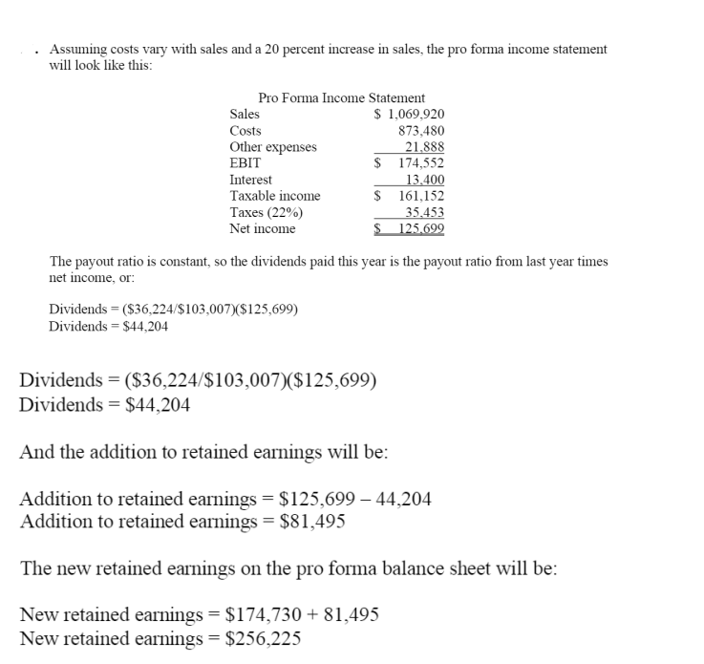



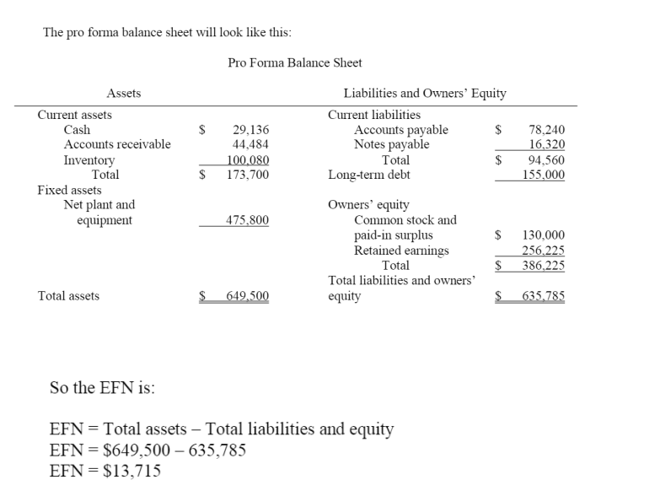



b)

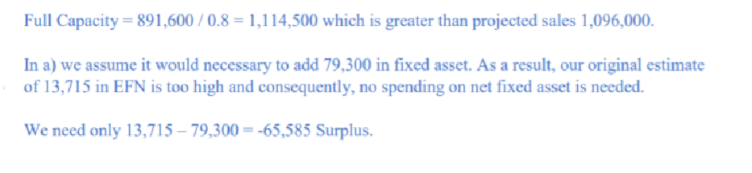



c)

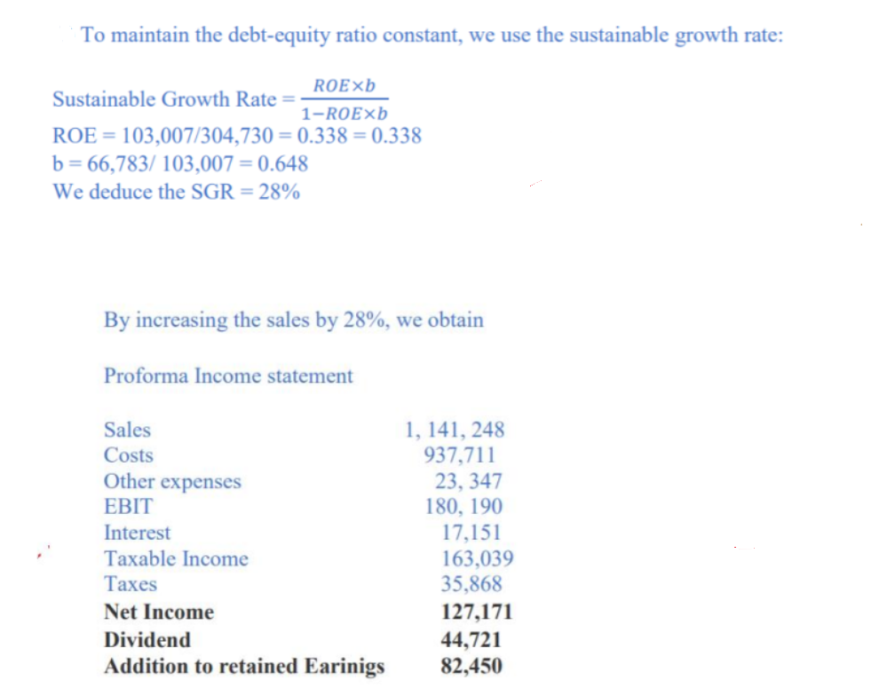





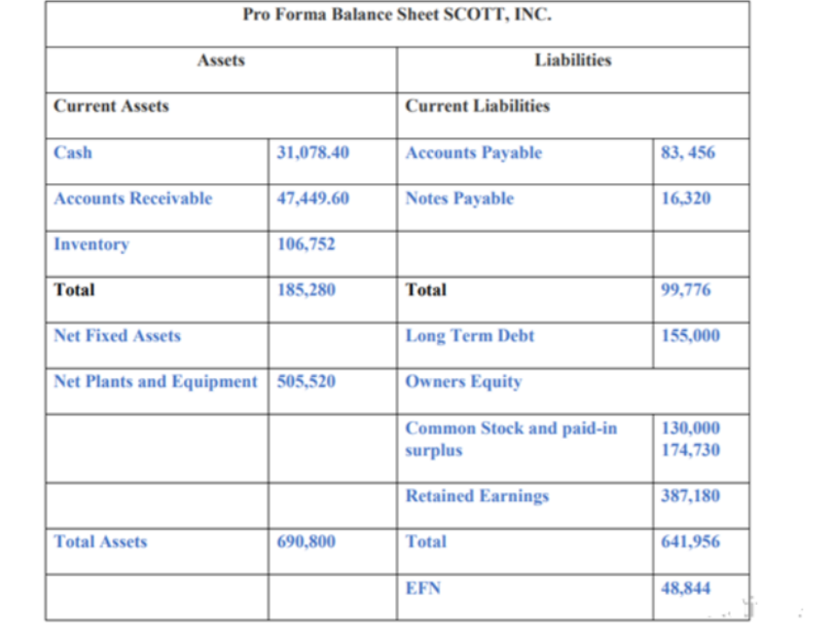



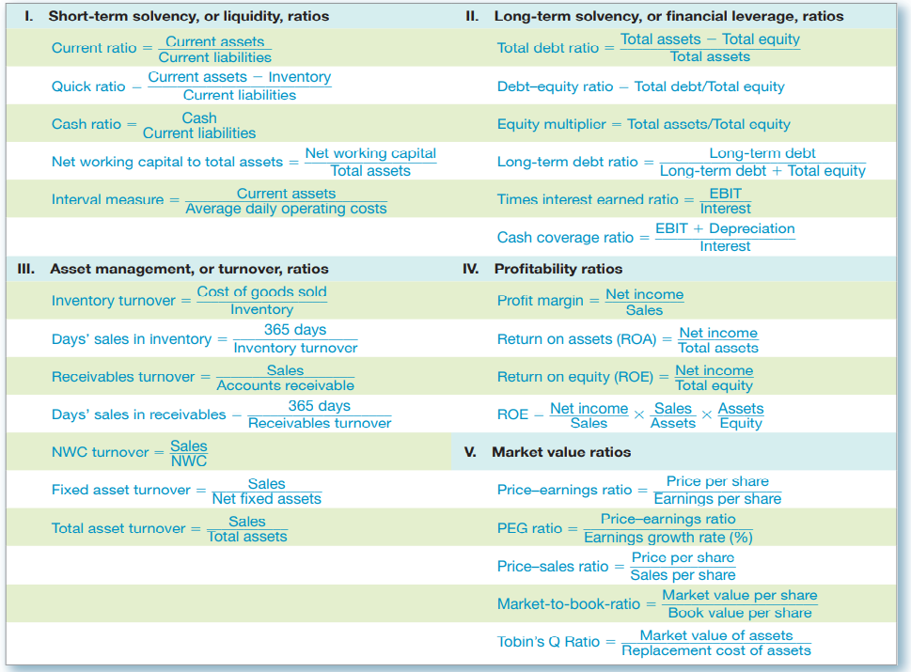

attractiven