**Practice Problems**

**Question 1**

1. State the **dimensions** in the MLt system for each of:

pressure, mass flow rate, and kinematic viscosity.

1. The specific weight γ of a liquid is 12400 N/m3. What mass of the liquid is contained in a volume of 500 cm3?
2. A gage pressure of 52.3 kPa is read on a gage. Find the absolute pressure at sea level where the atmospheric pressure is 100.3 kPa
3. A flow is described by velocity field given by

**V** = ay **i** + b x **j** + 0 **k** m/s

where a = 4 s-1, b = 2 s-1 and coordinates are given in meters.

i. Is the flow One-, Two-, or Three-dimensional? Why?

ii. Is the flow is steady or unsteady? Why?

iii. Find the equation of the stream-line that passes through point (0, 4 m, 0)

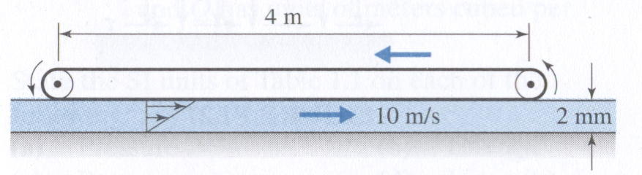**Question 2**

A 60-cm-wide belt moves on the top of water film as shown. The linear velocity of the belt is 10 m/s. The water film thickness is 2 mm. The velocity profile of water is linear. The dynamic viscosity µ of water is 0.001 kg/m s. Find

1. The shear stress τ on surface of the lower belt $τ=μ\frac{du}{dy}=0.001×\frac{4-0}{0.002}=2 Pa$
2. The shear force on surface of the lower belt. $F=τA=2×0.6×4=4.8 N$
3. The required power in kW in order to overcome

the resistance of water. $P=FV=4.8×4=17.2 W$

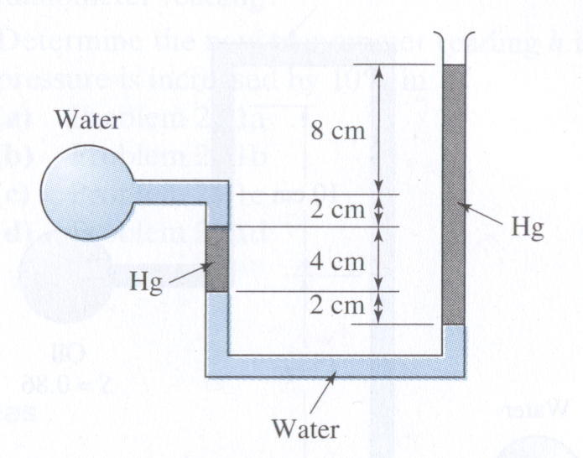**Question 3**

What is the gage pressure in the shown circular water reservoir?

SGHg =13.6

$$P_{w_{gage}}+ρ_{w}g×\left(0.02+0.02\right)+ρ_{Hg}g×0.04=ρ_{Hg}g×0.16$$

$$P_{w_{gage}}=ρ_{Hg}g×0.12-ρ_{w}g×0.04=13600×9.8×0.12-1000×9.8×0.04=15.602 kPa$$

**Question 4**

* 1. State three basic laws that are used in the study of the fluid mechanics.
  2. Express the dimensions of the following quantities in MLt system and the S.I units of:

1. Volume
2. Specific weight
3. Kinematic viscosity
4. Stress

**Question 5**

For the setup shown, calculate the trapped air pressure in the compartment at the top left corner.



The pressure difference is obtained from repeated application of Eq. 3.7, or in other words, from Eq. 3.8. Starting

from the right air chamber

pgage = SGHg × ρH2O × g × (3 ⋅ m − 2.9 ⋅ m) − ρH2O × g × 1 ⋅ m

pgage = ρH2O × g × (SGHg × 0.1 ⋅ m − 1.0 ⋅ m)= 3.48⋅kPa

**Question 6**

The velocity field is given by

$$\vec{V} = -\frac{My}{2π} \hat{i}+\frac{Mx}{2π} \hat{j} m/s$$

Where x and y are in meters.

1. Is the flow steady or unsteady? Why?
2. Is the flow 1-D, 2-D, 3-D, or uniform?, and
3. Find the equation of the streamline passing through point (2,-1).

Question 4



A concentric cylinder viscometer may be formed by rotating the inner member of a pair of closely fitting cylinders. The annular gap is small so that a linear velocity profile will exist in the liquid sample. Consider a viscometer with an inner cylinder of 100 mm diameter and 200 mm height, and a clearance gap width of 0.0254 mm filled with castor oil. Determine the torque required to turn the inner cylinder at 400 rpm. $μ_{oil}=0.38\frac{N.s}{m^{2}}$, Torque=FxR

$$V=ωR=\frac{400rpm}{60}×2×π×0.1=4.19 m/s$$

$$τ_{inner cylinder}=μ_{oil}\frac{dV}{dr}=0.38×\frac{V-0}{a}=0.38×\frac{4.19}{0.0254}=62.7 Pa$$

Force $F=τ×2×pi×R×h=7.9N$

Torque $T=F×R=7.9×.1=0.79 N.m$

Question 7

|  |  |
| --- | --- |
|  |  |







|  |  |
| --- | --- |
| Water flows steadily past a porous flat plate. Constant suction is applied along the porous section. The velocity profile at section *cd* is, $$\frac{u}{U_{∞}}=3\left[\frac{y}{δ}\right]-2{\left[\frac{y}{δ}\right]}^{3/2}$$ Evaluate the mass flow rate across section *bc*. |  |

${\dot{m}}_{bc}=1.42 kg/s$ out of the control volume