**Practice Problems**

**Question 1**

1. State the **dimensions** in the MLt system for each of:

pressure, mass flow rate, and kinematic viscosity.

1. The specific weight γ of a liquid is 12400 N/m3. What mass of the liquid is contained in a volume of 500 cm3?
2. A gage pressure of 52.3 kPa is read on a gage. Find the absolute pressure at sea level where the atmospheric pressure is 100.3 kPa
3. A flow is described by velocity field given by

**V** = ay **i** + b x **j** + 0 **k** m/s

where a = 4 s-1, b = 2 s-1 and coordinates are given in meters.

i. Is the flow One-, Two-, or Three-dimensional? Why?

ii. Is the flow is steady or unsteady? Why?

iii. Find the equation of the stream-line that passes through point (0, 4 m, 0)

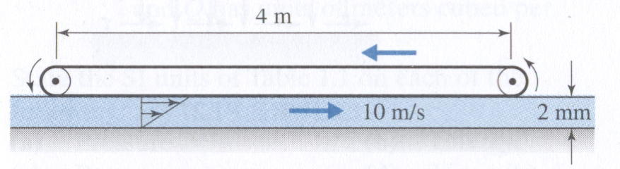**Question 2**

A 60-cm-wide belt moves on the top of water film as shown. The linear velocity of the belt is 10 m/s. The water film thickness is 2 mm. The velocity profile of water is linear. The dynamic viscosity µ of water is 0.001 kg/m s. Find

1. The shear stress τ on surface of the lower belt
2. The shear force on surface of the lower belt.
3. The required power in kW in order to overcome

the resistance of water.

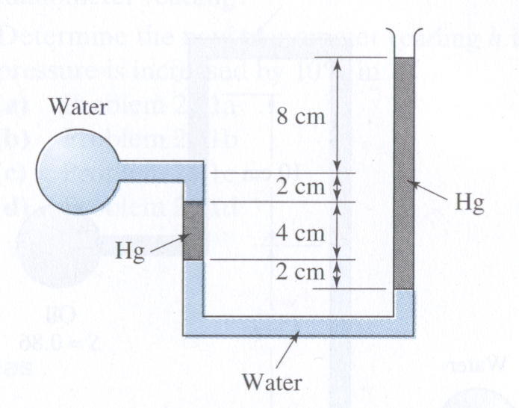

**Question 3**

What is the gage pressure in the shown circular water reservoir?

SGHg =13.6

**Question 4**

* 1. State three basic laws that are used in the study of the fluid mechanics.
  2. Express the dimensions of the following quantities in MLt system and the S.I units of:

1. Volume
2. Specific weight
3. Kinematic viscosity
4. Stress

**Question 5**

For the setup shown, calculate the trapped air pressure in the compartment at the top left corner.



**Question 6**

The velocity field is given by

$$\vec{V} = -\frac{My}{2π} \hat{i}+\frac{Mx}{2π} \hat{j} m/s$$

Where x and y are in meters.

1. Is the flow steady or unsteady? Why?
2. Is the flow 1-D, 2-D, 3-D, or uniform?, and
3. Find the equation of the streamline passing through point (2,-1).

Question 4



A concentric cylinder viscometer may be formed by rotating the inner member of a pair of closely fitting cylinders. The annular gap is small so that a linear velocity profile will exist in the liquid sample. Consider a viscometer with an inner cylinder of 100 mm diameter and 200 mm height, and a clearance gap width of 0.0254 mm filled with castor oil. Determine the torque required to turn the inner cylinder at 400 rpm. $μ_{oil}=0.38\frac{N.s}{m^{2}}$, Torque=FxR

Question 7

|  |  |
| --- | --- |
|  |  |





|  |  |
| --- | --- |
| Water flows steadily past a porous flat plate. Constant suction is applied along the porous section. The velocity profile at section *cd* is, $$\frac{u}{U_{∞}}=3\left[\frac{y}{δ}\right]-2{\left[\frac{y}{δ}\right]}^{3/2}$$ Evaluate the mass flow rate across section *bc*. |  |