King Saud University Mech. Eng. Department  College of Engineering | Second Semester (1433-1434 H)  Fluid Mechanics ME 383  Final Exam  Time allowed is 3 hrs.

Please answer ANY SIX questions.

Question 1
At $20℃$gage A reads $350 kPa$ absolute. What is the height h of the water in cm? What should gage B read in kPa absolute? | 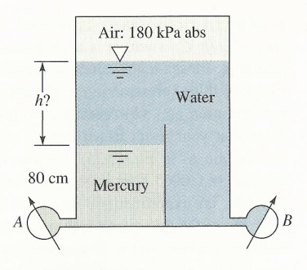  Figure 1, Question 1
Question 2
A stream of water from a 50 mm diameter nozzle strikes a curved vane, as shown in Figure 2. A stagnation tube connected to a mercury-filled U-tube manometer is located in the nozzle exit plane. Calculate the speed of the water leaving the nozzle. Estimate the horizontal component of force exerted on the vane by the jet. | 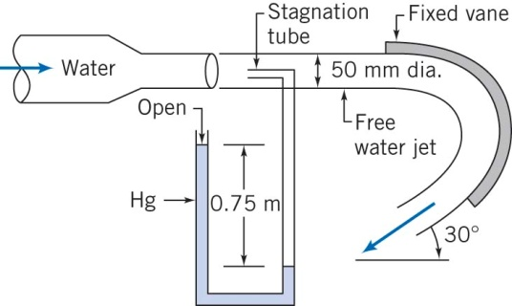  Figure 2, Question 2
Question 3
Consider the flow field given by
$$u=2V\left(\frac{x}{L}-\frac{y}{L}\right), v=-2V\frac{y}{L}$$
where $V = 10 m∙s^{-1}, L = 1 m$, and the coordinates are measured in meters.
- Does this velocity field represent incompressible flow? Why?
- Find the stream function that will yield this velocity field.
- Is the flow field rotational or irrotational and why?
- Is the flow field 1-D, or 2-D and why?

Question 4
The pressure head for a centrifugal pump $h$ depends on: the pump discharge $Q$, the impeller diameter $D$, rotational velocity $ω$, the density $ρ$ and viscosity $μ$ of the fluid. Using dimensional analysis, show that:

$$h/{ω^{2}D^{2}}=f\left(Q/{ωD^{3}, }{ρVD}/μ\right)$$

A pump is designed to deliver $1 L^{3}/s$ of water with pressure head of $H=\frac{h}{g}=3 m$ at $750 rpm$. The pump diameter is $0.3m$. A half-size scale model is to be built and tested. If the scaled pump is to operate at the same condition, what should the pump speed be and what is the scaled pump discharge if the scaled pump pressure head is $1m$? Ignore Reynolds number effects

Question 5
In Figure 3 both fluids are at $20 ℃$ . If $V_{1}=1.7 ft/s$ and losses are neglected, what should the manometer reading $h$be in $ft$? | 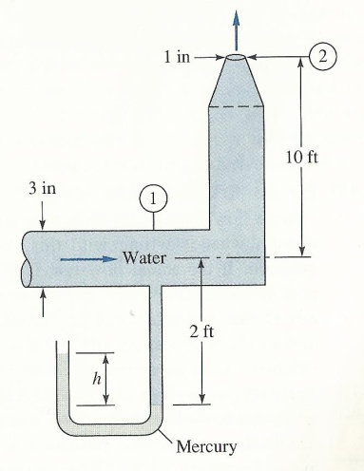  Figure 3, Question 5
Question 6
A pump supplies water to a tank through the shown piping system in Figure 4. The piping from B to C consists of a square edged entrance, $760 m$ of pipe, three gate valves, four $45°$ elbows and two $90°$ elbows. Gage pressure at C is $197 kPa$. The system from F to G contains $760 m$ of pipe, two gate valves and four $90°$ elbows. All piping is $508 mm$ diameter cast iron.  Calculate the following,  - Average velocity of water in the pipe  - The gage pressure at F  - The power input to the pump if its efficiency is $80\%$. | 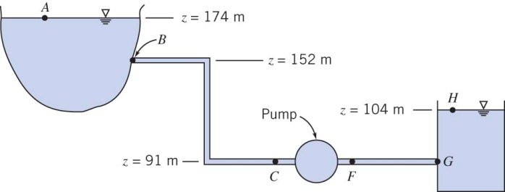  Figure 4, Question 6

Question 7

- Sketch the boundary layer over a flat plate showing the laminar, transitional and turbulent regimes. Sketch the velocity distribution in both laminar and turbulent boundary layers on the same graph in the form u/U= f (y/δ) with u/U along the horizontal.

- For the shown flow over a flat plate calculate the drag coefficient assuming the velocity profile at the plate trailing edge is linear and the boundary layer thickness, $δ$ is $25 mm$. The free stream speed is $3 m/s$ and the fluid density is $800 kg/m^{3}$. The plate is $3 m$ long and $1 m$ wide. Assume two-dimensional flow.
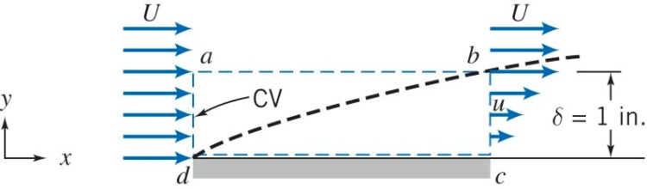
Figure 5, Flow over flat plate. Question 7.
Useful Equations:

$$\frac{∂ρ}{∂t}+∇∙\left(ρ\vec{V}\right)=0$$
$$\frac{∂\vec{V}}{∂t}+\left(\vec{V}∙∇\right)\vec{V}=-\frac{∇p}{ρ}+ν∇^{2}\vec{V}$$
$$\frac{D}{Dt}\left(\right)=\frac{∂}{∂t}\left(\right)+\vec{V}∙∇\left(\right)$$
$$\frac{p_{1}}{ρ}+\frac{{\overline{V}}_{1}^{2}}{2}+gz_{1}=\frac{p_{2}}{ρ}+\frac{{\overline{V}}_{2}^{2}}{2}+gz_{2}+h_{l_{T}}-\frac{\dot{W}}{ρQ}$$
$$h_{l}=f\frac{L}{D}\frac{{\overline{V}}^{2}}{2}$$
$$δ^{*}=\int_{0}^{∞}{\left(1-\frac{u}{U}\right)dy}$$
$$θ=\int_{0}^{∞}{\frac{u}{U}\left(1-\frac{u}{U}\right)dy}$$

Table 1, Representative dimensionless equivalent lengths $(L_{e}/D)$ for valves and fittings.
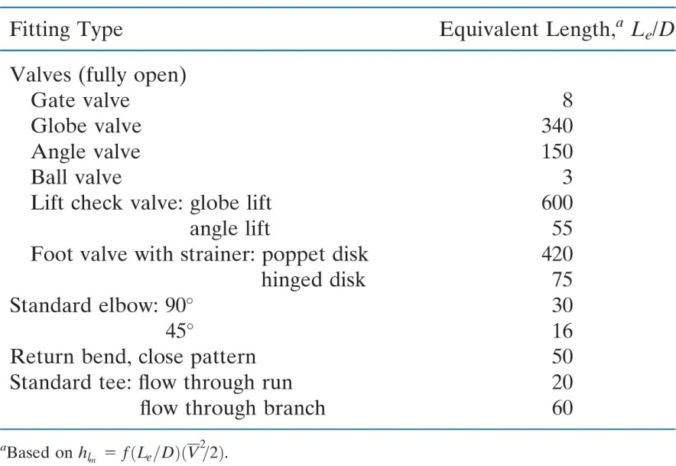

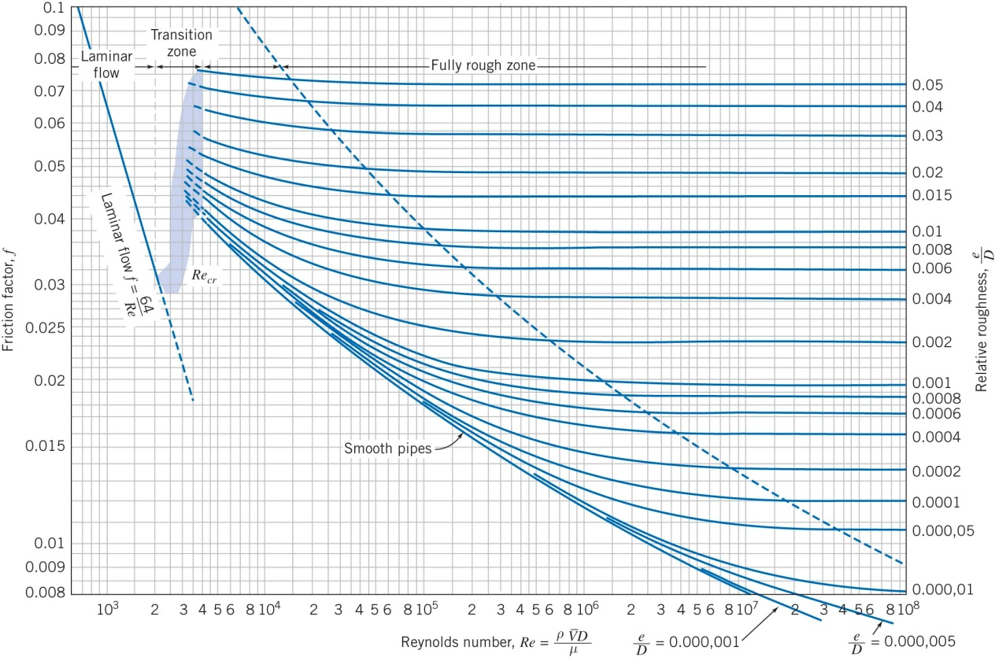
Figure 6, Moody Chart, Fox and McDonald, Eighth Edition, Wiley

