Math 240-Syllabus
Text book: Elementary Linear Algebra with Supplemental Applications, 11th Edition By Howard Anton and Chris Rorres

Chapter 1
1.1 Introduction to Systems of Linear Equations
1.2 Gaussian Elimination
1.3 Matrices and Matrix Operations
1.4 Inverses and Algebraic Properties of Matrices
1.5 Elementary Matrices and a Method for Finding 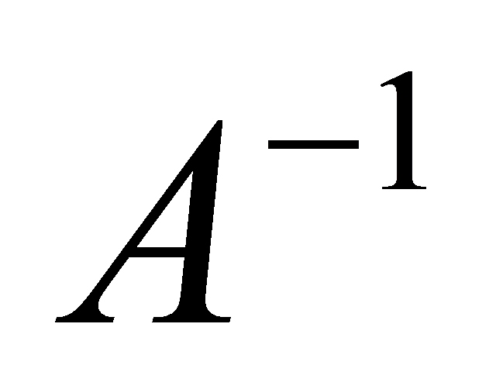
1.6 More on Linear Systems and Invertible Matrices
1.7 Diagonal, Triangular and Symmetric Matrices
1.8 Matrix Transformations ( From Definition 1 to the end of Example 1 and from Page 80 " A Procedure for Finding Standard Matrices" to the end of Example 4)

Chapter 2
2.1 Determinants by Cofactor Expansion
2.2 Evaluating Determinants by Row Reduction
2.3 Properties of the Determinants and Cramer's Rule

Chapter 3
Pages 169, 170
Chapter 4
4.1 Real Vector Spaces (Exercise 11 is solved in the lecture)
4.2 Subspaces (All except Example 12)
4.3 Linear Independence
4.4 Coordinates and Basis (From Definition 1)
4.5 Dimension (Exercise 7 (d) is solved in the lecture)
4.6 Change of Basis
4.7 Row Space, Column Space and Null space
4.8 Rank, Nullity and the Fundamental Matrix Spaces (The concept of orthogonal complement is NOT included)

Chapter 5
5.1 Eigenvalues and Eigenvectors
5.2 Diagonalization

Chapter 6
6.1 Inner Products (An Application of Weighted Inner Product on Page 347, Example 3, Example 8, Example 9, Example 10 and Example 11 are NOT included)
6.2 Angle of Orthogonality in Inner Product Spaces (From " Orthogonal Complements" on Page 359 to the end of the section is NOT included)
6.3 Gram-Schmidt Process; QR- Decomposition (From " Coordinates Relative to Orthonormal Bases" on Pages 366-369 are NOT included)

Chapter 8
8.1 General Linear Transformations (Examples 9, 17, 18 and 19 are NOT included)
8.4 Matrices for General Linear Transformations (Theorem 8.4.1 and Example 6 are NOT included)

