Suggestions for Mid2-106 by Waleed Lazkani 10/11/2019

**1** 

**2** 

**3** 

**4** Area:

**5** 

**Solutions**

1) 

2) 







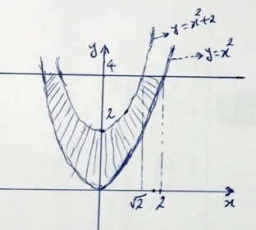**3)** 

4) Area **=** 