LabWork#9

Q#1 Design of a 3-bit ripple binary counter.

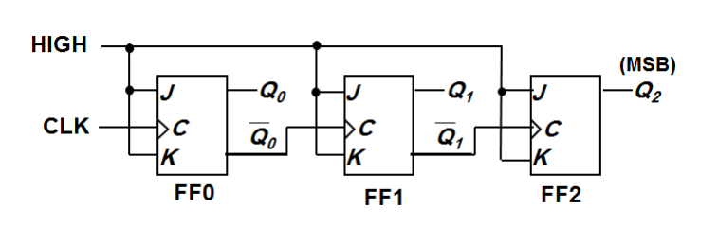

Q2. Design Asynchronous MOD-10 counter known as decade counter or BCD counter.

