* 1. **Flow Development in Pipes**

**PROPOSED OBJECTIVES:**

1. Draw the velocity profiles of fully-developed flows using a pitot-tube for different flow rate. Test the validity of the power-law exponent relationship

n=-1.7+1.8Log ReU

1. Measure the pressure, its drop and its gradients along a pipe entrance region for different flow-rates and determine the entrance length.
2. Measure air volumetric flow rate using a nozzle obstruction and compare from velocity profile measurement. Estimate K from measured velocity profile.
3. Estimate the friction factor from pressure loss measurements and compare with values obtained from Moody chart at different Reynolds number.

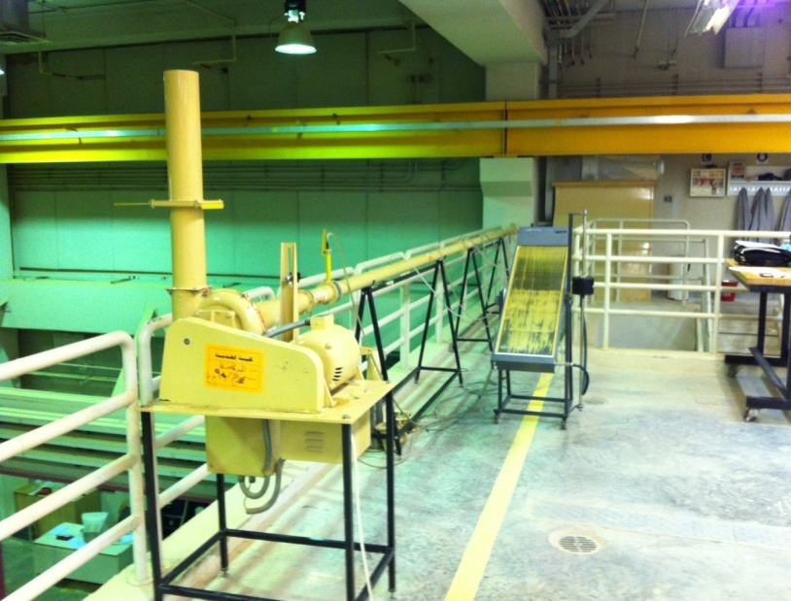

**Blanking Plate**

Figure 1: Experimental Apparatus

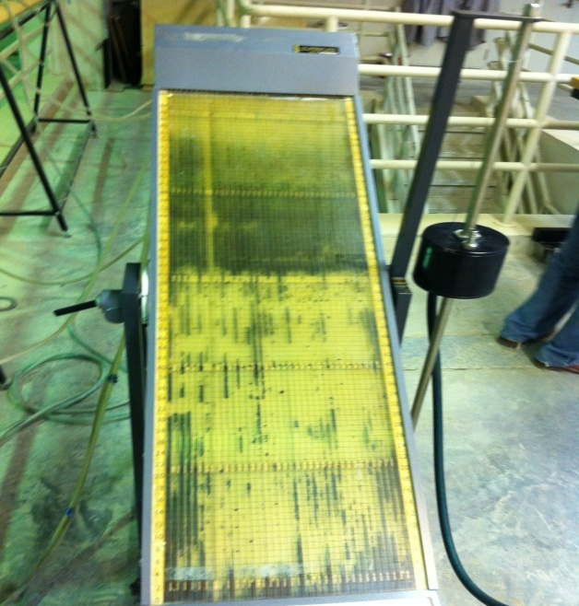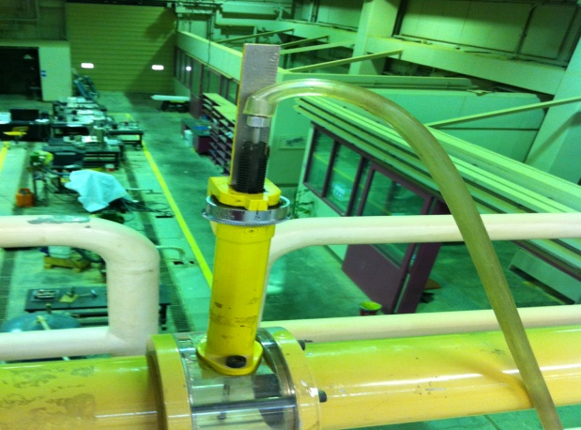

Figures 2 and 3: Inclined Manometer and Pitot-Tube Mechanisms

Nozzle Meter

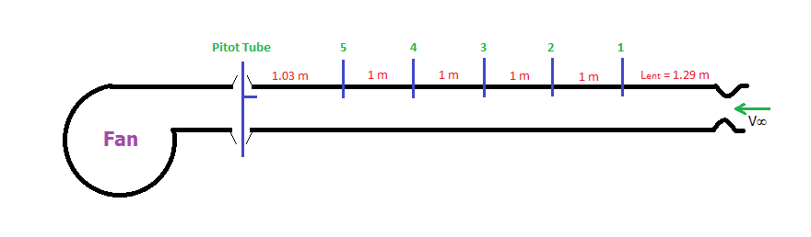

Figures 4: Device Locations and Pipe Lengths along the Pipe

**BACKGROUND:**

The movement of a flow along a surface nearly always generates a wall boundary layer. This area is where the flow speeds changes from that similar to that of the bounding wall (usually zero) near the wall to 99% of the free stream velocity for the flow at the pipe centre. It is this boundary layer that controls the flows’ change in direction, thermal convection levels and to some extent the drag (friction) created.

Figure 5 shows that the flow entering a pipe passes through rapid changes leading to a “fully-developed” profile at some distance along the pipe. While some estimate this distance to be 20-50 times the pipe diameter, others give even longer lengths for this purpose. The boundary layer is the place where high longitudinal pressure gradients and near wall thermal convection usually take place before any consistent velocity profiles are created.



Figure 5: Developing Velocity Profiles and Pressure Changes inside a Pipe



Figure 6: Developing Velocity Profiles and Pressure Changes inside a Pipe

Figure 6 shows that the flow profile inside a pipe can be laminar or turbulent depending on the average Reynolds number (ReD).

1800 > Re > 0: Laminar Flow

2300 > Re >1800: Transition Flow

∞ > Re > 2300: Turbulent Flow

Where;

ReD=



**CALCULATIONS:**

**PITOT-TUBE (Velocity Profile Measurement):**

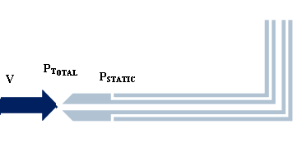Figure 7 shows a pitot-tube air velocity measuring device. This device has two pressure tapings that measure the total and static pressures. The pressure difference between these pressure gives the dynamic pressure which according to Bernoulli equation gives:

Eqn. 4

Figure 7: Typical Pitot-Tube Arrangement



**NOZZLE METER (Flow Rate Measurement):**

$Q=K\frac{π}{4}D_{N}^{2}\sqrt{\frac{Δp}{ρ_{air}}}$ Eqn. 5

DN= 0.05 m, K=0.985, Eqn. 6



Eqn. 7



Where Q is in m3/s, Ha is in (mm Hg) and hN is in (mm H2O).

Table 1: Observations Table

|  |  |  |
| --- | --- | --- |
| Inclined Manometer Angle (θ) | (º) |  |
| Static Pressure at Nozzle Outlet | cm H2O |  |
| Static Pressure at Man. 1 | cm H2O |  |
| Static Pressure at Man. 2 | cm H2O |  |
| Static Pressure at Man. 3 | cm H2O |  |
| Static Pressure at Man. 4 | cm H2O |  |
| Static Pressure at Man. 5 | cm H2O |  |
| Volumetric Flowrate at Start (1) | m3/s |  |
| Volumetric Flowrate at Start (2) | m3/s |  |
| Diameter (mm) | mm | **76.03** |
| Dynamic Viscosity | kg/m s (x 10-5) |  |
| Pipe Cross-Sectional Area (A) | m2 |  |
| Pipe Average Velocity 1 | m/s |  |
| Pipe Average Velocity 2 | m/s |  |
|  |  |  |

Table 2: Pitot-Tube Measurements Along Pipe Diameter

|  |  |  |
| --- | --- | --- |
| **Y: Normal Distance From Wall** | **Total Pressure** | **Static Pressure** |
| mm | cm H2O | cm H2O |
|  |  |  |
|  |  |  |
|  |  |  |
|  |  |  |
|  |  |  |
|  |  |  |
|  |  |  |
|  |  |  |
|  |  |  |
|  |  |  |
|  |  |  |
|  |  |  |
|  |  |  |
|  |  |  |
|  |  |  |
|  |  |  |
|  |  |  |
|  |  |  |
|  |  |  |
|  |  |  |
|  |  |  |
|  |  |  |
|  |  |  |
|  |  |  |
|  |  |  |
|  |  |  |
|  |  |  |
|  |  |  |
|  |  |  |
|  |  |  |
|  |  |  |
|  |  |  |
|  |  |  |
|  |  |  |
|  |  |  |
|  |  |  |
|  |  |  |
|  |  |  |
|  |  |  |
|  |  |  |
|  |  |  |
|  |  |  |
|  |  |  |
|  |  |  |
|  |  |  |
|  |  |  |
|  |  |  |
|  |  |  |