Experiment 5
Measurement of Thermal Conductivity

a. Objective
The objectives of this experiment are:
1. To evaluate the thermal conductivity of copper experimentally.
2. To use the conductivity value to determine the conduction through constant and variable area copper bars.

b. Introduction
When a temperature gradient exists in a stationary medium, which may be a solid or a fluid, we use the term conduction to refer to the heat transfer that will occur across the medium. The physical mechanism of conduction involves concepts of atomic and molecular activity, which sustains the transfer of energy from the more energetic to the less energetic particles of a substance due to interactions between the particles. Consider a gas occupying the space between two surfaces maintained at different temperatures and assume that there is no bulk motion. We associate the temperature at any point with the energy of the gas molecule. This energy is related to the random translational motion, as well as to the internal rotational and vibration motions of the molecules.
Higher temperatures are associated with higher molecular energies, and when neighboring molecules collide, as they are constantly doing, a transfer of energy from the more energetic to the less energetic molecules must occur. In the presence of a temperature gradient, energy transfer by conduction must then occur in the direction of decreasing temperature. We may speak of the net transfer of energy by this molecular motion as a diffusion of energy. The situation is much the same in liquids, although the molecules are more closely spaced and the molecular interactions are stronger and more frequent. In a solid, conduction is attributed to atomic activity in the form of lattice vibrations and electron migration. We treat the conduction phenomena by Fourier’s law, which is defined in terms of an important material property, defined as thermal conductivity.
It is important to emphasize that the origin of Fourier’s law is phenomenological. That is, it is developed from observed phenomena - the generalization of extensive experimental evidence rather than being derived from first principles. Mathematically, it is defined as
$q=kA\frac{∂T}{∂x}$ 1
c. Equipment
The objectives of this experiment are achieved through the use of Thermal Conduction System. The system consists of two hot plate type heat sources copper bars and 10 thermocouple junctions on each bar. Unit 3 has a tapered bar and Unit 4 has a cylindrical bar as indicated in the figure.
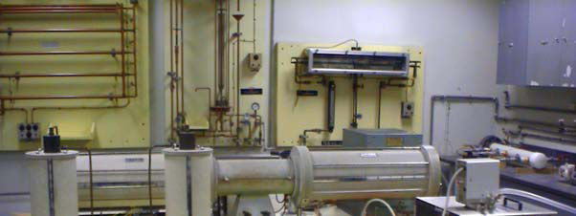
It should be noted that these units provide vertical heat flux paths. Referring to figure, the one at the left is a cylindrical bar while the one at the right is a tapered bar. Each bar is in contact at its lower end with its own hot plate. Contact for the tapered bar is at the smaller end. The maximum electrical input through the plate is 750 Watts. The surface temperature can be modulated between 5 oF above the room temperature to 400 oF. A metal plate attached to the actual heater plate functions as a heat source, concentrating the heat flux concentrically into the test bar. Both bars are of the same diameter at the upper end and in contact with a non-immersion type fluid-cooled heat sink. Instrumentation and control of coolant flow through these heat sinks is provided to monitor and control the heat flow rates through the bars.

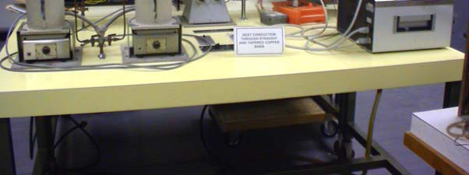
Figure 1, Themral conductivity measurement setup

d. Pre-Lab
List some metals in the order of their thermal conductivity
What are the methods available for temperature measurement?
What is Fourier’s Law of heat conduction?

e. Operating Instructions and Procedure
It is important to recognize that in the tapered bar, the heat flux is not constant along it. In
fact, it is the heat transfer rate that remains constant, while the flux increases with the
decrease of cross-sectional area. The temperature distribution through the bar can be calculated 6by using Equation 8.1 in the limiting condition; i.e.,
when Δx→0 .
The following experimental procedure should be followed while conducting this
experiment:
• Establish constant and steady cooling water flow of about 400 mL/min
• Turn on heaters to Units 3 and 4 - set each one to 500 W. Allow the system to
reach steady-state conditions.
• Start recording temperatures using the chrome alumel thermocouple and the milli-voltmetre. The milli-voltmeter reading is converted to temperature units using the table supplied to you.
• Measure cooling water flow rates using the flow rate-measuring device provided
by your instructor.
• Record data under steady conditions. You may have to wait for about an hour after setting up the apparatus to allow the unit to reach the desired state conditions.
Data Analysis
Notice that ten thermocouples, located at the centre of each bar and positioned along it,
enable the student to measure temperature under both dynamic and stable conditions.
The electrical input is determined by measuring (with laboratory meters) voltage and current.
The heat flux through the bar as well as the heat loss through the insulation should be calculated.
In your report, you are required to present the following:
(1) On a single graph plot the temperature versus position along the bar length for both the bards.
(2) Using data for constant cross-sectional area bar, calculate the thermal conductivity for the copper bar and compare with the value given in your heat transfer text.
(3) For the tapered bar, derive an equation that can be used to predict temperature distribution as a function of x.
(4) Plot the temperature distribution from your equation and the one obtained from your experiment for the tapered bar.
(5) Carry out sensitivity analysis of k in terms of input (measured) variables.
f. Calculations
Under steady-state condition, heat flux (in W/m2) through the constant cross-section cylindrical bar is constant over the entire length. As a result, the heat transfer rate along
the cylindrical bar, since it is insulated on its sides, is given by the above, while the
heat flux by
$ρc_{p}\frac{∂T}{∂t}=\frac{1}{A}\frac{∂}{∂x}\left(Ak\frac{∂T}{∂x} \right)+g$ 2

$\frac{1}{A}\frac{∂}{∂x}\left(Ak\frac{∂T}{∂x} \right)=0 ⇒{\dot{q}}_{x}=Ak\frac{dT}{dx}=Constnat$ 3
The quantity of heat, which is conducted through the rod, is transferred to the cooling water.
Therefore, the heat transferred to the cooling water can be expressed as
${\dot{q}}_{x}=-kA\frac{dT}{dx}=\dot{m}C_{p}ΔT_{H_{2}O}$ 4
Where,$ΔT_{H_{2}O}={\left(T_{H_{2}O}\right)}_{out}-{\left(T_{H_{2}O}\right)}_{in}$
g. Nomenclature
q is defined as the heat transfer rate, in Watts;
A, is the heat transfer area normal to the direction of heat flow, in m2;
k, is the material property defined as thermal conductivity, in W/m.K;
ΔT is the temperature difference, in K; and
Δx is the rod length, in m.
m is defined as the mass flow rate of water, in kg/s;
Cp, is the specific heat of water, in J/kg.K;
T w out , , is the outlet temperature of water, in oC;
T w in , , is the inlet temperature of water, in oC;
h.Reference
Fundamentals of Heat and Mass Transfer, Fifth Edition by Frank P. Incropera and David P. Dewitt.

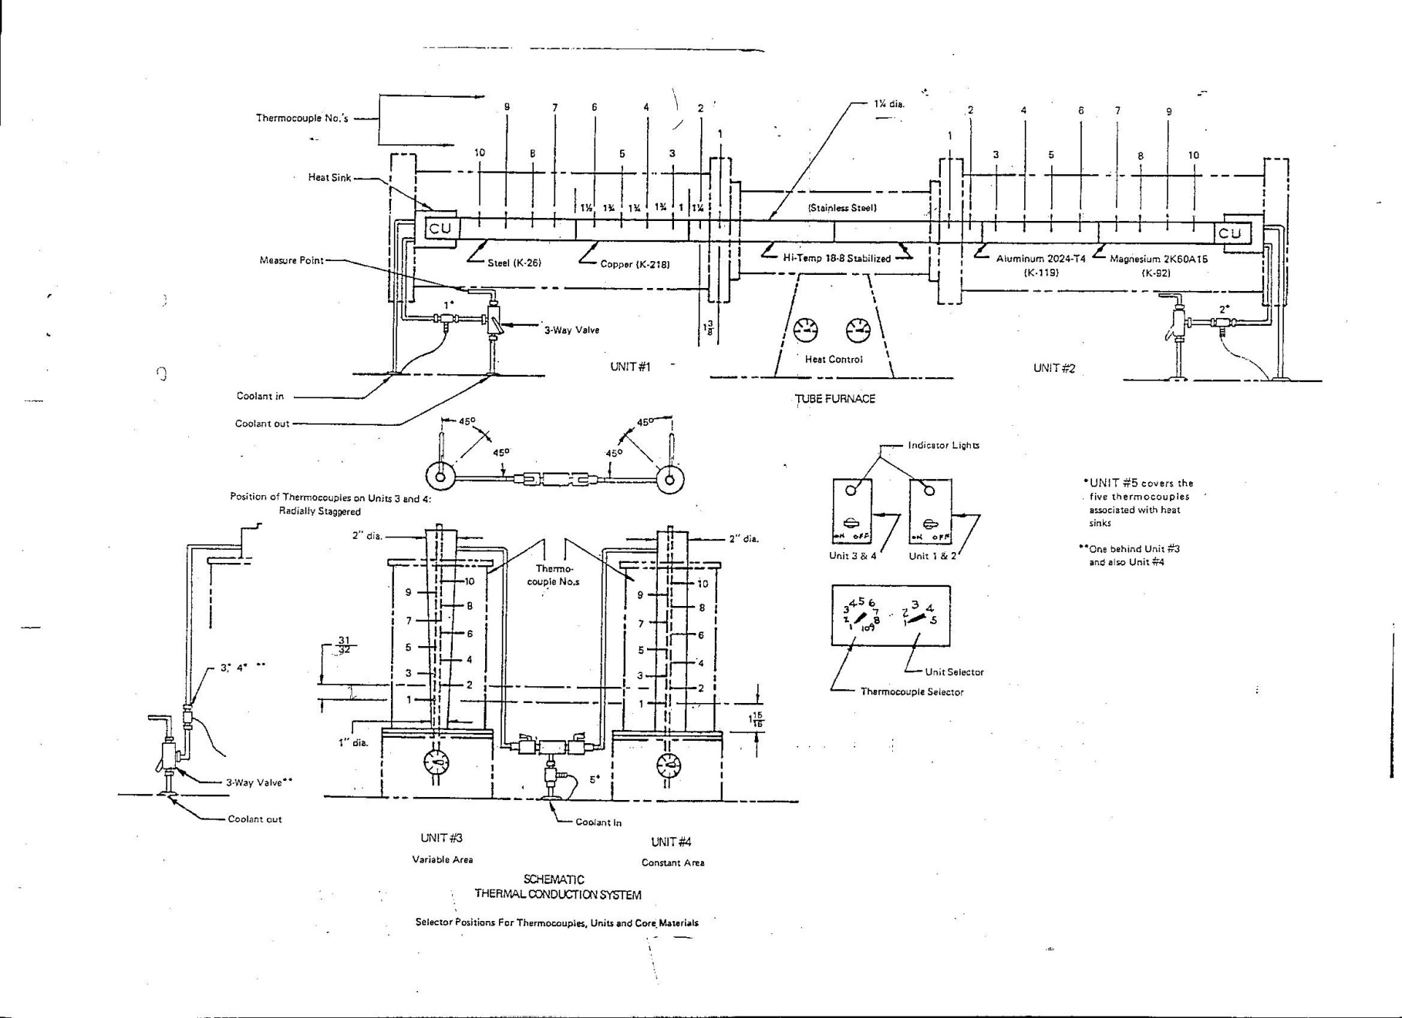
Figure 2, Experiment Setup.

Table 1,Data recording sheet.
 |  | Thermocouple voltage (mV) |  |  |  |  |  |  |  |  |  | Water Volume | Time | $T_{H_{2}O}$ in, | $T_{H_{2}O}$ out | $$T_{Room}$$
Unit | Run | 1 | 2 | 3 | 4 | 5 | 6 | 7 | 8 | 9 | 10 | mL | s | $$(℃)$$ | $$(℃)$$ | $$(℃)$$
3 | 1
 | 2
4 | 1
 | 2
 | 3

