Experiment Number 1
Separation of Serum and Plasma from Whole Blood and Their Proteins
Separation of Blood Components

  - You have a purple cap tube which contains………………

  - Measure the volume of the whole blood………..ml

Describe the layers that you got

Centrifuge at 3000 rpm
for 10 minutes

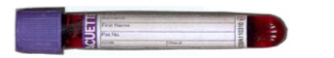

- Withdraw the liquid layer by pasture pipette into centrifuge tube, record the volume …….…ml
- The liquid phase is called ………………

Components | Total volume | Percentage
Whole blood
Liquid phase
Blood Cells

- How we can Separate Serum from the liquid phase that you got?
……………………………………………………………………………………………………………………………………………………………………………………………………………………………

Separation of Serum from Whole Blood

- You have a red cap tube which contains………………
- Measure the volume of the whole blood………..ml

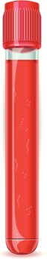

Centrifuge at 3000 rpm
for 10 minutes
Describe the layers that you got

- Withdraw the liquid layer by pasture pipette into centrifuge tube, record the volume ………ml.
- The liquid phase is called ………………

Separation of Main Proteins in Plasma
Plasma:
Aim to :…………………………………………………………..
This Separation by ……………….Method
(Supernatant):

Serum:
4ml serum + 4 ml saturated ammonium sulphate solution
Aim to :…………………………
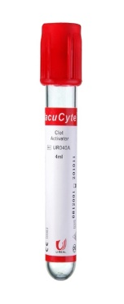

Centrifuge al 3500 rpm /10 min

Globulin Precipitate
Transfer the supernatant in to other test tube (Do not throw it!!) Dissolve the precipitate in 2ml 0.9% saline

Heat Coagulation Test (Tube B)
Aim to:…………..

Biuret test (Tube A)
Ain to:………………

1 ml Globulin + 1ml Biuret Reagent

Mix well, allow to stand in water bath at 37 °C/10 min
purple color (confirms the presence of protein “mainly globulin”)
1 ml Globulin + drops of 2M acetic acid

Heat the content of the tube at 70 °C/10 min
Cloudiness (confirms the presence of
protein “mainly globulin”)

To supernatant (Mainly Albumin)
Divide the filtrate into 2 tubes

Salting out (Tube A)
Aim to:………………….
Heat Coagulation Test (Tube B)
Aim to:……………
Add drops of 2M acetic acid

Heat the content of the tube at 70 °C/10 min
Cloudiness (confirms the presence of protein “albumin”)
Add solid ammonium sulphate until albumin is precipitated
(Confirms the presence of protein “albumin”)

