OPER 441: Modeling and Simulation
Tutorial: Handout #1
Q.1

Q.2

Q.4
Q.5
Q.6
Q.3

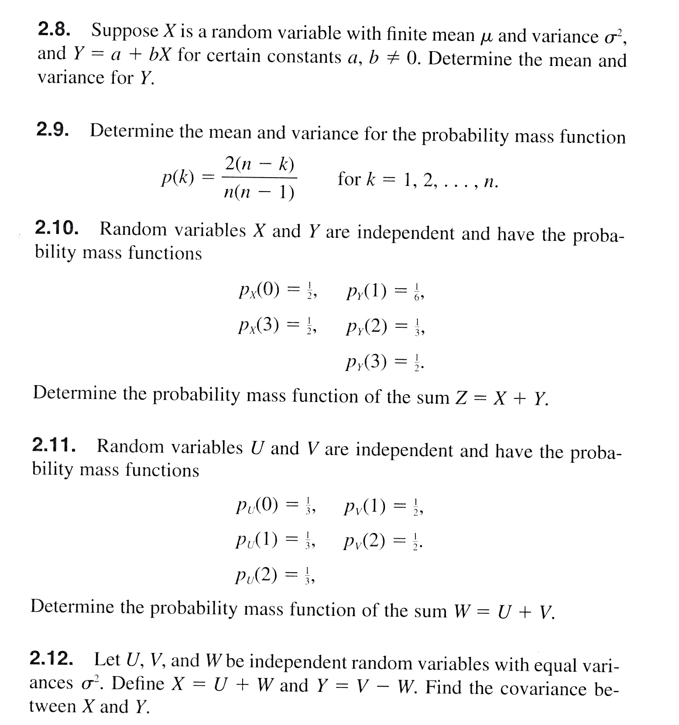
Q.7

Q.8

Q.9

Q.10

Q.11

Q.12 A fair die is rolled 10 times. What is the probability that the rolled die will not show an even number?

Q.13. Suppose that five fair coins are tossed independently. What is the probability that exactly one of the coins will be different from the remaining four?

Q.14. John Doe's daily chores require making 10 round trips by car between two towns. Once through with all 10 trips, Mr. Doe can take the rest of the day off, a good enough motivation to drive above the speed limit. Experience shows that there is a 40% chance of getting a speeding ticket on any round trip.
a. What is the probability that the day will end without a speeding ticket?
b. If each speeding ticket costs $80, what is the average daily fine?
Q.15. Customers arrive at a service facility according to a Poisson distribution at the rate of four per minute. What is the probability that at least one customer will arrive in any given 30-second interval?

Q.16 Customers arrive randomly at a checkout counter at the average rate of 20 per hour.
(a) Determine the probability that the counter is idle.
(b) What is the probability that at least two people are in line awaiting service?

Excel Application:
Consider a minimarket on a highway. Customers enter the minimarket randomly. Each customer spends a random amount of time in the minimarket to get his purchases. Data is collected on a given day for 60 customers.

Cust. # | Arrival time  (min) | Service time  (min) | Spending  (SR) |  | Cust. # | Arrival time  (min) | Service time  (min) | Spending  (SR)
1 | 5 | 5 | 68 |  | 31 | 140 | 1 | 40
2 | 13 | 4 | 35 |  | 32 | 142 | 2 | 51
3 | 21 | 14 | 63 |  | 33 | 144 | 1 | 37
4 | 32 | 3 | 65 |  | 34 | 149 | 5 | 52
5 | 34 | 1 | 57 |  | 35 | 150 | 9 | 66
6 | 42 | 5 | 66 |  | 36 | 150 | 2 | 47
7 | 46 | 6 | 51 |  | 37 | 152 | 2 | 39
8 | 47 | 5 | 52 |  | 38 | 154 | 1 | 39
9 | 54 | 1 | 53 |  | 39 | 158 | 2 | 51
10 | 58 | 2 | 27 |  | 40 | 159 | 2 | 65
11 | 60 | 1 | 42 |  | 41 | 162 | 3 | 45
12 | 73 | 2 | 45 |  | 42 | 167 | 5 | 58
13 | 73 | 3 | 58 |  | 43 | 176 | 4 | 40
14 | 86 | 2 | 40 |  | 44 | 181 | 1 | 29
15 | 90 | 8 | 29 |  | 45 | 182 | 4 | 34
16 | 91 | 6 | 34 |  | 46 | 190 | 14 | 57
17 | 106 | 2 | 57 |  | 47 | 192 | 2 | 34
18 | 111 | 2 | 34 |  | 48 | 200 | 2 | 60
19 | 115 | 4 | 60 |  | 49 | 204 | 1 | 44
20 | 118 | 7 | 44 |  | 50 | 205 | 5 | 43
21 | 120 | 3 | 43 |  | 51 | 207 | 9 | 60
22 | 121 | 5 | 52 |  | 52 | 214 | 2 | 44
23 | 122 | 4 | 57 |  | 53 | 227 | 3 | 43
24 | 127 | 1 | 55 |  | 54 | 230 | 1 | 52
25 | 129 | 4 | 53 |  | 55 | 243 | 5 | 57
26 | 131 | 14 | 34 |  | 56 | 245 | 6 | 55
27 | 136 | 2 | 72 |  | 57 | 249 | 5 | 53
28 | 139 | 2 | 64 |  | 58 | 249 | 4 | 34
29 | 140 | 1 | 32 |  | 59 | 252 | 7 | 52
30 | 140 | 1 | 64 |  | 60 | 262 | 3 | 66

Using Excel answer the following:
- Assume that the arrivals follow Poisson process. What is the parameter (λ cust./hr) for the distribution.
- What is the average number of customers arrived to the market in one hour?
- What is the variance of number of customers arrived in one hour?
- From your answers in (2) and (3) do you thing that Possion Process is a good assumption?
- Given your answer in (1), what is the probability that there is no arrival in one hour to the minimarket?
- From the data what is the probability that there is no arrival in one hour to the minimarket?
- Given your answer in (1), what is the probability that there will be at least 10 customers arrived to the market in one hour?
- Assume that the time spent by each customer follow Exponential distribution. What is the parameter (μ) for the distribution.
- Find the mean and standard deviation for the exponential distribution of the time spent by customers in the market.
- From your answers in (8) do you thing that Exponential distribution is a good assumption?
- Given your answer in (8), what is the probability that the customer will spend at least 5 minutes in the market?
- Given your answer in (8), what is the probability that the customer will spend more than 10 minutes in the market?
- From the data table, what is the probability that the customer will spend at least 5 minutes in the market?
- Compare your answeres in (11) and (13) and justify?
- From the data table, what is the probability that the customer will spend more than 10 minutes in the market?
- Compare your answeres in (12) and (15) and justify?

