

College of Engineering
Electrical Engineering Department

EE496
Project Title

Project Code: ……(Ex: A1_February 2023)
Student Team
……Name (ID)…………
……Name (ID)…………
Supervisors
Name Signature
………………… ………………
………………… ………………

Design Group
Code and Title: DG-XX (………Group Name………)
Coordinator (Academic Advsior): ………………

Submitted in Partial Fulfillment of the Requirement for the B.Sc. Degree,
5/1445H (December 2023)

Project Abstract

Write your abstract here. This electronic document is a live template. Make your abstract concise and comprehensive. Focus or the following:
- Your project objectives.
- Your design requirements and constraints.
- Your design attempts. Make sure to illustrate your efforts even some of the attempts did not achieve the requirements completely.
- Your final design specification
- Summary of your findings and results
- Your concluding remarks

Acknowledgement

Write your acknowledgement here.

Table of Contents

Project Abstract ii
Acknowledgement iii
Table of Contents iv
List of Figures v
List of Tables vi
1 Introduction 1
1.1 Problem Formulation 1
1.1.1 Problem Statement: 1
1.1.2 Problem Formulation: 1
1.2 Project Specifications 1
2 Background 3
2.1 Literature Review: 3
2.2 Concept Synthesis 3
2.2.1 Concept Generation: 3
2.2.2 Concept Reduction: 3
2.3 Detailed Engineering Analysis and Design Presentation 3
2.3.1 Cost Analysis 3
2.3.2 Bill of Materials: 4
2.3.3 Hazards and Failure Analysis 4
3 Write the Title of Your Chapter 5
3.1 Use of Styles 5
4 Citing References 6
5 Conclusions and Future Work 7
References 8
Appendices 9
Appendix A: Working with Endnote 10

List of Figures

Figure ‎1.1: Illustration of design management example. 2
Figure ‎3.1: Illustration of the shape of a cylinder. 5

List of Tables

Table ‎3.1: Dimensions of the cylinders considered. 5

Introduction

Problem Formulation

Problem Statement:
State the problem to be solved as indicated by the need (Supervisor, industry sponsor, or self proposed). Present the objectives and expectations of the need and constraints given to the problem.

Problem Formulation:
Show that the problem has been formulated by presenting appropriate design methods Objective taking into consideration the following factors:
- Problem is realistic or satisfies a specified need
- Easy to verify and/or validate by the end of the project

Project Specifications

- Give a clear set of design specifications for the project. The design specifications should be clear concise statements with a specific metric and an appropriate value.
- The specifications should provide an unambiguous measure of the success of the final design in meeting the need and constraints associated with the design problem.
- Problem Requirements Specifications is a dynamic process. Although it is desirable to freeze a set of requirements permanently, it is rarely possible. Requirements are likely to evolve through an iterative process that involves communication between customer specifying the need and the technical community. The impact of proposed requirements must be evaluated to ensure that the initial intent of the requirements baseline is maintained or that changes to the intent are understood and accepted by the customer. The following diagram in Fig. 1.1 summarizes the dynamic process of developing system requirements
- The design team may use any known problem management methods such as the Vee or Fishbone diagrams to keep track of the whole design process.

Need or
Customer
Developed
System
Requirements
Technical
Community
Environment/
Constraints
Raw Requirements
Customer Feedback
Customer
Representation
Technical
Representation
Technical
Feedback
Figure ‎1.1: Illustration of design management example.

Background

Literature Review:
Give a brief summary of the key literature that has been researched and used in the design effort. This can include textbooks, handbooks, technical papers, technical reports, web sources, codes and regulations. A summary of similar designs, processes, or techniques can also be discussed to show strength and weakness of your design compared to others. Indicate whenever the design process was supported by previous coursework.

Concept Synthesis

Concept Generation:
Show that design methods were used to generate several conceptual solutions to the design problem. Draw sketches or tree diagrams to describe the alternatives that were produced by this effort.

Concept Reduction:
Show that a judicial decision making process was used to reduce the number of possible conceptual solutions to a single (optimal) solution that is to be implemented and verified and/or validated by the end of the project. Discuss why alternative solutions were rejected/chosen over other solutions. Describe the criteria used to evaluate potential solutions. Substantiate that the proposed final concept is the optimal choice in providing the functionality necessary while best meeting the specified constraints of the design problem. Document in detail the decision making process.

Detailed Engineering Analysis and Design Presentation

Present and discuss the proposed design concepts, which have been used to solve the design problem. Although this section should be supported by a text discussion, it should be strongly supported by a detailed solid model and engineering analysis and design methods. Be sure to discuss the major subsystems in the design and the purpose and features of each subsystem. Include the following material to support this section:
Thoroughly present and discuss all engineering analysis used in the design process. Present all formulations, assumptions, and parameters used. Show results of the analysis. The discussion must be clear enough for reviewing process as well as repeating the design. You should be able to prove that the design will not fail and will perform as required solely through analysis. If you cannot predict it, then it is research, not engineered design.

Cost Analysis
Design should include some form of economic analysis. Although not required, realistic design must be concerned with cost. Where appropriate, include an analysis for:
  - Prototype cost (parts and implementation)
  - Lifetime operational cost

Bill of Materials:
Include a full parts list for the entire design if applicable. All standard parts should be completely identified by their code of specification. Custom parts must also be specified.

Hazards and Failure Analysis
It is the ethical responsibility of the engineer to ensure that the solution to the design problem is safe to the public and the environment. This is substantiated by showing that Design for Safety methods were employed in the design process and documented through a Hazards and Failure Analysis. Discuss the results of the analysis and how safety aspects are incorporated into your design.

Write the Title of Your Chapter

Use of Styles

You write information about your project here. You can add as many chapters as required.
Please make sure to adjust style as the following:
- Use Heading 1 style for chapter title.
- Use Heading 2 style for section titles
- Use Body Text style for main text.

Figure 3.1 presents a cylinder as is an example for use of figures.

Figure ‎3.1: Illustration of the shape of a cylinder.
A sample table is given in Table 3.1, presenting the sizes of cylinderd used in this project.
Table ‎3.1: Dimensions of the cylinders considered.
Cylinder Number | Base Radius  (cm) | Height  (cm) | Notes
1 | 1 | 1
2 | 2 | 2
3 | 3 | 3

For equations use the style EqStyle. A sample Equation is given below:
$A=πr^{2}$ (‎3-1)

Citing References

Use endnote to generate your references. You can download endnote from the university web site at http://etc.ksu.edu.sa/ar/node/164

Use the IEEE format for reference style
These are different reference examples:
- Example of citing a book is [1].
- Example of citing a journal article is [2].
- Example of citing a conference proceeding paper is [3].
- Example of citing an electronic article on a web site is [4].

Appendix A describes how to use endnote.

Conclusions and Future Work

Give a brief summary of the results that are accomplished. Describe and how well the final design functioned and/or met the specifications and needs of the client. Give recommendations for improving the design.
Describe the future work to be adopted by a team of students to continue this project.

References

[1] S. Haykin and M. Moher, "Introduction to Analog & Digital Communications, Hoboken," ed: NJ, John Wiley & Sons Inc, 2007.
[2] G. Vivone, P. Braca, and J. Horstmann, "Knowledge-Based Multitarget Ship Tracking for Hf Surface Wave Radar Systems," Geoscience and Remote Sensing, IEEE Transactions on, vol. 53, pp. 3931-3949, 2015.
[3] J. Bucek, P. Kubalik, R. Lorencz, and T. Zahradnicky, "System on Chip Design of a Linear System Solver," in System-on-Chip (SoC), 2014 International Symposium on, 2014, pp. 1-6.
[4] Mathworks. (2015). Matlab R2015a Documentation. Available: http://www.mathworks.com/

Appendices

Include in the appendices information that could not be included in the formal body of the report because it would disrupt the continuity of the discussion. Background materials, product catalogs, experimental data tables, and extra documentation should be placed in the appendix.

Appendix A: Working with Endnote

Steps to create your Endnote file:
- Open Endnote Program as shown below.
To add your papers that appear in IEEE Explorer
- Open IEEE Explorer
http://ieeexplore.ieee.org/Xplore/home.jsp
- Make a search on your subject. Select your records.
- Import records to endnote by clicking on download citation button. Choose citations & abstract and endnote. Your citations will automatically come into your endnote file.
To add articles which are not in IEEE Explorer
- Open the google scholar
http://scholar.google.com/
- Open the setting, and adjust it to import citations into EndNote as shown below.
- Make search on your subject. Click on Import into EndNote
- Again, your records will appear in your file.
- Copy one the references and paste it in the appropriate place in your document file.

The steps are shown with the following images:

- After Step 1
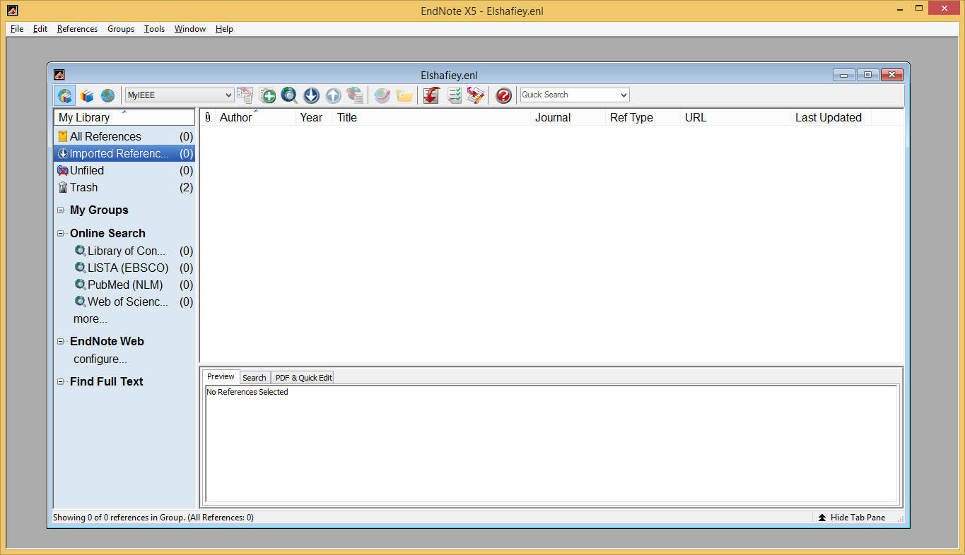

- After Step 2 and 3
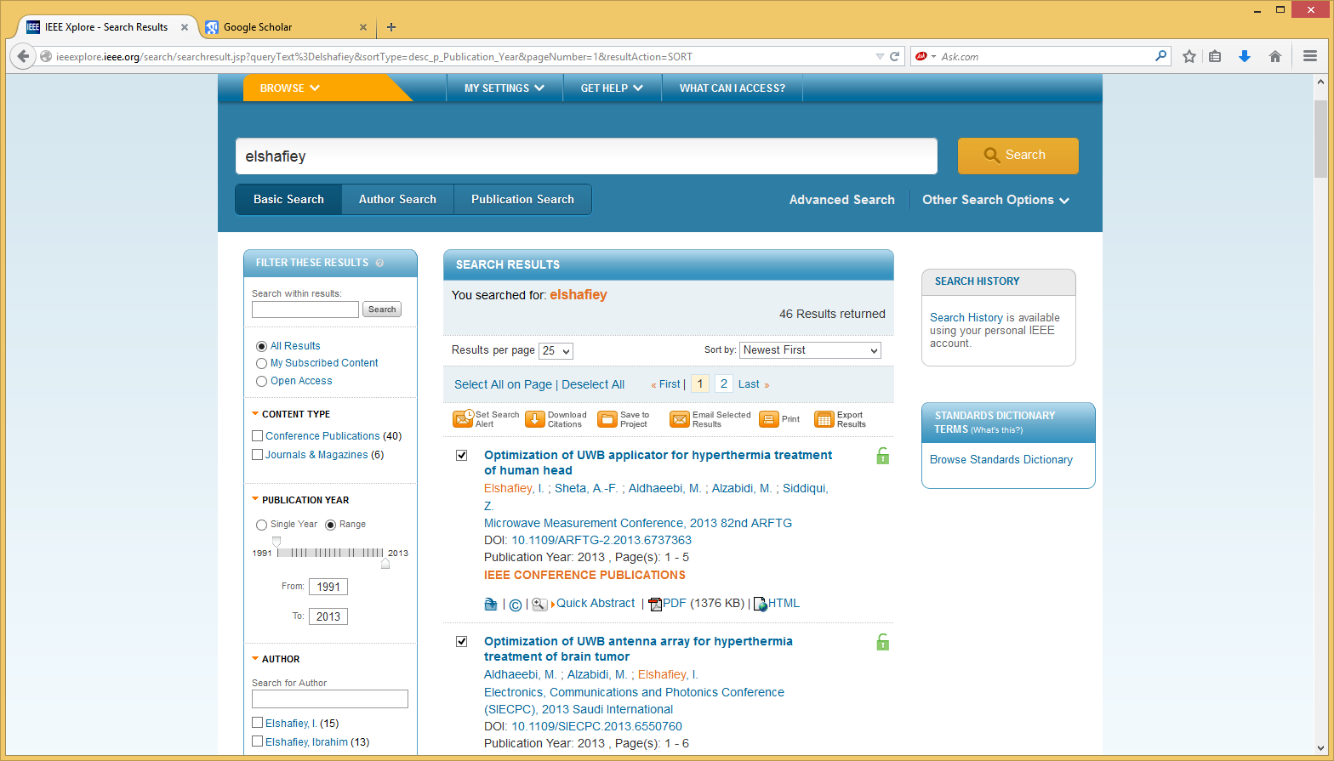

After Step 4
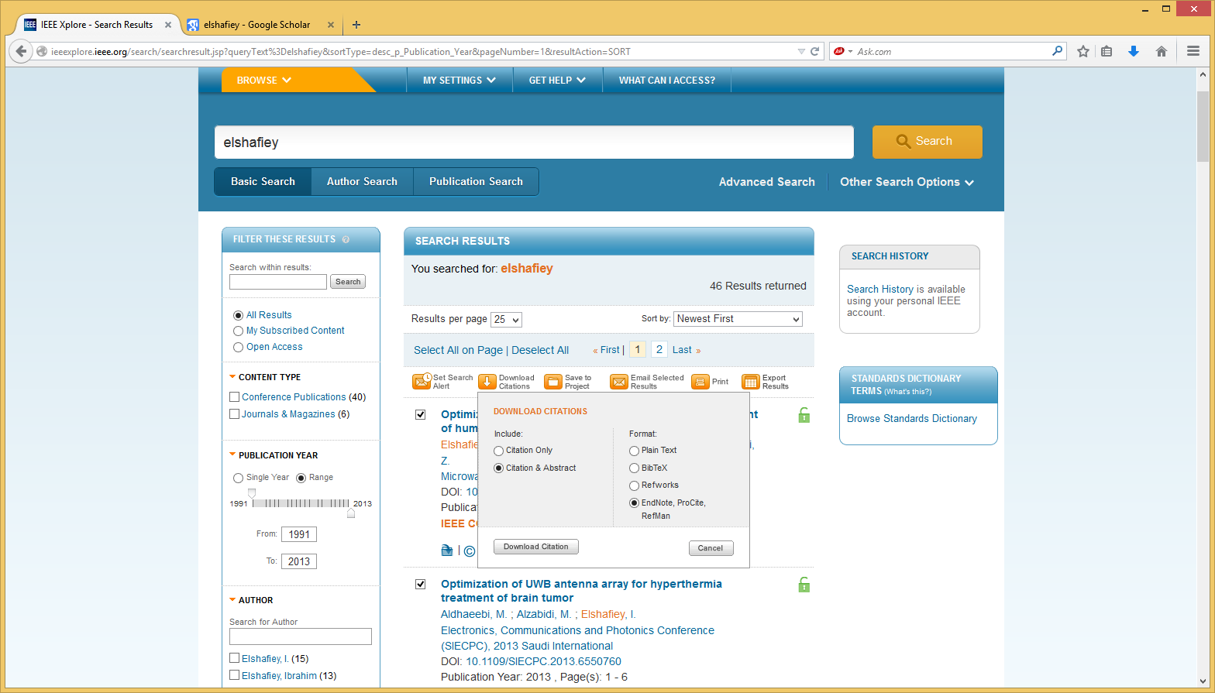

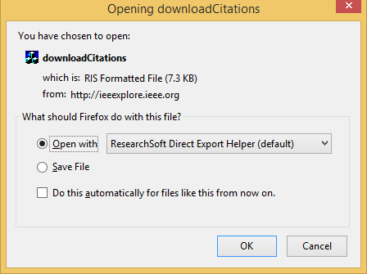

- After step 5


- After step 6
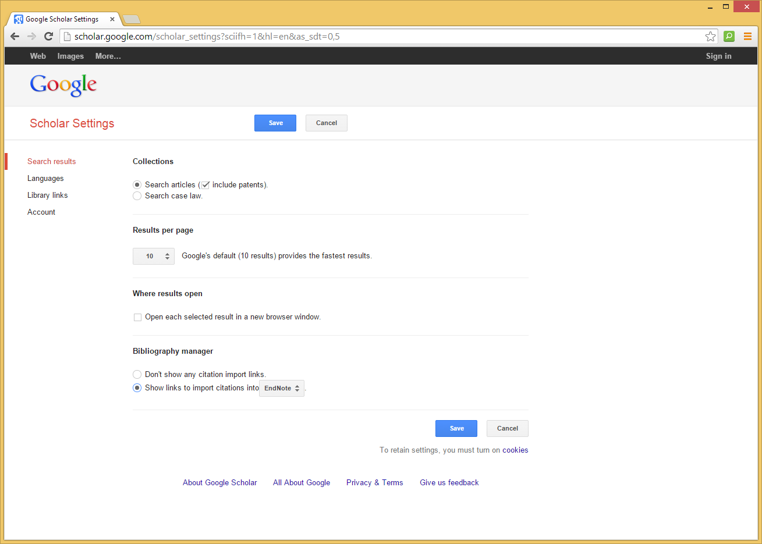

- 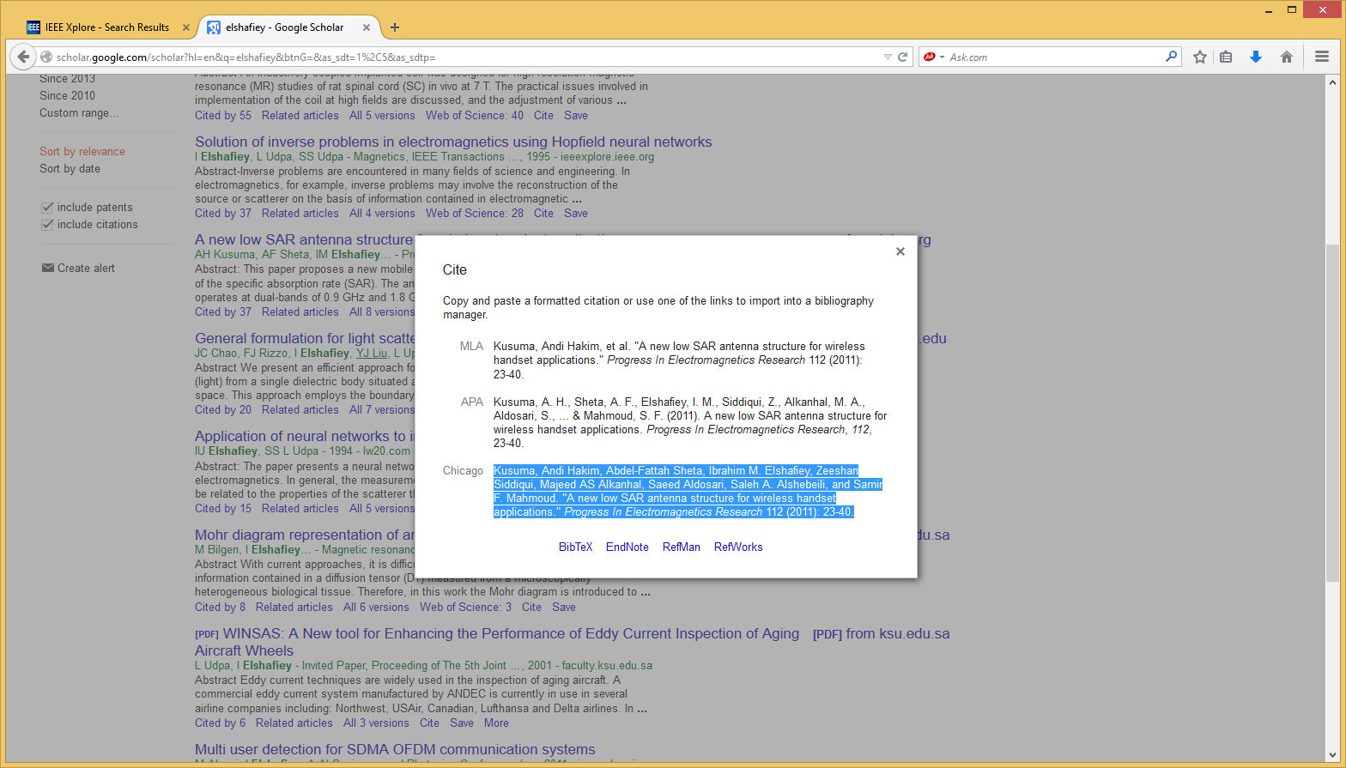

The following is the EndNote file used in this template.

