A BJT digital circuit is shown in the figure,

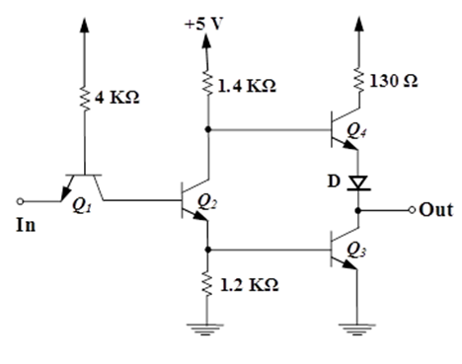

* 1. If the input is **low $V_{I}=0.2V$** ,calculate, fill the table ($V_{BE1}=0.7V,V_{BE3,4}=0.65V, V_{CE1}=0.1V$) :

|  |  |
| --- | --- |
| $$V_{B1}=$$ | $$I_{B1}=$$ |
| $Q_{1}$ region: | $$I_{IL}=$$ |
| $$V_{C1}=$$ | $$V_{B2}=$$ |
| $Q_{2}$ region: | $$I_{E2}=$$ |
| $$I_{1.2K}=$$ | $$I_{B3}=$$ |
| $Q_{3}$ region: | $V_{o}$ (low o/p current)= |
| $Q_{4}$ region: (low o/p current)= | $V_{o}$ (high o/p current)= |
| $Q_{4}$ region: (high o/p current)= |  |

* 1. Explain the role of the 130 Ω resistor

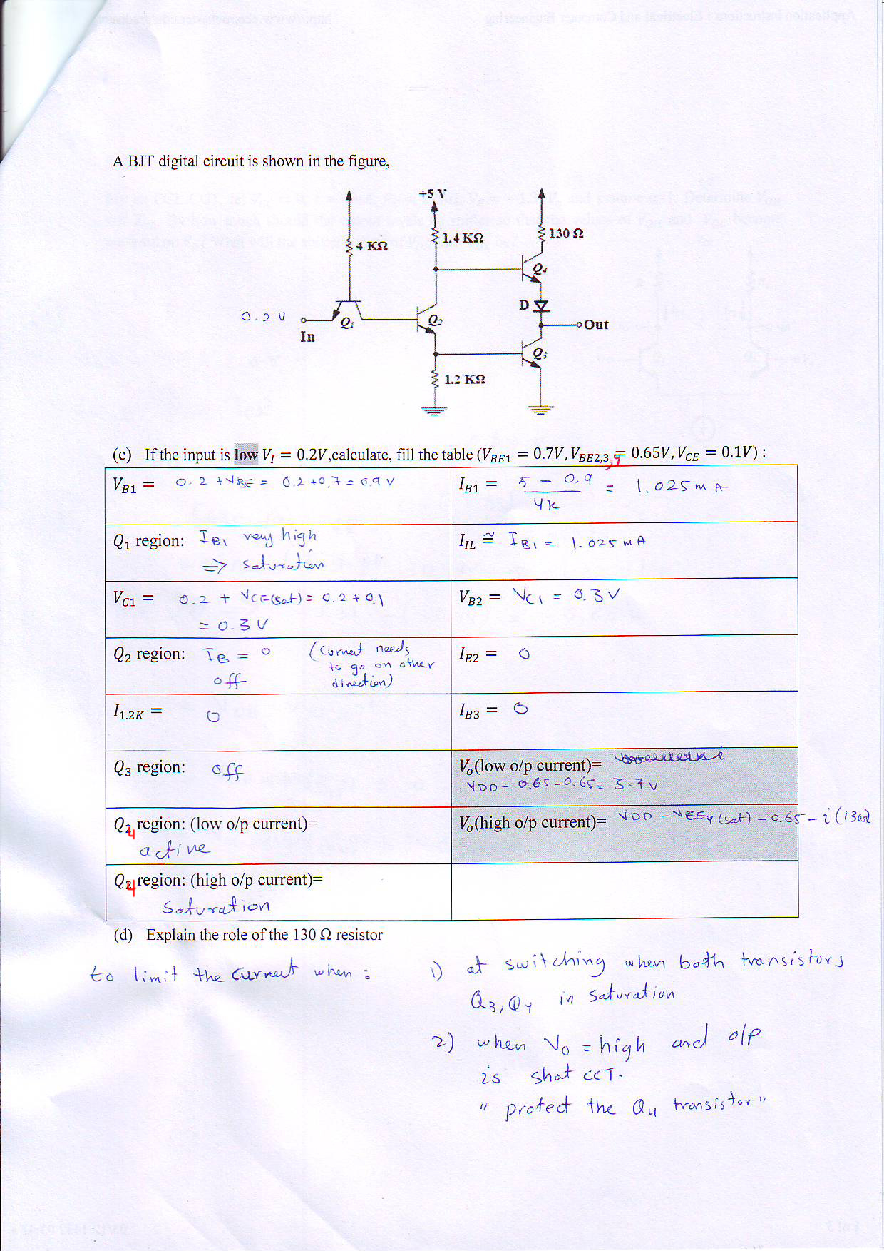

Exercise 11.17

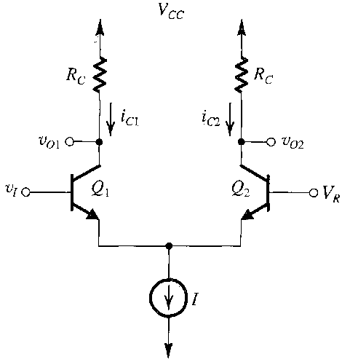For an ECL CCT, let $V_{CC}=0$, $I=4mA$, $R_{C}=220Ω$, $V_{R}=-1.32V$, and assume α=1. Determine $V_{OH}$ and $V_{OL}$. By how much should the output levels be shifter so that the values of $V_{OH}$ and $V_{OL}$ become centered on $V_{R}$? What will the shifter values of $V_{OH}$ and $V_{OL}$ be?

