1
  - Drag Force Measurement
OBJECTIVES:
- Calculation of velocity profile in the wake of a two-dimensional cylinder.
- Estimate the coefficient of drag and compare with values in the literature and from the force balance
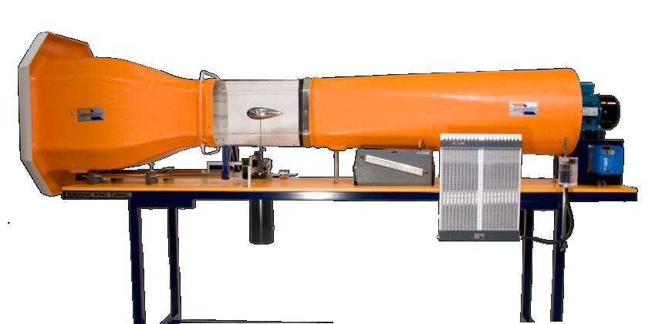
Figure 1, Armfield c2-10 subsonic wind tunnel.

THE EXPERIMENTAL UNIT:
The Armfield Wind Tunnel is simple and safe in operation. It is supplied as a complete self-contained facility mounted on castors for ease of movement. Main equipment comprises the tunnel with a two-component balance system and an air speed indicator. Air enters the test section through a carefully designed contraction followed by an aluminum honeycomb flow straightener designed to ensure that the flow is steady in both magnitude and direction and has a flat transverse velocity profile.
A low angle diffuser at the outlet end contributes to flow stability in the test section. A five bladed fan is located at the outlet of the diffuser section. The fan is driven by an AC motor supplied from an inverter speed control unit, allowing smooth control of air speed. The parallel octagonal test section is manufactured from clear acrylic and may be retracted on rails to permit unobstructed access to the models. The two-component balance consists of a pair of balances supported on knife edges on mutually perpendicular axes parallel to and normal to the axial centre of the tunnel. Lift and drag components of force exerted on the models under test are balanced by sliding weights along the arms of the balance until a state of null deflection is reached. Graduations in units of force allow lift and drag to be read directly. The complete assembly is linked to a simple oil filled damping pot. Models are mounted on the balance within the working section and a protractor with cursor allows angles of incidence to be changed quickly and accurately while the tunnel is running.
The wind tunnel has a variable speed motor driven unit downstream of the working section permitting stepless control of airspeed between 0 and 26ms-1. Balance: Lift and drag Lift - 7.0N, Drag - 2.5N, Sensitivity ±0.01N. Working section: 304mm wide x 304mm high x 457mm long (octagonal cross- section) . Contraction area ratio is 3:1. Motor rating is 1.5kW.

Multi Tube Manometer
This is an inclinable manometer board equipped with 20 tubes, acrylic manifold and a reservoir mounted on a vertical rod such that the position of the datum manometer tube levels may be adjusted to convenient heights before commencing experiments. Scale length is 370mm accommodating measurement of pressure up to 290mm water gauge. This general purpose kerosene manometer is suitable for use with many Armfield model accessories requiring pressure measurement (kerosene supplied).

PROCEDURE:
IN THE LAB:
- Check all pressure tubes are connected to the multi-tube manometer
- Check the model is firmly attached to the wind tunnel
- Set the wind tunnel speed to the desired value and let it stabilize
- Record manometer measurements for this setup as well as the rake distance from the model
- Use the force balance to measure the drag force on the object
- Change the speed and repeat

The velocity profile in the wake is calculated as

$$V=\sqrt{\frac{2\left(p_{0}-p\right)}{ρ}}$$
The total pressure is measured by the pressure rake and the static pressure is measured by the pitot-static tube mounted on the side wall.

Then the drag force is calculated as,
$$-Drag=F_{x}=\int_{wake}{ρu^{2}dA}-ρAU_{∞}^{2}$$
Where the area is the width of the rake times a unit length in the span-wise direction. Finally the drag coefficient is given by
$$C_{D}=\frac{Drag}{\frac{1}{2}ρU^{2}A}$$

Table 1, Measurements Table
Run # | 1 | 2 | 3 | 4 | 5
p_{a} (cm Hg)
T_{a} (C)
$$ρ_{a}kg/m^{3}$$
U∞ (m/s)
$p_{s} (cm H_{2}O)$
(x/D)
Re
1 |  |  |  |  |  | Rake Total pressure measurements (mm H2O)
2
3
4
5
6
7
8
9
10
11
12
13
14
15
16
17
18

$$p_{a} Atmospheric pressure \left(Pa\right)$$
$$T_{a} Atmospheric temperature \left(℃\right)$$
$$ρ_{a} Atmospheric density \left(kg/m^{3}\right)$$
$$U_{∞} Free stream speed \left(m/s\right)$$
$p_{s} Static pressure \left(Pa\right)$
$$x/D location of rake measurement downstream of the object$$
$$Re Reynolds number=\frac{ρU_{∞}D}{μ}$$

