Course Reference:

LIST OF ORTHOPAEDIC BOOKS and Journals

- Acta Orthopaedica Scandinavica + Supp.
- American Journal of Sports Medicine
- Archives of Orthopaedic and Traumatic Surgery
- British Journal of Sports Medicine
- Clinical Orthopaedics and Related Research
- Current Opinion in Orthopaedics
- Foot and Ankle
- Injury: British Journal of Accident Surgery
- International Journal of Sports Medicine
- International Orthopaedics
- Journal of Arthroplasty
- Journal of Bone and Joint Surgery (US)
- Journal of Bone and Joint Surgery (UK)
- Journal of Bone and Mineral Research

Books:
1. Fractures and Dislocations (Badr & Shaheen)
2. Apley's System of Orthopedics and Fractures (Graham Apley)
3. Clinical Orthopedic Examination (Ronald McRae)
5. Journal of Bone & Joint Surgery (British Edition)

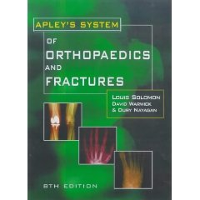
Apley's system of orthopedics and fractures 8th edition 2001.
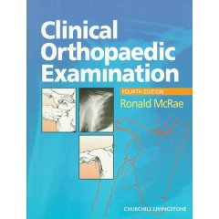
Clinical Orthopaedic Examination by Ronald McRae.
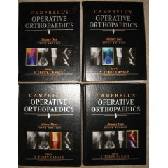
Campbell's Operative Orthopaedics. For Postgraduate students.
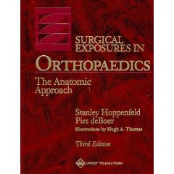
Surgical Exposures in Orthopadics,The anatomic approach. For Postgraduate students.
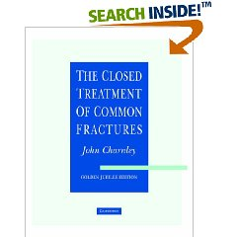
The closed Treatment of common fractures.
AO Manual of Fracture Management–Internal Fixators.

