**Ch 4 But (in text Book)) (Chapter 10)**

***Analysis of Insurance Contracts***

After studying this chapter, the student has to be able to answer the following questions:

* What is the definition of insurance contract and what are its contents?
* What are the contents of insurance contract? In other words, what are the basic parts of an insurance contract?
* Describe the common types of deductibles that appear in insurance contract ,including – straight deductible - calendar year deductible
* Explain how coinsurance works in a property insurance
* Explain how coinsurance works in a health insurance
* Explain how losses are paid when more than one insurance contract cover the same loss.
* What are the general requirements of insurance contract?

*10.1-Introduction*

In fact, *insurance contract( policy)*  is ***a legal contract***. It is similar to other civil legal contracts i.e. *lease contract*. Since, the lease contract is written under terms of which you agree to pay rent to the owner and the latter agrees to provide the **apartment** in turn. Moreover, the lease contract includes provisions as the date when you can occupy the apartment, the date when the rent is due, the term of rent and conditions under which, the lease contract can be cancelled … etc.

So, ***the insurance contract*** is like lease contract has indicated terms in the contract. By these terms, both insurance company and policyholder can know *their rights and their duties* toward each other. **Hence**, we can say "*purchasing insurance policy is not much* ***fun***", but it gives you *financial security towards a risk*, in spite of it is a piece of a paper.

Hence**, *insurance contract has the following elements****:*

* *The first party* is insurer or insurance company who pays or promises to pay the loss, if the risk occurs.
* *The second party* is insured who pays the premium
* *Sum insured* is the payment that is paid by insurer, if the risk occurs.
* *The premium* is the payment that is paid by insured to the insurer in exchange of transfer the risk to the latter.
* *Period contract* is the agreed period between insurer and insured through it, the insurance still in force.
* *Insurance policy* is *a written evidence* for existing an agreement between insurer and insured and it includes provisions and duties of each party toward the other,

***The contract*** is an *agreement enforceable by law*. For any such agreement to be legally enforceable, all contracts including insurance policy must have the following requirements:

* Offer and acceptance
* Competent parties
* Legal purpose
* Consideration

Before, Discussion of the previous requirements of insurance contract, the following question may be raised about insurance contract:-

***What are the contents of insurance contract?. In other words, what are the basic parts of an insurance contract?***

***The answer*** the insurance contract is composed of six basic parts:

1. ***Declarations***: *The declarations are the statements made by insured*. These statements represents *information* about the lo*cation* of the property insured, *the name* of policyholder and other matters relating to identification of the person or property insured.

***Declarations is*** usually in *the first page of the policy*.

***For example*** in *property insurance contract* , it contains name of the insured, location of property, period of protection, amount of insurance, premium and deductible information

1. ***Definitions*** : Insurance contracts typically contain a page or section of definitions For example, the insured is referred to as “you” and “your” and the insurer is referred to as “we” or “our”

*III)* ***Insuring agreement***: It summarizes *the major promises* of the insurer.

There are **two** basic forms of **an insuring agreement** (coverage) in property insurance are:

* Named perils coverage, where only those perils specifically named in the policy are covered
* Open-perils, or special coverage, where all losses are covered except those losses specifically excluded

***IV) Exclusions***: In this part, ***the insurance company determines what it will not do.*** The number of exclusions depending upon the policy. If the policy is written on a named-risk basis, the exclusions may be few, but if the policy is written on open-risk basis, the exclusions will be more to eliminate coverage for risks that are uninsurable.

* Insurance contracts contain three major types of exclusions
  + *Excluded perils*, e.g., flood, intentional act
  + *Excluded losses,* e.g., a professional liability loss is excluded in the homeowners policy
  + *Excluded property*, e.g., pe**ts** are not covered as personal property in the homeowners policy

***Why are Exclusions Necessary?*** The answer is:

Some perils are not commercially insurable e.g., catastrophic losses due to war Extraordinary hazards are present e.g., using the automobile for a taxi Coverage is provided by other contracts e.g., use of auto excluded on homeowners policy

Moral hazard problems e.g., coverage of money limited to $200 in homeowners policy

Attitudinal hazard problems e.g., individuals are forced to bear losses that result from their own carelessness

Coverage not needed by typical insureds e.g., homeowners policy does not cover aircraft

1. ***Conditions***: In this part, ***the duties*** and ***rights*** of both parties (insurance company and insured) should be illustrated in detail. *Conditions* are *provisions* in the policy that qualify or place limitations on the insurer’s promise to perform. If policy conditions are not met, insurer can refuse to pay the claim.
2. ***Miscellaneous Provisions***: Insurance policies contain a variety of miscellaneous provisions e.g., in property and casualty insurance ***Miscellaneous Provisions*** include, cancellation, subrogation, grace period, misstatement

**10-2-** Some ***terminologies or additionals parts may be added to insurance contract***

Sometimes, ***insurance contract*** contains the following ***terminologies or additionals or some of them*** such as ***:-***

***A- Endorsements and Riders***

* *In property and liability insurance*, an **endorsement** is *a written provision that adds to*, deletes from, or modifies the provisions in the original contract e.g., an earthquake endorsement to a homeowner’s policy.
* *In life and health insurance*, a **rider** is *a provision that amends or changes the original policy* e.g., a waiver-of-premium rider on a life insurance policy, if he exposed to disability.

1. ***Deductibles***

A deductible is *a common policy provision* that require the insured to pay part of the loss. **A deductible** is a provision by which *a specified amount is subtracted from the total loss payment* that otherwise would be payable.

***Notices***:-

1. ***Deductibles*** are found in property ,health and auto insurance .
2. ***Deductibles*** is not used in life insurance because *the insured`s death is* always *a total loss* . Also ***Deductibles*** is not used in personal liability insurance because the insurer must provide *a legal defense* ,even for a small claim.

*The purpose of a deductible is to*:

1. Eliminate small claims that are expensive to handle and process

2. Reduce premiums paid by the insured

3. Reduce moral hazard and attitudinal (morale) hazard

**kinds of deductibles**

***Examples for*** ***Deductibles*** **( kinds of deductibles**)

* ***I- Deductibles*** in **property insurance**

The following ***Deductibles are commonly found in*** in **property insurance** **contracts** **1- a straight deductible 2- aggregate deductible**

*- Deductibles With* ***a straight*** *deductible*, the insured must pay *a certain amount* before the insurer makes a loss payment e.g., *an auto insurance deductible*

*- An* ***aggregate*** *deductible* means that *all losses* that occur during a specified time, usually a policy year, *are accumulated to satisfy the deductible amount*. *For example*, if the aggregate deductible in the policy $10,000 , and the losses are $1000 and $2000 over the policy year ,the insurer does not pay anything because the deductible is not met ,but if there is a third loss $8000 over the policy year ,the insurer will pay just $ 1000 only. ( 11000 - 10000)

* ***II- Deductibles*** in **Health insurance**
* The following ***Deductibles are commonly found in*** in **Health insurance** **contracts** - A calendar-year deductible - An elimination (waiting) period
* *A calendar-year deductible* is a type of aggregate deductible that is found in individual medical expense and group medical insurance contracts
  + *An elimination (waiting) period* is a stated period of time at the beginning of a loss during which no insurance benefits are paid. It is appropriate for a single loss that occurs over some time period.

e.g., ***disability income contracts*** that replace part of a disabled worker’s earnings

Typically have *elimination periods* of 30, 60, or 90 days, or longer periods.

***C- Coinsurance***

Coinsurance is *a contractual provision* that often appears in property insurance contracts, in particular, commercial property insurance contracts

So, ***what is the meaning of Coinsurance?***

***A coinsurance clause*** in a property insurance contract encourages the insured to insure the property to ***a stated percentage*** of its insurable value.

If the coinsurance requirement ***is not met*** at the time of the loss, the insured must share in the loss as a coinsurer.

***Notice :*** the insurable value of the property is the actual cash value or replacement cost .**The *coinsurance formula*** *is as follow :-*



***An example***: a building its value $1,000,000 and the owner has insured it for only $600,000 . If 80% *coinsurance clause* is present in the policy. So, the required amount of insurance based on actual cash value will equals $ 800, 000 ( 80% × 1,000,000). If a $100,000 loss occurs, ***the amount of recovery*** will equal (600000/800000) × 100000 = $75,000 only because the *coinsurance requirement* ***is not met.***Consequently, the insured must charge the remaining amount of the loss.($ 25000)

***The purpose of coinsurance***

* The fundamental purpose of coinsurance is ***to achieve equity (justic) in rating***
* **A property owner** wishing to insure for *a total loss* would pay an inequitable premium قسط غير ملائم if other property owners only insure for partial losses
* *If the coinsurance requirement* ***is met****, the insured receives* ***a rate discount****, and the policyowner who* ***is underinsured*** *is penalized through application of the coinsurance formula as indicated in both Figure 10.1 and Figure 10.2*

***Notice :*** in this example ,we divide loss/ value of buildings . This = pure premium.

Figure 10.1 Insurance to Full Value

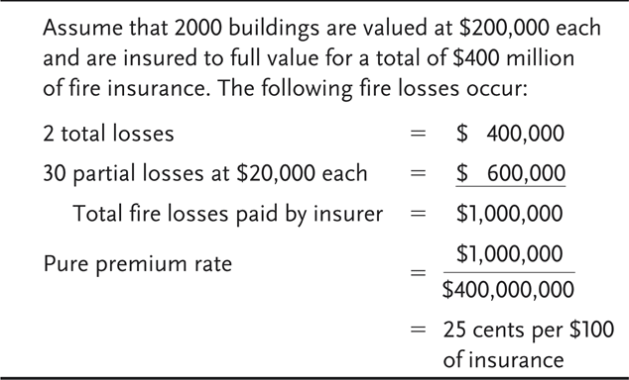

**Figure 10.2 Insurance to Half Value**

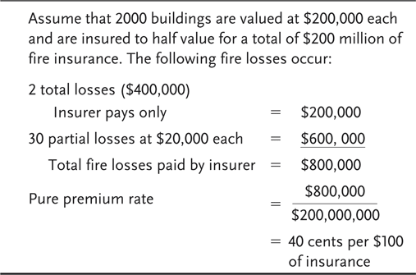

***Coinsurance in Health Insurance***

Health insurance policies frequently contain a coinsurance clause. This clause requires the insured to pay *a specified percentage of covered medical expenses* in excess of the deductible.

***The purposes of coinsurance in health insurance are***

- To reduce premiums and

- To prevent overutilization of policy benefits

***D- Other-insurance Provisions***

In effect, Other-insurance Provisions may be added ***to Insurance Contract*** , in particular, in **property and casualty insurance and Health Insurance** . ***These provisions apply*** when more than one contract cover the same loss. **The purpose** of *other-insurance provisions* is to prevent profiting from insurance and violation of ***the principle of indemnity***.

**\*\*\*\*Some *important other-insurance provisions***in property and casualty insurance include 1- *The pro rata liability provision 2- contribution by equal shares 3- primary and excess insurance provision*

1- *a pro rata liability provision* applies when 2 or more policies of the same type of cover ***the same insurable interest***  *in the property* . By virtue of it, each insurer’s share of the loss is based on the proportion that its insurance bears to the total amount of insurance on the property ( see Figure 10.3 ) , but if the*pro rata liability provision* not present , the insured will collect $ 100,000 from each insurer.

**Figure 10.3 Pro Rata Liability Example**

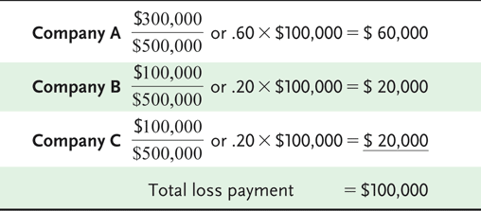

2-Contribution by equal shares, often appears ***in liability insurance contracts.*** Each insurer shares *equally* in the loss until the share paid by each insurer equals the lowest limit of liability under any policy, or until the full amount of the loss is paid (see **Figure 10.4 )**

**Figure 10.4 Contribution by Equal Shares (Example 1)**

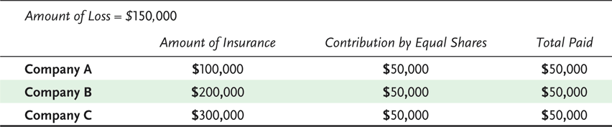

But if the amount of loss = $500.000 company B charge $100 more and company C charge $100 more . In the case amount of loss = $600 ,000 company C charge again $100 more.

**Figure 10.5** Contribution by Equal Shares (Example 2)

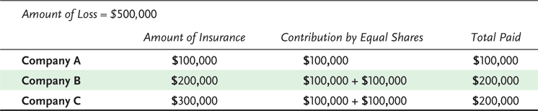

3- Primary and excess insurance provision. This provision applies in *auto insurance* . By virtue of it, *the primary insurer* pays first, and the excess insurer pays only after the policy limits under the primary policy are exhausted

***Another example for Primary and excess insurance*** is *The* coordination of benefits provision in *group health insurance* is designed to prevent overinsurance and the duplication of benefits if one person is covered under more than one group health insurance plan.

10.3 -The general requirements of insurance contract

The transfer of risk from individual to the insurance company is accomplished through *insurance contract* that is enforceable by law. Hence, the insurance law is derived from the general law. *Insurance contract should have some requirements to be binding legally*; these requirements may be summarized as follows:

1. ***There must be an agreement based upon an offer******and acceptance****.* It is worthwhile to mention that *offer and acceptance* are very necessary and essential requirements to create any contact. Hence, to create a legal enforceable insurance contract, there must be *a definite offer by one party* (the buyer of insurance) and this offer *must accept* in its exact terms by the *other party (insurance company or agent*). That is, the acceptance takes place when agent binds coverage or when the policy is issued. *Hence, when you call any an insurance agent for insurance on your house* and the agent say "*you are covered*", you have made **an offer** to buy and the agent has accepted on behalf of his company. This acceptance is called ***a binder***. A binder is *a temporary insurance contract* that is in effect until replaced by a formal written policy.

**A notice**: The offer may be verbal, as in the previous case, or it may be in the form of a written application

**The agent's authority** to act on behalf of an insurance company takes two forms either

*Express Authority* or *implied authority*.

**Express authority** is authority that is specifically granted **by agreement**. **Implied authority** is the incidental authority required or reasonably necessary to execute the express authority.

***In conclusion***, the offer will be by one party and acceptance of the offer by another party.

A **notice**: In **life insurance,** the agent does not have the power to bind the insurer. Furthermore, the application of life insurance is always in writing, and the applicant must take approval from insurer before the life insurance is in force.

1. ***There must be consideration***: Any contract requires consideration. So, this question may be raised, *what is consideration?* ***Consideration*** is *the price* that each party demands for agreeing to carry out the contract. ***Consequently***, the consideration given by the insured is *the first premium* (or promise to pay) plus agreement to abide by conditions specified in the policy. But, the consideration given by insurance company is *its promise to indemnify the insured* according to the terms of the policy in case of loss plus providing certain services such as loss prevention and safety services.
2. ***Insurance contract must have a legal purpose:*** Any contract must have legal purpose. If it is does not, to enforce, the contract will be contrary to public interest. **For example,** *Any contract by government employee* to sell secret information to an agent of an enemy country, ***for example,*** would be have an illegal purpose and would be unenforceable. Also**, any contract** in which a person agreed to commit murder ارتكاب جريمة قتل for a specified amount would be unenforceable because its purpose is not legal. **Likewise**, *an insurance contract* that encourages to cover losses caused by the ***insured’own arson*** would be *illegal*, contrary to public interest and thus unenforceable.
3. ***The two parties must be legally competent to*** ***make insurance contract***: The fourth requirement of a valid insurance contract is *the legal competence of parties*. **The legal competence** means ***the ability to inter into a binding contract.*** Consequently, in insurance contract, the parties must be capable of entering a contract in the eyes of the law. Most people are competent to contract except the persons who *insane person*, *intoxicated persons* are not competent. Also, *Minor* may enter into contracts, but such contracts may be voided (or terminated). If the minor reached the age 18 for example (depending upon the country) he may ratify the contract or reject it.