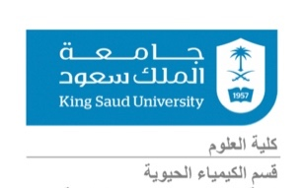

Demonstrator: Saad S. Alqarni, MSc Email: Salqarni1@ksu.edu.sa

- Blood Biochemistry BCH471 Practical Part content.

Week | Experiments | Date
1 | Introduction, Lab Safety | 28/8/2023
2 | Separation of Plasma and Serum from Whole Blood | 4/9/2023
3 | Separation of main Proteins from Plasma and Serum | 11/9/2023
4 | Haemolysing Agents | 18/9/2023
5 | ABO Blood grouping & Rh groups | 25/9/2023
6 | Haemoglobin and Anaemia | 2/10/2023
7 | HCT and ESR | 9/10/2023
8 | AST and ALT | 16/10/2023
9 | Red & White Blood Cell Count | 23/10/2023
10 | Presentation | 30/11/2023
11 | Revision | 6/11/2023
12 | Essay Submission | 13/11/2023
13 | FINAL EXAM | 20/11/2023

- Practical Detailed Marks:

# Final marks out of (30)

5 (Lab reports)

5 (Presentation)

5 (Essay 1000 words)

15 (Final Exam)

