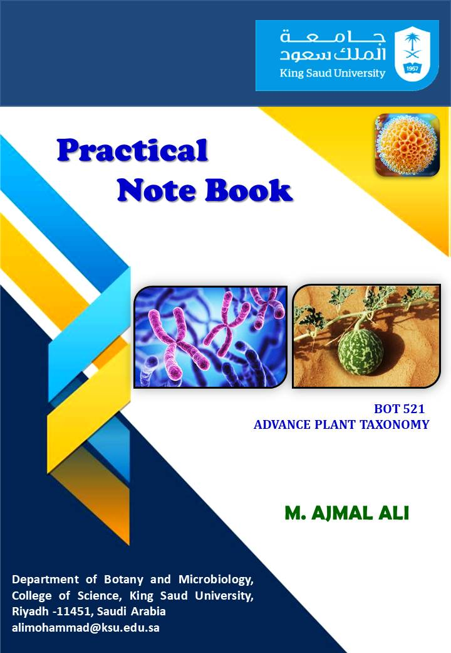

Lab Activity No 01
Title of the Activity: Identifying Plants Using Online Databases (Flora of Saudi Arabia)

Learning Objectives:
- To understand how to use online databases for plant identification.
- To explore the flora of Saudi Arabia using digital resources.
- To develop skills in plant taxonomy and classification.
- To analyze plant morphological features for correct identification.

Aim: To identify and classify plants from Saudi Arabia using online flora databases.

Apparatus:
- Computer or smartphone with internet access
- Notebook and pen
- Plant specimens (collected ethically and legally)
- Magnifying glass (optional)
- Camera (for capturing plant images)

Theory: Plant identification involves analyzing morphological characteristics such as leaves, flowers, stems, and reproductive structures. Online databases provide key references for species verification. The Flora of Saudi Arabia database is a crucial tool for researchers and students in plant taxonomy. This activity enhances the ability to match field observations with digital descriptions and classifications.

Diagram:

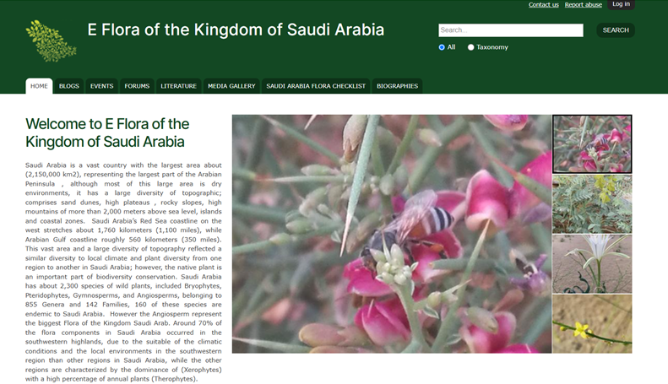

Procedure:
- Select a Plant Specimen: Choose a plant found in Saudi Arabia.
- Observe Morphological Features: Note leaf shape, venation, flower structure, and other distinctive traits.
- Capture Images: Take clear photographs of various plant parts for reference.
- Access Online Database: Visit the Flora of Saudi Arabia online database.
- Search for Similar Species: Use search filters based on observed characteristics.
- Compare Features: Match plant features with the descriptions in the database.
- Record Findings: Document scientific and common names, family, and key characteristics.

Observations Table:
Plant Feature | Description
Leaf Shape | _________
Flower Color | _________
Stem Type | _________
Venation Pattern | _________
Fruit Type | _________
Family Name | _________
Scientific Name | _________

Result: The plant was identified as (Scientific Name) belonging to the (Family Name) family.

Conclusion: Using online databases significantly improves accuracy in plant identification. The Flora of Saudi Arabia is a reliable tool for classifying regional plant species.

Precautions:
- Ensure plant collection is done ethically and legally.
- Cross-check findings with multiple sources for accuracy.
- Handle plants with care to avoid damage.
- Use clear images for better identification results.
- Follow proper botanical terminology while noting observations.

Lab Activity No 02
Title of the Activity: Study of Stomata and Its Characters for Taxonomical Studies

Learning Objectives:
- To understand the role of stomata in plant taxonomy.
- To examine different types of stomata in plant species.
- To analyze stomatal characteristics for classification purposes.

Aim: To study stomatal structure and its variations in different plant species for taxonomical classification.

Apparatus:
- Microscope
- Glass slides and cover slips
- Forceps
- Scalpel or blade
- Staining solution (safranin or iodine)
- Distilled water
- Blotting paper
- Notebook and pen
- Plant leaves (collected ethically and legally)

Theory: Stomata are microscopic pores on plant leaves and stems that regulate gas exchange. Their structure, distribution, and type vary among plant taxa, making them valuable for classification. Stomatal types include anomocytic, paracytic, diacytic, and actinocytic, among others. The study of stomatal characters provides insights into evolutionary relationships and adaptation mechanisms in plants.

Diagram:

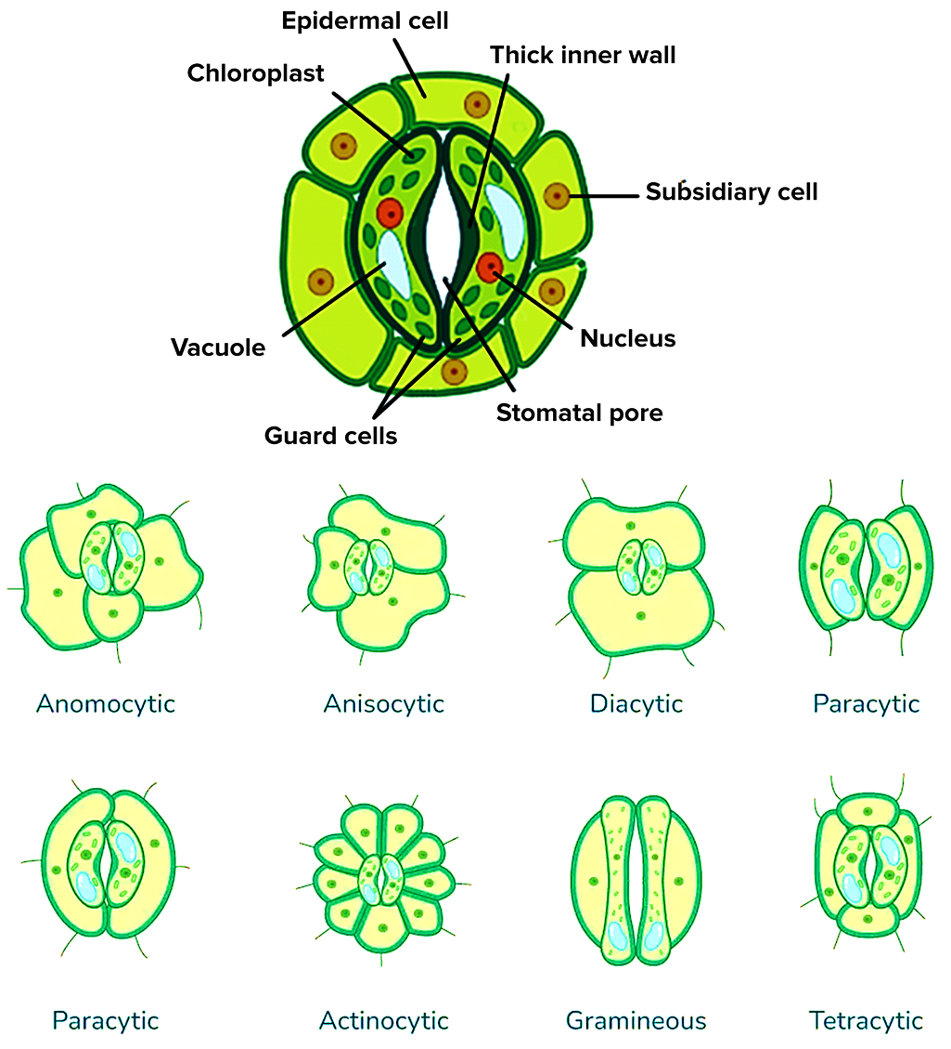

Procedure:
- Select Plant Specimens: Collect leaves from different plant species.
- Prepare Leaf Peel: Remove the epidermal layer using forceps.
- Stain the Sample: Apply a staining solution to highlight stomatal structures.
- Place on Slide: Mount the stained epidermal peel on a slide with a cover slip.
- Observe Under Microscope: Examine stomatal structure and count their distribution.
- Record Stomatal Features: Note the stomatal type, size, density, and arrangement.
- Compare Across Species: Identify taxonomical differences and similarities.

Observations Table:
Plant Name | Stomatal Type | Stomatal Density | Additional Features
_________ | _________ | _________ | _________
_________ | _________ | _________ | _________

Result: The stomatal characteristics of different plant species were analyzed and classified based on their taxonomical significance.

Conclusion: Stomatal structure and density vary among plant species and serve as an essential criterion for plant taxonomy. Their study provides valuable insights into species differentiation and evolutionary adaptations.

Precautions:
- Handle plant specimens carefully to avoid tissue damage.
- Use appropriate staining techniques for clear microscopic observation.
- Ensure proper focusing while using the microscope.
- Cross-check observations with reliable botanical references.
- Maintain ethical standards while collecting plant specimens.

Lab Activity No 03
Title of the Activity: Study of Trichomes and Their Characters for Taxonomical Studies

Learning Objectives:
- To understand the role of trichomes in plant taxonomy.
- To examine different types of trichomes in plant species.
- To analyze trichomal characteristics for classification purposes.

Aim: To study trichome structure and its variations in different plant species for taxonomical classification.

Apparatus:
- Microscope
- Glass slides and cover slips
- Forceps
- Scalpel or blade
- Staining solution (safranin or iodine)
- Distilled water
- Blotting paper
- Notebook and pen
- Plant specimens (collected ethically and legally)

Theory: Trichomes are hair-like outgrowths on the epidermis of plant organs such as leaves, stems, and flowers. They play a significant role in plant defense, water retention, and taxonomy. Trichomes are classified into glandular and non-glandular types, with further subcategories based on structure and function. The study of trichomal characters helps in distinguishing plant taxa and understanding evolutionary relationships.

Procedure:
- Select Plant Specimens: Collect leaves or stems from different plant species.
- Prepare Epidermal Peel or Section: Use a scalpel to obtain a thin layer of the epidermis.
- Stain the Sample: Apply a staining solution to enhance visibility.
- Mount on Slide: Place the prepared specimen on a slide with a cover slip.
- Observe Under Microscope: Identify and categorize trichomes based on morphology.
- Record Trichomal Features: Note type, size, density, and distribution of trichomes.
- Compare Across Species: Identify taxonomical differences and similarities.

Diagram:

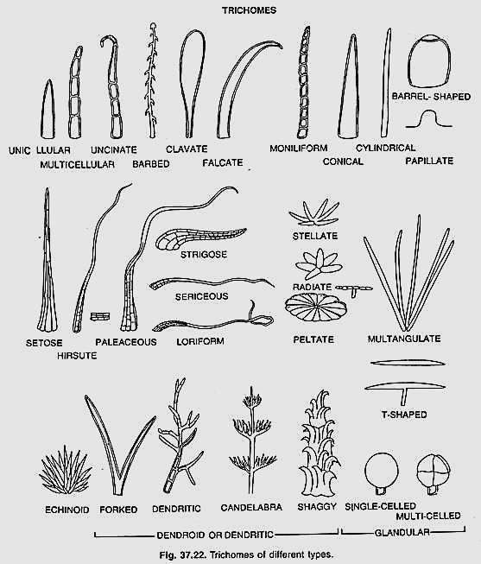
Observations Table:
Plant Name | Trichome Type | Trichome Density | Additional Features
_________ | _________ | _________ | _________
_________ | _________ | _________ | _________

Result: The trichomal characteristics of different plant species were analyzed and classified based on their taxonomical significance.

Conclusion: Trichome structure and density vary among plant species and serve as an essential criterion for plant taxonomy. Their study provides valuable insights into species differentiation and evolutionary adaptations.

Precautions:
- Handle plant specimens carefully to avoid tissue damage.
- Use appropriate staining techniques for clear microscopic observation.
- Ensure proper focusing while using the microscope.
- Cross-check observations with reliable botanical references.
- Maintain ethical standards while collecting plant specimens.

Lab Activity No 04
Title of the Activity: Study of Spermoderm and Its Characters for Taxonomical Studies

Learning Objectives:
- To understand the role of spermoderm (seed coat) in plant taxonomy.
- To examine different types of seed coat structures in plant species.
- To analyze spermoderm characteristics for classification purposes.

Aim: To study spermoderm structure and its variations in different plant species for taxonomical classification.

Apparatus:
- Microscope
- Glass slides and cover slips
- Forceps
- Scalpel or blade
- Staining solution (safranin or iodine)
- Distilled water
- Blotting paper
- Notebook and pen
- Seed specimens (collected ethically and legally)

Theory: The spermoderm, or seed coat, is the outer protective layer of a seed. It varies in texture, thickness, pattern, and cell structure, which are significant in plant taxonomy. Spermoderm characteristics such as reticulation, presence of trichomes, and surface ornamentation help in identifying and classifying plant species. The study of spermoderm provides insights into evolutionary relationships and adaptation mechanisms.

Diagram:

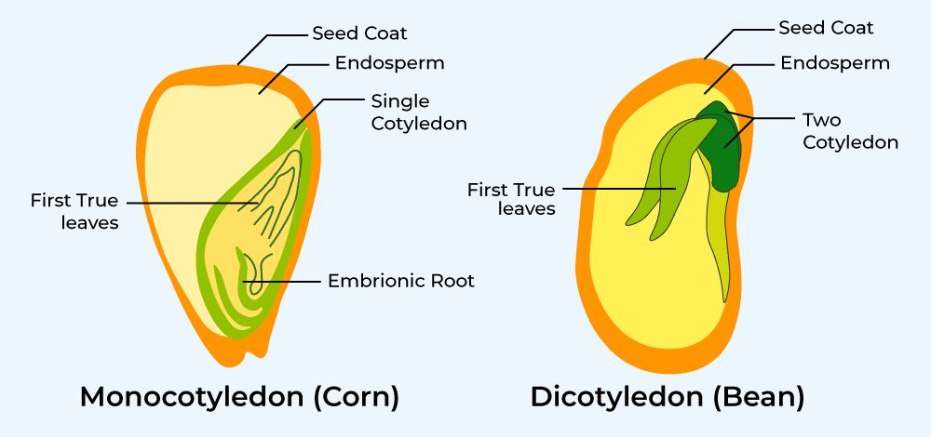

Procedure:
- Select Seed Specimens: Collect seeds from different plant species.
- Prepare Thin Sections: Use a scalpel to obtain a thin section of the seed coat.
- Stain the Sample: Apply a staining solution to enhance microscopic visibility.
- Mount on Slide: Place the prepared section on a slide with a cover slip.
- Observe Under Microscope: Identify and categorize spermoderm based on texture and structure.
- Record Spermoderm Features: Note surface patterns, cell arrangement, thickness, and additional characteristics.
- Compare across Species: Identify taxonomical differences and similarities.

Observations Table:
Plant Name | Spermoderm Type | Surface Texture | Additional Features
_________ | _________ | _________ | _________
_________ | _________ | _________ | _________

Result: The spermoderm characteristics of different plant species were analyzed and classified based on their taxonomical significance.

Conclusion: Spermoderm structure and texture vary among plant species and serve as an essential criterion for plant taxonomy. Their study provides valuable insights into species differentiation and evolutionary adaptations.

Precautions:
- Handle seed specimens carefully to avoid damage.
- Use appropriate staining techniques for clear microscopic observation.
- Ensure proper focusing while using the microscope.
- Cross-check observations with reliable botanical references.
- Maintain ethical standards while collecting plant specimens.

Lab Activity No 05
Title of the Activity: Preparation of Pollen from Different Flowers for Palynological Studies

Learning Objectives:
- To understand the significance of pollen in plant taxonomy.
- To learn methods for extracting and preparing pollen samples.
- To analyze pollen morphology and its role in classification.

Aim: To prepare and examine pollen from different flowers for palynological studies.
Apparatus:
- Microscope
- Glass slides and cover slips
- Forceps
- Scalpel or blade
- Acetolysis mixture (acetic anhydride & sulfuric acid) (optional)
- Staining solution (safranin or fuchsin)
- Distilled water
- Blotting paper
- Notebook and pen
- Fresh flowers (collected ethically and legally)

Theory: Palynology is the study of pollen and spores, which are significant in plant taxonomy, paleobotany, and evolutionary studies. Pollen morphology, including shape, size, aperture type, and exine ornamentation, helps in identifying plant species and understanding their evolutionary adaptations. Pollen grains can be extracted and observed under a microscope to study their taxonomic characteristics.

Procedure:
- Select Flower Specimens: Collect fresh flowers from different plant species.
- Extract Pollen: Use forceps to gently remove anthers from flowers.
- Transfer Pollen to Slide: Tap or crush the anthers on a clean glass slide.
- Stain the Sample: Add a drop of staining solution to enhance visibility.
- Mount with Cover Slip: Place a cover slip carefully over the sample.
- Observe Under Microscope: Examine pollen shape, aperture, and surface ornamentation.
- Record Observations: Note key characteristics and compare pollen structures across species.

Diagram:

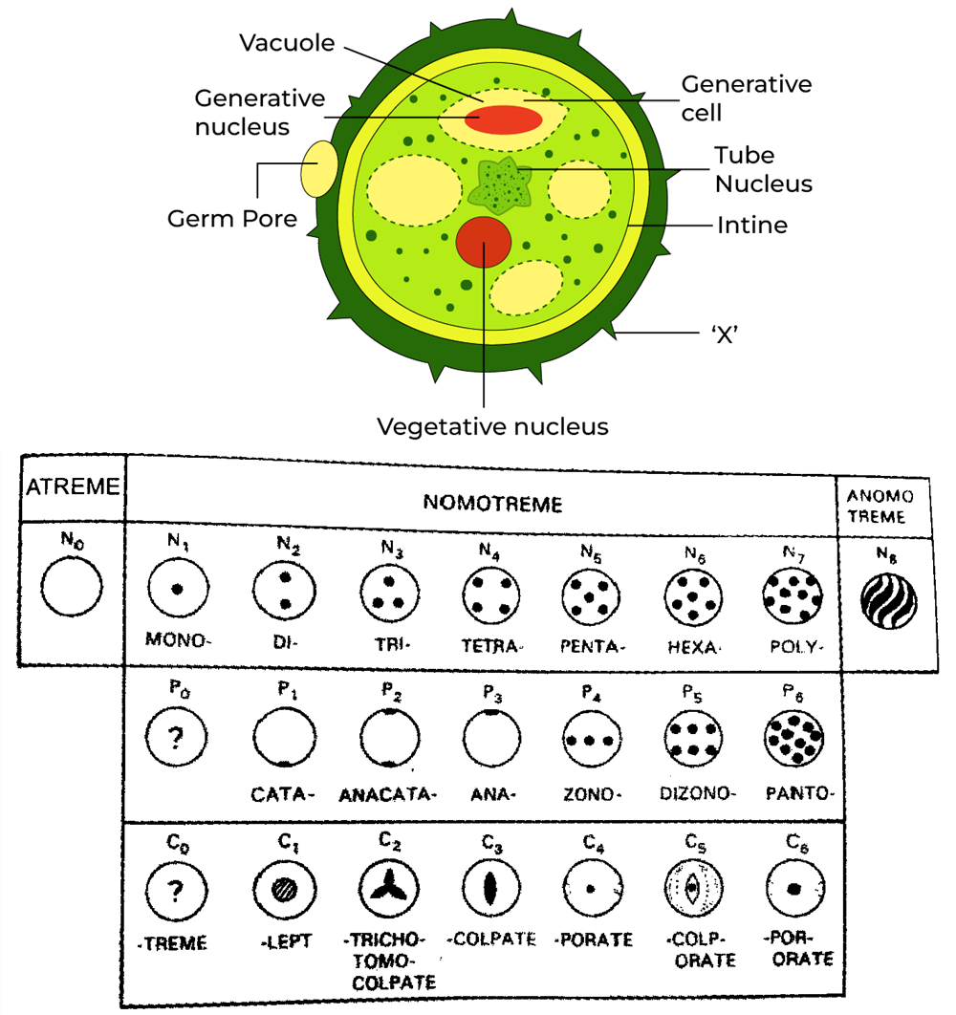

Observations Table:
Plant Name | Pollen Shape | Aperture Type | Surface Ornamentation
_________ | _________ | _________ | _________
_________ | _________ | _________ | _________

Result: The pollen characteristics of different plant species were analyzed and classified based on their palynological significance.

Conclusion: Pollen morphology varies among plant species and serves as an essential tool in taxonomy and evolutionary studies. The study of pollen helps in species identification and classification.

Precautions:
- Handle flower specimens carefully to avoid damage.
- Use appropriate staining techniques for clear microscopic observation.
- Ensure proper focusing while using the microscope.
- Cross-check observations with reliable botanical references.
- Maintain ethical standards while collecting plant specimens.

Lab Activity No 06
Title of the Activity: Preparation of Root Tip Mitosis Slides for Cytotaxonomical Studies

Learning Objectives:
- To understand the significance of mitotic studies in plant taxonomy.
- To learn the method of preparing root tip mitosis slides.
- To analyze chromosomal characteristics for cytotaxonomical classification.

Aim: To prepare and examine root tip mitosis slides for cytotaxonomical studies.

Apparatus:
- Microscope
- Glass slides and cover slips
- Forceps
- Scalpel or blade
- Hydrochloric acid (HCl) (1N)
- Aceto-orcein or Feulgen stain
- Distilled water
- Blotting paper
- Notebook and pen
- Root tips (onion, garlic, or other suitable plants)

Theory: Cytotaxonomy is the classification of plants based on chromosomal characteristics. The study of mitosis in root tips helps in understanding chromosome number, structure, and behavior, which are essential for species identification and evolutionary studies. Actively dividing cells in the meristematic region of root tips provide clear mitotic stages for cytological examination.

Diagram:

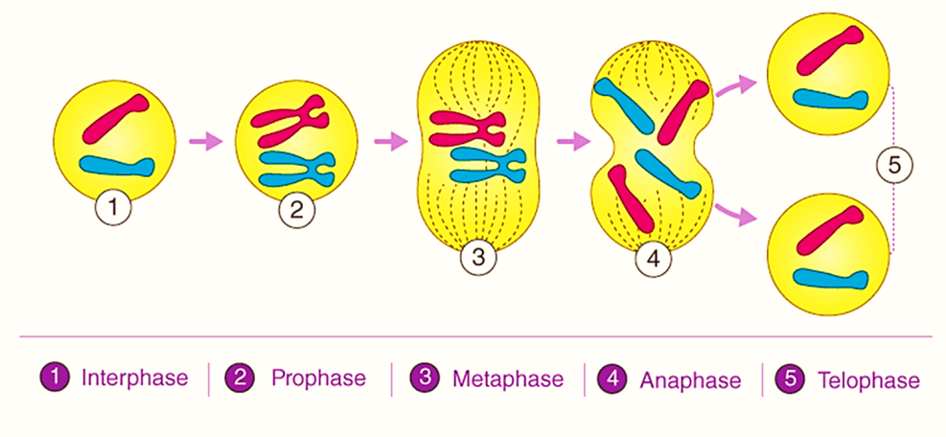

Procedure:
- Select Root Tips: Collect fresh root tips (1-2 cm) from actively growing plants.
- Pre-Treatment: Immerse root tips in 1N HCl at 60°C for 5 minutes to soften tissues.
- Staining: Transfer root tips to aceto-orcein stain for 10-15 minutes.
- Slide Preparation: Place a stained root tip on a slide, add a drop of stain, and gently squash with a cover slip.
- Observe Under Microscope: Identify different stages of mitosis (prophase, metaphase, anaphase, telophase).
- Record Observations: Note chromosome number, shape, and any abnormalities.

Observations Table:
Plant Name | Chromosome Number | Mitotic Stages Observed | Chromosome Features
_________ | _________ | _________ | _________
_________ | _________ | _________ | _________

Result: The mitotic chromosomes of different plant species were analyzed and classified based on their cytotaxonomical significance.

Conclusion: Cytological analysis of mitotic chromosomes provides valuable insights into plant taxonomy and evolutionary relationships. Differences in chromosome number and structure are useful for distinguishing plant species.

Precautions:
- Handle chemicals carefully and use safety measures.
- Use fresh root tips for optimal mitotic activity.
- Ensure proper staining for clear chromosomal visibility.
- Avoid air bubbles while placing the cover slip.
- Cross-check chromosome counts with reliable cytological references.

Lab Activity No 07
Title of the Activity: Tissue Sampling for Molecular Studies

Learning Objectives:
- To understand the importance of tissue sampling in molecular studies.
- To learn the proper method for collecting and preserving plant tissue samples.
- To analyze DNA extraction and molecular techniques for taxonomical classification.

Aim: To collect and preserve plant tissue samples for molecular studies such as DNA extraction and genetic analysis.

Apparatus:
- Sterile forceps and scissors
- Microcentrifuge tubes (1.5 mL or 2 mL)
- Liquid nitrogen or silica gel
- Ethanol (70%)
- Gloves and lab coat
- Notebook and pen
- Fresh plant leaves, stems, or root samples

Theory: Molecular taxonomy relies on DNA sequencing and genetic markers to classify plants accurately. Proper tissue sampling ensures high-quality DNA extraction, which is crucial for PCR, sequencing, and phylogenetic studies. Fresh or properly preserved tissue samples yield better molecular data for taxonomic research.

Procedure:
- Select Plant Samples: Choose healthy and contamination-free plant tissues (leaves, stems, or roots).
- Disinfect Equipment: Sterilize forceps and scissors with ethanol before use.
- Collect Tissue Samples: Cut a small portion of leaf, stem, or root (approximately 1 cm²).
- Preserve the Sample:
  - For immediate processing: Store in microcentrifuge tubes and freeze with liquid nitrogen.
  - For later processing: Dry the tissue using silica gel and store at room temperature.
- Label and Document: Record sample details, including species name, location, and date of collection.
- Transport to Lab: Ensure proper handling and transport to avoid DNA degradation.

Diagram:

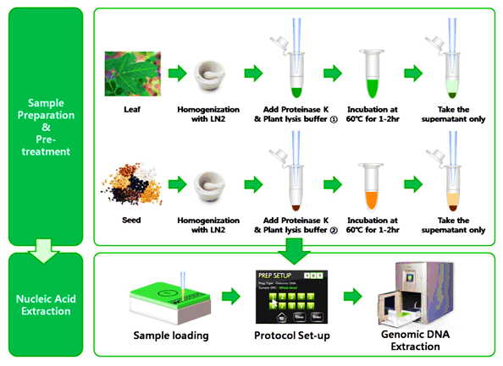

Observations Table:
Plant Name | Tissue Type | Preservation Method | Sample Condition
_________ | _________ | _________ | _________
_________ | _________ | _________ | _________

Result: The plant tissue samples were successfully collected and preserved for molecular analysis.

Conclusion: Proper tissue sampling and preservation are crucial for high-quality molecular studies. The collected samples can be used for DNA extraction, sequencing, and phylogenetic classification in plant taxonomy.

Precautions:
- Use sterile tools to prevent contamination.
- Avoid prolonged exposure of samples to heat or moisture.
- Ensure proper labeling and documentation.
- Wear gloves and handle chemicals with care.
- Transport frozen samples with dry ice to prevent DNA degradation.

Lab Activity No 08
Title of the Activity: Study of Tools for Molecular Phylogeny

Learning Objectives:
- To understand the significance of molecular tools in phylogenetic studies.
- To learn about different molecular techniques used in phylogenetic analysis.
- To analyze DNA sequences for evolutionary relationships.

Aim: To study various tools and techniques used for molecular phylogenetic analysis in plant taxonomy.

Apparatus:
- PCR machine
- Gel electrophoresis unit
- Spectrophotometer
- DNA extraction kit
- Computer with bioinformatics software
- Pipettes and microcentrifuge tubes
- Gloves and lab coat

Theory: Molecular phylogeny involves the analysis of genetic material to determine evolutionary relationships among organisms. Various molecular tools such as PCR, DNA sequencing, and bioinformatics software help in constructing phylogenetic trees. Molecular markers like rbcL, matK, and ITS regions are commonly used for plant phylogenetic studies.

Procedure:
- DNA Extraction: Isolate DNA from plant tissue using an extraction kit.
- PCR Amplification: Use specific primers to amplify target DNA regions.
- Gel Electrophoresis: Confirm amplification by running PCR products on an agarose gel.
- DNA Sequencing: Sequence the amplified DNA using Sanger or NGS techniques.
- Sequence Analysis: Use bioinformatics tools to align and compare sequences.
- Phylogenetic Tree Construction: Generate a phylogenetic tree using software like MEGA, PAUP, or PhyML.

Observations Table:
Sample ID | Marker Used | Sequence Length | Phylogenetic Relationship
_________ | _________ | _________ | _________
_________ | _________ | _________ | _________
Diagram:
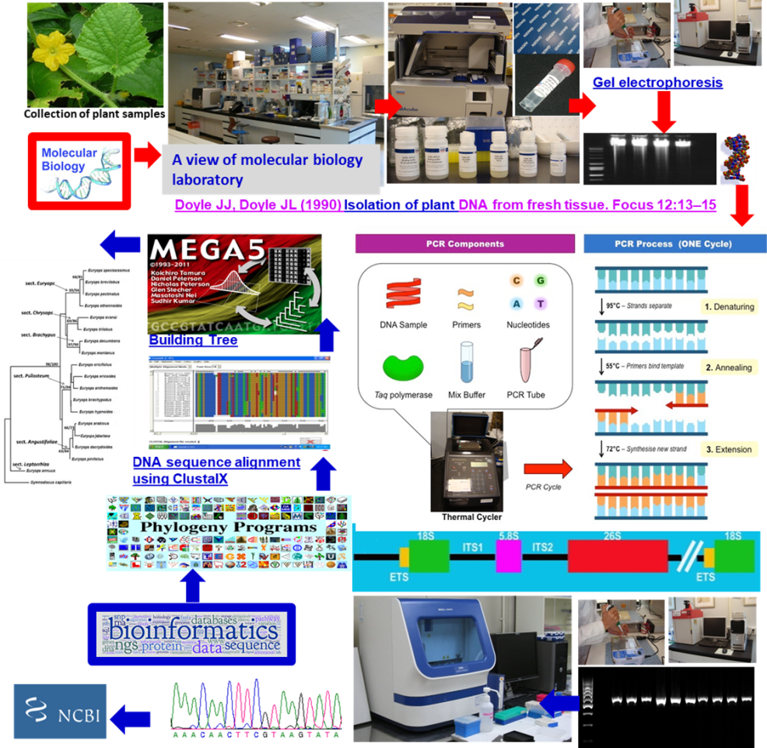

Result: The molecular tools used in phylogenetic studies were successfully applied to analyze evolutionary relationships among plant species.

Conclusion: Molecular phylogenetics provides a reliable method for understanding plant evolution. The use of molecular markers and bioinformatics tools helps in constructing phylogenetic trees and classifying species based on genetic data.

Precautions:
- Use sterile techniques to prevent DNA contamination.
- Handle PCR and sequencing reagents with care.
- Ensure proper calibration of bioinformatics software.
- Cross-check sequence alignments for accuracy.
- Store DNA samples properly to prevent degradation.

Lab Activity No 09
Title of the Activity: Retrieval of GenBank Sequence

Learning Objectives:
- To understand the process of retrieving genetic sequences from GenBank.
- To learn how to use online bioinformatics databases for molecular studies.
- To analyze retrieved sequences for phylogenetic and taxonomic studies.

Aim: To retrieve and analyze genetic sequences from GenBank for molecular phylogenetic research.

Apparatus:
- Computer with internet access
- NCBI GenBank database (https://www.ncbi.nlm.nih.gov/genbank/)
- Bioinformatics software (MEGA, BioEdit, or BLAST)
- Notebook and pen

Theory: GenBank is a publicly available database maintained by the National Center for Biotechnology Information (NCBI). It stores DNA and protein sequences submitted by researchers worldwide. These sequences can be retrieved and analyzed for evolutionary, taxonomic, and functional studies using various bioinformatics tools. Molecular markers such as rbcL, matK, and ITS regions are commonly retrieved for plant phylogenetic analysis.

Diagram:
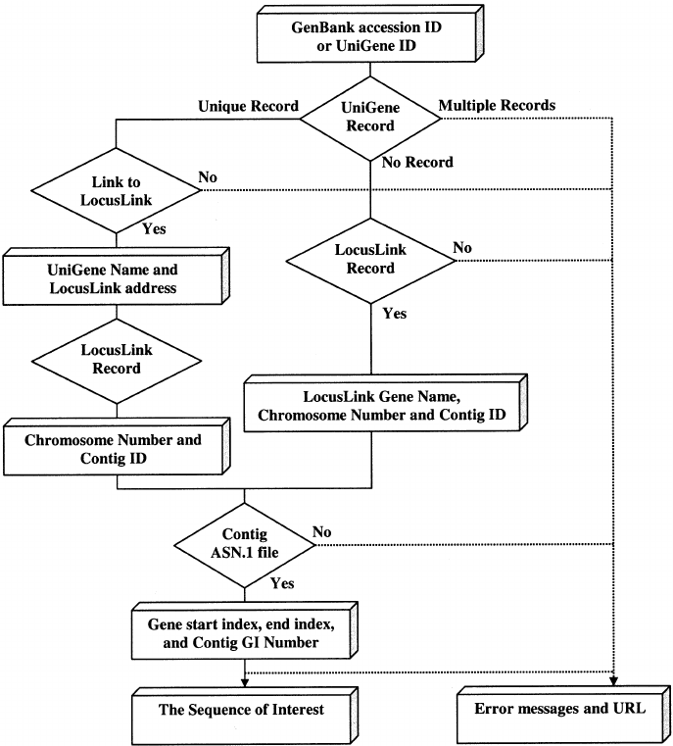

Procedure:
- Access GenBank: Open the NCBI GenBank website.
- Search for a Specific Gene or Organism: Use the search bar to enter a gene name (e.g., rbcL) or organism.
- Filter Search Results: Select sequences based on relevance, completeness, and source.
- Retrieve FASTA Format: Download the sequence in FASTA format for further analysis.
- Analyze the Sequence: Use tools such as BLAST for similarity searches and MEGA for phylogenetic tree construction.
- Store and Document Data: Save the retrieved sequences and record accession numbers for reference.

Observations Table:
Accession Number | Gene Name | Organism | Sequence Length
_________ | ________ | ________ | ________
_________ | ________ | ________ | ________

Result: Genetic sequences were successfully retrieved from GenBank and analyzed for molecular studies.

Conclusion: The retrieval of genetic sequences from GenBank is an essential step in molecular phylogenetics. The sequences can be used for evolutionary analysis, species identification, and taxonomic classification.

Precautions:
- Verify the reliability of sequences before using them for analysis.
- Use correct search filters to obtain accurate and relevant sequences.
- Ensure proper documentation of retrieved accession numbers.
- Cross-check sequence alignments for consistency.
- Use appropriate bioinformatics tools for data analysis.

Lab Activity No 10
Title of the Activity: Study of Phylogenetic Tree

Learning Objectives:
- To understand the concept and significance of phylogenetic trees in evolutionary biology.
- To learn how to construct and interpret phylogenetic trees using molecular data.
- To analyze evolutionary relationships among different species.

Aim: To construct and study phylogenetic trees using molecular sequences for understanding evolutionary relationships.

Apparatus:
- Computer with internet access
- Bioinformatics software (MEGA, PhyML, RAxML, or Clustal Omega)
- NCBI GenBank database (for retrieving sequences)
- Notebook and pen

Theory: A phylogenetic tree is a graphical representation of evolutionary relationships among organisms based on genetic or morphological data. Molecular phylogenetics uses DNA or protein sequences to infer evolutionary history. Common methods for tree construction include:
- Neighbor-Joining (NJ): A distance-based method for quick tree construction.
- Maximum Likelihood (ML): A statistical approach to infer the best tree topology.
- Bayesian Inference (BI): A probabilistic model for phylogenetic reconstruction.
- Parsimony: Selects the tree with the fewest evolutionary changes.

Diagram:

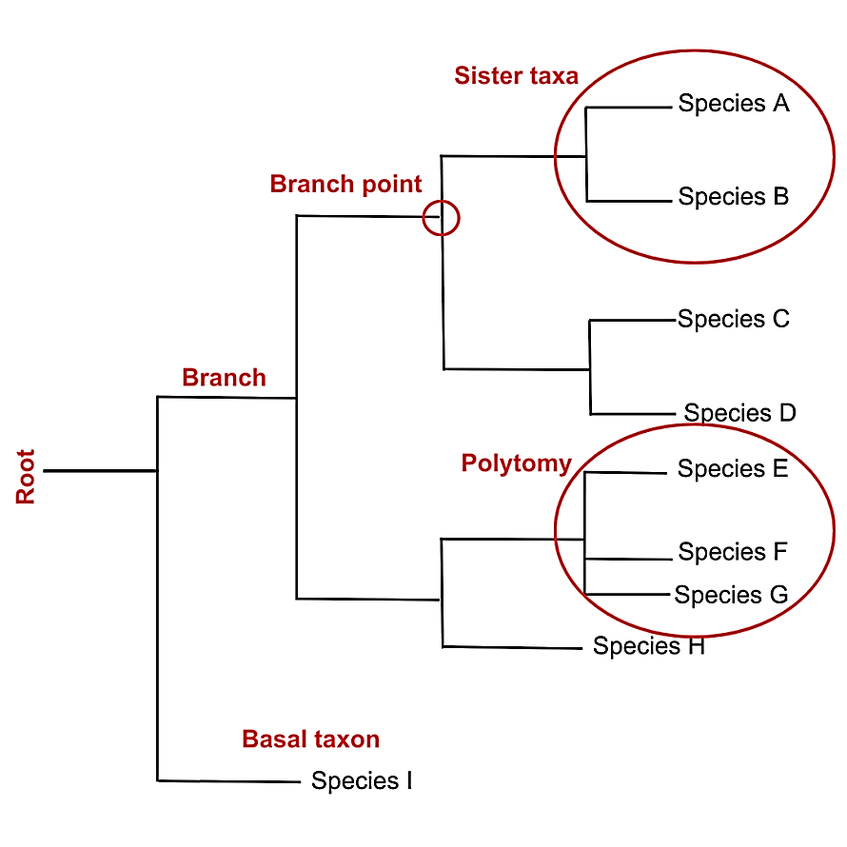

Procedure:
- Retrieve Sequences: Download DNA or protein sequences from GenBank.
- Sequence Alignment: Use Clustal Omega or MUSCLE for multiple sequence alignment.
- Model Selection: Determine the best substitution model using MEGA or jModelTest.
- Tree Construction:
  - Use Neighbor-Joining (NJ) for a quick estimate.
  - Apply Maximum Likelihood (ML) or Bayesian Inference (BI) for accuracy.
- Interpret Results: Analyze branch lengths, bootstrap values, and clade relationships.
- Visualize the Tree: Use FigTree or iTOL for graphical representation.

Observations Table:
Sample ID | Method Used | Tree Type | Evolutionary Relationship
_________ | _________ | _________ | _________
_________ | _________ | _________ | _________

Result: Phylogenetic trees were successfully constructed, and evolutionary relationships among species were analyzed.

Conclusion: Phylogenetic trees help in understanding evolutionary patterns, species divergence, and taxonomic classifications. Molecular methods provide reliable insights into genetic relationships.

Precautions:
- Use high-quality sequence data for accurate results.
- Ensure proper sequence alignment before tree construction.
- Select the appropriate evolutionary model for analysis.
- Interpret bootstrap values carefully to assess tree reliability.
- Cross-check results using multiple phylogenetic methods.

