(1)

World Arabic Language Day (18 December 2012)

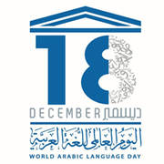

Languages contribute to the beauty of the world because each one enriches that which it names. Our languages are not only tools of communication, they carry values and identities. Linguistic diversity broadens the mind and provides the means to build intercultural and interreligious dialogue based on genuine mutual understanding. World Arabic Language Day is an opportunity to celebrate the language of 22 Member States of UNESCO, a language with more than 422 million speakers in the Arab world and used by more than 1.5 billion Muslims.
Celebrating the Arabic Language is also acknowledging the tremendous contribution of its writers, scientists and artists to universal culture. These are the Arabic language authors who enabled the transmission of Greek knowledge to the Latin of medieval Europe, weaving indissoluble ties between cultures through time. The works of Averroës, Ibn Khaldun and Naguib Mahfouz are among the most profound of the human spirit and it is in Arabic that they deliver their full power. This love and fascination for the language – expressed for example in calligraphy and poetry, so dear to the Arab culture – is a crucible from which the greatest cultures have emerged.

