Acupuncture TENS for the treatment of Tennis elbow
Students: Tarfah AlGhanim & Nuha AlMaimani
ID: 432202298 - 432201065

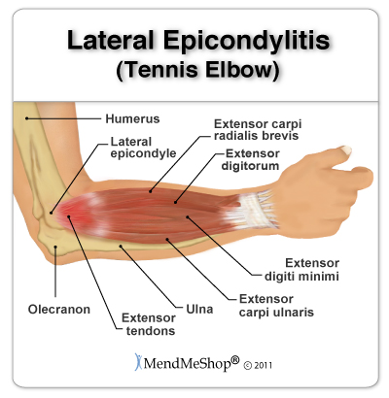

Tennis elbow:
Tennis elbow is an overuse injury occurring in the lateral side of the elbow region, but more specifically it occurs at the common extensor tendon that originates from the lateral epicondyle. The acute pain that a person might feel occurs when they fully extend their arm.

Main symptoms:
pain
tenderness
sometimes swelling

EFFECTS OF TENNIS ELBOW:
- wrist weakness
- hand grip weakness
- pain when the elbow is bent backwards against resistance
- pain in the forearm
- pain when fingers are straightened against resistance

Acupuncture is the best effective treatment for tennis elbow because:.
  - IT HAS side effect free pain relief effect
  - It is helpful in the repair and rehabilitation of tennis elbow. because IT has a natural anti-inflammatory effect.
  - .it helps to boost the body’s natural immune response to encourage healing of the tendons of the outer elbow

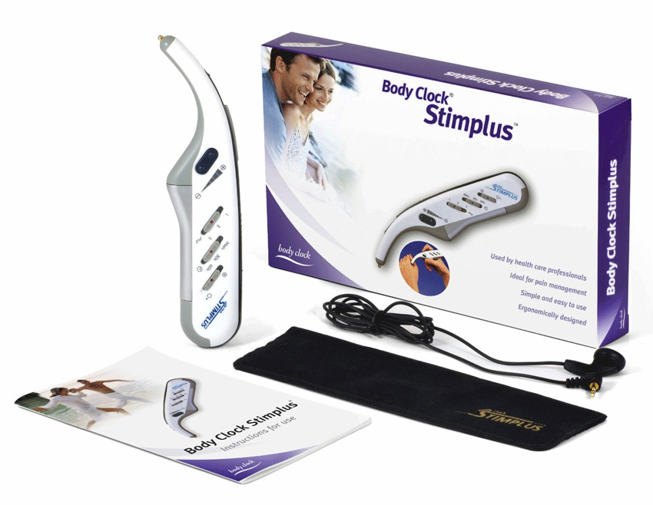

Safety:
Safety of TENS devices for use during pregnancy or delivery has not been established. For external use only. Electronic equipment such as EKG monitors and EKG alarms may not operate properly when TENS is in use. The user must keep the device out of the reach of children. Also, this device should not be used over metal implants or sleep apnea monitors.

TENS is not recommended for patients with known heart disease without a physician's evaluation of risk. Do not stimulate over the eyes or carotid sinus nerves. Do not apply TENS for
1. undiagnosed pain syndromes until etiology is established.
2. electrode placement that causes current to flow transcerebrally (through the head).

Precautions :
Avoid adjusting controls while operating machinery or vehicles. Turn the stimulator off before applying or removing electrodes. Long-term stimulation at the same electrode site may cause skin irritation. Use only for the specific pain problem prescribed by the physician. Effectiveness is dependent upon patient selection.

Electrode placement:
Wear the cuff and place it near to your elbow and apply gel on it. Also apply gel on the tip of the electrode. Connect the cuff to the device. Move the device on your elbow and around it to indicate the acupuncture points.

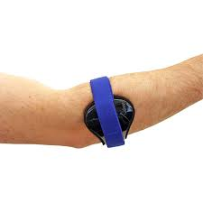

Application:
Switch the power button to “on”. For time selector switch, choose 30s or 60s according to the patient’s condition (acute or chronic). Also intensity should be chose (maximum or minimum) according to the patient’s condition. Rhythm switch is for turning the sound “on” or “off” when applying the current press on the button on the top (stim switch).

