**Magnetism in materials,675 PHY**

**Contents**



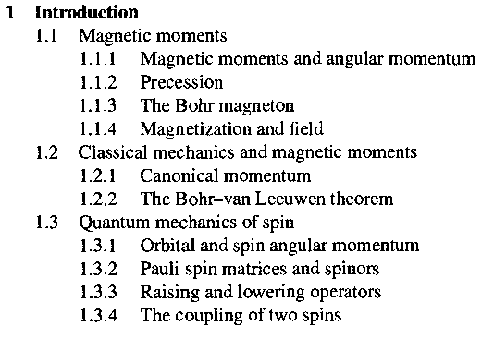

**Chapter one: **



**Chapter two: 2 **



**Chapter four: 3 **





**Chapter five: 4 **



**Chapter six: **





