Course Title: | Ecological Field Training
Course Code: | BOT 492 5(0+0+10)
Program: | Botany
Department: | Department of Botany And Microbiology
College: | Science
Institution: | King Saud University

Table of Contents
A. Field Experience Identification 3
B. Learning Outcomes, and Training and Assessment Methods 3
1. Field Experience Learning Outcomes 3
2.Alignment of Learning Outcomes with Training and Assessment Methods/ Activities 3
3. Field Experience Learning Outcomes Assessment 4
C. Field Experience Administration 4
1. Field Experience Locations 4
2. Supervisory Staff 4
3. Responsibilities 5
4. Field Experience Implementation 5
5. Safety and Risk Management 6
G. Training Quality Evaluation 6
E. Specification Approval Data 6

A. Field Experience Identification
1. Credit hours: 5 (0+ 0 + 10 )
2. Level/year at which this course is offered: 7 level summer course
3. Dates and times allocation of field experience activities.
- Number of weeks: (4.) week
- Number of days: (28.) day
- Number of hours: (5.) hour
4. Pre-requisites to join field experience (if any): 75 unit

B. Learning Outcomes, and Training and Assessment Methods

1. Field Experience Learning Outcomes
CLOs |  | Aligned PLOs
1 | Knowledge and Understanding
1.1 | Students will be able to describe the different ecosystem and habitats of Saudi Arabia
1.2 | Students will be able to identify plant specimens and classify according their taxonomical position in different habitats and the ecological factors affecting the distribution of vegetation.
1.3
1...
2 | Skills:
2.1 | Students will be able to apply the numerical analysis for classification and ordination of plant communities and soil analysis and introduce presentation.
2.2 | Students will be able to extract, explain and the distribution of the plant communities and their associations with special reference to their adaptations to these habitats
2.3
2...
3 | Values:
3.1 | Students will be able to use ecological methods & working in groups or independently and take up responsibility in the field
3.2 | Students will be able to use statistical and numerical ecological computer programs, libraries, Internet, Books and scientific forums for data analysis and write report.
3.3
3...

2.Alignment of Learning Outcomes with Training Activities and Assessment Methods
Code | Learning Outcomes | Training Methods/Activities | Assessment Methods
1.0 | Knowledge and Understanding
1.1 | Students will be able to describe the different ecosystem and habitats of Saudi Arabia | Mentoring and visiting different ecosystem and habitats (protected and non protected wild regions). | Group working, tutorial session & discussion
1.2 | Students will be able to identify plant specimens and classify according their taxonomical position in different habitats and the ecological factors affecting the distribution of vegetation. | Collecting herbarium samples and applies the multi-plot methods for assessment of vegetation and diversity attributes.  Field soil, plant sampling and analyzing | Research project and Final report
…
2.0 | Skills
2.1 | Students will be able to apply the numerical analysis for classification and ordination of plant communities and soil analysis and introduce presentation. | Gathering and collecting the vegetation and soil data from the field. Weekly duties Attend field trips | Group working & discussion Performance evaluation and practical report
2.2 | Students will be able to extract, explain and the distribution of the plant communities and their associations with special reference to their adaptations to these habitats | Formatting vegetation data in XLS Models. Tutorial, field trip, lab work | Research project and Final report
…
3.0 | Values
3.1 | Students will be able to use ecological methods & working in groups or independently and take up responsibility in the field observations. | Plant herbarium and samples collection in the field | Research project & Presentation
3.2 | Students will be able to use statistical and numerical ecological computer programs, libraries, Internet, Books and scientific forums for data analysis and write report. | Use of vegetation numerical tools e.g. analytical Programs tools in vegetation description | Final Report
…

3. Field Experience Learning Outcomes Assessment
a. Students Assessment Timetable
# | Assessment task* | Assessment timing  (Week) | Percentage  of Total Assessment Score
1 | Test evaluation: Preparation of field trip tools: Classroom preparation—covering important information about the upcoming trip, including when and where the trip will be, the purpose of the trip, what to wear and bring, etc. | 1 | 5
2 | Test evaluation: Monitoring of habitats and samples selection: Collaboration—communication between the facilitator and the teacher to clarify learning goals and mutual expectations. | 2 | 15
3 | Test evaluation: Connection to curriculum—making explicit connections between the field trip content and the students’ classroom curriculum | 2 | 15
4 | Activity evolution: Herbarium specimen’s quality. | 3 | 15
5 | Activity evolution: Soil and data analysis | 4 | 10
6 | Oral presentation and Final Report | 5 | 40
7 | Total |  | 100
8
*Assessment task (i.e., Practical test, oral test, presentation, group project, essay, etc.)
b. Assessment Responsibilities
م | Category | Assessment Responsibility
1 | Teaching Staff | -Experience in the field of education for the course  - Ability to communicate effectively  - Communicate with training site officials  - Receive reports from students  - Dissemination of student feedback  - Correct reports and monitor scores
2 | Field Supervisor | Communicate with training site officials field experience locations.  -Monitoring attendance and absence  -Supervising students at field experience locations.  -Monitoring attendance and absence
3 | Others (specify)  Laboratory technician | Preparation of solutions and devices in the laboratory

C. Field Experience Administration

1. Field Experience Locations
a. Field Experience Locations Requirements
Suggested Field Experience Locations | General Requirements* | Special Requirements**
Field Trip to the natural habitats of the South Western of Saudi Arabia (Duration 28 days) | 1-Official letters for preparation funding, transports, housing etc. arranged by KSU  2-Housing, 3-Cars  4- Specimen Bags, 5-Herbarium press  6- Book notes, field manuals, Spades, Scissors, soil Augurs, lenses  7-soil kets  8- Computers  9-Programmes | safety standards kits are wanted for each student  Student with special needs has a medical specialties.
National Agriculture & Animal Resources Research Center | Official letters for preparation visit facility, transports, etc. arranged by KSU | First aid, and fire extinguisher
Saudi Commission for Wildlife |  | Car equipped with safety requirements
*Ex: provides information technology, equipment, laboratories, halls, housing, learning sources, clinics etc.
**Ex: Criteria of the training institution or related to the specialization, such as: safety standards, dealing with patients in medical specialties, etc.
b. Decision-making procedures for identifying appropriate locations for field experience
- Candidates for suitable field experience are chosen by a Program Faculty and Teaching Staff base on previous experiences and situations.
- Submit the request to the Employment and Training Unit at the University to communicate and conclude the agreements.
- After approval, contact with the department concerned with arranging the procedures of transportation and providing supervisors from the department concerned.

Supervisory staff meeting for selecting the suitable location of field trip according climate, habitat diverse, different ecosystem and topography of the land.
- Ecology study: Understanding the different plant habitats in Saudi Arabia and their ecological factors which affecting the distribution of vegetation. Analytical and structural studies on plant communities and associations with special reference of their adaptations to these habitats. Effect of human activities, pollution types and their effects on the degradation of plant habitats.
- Floristic study: Study of how to collect the plan specimens, and preserve and make herbarium specimens.
- Taxonomic study: how to identify the plant species by using Keys and flora references of Saudi Flora.

2. Supervisory Staff
a. Selection of Supervisory Staff
Selection Items | Field  Supervisor | Teaching Staff
Qualifications | - Communicate with training site officials  - Receive reports from students  - Correct reports and monitor scores | - Experience in the field of education for the course
Selection Criteria | - Dissemination of student feedback | - Ability to communicate effectively  -implementing training activities, the follow-up and evaluation of students
b. Qualification and Training of Supervisory Staff
(Including the procedures and activities used to qualify and train the supervisory staff on supervising operations, implementing training activities, the follow-up and evaluation of students, etc.)
The Coordinator of the Academic Program Unit distributes the teaching load according to the regulations governing the faculty members.

3. Responsibilities
a. Field Experience Flowchart for Responsibility
including units, departments, and committees responsible for field experience, as evidenced by the relations between them.
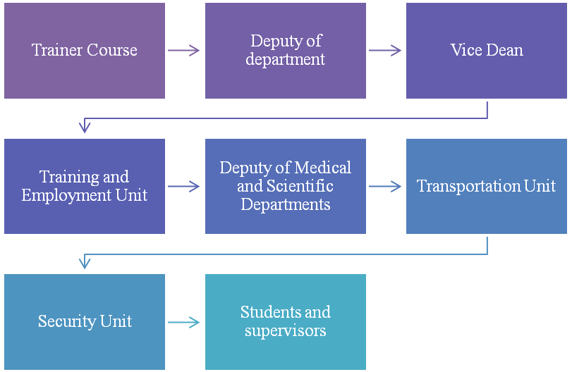

b. Distribution of Responsibilities for Field Experience Activities
Activity | Department or College | Teaching Staff | Student | Training  Organization | Field  Supervisor
Selection of a field experience site
Selection of supervisory staff
Provision of the required equipment
Provision of learning resources
Ensuring the safety of the site
Commuting to and from the field experience site
Provision of support and guidance
Implementation of training activities (duties, reports, projects, .....)
Follow up on student training activities
Adjusting attendance and leave
Assessment of learning outcomes
Evaluating the quality of field experience
Others (specify)

4. Field Experience Implementation
a. Supervision and Follow-up Mechanism
- Supervising staffs fill in Course Evaluation and Recommendations Questionnaire provided by coordinator and submit the result to evaluation staff
- Evaluation of students
- Supervising faculty received the questionnaire result sheets from students and supervising staffs and make list recommendations for improvement of field experience.
- Peer to peer evaluation.
b. Student Support and Guidance Activities
Preparing of all student field requirements and field manual guides:

5. Safety and Risk Management
Potential Risks | Safety Actions | Risk Management Procedures
- Land or Mountains height | Visit the training site before sending students , to find out the full training requirements | Communicate with the training body to ensure the application of safety and security rules
2- Allergy and another diseases | Preparing of students questionnaire for suffering of diseases | Preparing a suitable Kits of safety

G. Training Quality Evaluation
Evaluation  Areas/Issues | Evaluators | Evaluation Methods
Evaluation of students  achievement of course learning outcomes, | Coordinator or supervising staff and teaching staff | Evaluation and Recommendations
Final report | Teaching staff | Supervising faculty received the questionnaire result sheets from students and supervising staffs and make list recommendations for improvement of field experience
Training evaluation and Quality of learning resources | Independent evaluator | . Evaluate the recommendations and assess for implementation
Evaluation areas (e.g., Effectiveness of Training and assessment, Extent of achievement of course learning outcomes, Quality of learning resources, etc.)
Evaluators (Students, Supervisory Staff, Program Leaders, Peer Reviewer, Others (specify)
Assessment Methods (Direct, Indirect)
a. Students
Describe evaluation process
- Students fill in Course Evaluation and Recommendations Questionnaire provided by coordinator and submit the result to evaluation staff
- Evaluation of the training institution

b. Supervising staff in the field setting
Describe evaluation process
- Supervising staffs fill in Course Evaluation and Recommendations Questionnaire provided by coordinator and submit the result to evaluation staff
- Evaluation of students

c. Supervising faculty from the institution
Describe evaluation process
- Supervising faculty received the questionnaire result sheets from students and supervising staffs and make list recommendations for improvement of field experience.
- Peer to peer evaluation

e. Others (e.g. graduates, independent evaluator, etc.)
Describe evaluation process
Independent evaluator: Evaluate the recommendations and assess for implementation.

E. Specification Approval Data
Council / Committee
Reference No.
Date

