**Protein Metabolism**

**LEARNING OBJECTIVES**

By the end of this section, you will be able to:

* Describe how the body digests proteins.
* Explain how the urea cycle prevents toxic concentrations of nitrogen Differentiate between glucogenic and ketogenic amino acids.
* Explain how protein can be used for energy

**MEDICAL AND BIOLOGICAL IMPORTANCE1.**

1. A 70 kg human adult body contains about 12 kg of protein.2. Body proteins have life times. They undergo degradation and re-synthesis.
2. About 400gm of body protein is synthesized and degraded per day i.e., about 6 gm of protein is synthesized and broken down per kg body weight per day
3. .Aged proteins, damaged or modified proteins and non-functional proteins of the body undergo degradation. Further degradation is one way of controlling enzyme activity. Hence, continuous re-synthesis and degradation of proteins is a quality control mechanism.
4. Protein degradation may play important role in shaping tissues and organs during pregnancy and development.
5. In starvation, diabetes and tissue injury, protein degradation is more.
6. Protein synthesis and degradation is an integral part of cellular adaptation to changed. Plasma free amino acid concentration ranges from 40 to 60 mg%. Excess amino acids cannot be stored in the body. First amino group is extracted as ammonia and then carbon skeleton is oxidized to produce energy. In starvation carbon skeletons are used for glucose formation. Carbon skeletons of some amino acids produce acetyl-CoA as end product.
7. Ammonia, which is toxic to cells is converted to urea in the liver. Conversion of ammonia to urea is impaired in some inherited diseases and liver disease.
8. Amino acids are needed for the formation of specialized products like hormones, purines, pyrimidines, porphyrins, vitamins, amines, creatine and glutathione.
9. Amino acid degradation is impaired in several inherited diseases due to lack of enzymes.
10. Amino acid degradation is more in starvation, diabetes and high protein diet. Some cancer cells have high amino acid (aspargine) requirement.
11. Protein turn over in all forms of life, proteins once formed may not remain forever. Like intermediates of metabolic path ways, proteins are synthesized and degraded. Hence, body protein is in dynamic state. Continuous synthesis and degradation of protein is called as protein turnover. The rates of protein synthesis and degradation vary according to physiological needs. The rate of protein synthesis is high during growth, lactation and post-operative recovery. In starvation, cancer, fever and during morphogenesis rate of degradation of protein is more.

Much of the body is made of protein, and these proteins take on a myriad of forms. They represent cell signaling receptors, signaling molecules, structural members, enzymes, intracellular trafficking components, extracellular matrix scaffolds, ion pumps, ion channels, oxygen and CO2 transporters (hemoglobin). That is not even the complete list! There is protein in bones (collagen), muscles, and tendons; the hemoglobin that transports oxygen; and enzymes that catalyze all biochemical reactions. Protein is also used for growth and repair. Amid all these necessary functions, proteins also hold the potential to serve as a metabolic fuel source. Proteins are not stored for later use, so excess proteins must be converted into glucose or triglycerides, and used to supply energy or build energy reserves. Although the body can synthesize proteins from amino acids, food is an important source of those amino acids, especially because humans cannot synthesize all of the 20 amino acids used to build proteins.

**DIGESTION OF PROTEIN**

The digestion of proteins begins in the stomach. When protein-rich foods enter the stomach, they are greeted by a mixture of the enzyme **pepsin** and hydrochloric acid (HCl; 0.5 percent). The latter produces an environmental pH of 1.5–3.5 that denatures proteins within food. Pepsin cuts proteins into smaller polypeptides and their constituent amino acids. When the food-gastric juice mixture (chyme) enters the small intestine, the pancreas releases **sodium bicarbonate** to neutralize the HCl. This helps to protect the lining of the intestine. The small intestine also releases digestive hormones, including **secretin** and CCK, which stimulate digestive processes to break down the proteins further. Secretin also stimulates the pancreas to release sodium bicarbonate. The pancreas releases most of the digestive enzymes, including the proteases trypsin, chymotrypsin, and **elastase**, which aid protein digestion. Together, all of these enzymes break complex proteins into smaller individual amino acids ([Figure 1](https://opentextbc.ca/anatomyandphysiology/chapter/24-4-protein-metabolism/#fig-ch25_04_01)), which are then transported across the intestinal mucosa to be used to create new proteins, or to be converted into fats or acetyl CoA and used in the Krebs cycle.

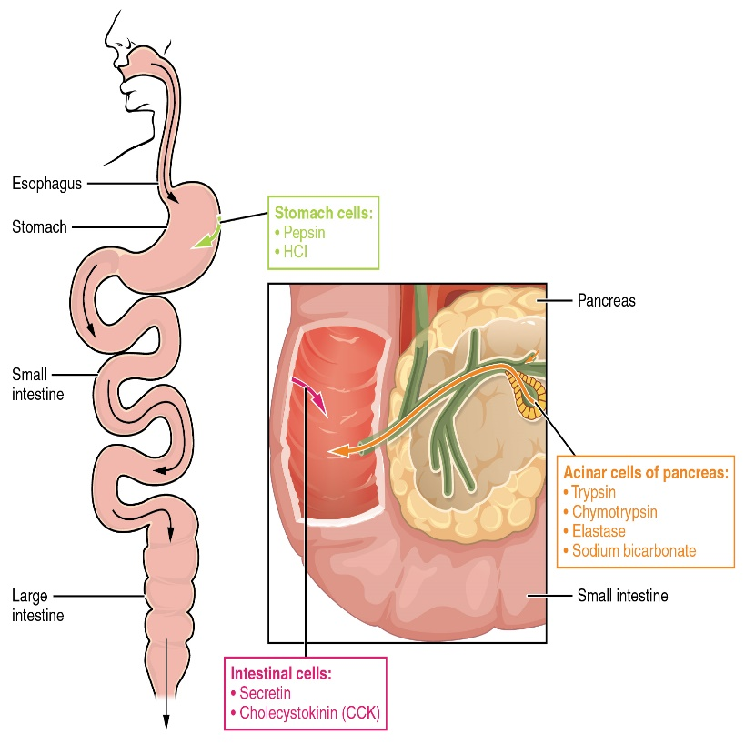

Figure 1. Digestive Enzymes and Hormones.

Enzymes in the stomach and small intestine break down proteins into amino acids. HCl in the stomach aids in proteolysis, and hormones secreted by intestinal cells direct the digestive processes.In order to avoid breaking down the proteins that make up the pancreas and small intestine, pancreatic enzymes are released as **inactive proenzymes** that are only activated in the small intestine. In the pancreas, vesicles store **trypsin** and **chymotrypsin** as **trypsinogen** and **chymotrypsinogen**. Once released into the small intestine, an enzyme found in the wall of the small intestine, called **enterokinase**, binds to trypsinogen and converts it into its active form, trypsin. Trypsin then binds to chymotrypsinogen to convert it into the active chymotrypsin. Trypsin and chymotrypsin break down large proteins into smaller peptides, a process called **proteolysis**. These smaller peptides are catabolized into their constituent amino acids, which are transported across the apical surface of the intestinal mucosa in a process that is mediated by sodium-amino acid transporters. These transporters bind sodium and then bind the amino acid to transport it across the membrane. At the basal surface of the mucosal cells, the sodium and amino acid are released. The sodium can be reused in the transporter, whereas the amino acids are transferred into the bloodstream to be transported to the liver and cells throughout the body for protein synthesis.Freely available amino acids are used to create proteins. If amino acids exist in excess, the body has no capacity or mechanism for their storage; thus, they are converted into glucose or ketones, or they are decomposed. Amino acid decomposition results in hydrocarbons and nitrogenous waste. However, high concentrations of nitrogen are toxic. The urea cycle processes nitrogen and facilitates its excretion from the body.**Urea Cycle**The **urea cycle** is a set of biochemical reactions that produces urea from ammonium ions in order to prevent a toxic level of ammonium in the body. It occurs primarily in the liver and, to a lesser extent, in the kidney. Prior to the urea cycle, ammonium ions are produced from the breakdown of amino acids. In these reactions, an amine group, or ammonium ion, from the amino acid is exchanged with a keto group on another molecule. This **transamination** event creates a molecule that is necessary for the Krebs cycle and an ammonium ion that enters into the urea cycle to be eliminated.In the urea cycle, ammonium is combined with CO2, resulting in urea and water. The urea is eliminated through the kidneys in the urine ([Figure 2](https://opentextbc.ca/anatomyandphysiology/chapter/24-4-protein-metabolism/#fig-ch25_04_02)).

**Summary of Urea Cycle**1.

1. Since ammonia is toxic to CNS even in traces liver rapidly removes ammonia from circulation and converts it to a non-toxic water soluble urea. Hence site of urea synthesis is liver.
2. The reactions leading to formation of urea from ammonia are proposed by Krebs and Henseleit. Hence, urea cycle is also called as Krebs-Henseleit cycle.
3. Formation of urea from ammonia in urea cycle occurs in five reactions. However the first reaction is not a part of the cycle but for the continuation of the cycle which consist of remaining four reactions product of the first reaction is essential. Further, the intermediates of the four reactions are amino acids. However no codons exist for them.
4. Synthesis of urea from ammonia is an energy dependent process.5. Enzymes of urea cycle are present in mitochondria and cytosol.
5. First two reactions of urea formation occurs in mitochondria and remaining reactions occur in cytosol.

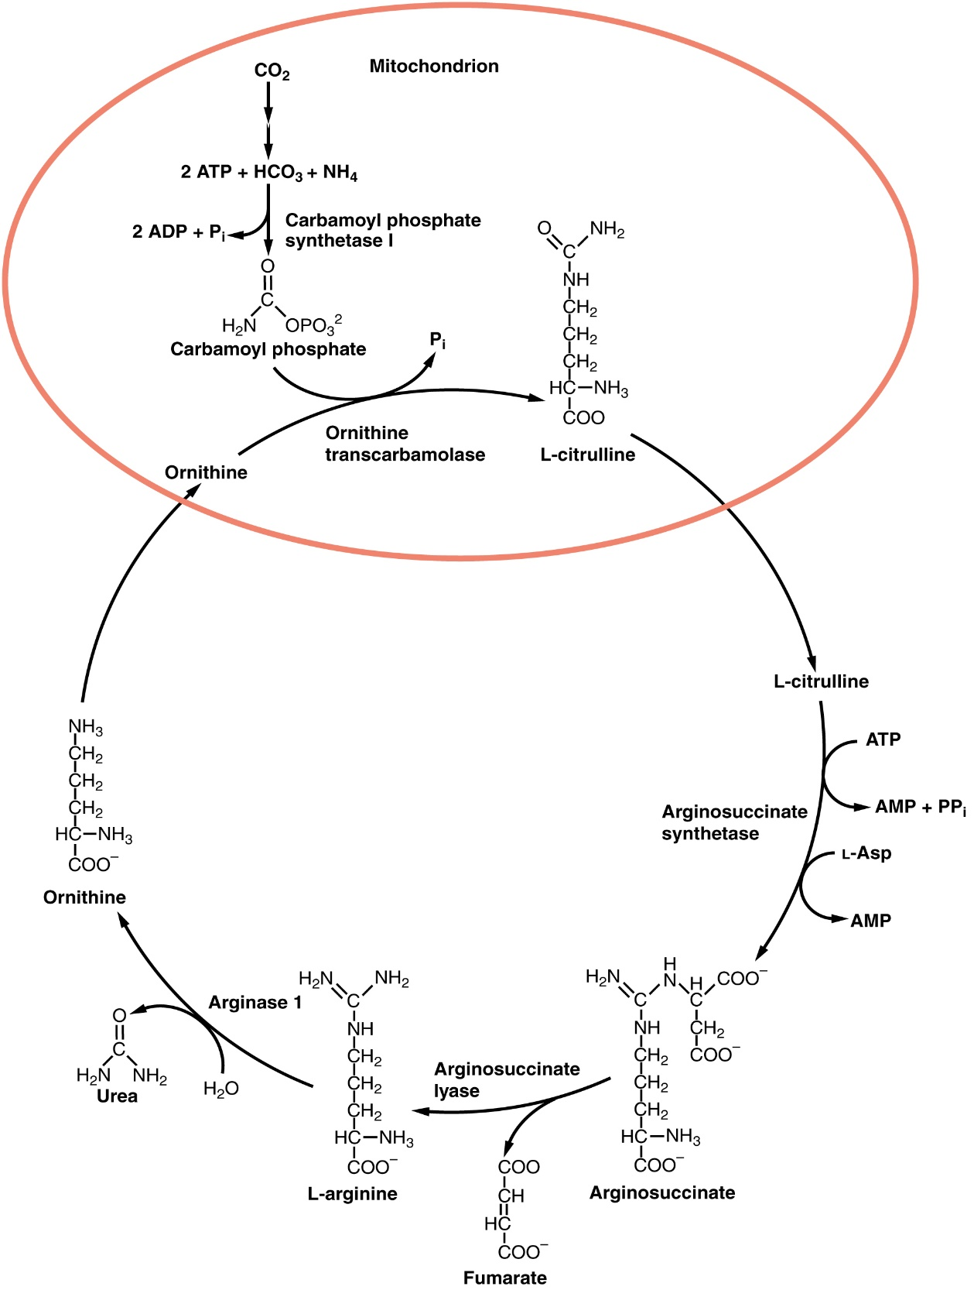 

**Fate of urea**

Urea has no physiological function. Hence it is transported to kidneys where it is excreted in urine. It is major end product of protein catabolism in humans. About 10-25 gm of urea is excreted in urine per day which makes up to 80-90% of total nitrogen excreted per day. However, blood also contains some urea.

Blood urea: Normal blood urea level is 16-36 mg/100 ml. Medical Importance Urea formation is impaired in several inherited diseases. They are due to deficiency of enzymes of urea cycle. The rate of incidence of urea cycle disorders is one in 2500. Most of these inherited diseases are due to defective genes and are fatal. Since the urea cycle converts ammonia to urea these disorders of urea cycle cause ammonia intoxication. Some common clinical symptoms seen in these diseases are vomiting, irritability, lethargy, seizures, mental retardation, coma and early death.

They are:

1. Hyper ammonemia Type I: It is due to deficiency of enzyme carbamoyl phosphate synthetase-I. Mental retardation is the main symptom of this condition.
2. Hyper ammonemia Type II: It is most common among others. It is due to deficiency of enzyme ornithine trans carbamoylase. So, in this condition carbamoyl phosphate accumulates and diverted to pyrimidine formation. This results in excretion of oroticacid and uracil in urine. Glutamate also accumulates in this condition.
3. Citrullinemia: This condition is due to the absence of enzyme argininosuccinate synthetase. Hence citrulline accumulates in blood and excreted in urine.
4. Argininosuccinicaciduria: Argininosuccinase is absent in this condition. So, argininosuccinate accumulates in blood and excreted in urine.
5. Hyper argininemia: This condition is due to low arginase activity. Hence, arginine accumulates and excreted in urine. However some urea may be excreted in urine due to kidney arginase.

Amino acids can also be used as a source of energy, especially in times of starvation. Because the processing of amino acids results in the creation of metabolic intermediates, including pyruvate, acetyl CoA, acetoacyl CoA, oxaloacetate, and α-ketoglutarate, amino acids can serve as a source of energy production through the Krebs cycle ([Figure 3](https://opentextbc.ca/anatomyandphysiology/chapter/24-4-protein-metabolism/#fig-ch25_04_03)). [Figure 4](https://opentextbc.ca/anatomyandphysiology/chapter/24-4-protein-metabolism/#fig-ch25_04_04) summarizes the pathways of catabolism and anabolism for carbohydrate s, lipids, and proteins.

Although most tissues can synthesize urea, most urea is produced in the liver. Because urea is uncharged, urea excretion does not involve the loss of any electrolytes as counter ions. Excretion of urea is, however, associated with considerable loss of water due to osmotic pressure. Urea is produced as part of the series of reactions that comprise the urea cycle. The urea cycle is the first of the two major metabolic cycles discovered by Hans Krebs. In fact, the urea cycle was the first biological cycle to be discovered, and helped establish the concept for the discovery of the TCA cycle.

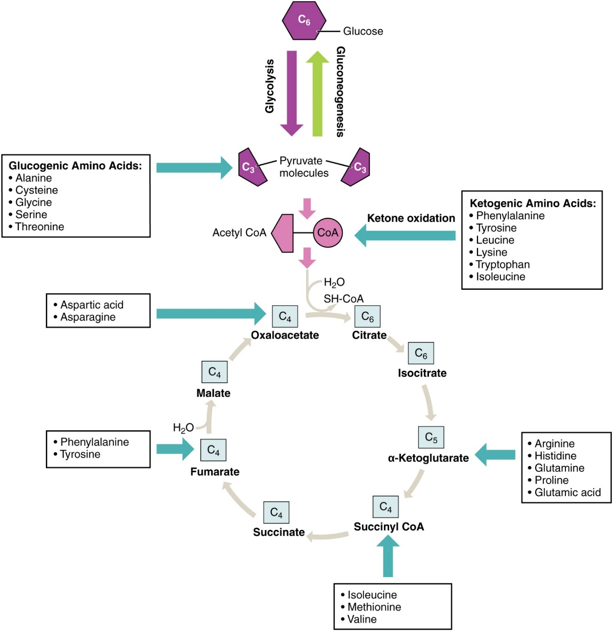

pathway.

Figure 3. Energy from Amino Acids. Amino acids can be broken down into precursors for glycolysis or the Krebs cycle. Amino acids (in bold) can enter the cycle through more than one pathway.

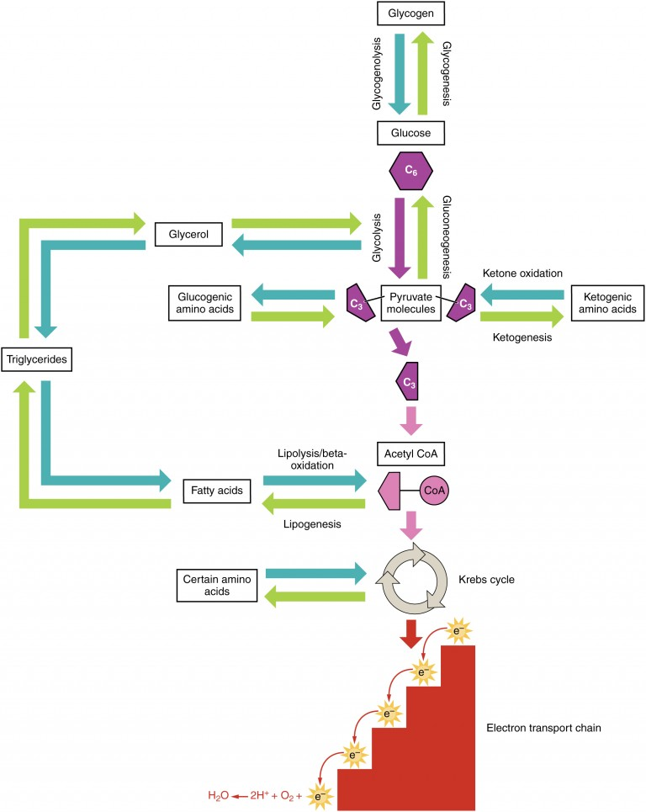

Figure 4. Catabolic and Anabolic Pathways. Nutrients follow a complex pathway from ingestion through anabolism and catabolism to energy production.

**DISORDERS OF THE PROTEIN METABOLISM**

**Metabolism: Pyruvate Dehydrogenase Complex Deficiency and Phenylketonuria**  
Pyruvate dehydrogenase complex deficiency (PDCD) and phenylketonuria (PKU) are genetic disorders. Pyruvate dehydrogenase is the enzyme that converts pyruvate into acetyl CoA, the molecule necessary to begin the Krebs cycle to produce ATP. With low levels of the pyruvate dehydrogenase complex (PDC), the rate of cycling through the Krebs cycle is dramatically reduced. This results in a decrease in the total amount of energy that is produced by the cells of the body. PDC deficiency results in a neurodegenerative disease that ranges in severity, depending on the levels of the PDC enzyme. It may cause developmental defects, muscle spasms, and death. Treatments can include diet modification, vitamin supplementation, and gene therapy; however, damage to the central nervous system usually cannot be reversed. PKU affects about 1 in every 15,000 births in the United States. People afflicted with PKU lack sufficient activity of the enzyme phenylalanine hydroxylase and are therefore unable to break down phenylalanine into tyrosine adequately. Because of this, levels of phenylalanine rise to toxic levels in the body, which results in damage to the central nervous system and brain. Symptoms include delayed neurological development, hyperactivity, mental retardation, seizures, skin rash, tremors, and uncontrolled movements of the arms and legs. Pregnant women with PKU are at a high risk for exposing the fetus to too much phenylalanine, which can cross the placenta and affect fetal development. Babies exposed to excess phenylalanine in utero may present with heart defects, physical and/or mental retardation, and microcephaly. Every infant in the United States and Canada is tested at birth to determine whether PKU is present. The earlier a modified diet is begun, the less severe the symptoms will be. The person must closely follow a strict diet that is low in phenylalanine to avoid symptoms and damage. Phenylalanine is found in high concentrations in artificial sweeteners, including aspartame. Therefore, these sweeteners must be avoided. Some animal products and certain starches are also high in phenylalanine, and intake of these foods should be carefully monitored.

**Chapter Review**

Digestion of proteins begins in the stomach, where HCl and pepsin begin the process of breaking down proteins into their constituent amino acids. As the chyme enters the small intestine, it mixes with bicarbonate and digestive enzymes. The bicarbonate neutralizes the acidic HCl, and the digestive enzymes break down the proteins into smaller peptides and amino acids. Digestive hormones secretin and CCK are released from the small intestine to aid in digestive processes, and digestive proenzymes are released from the pancreas (trypsinogen and chymotrypsinogen). Enterokinase, an enzyme located in the wall of the small intestine, activates trypsin, which in turn activates chymotrypsin. These enzymes liberate the individual amino acids that are then transported via sodium-amino acid transporters across the intestinal wall into the cell. The amino acids are then transported into the bloodstream for dispersal to the liver and cells throughout the body to be used to create new proteins. When in excess, the amino acids are processed and stored as glucose or ketones. The nitrogen waste that is liberated in this process is converted to urea in the urea acid cycle and eliminated in the urine. In times of starvation, amino acids can be used as an energy source and processed through the Krebs cycle.

## **Glossary**

**chymotrypsin**

*pancreatic enzyme that digests protein*

**chymotrypsinogen**

*proenzyme that is activated by trypsin into chymotrypsin*

**elastase**

*pancreatic enzyme that digests protein*

**enterokinase**

*enzyme located in the wall of the small intestine that activates trypsin*

**inactive proenzymes**

*forms in which proteases are stored and released to prevent the inappropriate digestion of the native proteins of the stomach, pancreas, and small intestine*

**pepsin**

*enzyme that begins to break down proteins in the stomach*

**proteolysis**

*process of breaking proteins into smaller peptides*

**secretin**

*hormone released in the small intestine to aid in digestion*

**sodium bicarbonate**

*anion released into the small intestine to neutralize the pH of the food from the stomach*

**transamination**

*transfer of an amine group from one molecule to another as a way to turn nitrogen waste into ammonia so that it can enter the urea cycle*

**trypsin**

*pancreatic enzyme that activates chymotrypsin and digests protein*

**trypsinogen**

*proenzyme form of trypsin*

**urea cycle**

*process that converts potentially toxic nitrogen waste into urea that can be eliminated through the kidneys*