Lipid Metabolism

LEARNING OBJECTIVES

By the end of this section, you will be able to:
- Explain how energy can be derived from fat
- Explain the purpose and process of ketogenesis
- Describe the process of ketone body oxidation
- Explain the purpose and the process of lipogenesis

MEDICAL AND BIOLOGICAL IMPORTANCE

- In fed condition, excess calories consumed in the form of carbohydrates are conserved in the form of lipids. Of course dietary lipids are also stored under well-fed condition.
- Even though excess energy may be stored in the form of carbohydrate (glycogen) humans and other mammals prefers to store excess energy only in the form of lipid because (a) Energy content of lipid is 2-3 times higher. (b) Lipid can be stored without water of hydration, which is not possible with glycogen. For example 1 gm of glycogen needs 2 gm of water for storage. (c) Oxidation of lipid produces more water. For example, oxidation of glucose produces approximately 45 water molecules where as oxidation of stearic acid produces nearly 165 water molecules.
- Usually lipid stores are greater compared to glycogen. A 70 kg individual may have lipid store of about 15 kg. However, his glycogen store is about only 0.22 kg.
- During fasting or in between meals stored lipids are used to meet energy demands. Glycogen store get depleted within 24 hours of fasting. Later, energy requirement of the body is entirely met by stored lipid. Lipids can meet body energy requirements for weeks.
- Desert animal camel suits well to dry conditions because it derives water and energy from large amounts of lipids stored in hump. Hibernating and migratory birds also use lipid stores to meet water and energy demands during hibernation and migration, respectively.
- Defect or changes in the pathways of lipid metabolism are directly related to development of diseases.
- Increased fatty acid oxidation in starvation and diabetes leads to keto acidosis. Decreased fatty acid oxidation leads to hypoglycemia.
- Some drugs and poisons work by inhibiting pathways of lipid metabolism. Aspirin an anti inflammatory drug works by inhibiting prostaglandin formation. Hypoglycin a toxin causes hypoglycemia.
- Transport and storage of triglycerides are affected in obesity, diabetes and hyper lipoproteinemia. Block in the movement of triglycerides cause fatty livers.
- Abnormalities in lipoprotein metabolism cause various dyslipoproteinemias (dyslipidemias) and fatty livers.
- Accumulation of complex lipids leads to lipidoses.
- Cholesterol is the major player in the development of atherosclerosis. Atherosclerosis can cause coronary artery disease and other vascular diseases.
- Excessive fat accumulation leads to obesity.
- Cholesterol produces bile salts, which are required for digestion and absorption of dietary lipids. Inhibitors of bile acid formation are used in the treatment of atherosclerosis. Among lipids, triglycerides serves as stored form of energy. During fasting and or in between meals they are broken down to glycerol and fatty acids. Fatty acids accounts for 95% of oxidation energy of triglycerides. The remainder is derived from glycerol. Hence oxidation of fat or lipid is nothing but oxidation of fatty acids.

FAT METABOLISM

Fats (or triglycerides) within the body are ingested as food or synthesized by adipocytes or hepatocytes from carbohydrate precursors (Figure 1). Lipid metabolism entails the oxidation of fatty acids to either generate energy or synthesize new lipids from smaller constituent molecules. Lipid metabolism is associated with carbohydrate metabolism, as products of glucose (such as acetyl CoA) can be converted into lipids.
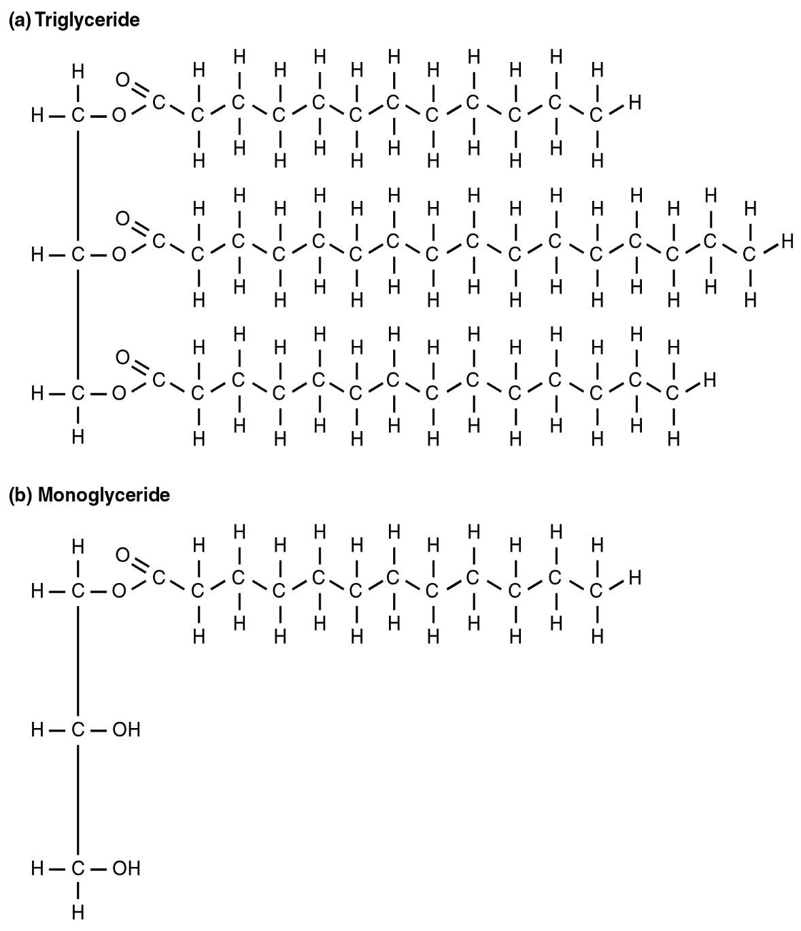
Figure 1. Triglyceride Broken Down into a Monoglyceride A triglyceride molecule (a) breaks down into a monoglyceride (b).

Lipid metabolism begins in the intestine where ingested triglycerides are broken down into smaller chain fatty acids and subsequently into monoglyceride molecules (see Figure 1b) by pancreatic lipases, enzymes that break down fats after they are emulsified by bile salts. When food reaches the small intestine in the form of chyme, a digestive hormone called cholecystokinin (CCK) is released by intestinal cells in the intestinal mucosa. CCK stimulates the release of pancreatic lipase from the pancreas and stimulates the contraction of the gallbladder to release stored bile salts into the intestine. CCK also travels to the brain, where it can act as a hunger suppressant.

Together, the pancreatic lipases and bile salts break down triglycerides into free fatty acids. These fatty acids can be transported across the intestinal membrane. However, once they cross the membrane, they are recombined to again form triglyceride molecules. Within the intestinal cells, these triglycerides are packaged along with cholesterol molecules in phospholipid vesicles called chylomicrons (Figure 2). The chylomicrons enable fats and cholesterol to move within the aqueous environment of your lymphatic and circulatory systems. Chylomicrons leave the enterocytes by exocytosis and enter the lymphatic system via lacteals in the villi of the intestine. From the lymphatic system, the chylomicrons are transported to the circulatory system. Once in the circulation, they can either go to the liver or be stored in fat cells (adipocytes) that comprise adipose (fat) tissue found throughout the body.

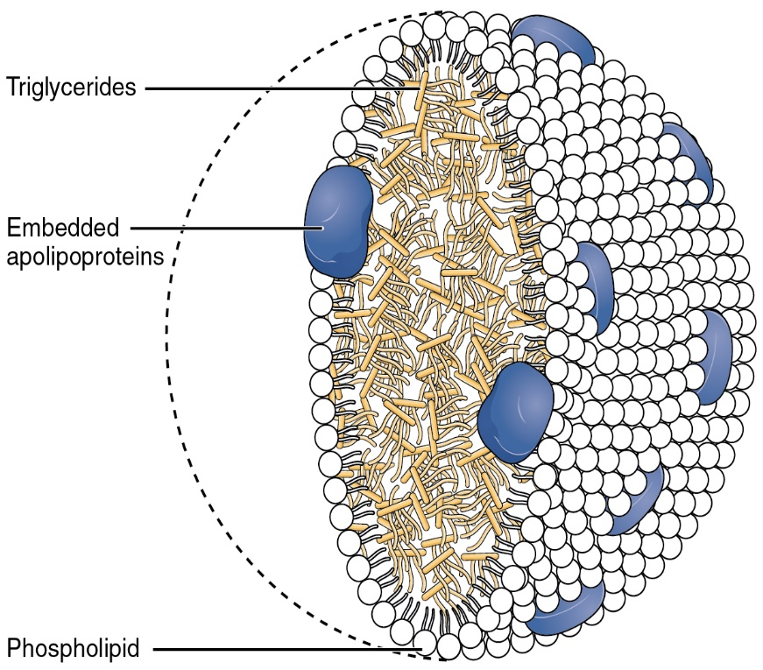

Figure 2. Chylomicrons. Chylomicrons contain triglycerides, cholesterol molecules, and other apolipoproteins (protein molecules). They function to carry these water-insoluble molecules from the intestine, through the lymphatic system, and into the bloodstream, which carries the lipids to adipose tissue for storage.

LIPOLYSIS

To obtain energy from fat, triglycerides must first be broken down by hydrolysis into their two principal components, fatty acids and glycerol. This process, called lipolysis, takes place in the cytoplasm. The resulting fatty acids are oxidized by β-oxidation into acetyl CoA, which is used by the Krebs cycle. The glycerol that is released from triglycerides after lipolysis directly enters the glycolysis pathway as DHAP. Because one triglyceride molecule yields three fatty acid molecules with as much as 16 or more carbons in each one, fat molecules yield more energy than carbohydrates and are an important source of energy for the human body. Triglycerides yield more than twice the energy per unit mass when compared to carbohydrates and proteins. Therefore, when glucose levels are low, triglycerides can be converted into acetyl CoA molecules and used to generate ATP through aerobic respiration.

The breakdown of fatty acids, called fatty acid oxidation or beta (β)-oxidation, begins in the cytoplasm, where fatty acids are converted into fatty acyl CoA molecules. This fatty acyl CoA combines with carnitine to create a fatty acyl carnitine molecule, which helps to transport the fatty acid across the mitochondrial membrane. Once inside the mitochondrial matrix, the fatty acyl carnitine molecule is converted back into fatty acyl CoA and then into acetyl CoA (Figure 3). The newly formed acetyl CoA enters the Krebs cycle and is used to produce ATP in the same way as acetyl CoA derived from pyruvate.
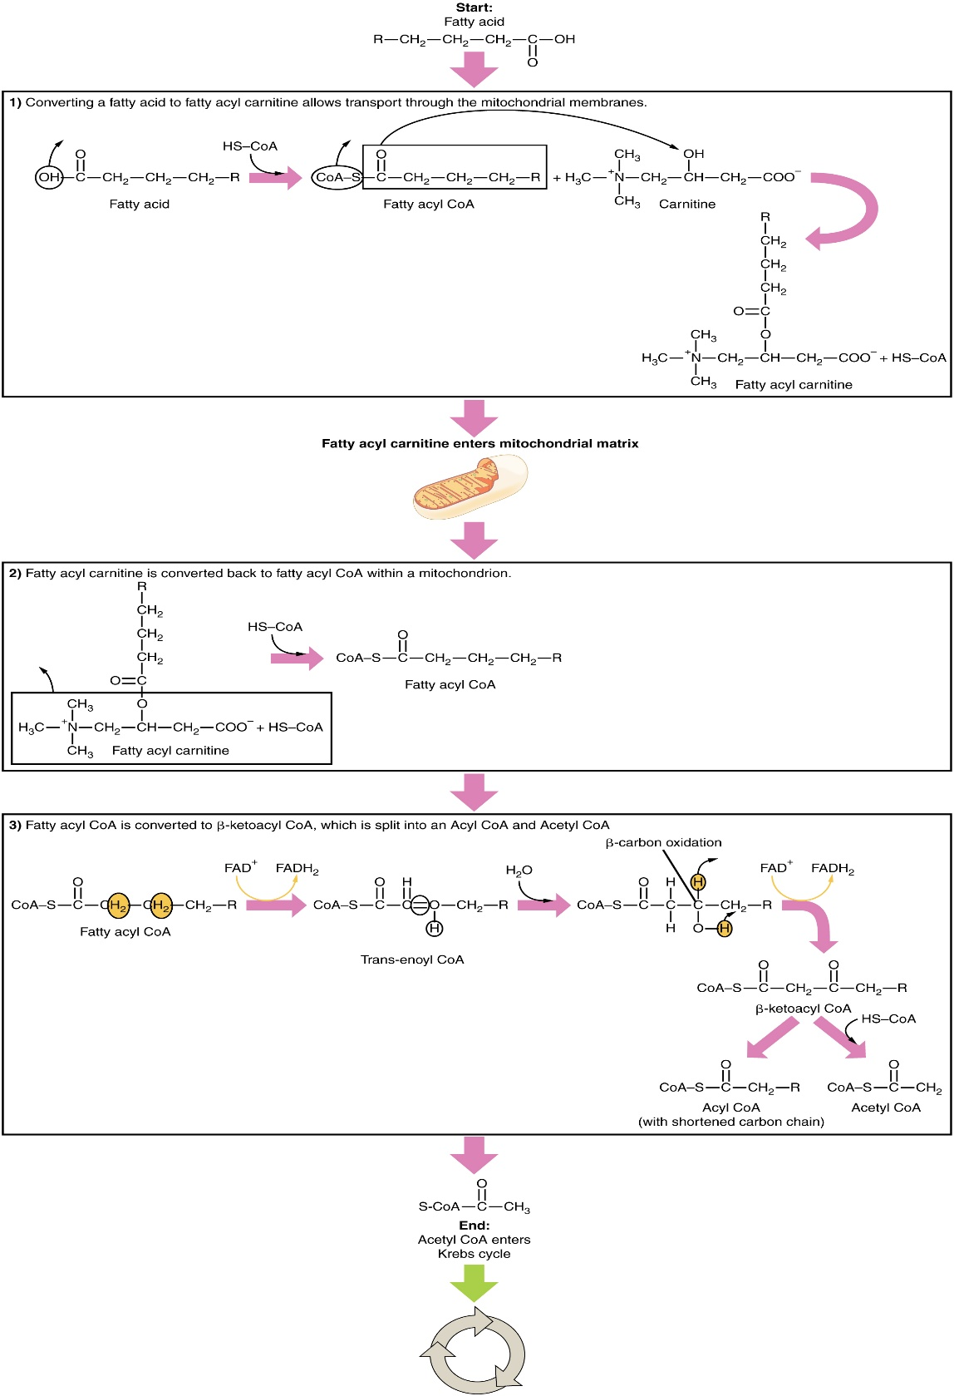
Figure 3. Breakdown of Fatty Acids. During fatty acid oxidation, triglycerides can be broken down into acetyl CoA molecules and used for energy when glucose levels are low.

KETOGENESIS

If excessive acetyl CoA is created from the oxidation of fatty acids and the Krebs cycle is overloaded and cannot handle it, the acetyl CoA is diverted to create ketone bodies. These ketone bodies can serve as a fuel source if glucose levels are too low in the body. Ketones serve as fuel in times of prolonged starvation or when patients suffer from uncontrolled diabetes and cannot utilize most of the circulating glucose. In both cases, fat stores are liberated to generate energy through the Krebs cycle and will generate ketone bodies when too much acetyl CoA accumulates.

In this ketone synthesis reaction, excess acetyl CoA is converted into hydroxymethylglutaryl CoA (HMG CoA). HMG CoA is a precursor of cholesterol and is an intermediate that is subsequently converted into β-hydroxybutyrate, the primary ketone body in the blood (Figure 4).

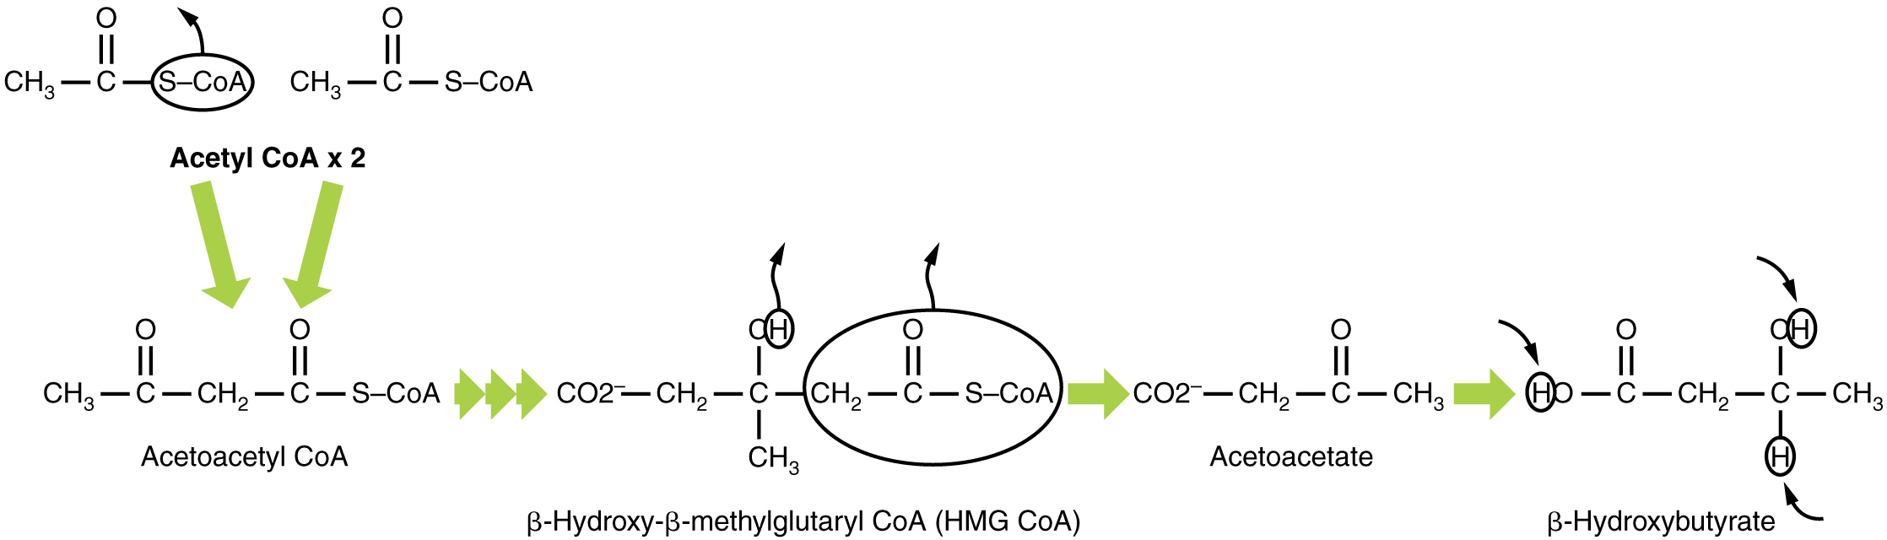

Figure 4. Ketogenesis. Excess acetyl CoA is diverted from the Krebs cycle to the ketogenesis pathway. This reaction occurs in the mitochondria of liver cells. The result is the production of β-hydroxybutyrate, the primary ketone body found in the blood.

In summary,
- Synthesis of ketone bodies is called as ketogenesis.
- Under certain conditions, production of acetyl-CoA either from β-oxidation or pyruvate oxidation is more rapid than it can be utilized for other metabolic processes.
- Liver converts the excess acetyl-CoA to ketone bodies. Hence, liver can be considered as net producer of ketone bodies.

Biological importance
- The major purpose of ketone body formation in liver is to distribute excess fuel (acetylCoA) to other tissues.
- Even number fatty acids are more ketogenic than odd number fatty acids.
- Fat is more ketogenic than carbohydrate because fat generates more acetyl-CoA.Lipogenesis

KETONE BODY OXIDATION

Organs that have classically been thought to be dependent solely on glucose, such as the brain, can actually use ketones as an alternative energy source. This keeps the brain functioning when glucose is limited. When ketones are produced faster than they can be used, they can be broken down into CO₂ and acetone. The acetone is removed by exhalation. One symptom of ketogenesis is that the patient’s breath smells sweet like alcohol. This effect provides one way of telling if a diabetic is properly controlling the disease. The carbon dioxide produced can acidify the blood, leading to diabetic ketoacidosis, a dangerous condition in diabetics.

Ketones oxidize to produce energy for the brain. beta (β)-hydroxybutyrate is oxidized to acetoacetate and NADH is released. An HS-CoA molecule is added to acetoacetate, forming acetoacetyl CoA. The carbon within the acetoacetyl CoA that is not bonded to the CoA then detaches, splitting the molecule in two. This carbon then attaches to another free HS-CoA, resulting in two acetyl CoA molecules. These two acetyl CoA molecules are then processed through the Krebs cycle to generate energy (Figure 5).
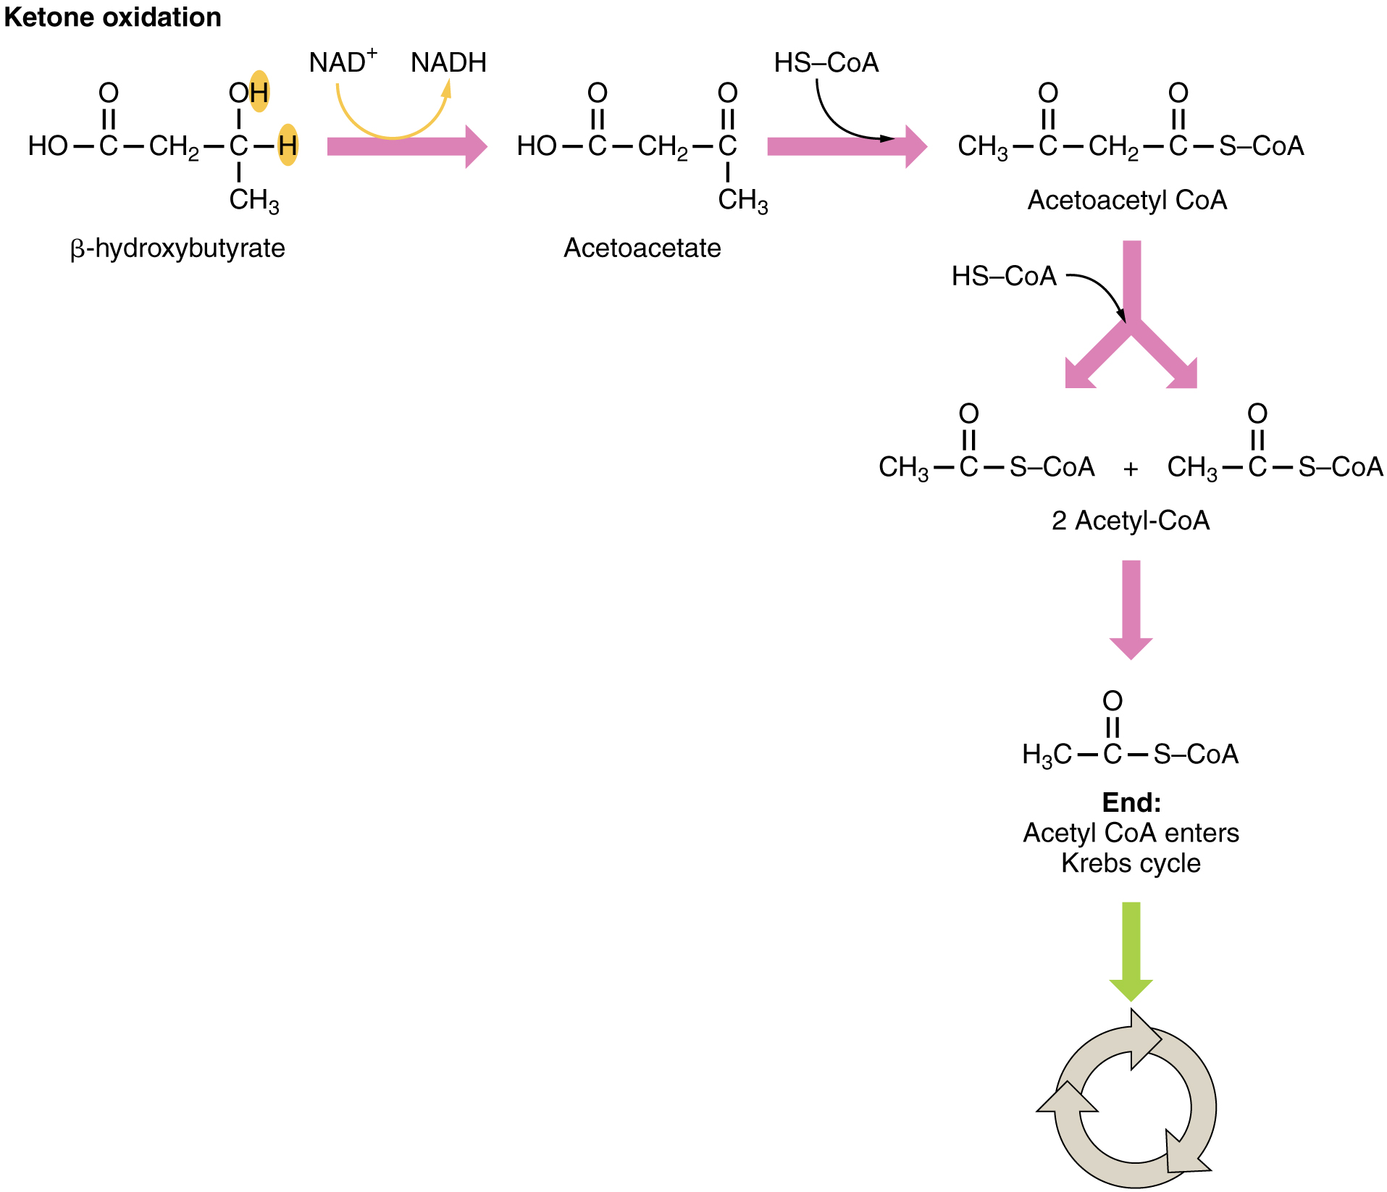
Figure 5. Ketone Oxidation. When glucose is limited, ketone bodies can be oxidized to produce acetyl CoA to be used in the Krebs cycle to generate energy.

When glucose levels are plentiful, the excess acetyl CoA generated by glycolysis can be converted into fatty acids, triglycerides, cholesterol, steroids, and bile salts. This process, called lipogenesis, creates lipids (fat) from the acetyl CoA and takes place in the cytoplasm of adipocytes (fat cells) and hepatocytes (liver cells). When you eat more glucose or carbohydrates than your body needs, your system uses acetyl CoA to turn the excess into fat. Although there are several metabolic sources of acetyl CoA, it is most commonly derived from glycolysis. Acetyl CoA availability is significant, because it initiates lipogenesis. Lipogenesis begins with acetyl CoA and advances by the subsequent addition of two carbon atoms from another acetyl CoA; this process is repeated until fatty acids are the appropriate length. Because this is a bond-creating anabolic process, ATP is consumed. However, the creation of triglycerides and lipids is an efficient way of storing the energy available in carbohydrates. Triglycerides and lipids, high-energy molecules, are stored in adipose tissue until they are needed.

Although lipogenesis occurs in the cytoplasm, the necessary acetyl CoA is created in the mitochondria and cannot be transported across the mitochondrial membrane. To solve this problem, pyruvate is converted into both oxaloacetate and acetyl CoA. Two different enzymes are required for these conversions. Oxaloacetate forms via the action of pyruvate carboxylase, whereas the action of pyruvate dehydrogenase creates acetyl CoA. Oxaloacetate and acetyl CoA combine to form citrate, which can cross the mitochondrial membrane and enter the cytoplasm. In the cytoplasm, citrate is converted back into oxaloacetate and acetyl CoA. Oxaloacetate is converted into malate and then into pyruvate. Pyruvate crosses back across the mitochondrial membrane to wait for the next cycle of lipogenesis. The acetyl CoA is converted into malonyl CoA that is used to synthesize fatty acids. Figure 6 summarizes the pathways of lipid metabolism.
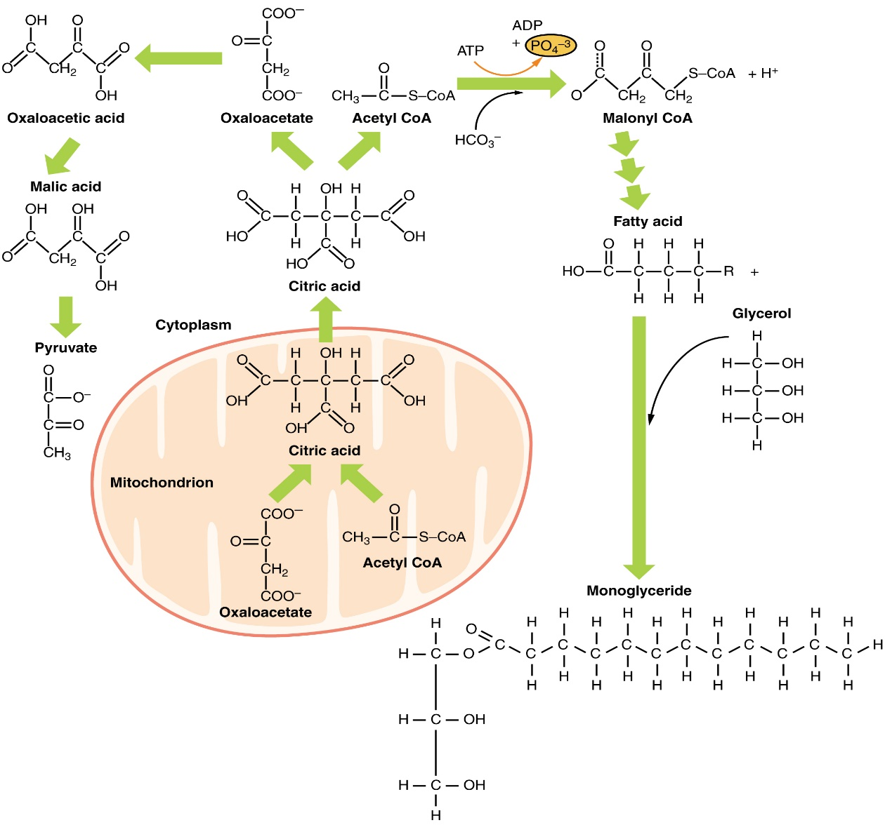
Figure 6. Lipid Metabolism. Lipids may follow one of several pathways during metabolism. Glycerol and fatty acids follow different pathways.

Chapter Review

Lipids are available to the body from three sources. They can be ingested in the diet, stored in the adipose tissue of the body, or synthesized in the liver. Fats ingested in the diet are digested in the small intestine. The triglycerides are broken down into monoglycerides and free fatty acids, then imported across the intestinal mucosa. Once across, the triglycerides are resynthesized and transported to the liver or adipose tissue. Fatty acids are oxidized through fatty acid or β-oxidation into two-carbon acetyl CoA molecules, which can then enter the Krebs cycle to generate ATP. If excess acetyl CoA is created and overloads the capacity of the Krebs cycle, the acetyl CoA can be used to synthesize ketone bodies. When glucose is limited, ketone bodies can be oxidized and used for fuel. Excess acetyl CoA generated from excess glucose or carbohydrate ingestion can be used for fatty acid synthesis or lipogenesis. Acetyl CoA is used to create lipids, triglycerides, steroid hormones, cholesterol, and bile salts. Lipolysis is the breakdown of triglycerides into glycerol and fatty acids, making them easier for the body to process.

In summary:

- Degradation of ketone bodies is called as ketolysis.
- Ketone bodies produced in liver reaches peripheral tissues through circulation.
- Heart, kidney cortex, brain and to some extent skeletal muscle uses ketone bodies for energy production.

Biological importance

- Heart and kidney cortex prefers to use ketone bodies rather than glucose. During prolonged starvation, brain derives most of energy from ketone bodies.
- Liver is unable to use ketone bodies due to lack of enzymes.

FATTY ACID SYNTHESIS

- humans and other mammals store energy in the form of lipid. But energy is consumed mostly in the form of carbohydrate. Therefore, these organisms must have mechanism for the conversion of carbohydrate to fat.
- Fatty acid synthase a multi enzyme complex is responsible for the formation of fatty acids, acetyl-CoA derived from pyruvate is substrate for this complex and palmitate is end product.
- Fatty acids are formed by the condensation of two carbon units.
- So, fatty acid formation is the reversal of β-oxidation. However, enzymes are different for two processes.
- Site: Fatty acid synthesis occurs in the cytosol of liver, kidneys, brain, lung, adipose tissue and mammary gland.

Medical Importance

- Few of the drugs used in the treatment of obesity work by inhibiting fatty acid synthesis.
- Hydroxy citrate is one such drug ATP citrate lyase is the target of its action. In presence of hydroxy citrate, the enzyme can not act on its natural substrate citrate. As a result, availability of acetyl-CoA for fatty acid synthesis is impaired. Garcinia cambogia (malabar tamarind) contains hydroxy citrate.
- In malarial parasite, fatty acid synthesis is brought about fatty acid synthesis system type-II in which reactions of the pathway are catalyzed by independent enzymes. This is different from that of host in which multi-enzyme complex of fatty acid synthase system type-I is involved in fatty acid synthesis. It is of great pharmacological importance. It allows development of new drugs for treatment of malaria, which act by blocking action of each of independent enzyme of parasite fatty acid synthesis. Triclosan and cerulenin are inhibitors of enoyl reductase and ketoacyl synthase, respectively. They are effective in killing malarial parasite in in vitro and in vivo.
- Fatty acid oxidation and synthesis are two opposite processes. Their simultaneous occurrence results in wasting of cellular resources.
- In fed conditions, malonyl-CoA formation is increased due to activation of acetyl-CoA carboxylase by citrate. Malonyl-CoA inhibits CAT-I activity. As a result, fatty acid oxidation is decreased. Therefore, under fed conditions fatty acid synthesis is promoted and fatty acid oxidation is inhibited.
- In starvation, diabetes and high fat diet consumption raised plasma acyl-CoA inhibit fatty acid synthesis by inactivating acetyl-CoA carboxylase. Less of malonyl-CoA formation due to inactivation of acetyl-CoA carboxylase stimulates CAT-I activity. This results in more fatty acid oxidation. Therefore, under above mentioned conditions, fatty acid synthesis is inhibited and at the same time fatty acid oxidation is favoured.
- Thus, malonyl-CoA is the reciprocal regulator of fatty acid oxidation and fatty acid synthesis.

TRIGLYCERIDE SYNTHESIS

Triglyceride biosynthesis It occurs in the liver, adipose tissue and intestine of non-ruminants. Triglycerides synthesized in liver and intestine are transported to other tissues where as in adipose tissue triglycerides are stored. Both saturated and unsaturated fatty acids having 16-18 carbon atoms are used for triglycerides formation after activation. They are used in the CoA form.

Medical importance

- Diet influences the type of fat produced in adipose tissue. Carbohydrate or starchy diets produce hard fat whereas diets rich is peanut oil or corn oil produce soft fat.
- Triglyceride formation is marked in well fed state and decreased in starvation, diabetes. High fat diet also decreases fat formation.
- Usually triglyceride biosynthesis is directly related to fatty acid biosynthesis.

FAT MOBILIZATION OR TRIGLYCERIDE DEGRADATION OR LIPOLYSIS

Medical importance
- Triglycerides stored in adipose tissue are degraded when there is stress or in energy deficient conditions like starvation or diabetes.
- Under stressful conditions or starvation, hormones like epinephrine and glucagon are released. They stimulate lipolysis to meet energy requirement of the tissues.
- In diabetes lack of insulin causes increased lipolysis.
- In pheochromocytoma plasma free fatty acid level is increased due to increased lipolysis.

CHOLESTEROL METABOLISM

Biosynthesis of cholesterol
- About 1 gm of cholesterol is synthesized in the body per day.
- Site. Cholesterol synthesis takes place in all nucleated cells particularly liver, adrenal cortex, testis, ovaries, brain, placenta, aorta and skin. The enzymes of cholesterol biosynthesis are present in micro somes and cytosol of the cells.
- Precursors. Acetyl-CoAs generated from the breakdown of carbohydrates, fats and aminoacids act as precursors of cholesterol. Acetyl-CoAs are transported from mitochondria to cytosol by similar mechanism described for fatty acid biosynthesis

Catabolism of cholesterol
Humans lack enzyme system which can break steroid nucleus of cholesterol. So cholesterol is not degraded to small compounds in the body. However, it is converted to bile acids in the liver and eliminated through the bile.

Formation of bile acids

- It is the major pathway of cholesterol catabolism. About 80% cholesterol is converted to primary and secondary bile acids in liver and intestine. However, only small portions of bile acids are excreted through feces.
- About 0.5 gm of bile acids are formed per day in the body.

Other catabolic fates of cholesterol
- Another important catabolic fate of cholesterol relates to steroid hormones.
- Steroid hormones are synthesized in various tissues using cholesterol as starting material. Finally, they are excreted in urine after conjugation.

Plasma cholesterol concentration

Normal plasma cholesterol level is 150-250 mg%. Plasma cholesterol is mainly due to cholesterol present in lipoproteins. Highest proportion is found in LDL and significant amount in HDL and VLDL. Chylomicrons contain less cholesterol. It is present as free (30%) and remaining is in the estrified form. Normal HDL-cholesterol level is 25-50 mg% and LDCcholesterol level is 75-150 mg%.

Factors affecting plasma cholesterol
- It increases with age 2. Physical activity 3. Life style 4. Dietary fat 5. Smoking 6. Genetic factors

Hyper cholesterolemia

Plasma cholesterol level is high in atherosclerosis, coronary artery disease, diabetes, xanthomatosis, nephrotic syndrome, hypothyroidism and obstructive jaundice.

Atherosclerosis
- It is an abnormality associated with cholesterol metabolism. Blood cholesterol level is always high in atherosclerosis.
- However, genetic factors are also involved in the development of this disease.
- In this condition, initially cholesterol esters particularly cholesterol oleates of arterial smooth muscle cells deposits in arterial intima. This leads to fatty streaks formation and condition is reversible. If condition is not controlled continued extracellular deposition of cholesterol esters along with apo B-100 of lipoproteins results in the formation of plaque in the arterial wall.
- Plaque formation in the arterial wall causes narrowing of arterial lumen. 5. Blood vessel narrowing due to deposition of cholesterolester and apo B-100 is called as atherosclerosis. 6. Plaque in arteries promotes clot formation.
- If clot formation occurs in coronary artery, the blood and O2 supply to cardiac muscle diminishes. This manifest as myocardial infarction or stroke because anoxia causes necrosis of cardiac tissue.
- Thus atherosclerosis cause coronary artery, disease (CAD) 9. Atherosclerosis may develop as secondary complication of diseases like diabetes, hypothyroidism, lipid nephrosis and other type of dyslipoproteinemias.
- Some atherosclerotic lesions occurs even with normal blood cholesterol level. Inflammatory factors, low HDL levels are involved in this type of atherosclerosis development. Decreased HDL level leads to monocyte in filtration into arterial wall, macrophage, foam cell formation and lesion.

Brown Fat

- It is a special type of adipose tissue. It is present in humans, hibernating animals like grizzly bear, dormouse and mammals that live in cold environment.
- Large number of mitochondria present are responsible for characteristic colour.
- Brown adipose tissue mitochondrial respiratory chain does not produce ATP. It generates heat.
- Thermogenin, an inner mitochondrial protein act as proton channel. Hence, protons pumped out by respiratory chain flows back into mitochondria. As a result, respiratory chain energy is released as heat instead of ATP.

Medical importance

- In humans, it is present in front and back side of upper chest and neck.
- In cold environment, epinephrine stimulates fat mobilization oxidation of fatty acids produce heat rather than ATP. Thus, in cold environment, brown fat act as warming oven.
- Brown fat is less or absent in obese people. 4. Brown fat may be more in people who can eat but not get fat.

BIOSYNTHESIS OF COMPOUND LIPIDS

Major compound lipids present in mammalian membranes are phospholipids and glycolipids.
Phospholipid Biosynthesis

GLOSSARY

beta (β)-hydroxybutyrate
primary ketone body produced in the body
beta (β)-oxidation
fatty acid oxidation
bile salts
salts that are released from the liver in response to lipid ingestion and surround the insoluble triglycerides to aid in their conversion to monoglycerides and free fatty acids
cholecystokinin (CCK)
hormone that stimulates the release of pancreatic lipase and the contraction of the gallbladder to release bile salts
chylomicrons
vesicles containing cholesterol and triglycerides that transport lipids out of the intestinal cells and into the lymphatic and circulatory systems
fatty acid oxidation
breakdown of fatty acids into smaller chain fatty acids and acetyl CoA
hydroxymethylglutaryl CoA (HMG CoA)
molecule created in the first step of the creation of ketone bodies from acetyl CoA
ketone bodies
alternative source of energy when glucose is limited, created when too much acetyl CoA is created during fatty acid oxidation
lipogenesis
synthesis of lipids that occurs in the liver or adipose tissues
lipolysis
breakdown of triglycerides into glycerol and fatty acids
monoglyceride molecules
lipid consisting of a single fatty acid chain attached to a glycerol backbone
pancreatic lipases
enzymes released from the pancreas that digest lipids in the diet
triglycerides
lipids, or fats, consisting of three fatty acid chains attached to a glycerol backbone

