**CHS 233**

**Skin Health**

**What is skin?**

The skin is the largest organ in the body. It acts as the first defense mechanism against diseases and infections.

**The Structure of Skin**

To understand how to keep your skin healthy, it may help to learn about your skin's structure

**Skin is composed of three layers:**

1. the [epidermis](http://www.healthywomen.org/glossary/term/5352) (the outermost layer of skin—about the thickness of a piece of paper),
2. the dermis (the middle layer)
3. the [subcutaneous](http://www.healthywomen.org/glossary/term/6274) layer (the deepest layer).

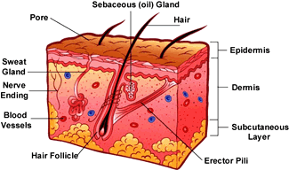

**The epidermis** has three sub-layers: the [stratum corneum](http://www.healthywomen.org/glossary/term/6263), the squamous cell layer and the basal cell layer

**The stratum corneum** or outer layer of the epidermis is the layer of skin that can be seen and felt. Proteins known as [keratin](http://www.healthywomen.org/glossary/term/5670), a fatty waterproof envelope, and flat, closely packed dead cells make up the stratum corneum. This layer is the barrier between your body and the outside world

**The squamous cell** **layer** produces keratin for the stratum corneum

**The basal cell layer** is the lowest layer of the epidermis. This is where the skin cells are reproduced and give rise to the more superficial layers of the epidermis. [Melanocytes](http://www.healthywomen.org/glossary/term/5767), which produce [melanin](http://www.healthywomen.org/glossary/term/5766), or skin pigment, sit along this layer among these cells.

It takes about **one month** for skin cells to move from the basal cell layer to the top of the stratum corneum and slough off.

**The most common forms of skin cancer** **are**:

1- Squamous cell carcinoma arises from Squamous cell layer

2- Basal cell carcinoma arises from The basal celllayer.

3- [Melanoma](http://www.healthywomen.org/glossary/term/5768) originates from melanocytes ; the pigment-producing cells.

**Dermis**: The dermis is the middle layer of skin. The thickness of the dermis varies depending on the location. For example, eyelid dermis is quite thin, but back dermis is about half an inch thick.

It has a combination of blood [vessels](http://www.healthywomen.org/glossary/term/4687), nerves, hair follicles and sebaceous (or oil) glands.

The proteins [collagen](http://www.healthywomen.org/glossary/term/5134) and [elastin](http://www.healthywomen.org/glossary/term/5302) are found in the dermis. They provide support and [elasticity](http://www.healthywomen.org/glossary/term/5301) to the skin. The sun's rays can break down these proteins and, eventually, the skin begins to wrinkle and sag.

**The subcutaneous layer**, is a layer of fatty tissue that provides nourishment to the dermis and upper layers of skin. It also conserves body heat and cushions internal organs against trauma. Blood vessels, nerves, sweat glands and deeper hair follicles extend from the dermis into the fat ([hypodermis](http://www.healthywomen.org/glossary/term/5576)).

[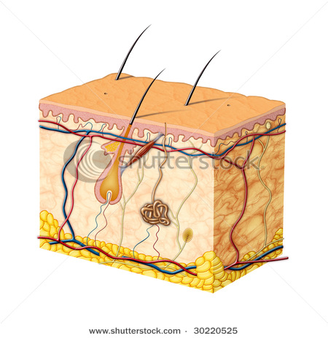](http://www.shutterstock.com/subscribe.mhtml)

**Changes in aging skin:**

Facial skin typically looks its best during a woman's 20s. As you age, your skin becomes thinner and often drier.

Thinning skin is a result of a breakdown of collagen and elastin fibers. As it ages, skin loses elasticity—especially if it has been exposed to excessive sunlight—and becomes more fragile and drier.

**Significant exposure to the sun will lead to**:

1. wrinkle skin
2. dry skin.
3. Uneven pigmentation—from freckles to small or large brown spots—
4. Coloasma of pregnancy, is brought out by the sun and produces large brown patches on the forehead and cheeks.
5. The most serious consequence of sun exposure is skin cancer.

Most sun damage occurs prior to the age of 18, but skin cancer can take up to 20 or more years to develop; children who experience just a few serious sunburns are believed to have an increased risk of developing skin cancer later in life.

**Recommendations for skin care:**

**1. Protect yourself from the sun:**

Use sunscreen

Seek shade

Wear protective clothing

**2. Don't smoke:**

Smoking makes your skin look older and contributes to wrinkles. Smoking narrows the tiny blood vessels in the outermost layers of skin, which decreases blood flow. This depletes the skin of oxygen and nutrients that are important to skin health. Smoking also damages collagen and elastin

In addition, the repetitive facial expressions you make when smoking — such as pursing your lips when inhaling and squinting your eyes to keep out smoke — can contribute to wrinkles.

**3. Consider these skin-friendly foods:**

* Carrots, apricots, and other yellow and orange fruits and vegetables
* Spinach and other green leafy vegetables
* Tomatoes
* Blueberries
* Beans, peas and lentils
* Salmon, mackerel and other fatty fish
* Nuts

**4. drink 6 to 8 glasses of water per day. This will help to keep your skin moist**  
**5. Applying moisturizer after a warm face wash** or a warm shower is the best remedies for skin. Moisturizing helps to restore the oils that our skin has and helps to keep the skin hydrated  
  
**6. Keep up regular exercise**. Regular exercise helps to keep the skin elasticity which prevents wrinkles.   
  
**7. Try and maintain a constant sleep pattern**  
  
**8. Do not scrub and wash too hard**. By doing this it removes the required oils that the skin needs to regenerate. When washing, wash lightly and in circular motion. This helps to keep the blood flow in your skin and does not allow the essential oils to escape  
  
**9. Do not squeeze acne spots.** by squeezing spots and black heads, the disease spreads and your acne will not disappear. By not squeezing your skin can heal the spot on its own and scars will not be formed.

**Assignment**

**1) Complete:**

**A) The most common forms of skin cancer** **are**:

1-……………………………………………………………………

2-…………………………………………………………………..

3-……………………………………………………………………..

**B) Changes in aging skin include:**

1-…………………………………………………………………………………………….

2-……………………………………………………………………………………………

**C) Food items that help attain healthy skin include:**

1…………………………………………………………………..

2………………………………………………………………….

3………………………………………………………………..

**2- Draw an illustration for skin layers.**